Pronunciation - trang 5 Unit 1 Sách Bài Tập (SBT) Tiếng anh 10 mới
Tổng hợp các bài tập trong phần Pronunciation - trang 5 Unit 1 Sách Bài Tập (SBT) Tiếng anh 10 mới
1 Write the words below in the correct column.
Viết những từ dưới đây vào đúng cột.
brother crash trash critical traffic create brown brainstorm
treat crane breadwinner tradition breakfast tree ice-cream
/tr/ | /kr/ | /br/

Đáp án:
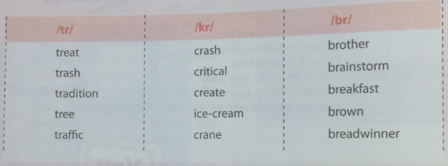
2 Write /tr/, /kr/ and /br/ above the word that has the corresponding consonant cluster sound. Then, practise reading the sentences.
Viết / tr /, / kr / và / br / phía trên từ chứa âm thanh có cụm phụ âm tương ứng. Sau đó, thực hành đọc các câu.
1. He has bread and ice-cream for breakfast.
2. My brother plans to travel by train but he has some trouble getting the ticket.
3. He went so crazy that he couldn't control himself and crashed Into a truck.
4. Mr Brown is a very bright and creative person.
5. Treat others the way you want to be treated.
Đáp án:
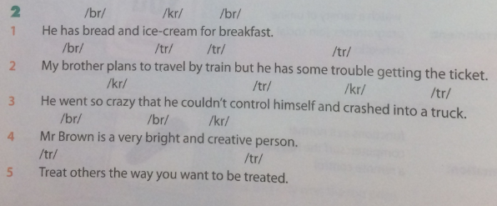

Vocabulary & Grammar - trang 5 Unit 1 Sách Bài Tập (SBT) Tiếng anh 10 mới
Tổng hợp các bài tập trong phần Vocabulary & Grammar - trang 5 Unit 1 Sách Bài Tập (SBT) Tiếng anh 10 mới
1 Look at the pictures. What are the chores in the pictures? Write them down in the space below the pictures.
Nhìn vào những bức tranh. Các công việc vặt trong các bức tranh là gì? Viết chúng xuống trong không gian bên dưới hình ảnh.
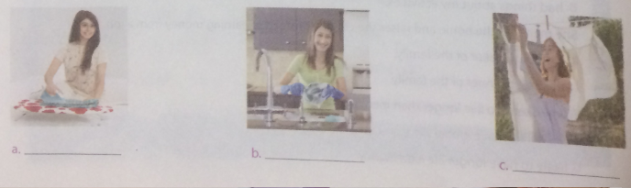
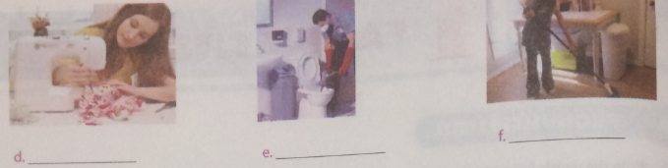
Đáp án:
a. ironing b. washing the dishes c hanging up clothes
d. sewing e. cleaning the toilet f. mopping the house
2 Complete the sentences using the correct form of the phrase about household chores in the box below.
Hoàn thành các câu bằng cách sử dụng đúng mẫu của cụm từ về việc nhà trong hộp dưới đây.
do the cooking shop for groceries clean the house take out the trash
do the laundry dothewashing-up water the houseplants feed the cat
1. She often____ at the supermarket near her house.
2. Lan loves animals so she____ after each meal.
3. They___ every day, so it is spotlessly clean.
4. He likes___ to see them growing.
5. Her father sometimes____. Everybody in the family enjoys the meals he cooks.
6. It does not take him much time to____ because he has a washing machine.
7. He hates___ after dinner and sometimes breaks a bowl or a plate.
8. Nam has to__ every day when the trash collector comes.
Đáp án:
1. shops for groceries 2.feeds the cat 3. clean the house
4, watering the houseplants 5. does the cooking 6. do the laundry
7. doing the washing-up 8. take out the trash
3 Circle the correct option to complete the sentence.
Khoanh tròn tùy chọn đúng để hoàn thành câu.
1. Being the breadwinner of the family,
a. she works hard to provide for her children.
b. she looks after the children carefully.
2. He is very friendly and enjoys being with other people. Everybody says that
a. he's a sociable man.
b. he's an unsociable man.
3. My brother is always very critical of things about me. He often says
a. good things about my activities.
b. bad things about my activities.
4. She manages the home and raises the children instead of earning money from a job. She's
a. the homemaker of the family.
b. the breadwinner of the family.
5. Women tend to live longer than men. They are
a. unlikely to have longer life expectancy.
b. likely to have longer life expectancy.
Đáp án:
1a 2a 3b 4a 5b
4. Fill the gaps with the correct of the verbs in brackets.
Điền vào các khoảng trống với hình thức đúng của các động từ trong ngoặc đơn.
1. I’m busy right now. I_________(prepare) dinner.
2. Mai _______(not/study) very hard at the moment. I ________(not/think) she’ll pass the exam.
3. “What_______(he/do)” “He_______(try) to fix the television antenna.”
4. Be quiet! Your dad ______(listen) to the news.
5. The houseplants________ (grow) very fast because he________(water) them every day.
6. In Viet Nam, many people ________(live) in extended families.
7. “Where’s your brother?” “He _______(read) upstairs.”
8. Look! Mary________ (wear) a pink skirt. She________(look) so pretty in it.
Đáp án:
1.am preparing 2. is not studying, don't think 3. is he doing, is trying
4. is listening 5. are growing, waters 6. live
7. is reading 8. is wearing, looks
5. Choose the correct endings for the sentences.
Chọn kết thúc chính xác cho các câu.
1 | My mother is watching television | a | Because her favorite film is on.
1 | My mother is watching television | b | When she has time.
2 | I’m having dinner | a | At 6.30 every day
2 | I’m having dinner | b | Now.
3 | What are you doing | a | To your sister when she doesn’t listen to you?
3 | What are you doing | b | To your sister? Don’t make her cry.
4 | I wear jeans | a | At the weekend.
4 | I wear jeans | b | Because we are going out for a picnic.
5 | My sister works hard | a | For the exam next week.
5 | My sister works hard | b | But she also spends time on her hobbies.
6 | He’s thinking of retiring early | a | Because he isn’t happy at work anymore.
6 | He’s thinking of retiring early | b | When something bad happens at work.
7 | She’s watching her hair | a | So she can’t talk to you now.
7 | She’s watching her hair | b | Twice a week.
8 | I listen to Mozart | a | Whenever I feel sad.
8 | I listen to Mozart | b | Because I’m feeling happy.

Đáp án:
1a 2b 3b 4a
5b 6a 7a 8a
6 Some of the verbs in the following sentences are incorrect form. Underline the mistakes and correct them.
Một số động từ trong các câu sau đây là không chính xác. Gạch chân những sai lầm và sửa chúng.
1 | Look. That young girl smiles at you. Do you know her?
2 | She has three big sons, so she’s doing the laundry every day.
3 | Take an umbrella with you. It’s raining heavily.
4 | “What is your father doing?” “ He’s a teacher.”
5 | David isn’t very good at housework, but he’s trying to share some chores when he has free time.
6 | Nowadays, most British people are living in nuclear families.
7 | Today, Nam’s parents are away on business, so his aunt takes care of him and his sister.
8 | Whenever Nam’s parents away on business, his aunt takes care of him and his sister.

Đáp án:

1 | Look. That vounq airl smiles at vou. Do vou know her? | is smiling
2 | She has three big sons, so she's doing the laundry every day. | does
3 | Take an umbrella with you. It's raining heavily. | correct
4 | 'What is your father doing?’ 'He's a teacher’. | 'What does your father do?’
5 | David isn't very good at housework, but he's trying to share some chores when he has free time. | tries
6 | Nowadays, most British people are living in nuclear families. | live
7 | Today Nam's parents are away on business, so his aunt takes care of him and his sister. | is taking
8 | Whenever Nam's parents are away on business, his aunt takes care of him and his sister. | correct
Reading - trang 8 Unit 1 Sách Bài Tập (SBT) Tiếng anh 10 mới
Tổng hợp các bài tập trong phần Reading - trang 8 Unit 1 Sách Bài Tập (SBT) Tiếng anh 10 mới
1 Read the text and fill each gap with a word or phrase from the box.
Đọc văn bản và điền vào mỗi khoảng trống bằng một từ hoặc cụm từ từ hộp.
Breadwinning hardstuff care tidy contribute manager repair
In a typical family in Japan, different members have their roles and responsibilities to perform. The father is the head of the family. He takes (1)___________of his family by earning a living, guiding the children, and making the final decisions that affect the family. He help the mother manage the household and is responsible for the (2)____________ like lifting heavy things and repair work like fixing plumbing and electricity.
The mother is usually the (3)___________of the household. She takes care of the children and supervises household takes. She also helps to earn a living and (help) make decisions affecting the family. She plans the menu, does the shopping, and prepares the family meals. She either supervises or does house cleaning, laundry, ironing and other similar tasks. Today, however, both mother and father can share roles in homemaking and (4)_________.
The son in the family helps the father with some household activities such as doing simple home (5)__________. He helps the mother in the kitchen and with other household tasks. He also assists with other activities in the home like taking care of younger brothers or sisters watering the plants, and cleaning the house.
The daughter In the family helps the mother to do some of the household tasks like grocery shopping, cooking, washing dishes, cleaning, and keeping the house (6)________________. She also helps in taking care of the younger brothers or sisters. She may assist brother in other household tasks like doing the laundry.
In short, every member of the family should do some kind of household work, considering his or her age and health condition, and (7)________to making the home and beautiful and happy place to live in.
Đáp án:
1. care 2. hard stuff 3. manager 4. breadwinning
5. repair 6 tidy 7. contribute
2. Look for the words from the text which mean
Tìm các từ trong văn bản có nghĩa là
1.duty
2.someone in charge of or leading an organization, group, etc.
3. be responsible for controlling or organizing something
4. watch a person or activity to make certain that everything is done correctly
5. the list of food you can eat
6. help
Đáp án:

1. responsibility | 2. head | 3. manage
4. supervise | 5. menu | 6. assist
3. Based on the information in the text, decide whether the following statements are true (T), false (F), or not given (NG).
Dựa vào thông tin trong văn bản, hãy quyết định xem các câu sau đây là đúng (T), sai (F) hay không xác định (NG).

1. The father in a typical Japanese family never cooks
2. Both the father and mother make the final decisions that affect the family.
4. The mother decides what the family eats.
5. Both the son and daughter help housework.
6. Sometimes the mother takes the family to the restaurant and chooses the menu for the family.
7. Male and female members of the family usually do the same
8. What household duties a family member does depend on his or her health and age.
Đáp án:
1.NG 2.T 3. F 4.T 5.T 6.NG 7. F 8.T
4. Complete the table about each member’s role and responsibilities in a typical Japanese family.
Hoàn thành bảng về vai trò và trách nhiệm của mỗi thành viên trong một gia đình điển hình của Nhật Bản.

 | Role | Responsibility
Father
Mother
Son
Daughter

Gợi ý
 | Role | Responsibilities
Father | head of the family | ] earning a living, guiding the children, and making 1 decisions, helping mother, doing hard stuff, doing repair work.
Mother | manager of the family | taking care of the children, supervising household tasks, earning a living and helping make decisions, j planning the menu, doing the shopping and preparing the family meals.
Son | assistant / helper | helping father in small home repairs, helping mother J in household tasks, taking care of younger sister/ brother.
Daughter | assistant / helper | helping mother in household tasks like grocery shopping, cooking, washing dishes, cleaning, and keeping the house tidy; taking care of younger sister/brother.
Speaking - trang 10 Unit 1 Sách bài tập (SBT) Tiếng anh 10 mới
Tổng hợp các bài tập trong phần Speaking - trang 10 Unit 1 Sách bài tập (SBT) Tiếng anh 10 mới
1. Complete the following interview with the questions to the given answers.
Hoàn thành cuộc phỏng vấn sau với các câu hỏi cho các câu trả lời đã cho.
1. A: _____________?
B: Yes, I do. Everybody in my family shares the housework.
2. A:_____________?
B: Well, I do the washing-up and sweep the floor.
3. A:_____________?
B: My mother does. She’s a very good cook. I like all the food she cooks.
4. A:_____________?
B: Oh, yes, he does . My father also contributes to household duties.
5. A:_____________?
B: No. We never complain about doing household chores . We understand that it is the duty of all ….. members to make a happy home.
Đáp án:
1. Do you often do housework?
2. What household chores do you do?
3. Who does the cooking / Who cooks in your family?
4. Does your father do some housework, too?
5. Do you complain about doing housework?
2 Make a conversation between two students using the cues given.
Thực hiện một cuộc nói chuyện giữa hai học sinh sử dụng các tín hiệu đã cho.
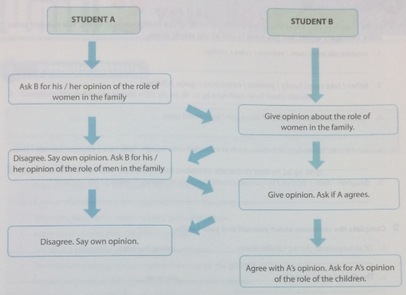
3 Complete the questions about the underlined parts of the text below.
Hoàn thành các câu hỏi về các phần được gạch chân của văn bản dưới đây.
(1)In Viet Nam, the family meal is very important. It is one part of a happy family, especially when people become busier with their work. Dinner is when family members share a meal and (2) talk together after a hard day. Therefore, dinner is not simply understood as a meal (3) because it is also an opportunity for feeling and sympathy, sharing and care. In many Vietnamese families, (4) the wife knows what other family members' favourite dishes are. Then, she tries to make those dishes (5) as frequently as she can, or at least on special occasions.
1. Is the family meal ___________?
2. What ___________?
3. Why ___________?
4. Who ___________?
5. How often ___________?
Đáp án:
1. Is the family meal very important in Viet Nam?
2. What do family members do at dinner besides sharing a meal?
3. Why is dinner more than a meal?
4. Who knows what other family members'favourite dishes are?
5. How often does the wife make her family's favourite dishes?
Writing - trang 12 Unit 1 Sách Bài Tập (SBT) Tiếng anh 10 mới
Tổng hợp các bài tập trong phần Writing - trang 12 Unit 1 Sách Bài Tập (SBT) Tiếng anh 10 mới
1 Write complete sentences using the words / phrases given in their correct forms. You can add some more necessary words, but you have to use all the words given.
Viết câu hoàn chỉnh bằng cách sử dụng các từ / cụm từ được đưa ra trong các mẫu chính xác của chúng. Bạn có thể thêm một số từ cần thiết hơn, nhưng bạn phải sử dụng tất cả các từ đã cho.
1. modem society / men / women / roles / similar.
2. father / take care /family / provide / necessities / guide / children.
3. mother / look after / children / supervise / household tasks.
4. son / assist / household activities / such as / simple home repairs / take care / younger brother / sister.
5. daughter / help / mother / household chores / grocery shopping / cooking / house / tidy.
Gợi ý:
1. In modern society, men's and women's roles (the roles of men and women) are similar.
2. The father takes care of the family by providing all the necessities and guiding the children.
3. The mother looks after the children and supervises household tasks.
4. The son assists in household activities such as doing simple home repairs and taking care of younger brothers and sisters.
5. The daughter helps the mother with household chores such as grocery shopping, cooking, and keeping the house tidy.
2 Complete the sentences about yourself and your family.
Hoàn thành các câu về bản thân và gia đình bạn.
1. Of all household chores, I dislike doing_______________ most, because ______________.
2. The chore I enjoy doing is ______________ because ______________.
3. Among h is household tasks, my brother prefers ______________ to ______________ because ______________.
4. My father also shares in housework. His main responsibilities are ______________.
5. My mother is the manager of the household. She ______________.
3 Write a paragraph about doing housework in your family, using the cues given below.
Viết một đoạn văn về việc nhà trong gia đình của bạn, sử dụng các tín hiệu dưới đây.
• How many and who the people are in the family
• What roles the father and mother perform
• What responsibilities each family member takes
• What attitude to doing household tasks each family member has
• The general atmosphere of the family

