Pronunciation - trang 20 Unit 3 Sách Bài Tập (SBT) Tiếng anh 10 mới
1.Complete the words with the letters sounding /est/, /ent/, or, /eit/.
Hoàn thành các từ có chữ cái có phát âm / est /, / ent /, hoặc, / eit /.
1. requ . 5.penetr .
2.activ . 6.achievem .
3.differ . 7.conqu .
4.pres . 8.tal .
Đáp án:
1. request 5. penetrate
2. activate 6. achievement
3. different 7. conquest
4. present 8. talent
2.Choose the odd one out, then read the rest of the words aloud.
Chọn ra một cái khác biệt, sau đó đọc to những từ còn lại
1.A.request | B.arrest | C.honest | D.invest | .
2.A.accurate | B.accelerate | C.abbreviate | D.activate | .
3.A.best | B.conquest | C.chest | D.dearest | .
4.A.development | B.indent | C.astablishment | D.employment | .
5.A.penetrate | B.accommodate | C.apporoximate | D.administrate | .
6.A.replacement | B.measurement | C.comment | D.government | .
Đáp án:
1C 2A 3D 4B 5C 6C
Vocabulary & Grammar - trang 20 Unit 3 Sách Bài Tập (SBT) Tiếng anh 10 mới
1. Look for four more adjectives and write them down in the spaces
Tìm bốn tính từ khác và viết xuống các khoảng trống
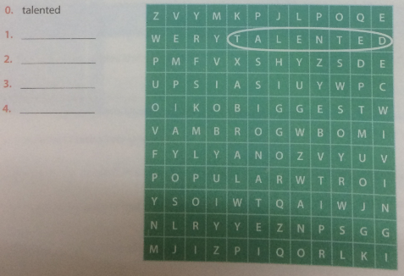
Đáp án:
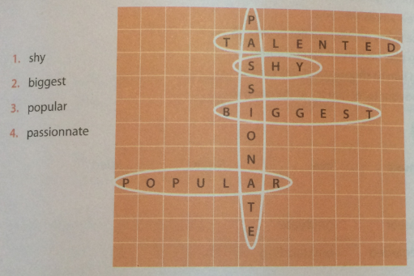
2 Complete the sentences with the adjectives from the wordsearch above.
Hoàn thành các câu với các tính từ được tìm thấy ở trên.
1. This is the_______ show of the year.
2. The teacher has considered what to do with the _______or gifted children in her class.
3. The teen singer looked _______ on stage, but actually he is daring and professional.
4. The artist quickly became_______ because her debut album gained Top 40 in a short time.
5. The pianist has devoted his entire life to music and been deeply _______ about
Đáp án:
1. biggest 2. talented 3. shy
4. popular 5. passionate
3 Complete the sentences using the coordinating conjunctions from the box.
Hoàn thành các câu sử dụng từ kết hợp từ hộp.
and or but so
1. American Idol began in 2002, _______quickly became the most popular entertainment series with viewers in the hundreds of millions.
2. He was a gifted composer,_______ he had to suffer poor health.
3. The first season of Vietnam Idol aired in 2007,_______ the fourth season aired in 2012.
4. You can go to the concert with me, _______ you can go to the cinema alone.
5. The actress did not finish secondary school, _______ she could not go to the university.
Đáp án:
1. and 2. but 3. and 4. or 5. so
4 Combine each pair of sentences, using the coordinating conjunctions.
Kết hợp mỗi cặp câu, sử dụng các liên từ kết hợp.
1. He is a talented singer. He has prestige and responsibility.
2. His voice is beautiful. His performance is not skillful.
3. You can go with us to the event. You can stay home watching TV.
4. The artist played passionately and skillfully. At the end of his performance, he got the hearty applause from the audience.
5. The concert was cancelled at the last minute. We had to stay home.
Đáp án:
1. He is a talented singer, and he has prestige and responsibility.
2. His voice is beautiful, but his performance is not skillful.
3. You can go with us to the event, or you can stay home watching TV.
4. The artist played passionately and skillfully. At the end of his performance, he got the hearty applause from the audience.
5. The concert was cancelled at the last minute, so we had to stay home.
5 Underline the incorrect parts in the following sentences. Then rewrite the sentences correctly.
Gạch dưới các phần không chính xác trong các câu sau. Sau đó ghi lại các câu đúng.
1. There was a very long line queueing at the theatre box office, but we had to change our entertaining plan.
2. It started raining, so the music band still performed under the rain.
3. The young man wanted to finish his study at the music school, and his family could not afford it.
4. You can go to the concert with us, and you can stay at home watching your favourite videos.
5. Switch off the power, or locked the door when you leave.
Đáp án:
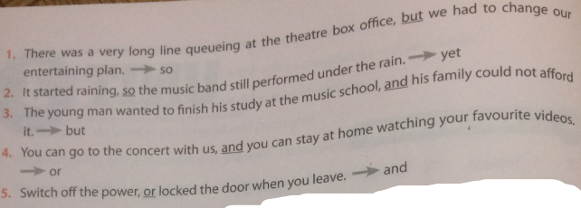
6 Complete the sentences, using the infinitives.
Hoàn thành các câu, sử dụng các động từ nguyên thể.
1. The girl asked her parents_____ her some advice, (give)
2. They advised her not _____ her secondary school until she finished it (quit)
3. They asked her_____ their advice before she made up her mind, (consider)
4. The purpose of a music schools is_____ children_____towards self-sustaining careers in music. (train), (proceed)
5. Conservatories are suitable for students who wish _____their performance, conducting or composition skills to a professional standard, (develop)
6. The time required_____a music degree is 3-4 years for a Bachelor of Music degree, 1 -2 years for a Master of Music degree, and 3-5 years for a Doctor of Musical Arts or Doctor of Music Degree, (complete)
Đáp án:
1. to give 2. to quit 3. to consider 4. to train, to proceed 5. to develop 6. to complete
7 Complete the sentences, using the infinitives.
1. He decided______________________
2. He was about______________________ .
3. She began______________________
4. My father wanted me______________________
5. Allow me______________________
6. She did not hesitate ______________________
7. The artist offered ______________________
8. His parents advised him ______________________
9. He persuaded his advisor______________________
Gợi ý trả lời:
1. He decided to go to the contest.
2. He was about to sing an inspirational song.
3. She began to post her first video clips last week.
4. My father wanted me to go with him to the concert.
5. Allow me to say a few words with you.
6. She did not hesitate to say goodbye to her boyfriend.
7. The artist offered to play his newest composition.
8. His parents advised him to choose a suitable career.
9. He persuaded his advisor to let him try in the contest.
Reading - trang 22 Unit 3 Sách Bài Tập (SBT) Tiếng anh 10 mới
1 Read the text below and fill in each blank with an appropriate word.
Đọc đoạn văn dưới đây và điền vào mỗi chỗ trống bằng từ thích hợp.
Elvis Aaron Presley, Elvis Presley, or the King of Rock 'N' Roll was (1)______ in Mississippi, in 1935. His family moved to Memphis, Tennessee, in 1948, and Elvis graduated from high school in 1953. Elvis' musical influences were the pop and country (2)______ , As a Memphis teenager, he was influenced by the gospel music in church and the R&B. Elvis began his singing career with the Sun Records in Memphis in 1954. In late 1955, his recording contract was sold to RCA Victor. By 1956, he was an international sensation. He began a whole new era of American music and popular culture with his uniquely combined sound and style which challenged the social and racial barriers of the time.
Elvis presley starred in 33 successful films. He was acclaimed through his record-breaking, (3)…………… concert performances on tour and in Las Vegas. He has sold over one billion records, more than any other artist. His American sales have earned him gold, platinum, or multi-platinum awards. He got 14 Grammy nominations and won …. Careers awards from the National Academy of Recording Arts & Sciences. He got the Grammy Lifetime Achievement (4)…………….. at age…. Was named One of the Ten Outstanding young Men of the Nation for 1970 by the United States Jaycees. He is regarded as one of the most important figures of twentieth century popular culture. Elvis (5)………….. at his Memphis home, Graceland, in 1977.
Đáp án:
1. born 2. music 3. live 4. Award 5. died
2. Select the best title for the reading text.
Chọn tiêu đề tốt nhất cho văn bản đọc.
A. THE KIND OF POP MUSIC
B. ELVIS PRESLEY
C. THE UNITED STATES JAYCEES
D. ONE OF THE TEN OUTSTANDING YOUNG MEN OF USA FOR 1970
Đáp án:
B. ELVIS PRESLEY
3 Look for the words from the reading text which mean
Tìm những từ trong văn bản đọc có nghĩa là
1. religious music 2. job
3. finish school or college 4. young people aged 13 to 19
5. considered 6. sensational
Đáp án:
1. gospel music 2. career 3. graduate
4. teenagers 5. regarded 6. outstanding
4. Complete the table, using the information from the reading text.
Hoàn thành bảng, sử dụng thông tin từ văn bản đọc.
Full name | Born | Typical works | Important Achievements | Died
Đáp án:
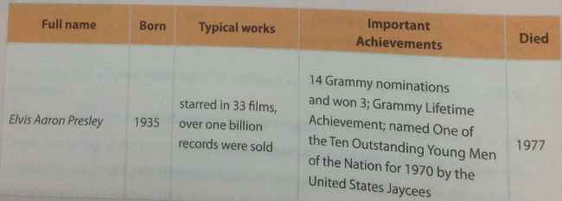
5. Choose the best answer for the following questions.
Chọn câu trả lời đúng nhất cho các câu hỏi sau.
1. Where was Elvis Presley’s hometown?
A. Las Vegas
B. Mississippi
C. Memphis
D. Tennessee
2.What kind of music influenced him?
A. Rock’N’Roll
B. Jazz
C. Gospel music
D. Pop
3. When did he begin his singing career?
A. 1935
B. 1945
C. 1948
D. 1954
4. How many awards did he get from 14 Grammy Awards nominations?
A. 3
B. 5
C. 10
D. 14
5. How old was he when he got the Grammy …. Achievement Awards?
A. 14
B. 25
C. 36
D. 40
6. How old was he when he died?
A. 30
B. 42
C. 46
D. 52
Đáp án:
1.B 2. C 3. D 4. A 5. C 6. B
Speaking - trang 24 Unit 3 Sách bài tập (SBT) Tiếng anh 10 mới
1. Using the questions provided, interview a friend and take notes.
Sử dụng các câu hỏi được cung cấp, phỏng vấn bạn bè và ghi chép.
A: Do you watch music shows on the TV? If so, what do you watch?
B: ……………………………………………………………………….
A: What kind of music do you like?
B:……………………………………………………..
A: How does music make you feel?
B: …………………………………………………………..
A: How much time do you spend listening to music?
B: ………………………………………………………….
A: Do you listen to music while doing your homework?
B: ……………………………………………
A: Can you concentrate on other things when you are listening to music?
B: ……………………………………………………….
A: Do you like singing karaoke?
B: ………………………………..
A: How often do you sing karaoke?
B: …………………………………..
A: What is your favorite karaoke song to sing?
B: …………………………….
A: Which do you prefer, songs in English or songs in Vietnamese?
B: ……………………………………………………..
A: Who is your favorite singer or group?
B: ………………………………………….
A: What do you think the world would be like without music?
B:……………………………………………………………….
2. Work in groups. Report your interview.
Làm việc nhóm. Báo cáo cuộc phỏng vấn của bạn.
Example
Minh often watches music shows on TV.
He likes The Voice very much.
3. Match the utterances with the responses.
Phù hợp với lời nói với câu trả lời.
1. Thanks for taking the time to talk to us about your life. | a. In the evening, I go home, have dinner and work on my lyrics.
2.Could you tell us about an average day in your life. | b. Well, only one song.It is very difficult.
3. What is the name of your new album ? | c. Not always. I like going out on Sundays.
4. What do you do in the afternoon? | d. the music Paradise.
5. How many songs have you rehearsed today? | e. Sure, Iget up at 7in the morning. Then I have breakfast. After that, I go to the studio to work on my new album.
6. That’s very interesting. What do you do in the evening ? | f. It’s my pleasure.
7. Do you go out at night? | g. First, I have lunch, then I go to the studio to rehearse some songs with my team.
Đáp án:
1f 2e 3d 4g 5b 6a 7c
4. Practise the conversation with a friend.
Thực hành cuộc trò chuyện với bạn bè.
Writing - trang 26 Unit 3 Sách Bài Tập (SBT) Tiếng anh 10 mới
1. Complete the second sentence so that it means the same as the sentence provided.
Hoàn thành câu thứ hai để nó có ý nghĩa giống như câu được cung cấp.
1. Linh has a great natural singing ability.
She is a ________________________________________.
2. He has an intense desire for music.
He is _______________________________________.
3. This singer is known by many people.
This singer________________________________.
4.Within a short time, the teen supersta’r debut album sold more than one billion copies.
Within a short time, the teen supersta’r debut album________________________
5.The girl is uncomfortable in the company of others.
The girl is _________________________.
Đáp án:
1. She is a talented / gifted singer.
2. He is passionate about music.
3. This singer is popular.
4. Within a short time, the teen superstar's debut album got the platinum award.
5. The girl is shy.
2.Write a biography of about 150 words, using the facts below.
Viết tiểu sử khoảng 150 từ, sử dụng các sự kiện dưới đây.
• Name: Michael Jackson
• Born: 1958, started in the music business at age 11 as a member of the Jackson 5.
• Typical works: sold estimated 750 million records worldwide, released 13 No.1 singles, was inducted twice into the Rock and Roll Hall of Fame.
• Important achievenents: recognized as the Most Successful Entertainer of All Time; Thriller (1982) was name the Biggest Selling Album pf All Time; won 13 Grammy Awards; received the American Music Award’s Artist of the Century Award.
• Died: 2009
• Conclusion: Career as the King of Pop, transformed the face do pop music popular culture.

