Pronunciation - trang 5 Unit 6 Sách Bài Tập (SBT) Tiếng anh 10 mới
1. Find the word with a stress pattern that is different from the others.
Tìm từ có trọng âm khác với những từ còn lại
1 | A. inspire | B. person | C. major | D. female
2 | A. support | B. window | C. pursue | D. employ
3 | A. party | B. workforce | C. accept | D. student
4 | A. freedom | B. fighter | C. image | D. admire
5 | A. problem | B. open | C. correct | D. follow
6 | A. police | B. famous | C. courage | D. office
Đáp án:
1 A 2 B 3C 4D 5C 6A
2. Read the following sentences aloud. Underline the two-syllable words and put a mark (') before the stressed syllable.
Đọc to các câu sau đây. Gạch dưới các từ có hai âm tiết và đặt một dấu (') trước trọng âm.
- Working mothers can inspire their kids with their hard work and devotion.
- Now I wish I could pursue a medical career to become a doctor.
- Two thirds of the workforce in this textile factory is female.
- All of the students have admired his excellent teaching.
- Educated women are becoming more independent and they may not wait for their husbands' decisions.
- This female firefighter is famous for her courage and strong will.
Đáp án:
- 'working,'mothers, in'spire
- pur'sue, ca'reer, be'come, 'doctor
- 'workforce, 'textile, 'factory, 'female
- 'students, ad'mired, 'teaching
- 'women,'husbands'
- 'female, 'famous, 'courage
Vocabulary & Grammar - trang 5 Unit 6 Sách Bài Tập (SBT) Tiếng anh 10 mới

1. Complete the following sentences, using the phrases given in the box in the correct form. Make changes to the word forms when necessary.
Hoàn thành các câu sau, sử dụng các cụm từ được đưa ra trong hộp trong đúng mẫu. Thay đổi các mẫu từ khi cần thiết.
get more important satisfy their children's needs
join the army promote gender equality
become a childcare worker have a preference
- My cousin is thinking of____________________ because he loves young children.
- The government has done a lot to___________________ in education, employment and healthcare.
- The old man ________________ during the war and left one arm on the battlefield.
- In the past, some parents ________________ for boys over girls.
- Women's salaries are___________________ to their household income.
- Working mothers help their husbands____________________ .
Đáp án:
1. becoming a childcare worker 2. promote gender equality
3. joined the army 4. had a preference
5. getting more important 6.satisfy their children's needs
2 Choose the correct passive modals a - f in the boxes to complete sentences 1 -6.
Chọn các động từ khuyết thiếu ở dạng bị động chính xác a - f trong các ô để hoàn thành câu 1 -6.
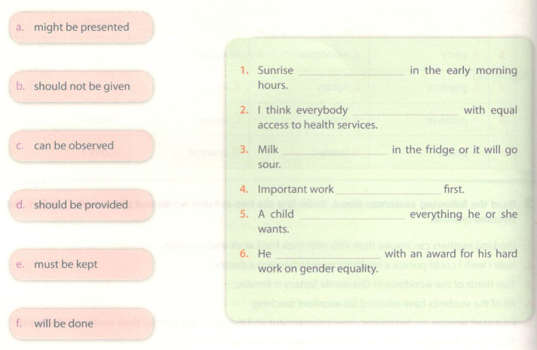
Đáp án:
1c 2d 3e 4f 5b 6a
3 Complete the incomplete sentence so that it means the same as the one above it. Use the passive voice.
Hoàn thành câu không đầy đủ để nó có ý nghĩa như câu trên. Sử dụng dạng bị động
1. They might give her an opportunity to go abroad to study.
She might be given an opportunity to go abroad to study.
2. We must eliminate gender discrimination.
Gender discrimination________________________ by us.
3. They will sue the company for wage discrimination.
The company ______________________ for wage discrimination.
4. Governments should offer poor women more help.
Poor women ______________________ more help by governments.
5. We can encourage married women to pursue a career of their preference.
Married women_______________________ to pursue a career of their preference.
6. They must not allow any kind of violence at school.
Any kind of violence________________________ at school.
Đáp án:
1. might be given 2.must be eliminated
3. will be sued 4. should be offered
5. can be encouraged 6.must not be allowed

4 Choose the correct endings for the sentences.
Chọn kết thúc chính xác cho các câu.
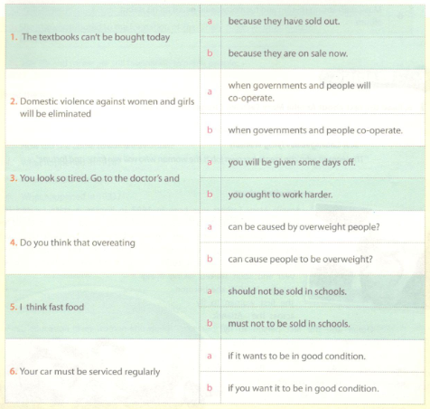
Đáp án:
1a 2b 3a 4b 5a 6b
5 Some of the verbs in the following sentences are incorrect. Underline the verbs and correct them if necessary.
Một số động từ trong các câu sau đây là không chính xác. Gạch dưới động từ và sửa chúng nếu cần.

1 | The students must give enough time to finish their tests.
2 | I'll be pay at the end of the month.
3 | This wine can be serve with seafood.
4 | You will be told the story later.
5 | The work should do by one of the students.
6 | Music with strong rhythm and harmony could heard on his debut album.
Đáp án:
1 | The students must give enough time to finish their tests. | be given
2 | I'll be pay at the end of the month. | paid
3 | This wine can be serve with seafood. | served
4 | You will be told the story later. | Correct
5 | The work should do by one of the students. | be done
6 | Music with strong rhvthm and harmonv could heard on his debut album. | be heard
Reading - trang 8 Unit 6 Sách Bài Tập (SBT) Tiếng anh 10 mới
1 a. Read the text about Amelia Mary Earhart. Choose the best title for it.
a. Amelia Earhart's Disappearance
b. A Courageous Flying Woman
1 a. Đọc nội dung về Amelia Mary Earhart. Chọn tiêu đề tốt nhất cho nó.
a. Sự biến mất của Amelia Earhart
b. Một phụ nữ phi hành can đảm
' The woman who can create her own job is the woman who will win fame and fortune’
'Người phụ nữ có thể tạo ra công việc của mình là người phụ nữ sẽ giành được danh vọng và tài sản'
- Amelia Earhart
Amelia Mary Earhart was born in 1897 in Kansas, a state located in the Midwestern United States. She showed an early aptitude for science and sports at school. After finishing school, she worked as a nurse for the Red Cross where she got to know many of the wounded pilots and came to admire aviation. Earhart enrolled in medical studies at Columbia University, but quit after one year and soon started taking flying lessons. In 1928 she became the first woman to fly across the Atlantic Ocean and the first person to fly over both the Atlantic and Pacific. She set many other records and wrote best-selling books about her flying experiences. She also contributed to the formation of The Ninety-Nines, an organisation for female pilots, gave advice to women on careers and helped inspire others. In 1937, she mysteriously disappeared during a flight. Even today, her life and career remain fascinating tc many people.
Đáp án:
Tiêu đề phù hợp là b. A Courageous Flying Woman (Một phụ nữ phi hành can đảm)
b. Decide if the following statements are true (T), false (F) or not given (NG). Tick the correct boxes.
b. Quyết định xem các câu sau đây là đúng (T), sai (F) hay không xác định (NG). Đánh dấu đúng ô.

 | T | F | NG
1. Kansas is a state located in the Western United States.
2. Amelia Mary Earhart was interested in Literature.
3. She worked as a pilot right after finishing school.
4. Earhart enrolled in medical studies, but quit after one year and soon started taking flying lessons.
5. She also contributed to the formation of The Ninety-Nines, an organisation for pilots.
6. Her life and career are still fascinating to many people.
Đáp án:
1.F 2. NG 3. F 4.T 5. F 6.T
c. Read the text again. Answer the questions.
Đọc văn bản một lần nữa. Trả lời các câu hỏi.

1. | Where and when was she born?
2. | What did she show at school?
3. | How did she come to admire aviation?
4. | What happened in 1928?
5. | What else did she do?
6. | What happened in 1937?

Hướng dẫn trả lời:
- She was born in Kansas, the USA, in 1897.
- She showed an early aptitude for science and sports.
- She worked as a nurse for the Red Cross and got to know many of the wounded pilots.
- She became the first woman to fly across the Atlantic Ocean and the first person to fly over both the Atlantic and Pacific.
- She set many other records, wrote best-selling books, contributed to The Ninety-Nines, gave advice to women on careers and helped inspire others.
- She mysteriously disappeared in a flight.
2 a. Read the text about Education and Gender Equality. Fill each blank with an appropriate word from the box.
Đọc văn bản về Giáo dục và Bình đẳng Giới. Điền vào mỗi ô bằng một từ thích hợp từ hộp.
a. equality b. well-paid c. knowledge
d. decisions e. women
Education helps (1)______ win equality.
First, education gives women knowledge necessary for their lives. It is impossible for a woman to be a doctor, a teacher or a lawyer without adequate (2)______ . Education realises women's dreams of having jobs with the same pay as men.
Second, education shapes women's character. It teaches them about life and develops their abilities to think, analyse and judge. Women with strong characters often make (3)______ about their own lives without being dependent on their husbands.
Finally, education improves women's position both at home and in society. Educated women are more likely to get (4)______ jobs, earn more money and become more important at home. They can join political activities and gain important positions as leaders, policy makers or politicians.
So we can clearly see, education enables women to achieve (5)______.
Đáp án:
1.e 2. c 3. d 4. b 5. a
b. Look for the words from the text which mean:
Tìm các từ trong văn bản có nghĩa là:
- a person whose job is to give legal advice and assistance
- form an opinion about somebody/ something after careful consideration
- needing somebody/ something for aid, support, life, etc.
- the way in which somebody is placed; status; rank
- a person who is actively involved in politics
Đáp án:
1. lawyer 2. judge 3. dependent 4. position 5. politician
c. Read the text again. Answer the following questions.
Đọc văn bản một lần nữa. Trả lời các câu hỏi sau đây.
- What does education give women?
- What does education realise?
- How does education shape women's character?
- What do women with strong character often do?
- What are educated women likely to do?
- What can educated women do outside their home?
Đáp án:
- It gives them knowledge necessary for their lives.
- It realises women's dreams of having jobs with the same pay as men.
- It teaches them about life and develops their abilities to think, analyse and judge.
- They often make decisions about their own lives without being dependent on their husbands.
- Educated women are likely to get well-paid jobs, earn more money and become more important at home.
- They can join political activities and gain important positions as leaders, policy makers or politicians.
Speaking - trang 10 Unit 6 Sách bài tập (SBT) Tiếng anh 10 mới
1. Work in pairs. Ask questions to fill the gaps with the missing information about Alice Stebbin Wells - the first US-born policewoman. Student A, look at the information below. Student B, look at the information on page 11.
Làm việc theo cặp. Đặt câu hỏi để lấp đầy khoảng trống với thông tin còn thiếu về Alice Stebbin Wells - nữ cảnh sát trưởng người Mỹ đầu tiên. Sinh viên A, xem thông tin dưới đây. Học sinh B, nhìn vào thông tin ở trang 11.
Example:
Student A: When was Alice Stebbin Wells born?
Student B: She was born in 1873.
Student A writes ' 1873’ in the gap.
Student A:
Alice Stebbin Wells was born in Kansas (1)_______ (when?). When she was young, she saw (2)
(what?) involving teenagers and women. She decided to become a (3)___________ (who?) because she
believed that she could help more.
Things weren't easy for her. (4) ______ (who?) welcomed her. She kept asking and persuading the city
and the police authorities, and finally she was successful. (5)________ (who?) was accepted to the police
force in Los Angeles in (6)______ (when?) and became the first US-born female police officer. Her story-
interested (7)_______ (who?). The film The Policewoman was about her and it was made in (8)______ (when?).
During her service, she actively worked to protect teenagers and females and to prevent crimes. (9)______ (who?) became the first president of the Women's Peace Officers Association of California. She passed away in (10) ______ (when?).
Student B:
Alice Stebbin Wells was born in (1) _____ (where?) in 1873. When she was young, she saw crimes involving
(2)______ (who?). She decided to become a policewoman because she believed that she could
(3 )________ (what?).
Things weren't easy for her. Nobody welcomed her. She kept asking and persuading the city and the
(4) ______(who?), and finally she was successful. Alice Wells was accepted to the police force in
(5)______(where?) in 1910 and became the first US-born female (6)___________ (what?). Her story
interested people. The film (7)______ (which?) was about her and it was made in 1914.
During her service, she actively (8) ______ (what?) to protect teenagers and females and to prevent
crimes. Alice Wells became the first president of the Women's Peace Officers Association of California in (9)______ (when?). She passed away in 1957.
Đáp án:
Student A's questions & answers
1 | When was Alice Stebbin Wells born? | 1873
2 | What did she see when she was young? | Crimes
3 | What did she decide to become? | A police officer
4 | Who welcomed her? | Nobody
5 | Who was accepted to the police force? | Alice Wells
6 | When was she accepted (to the police force)? | 1910
7 | Who did her story interest? | People
8 | When was the film made? | 1914
9 | Who became the first president of the Women's Peace Officers Association of California? | Alice Wells
10 | When did she pass away? | 1957
Student B's questions & answers
1 | Where was Alice Stebbin Wells born? | Kansas
2 | Who did crimes involve? | Teenagers and women
3 | What could she do?/What did she believe that she could do? | Help more
4 | Who did she keep asking and persuading? | Police authorities
5 | Where was she accepted to the police force? | Los Angeles
6 | What did she become? | A police officer
7 | Which film was about her? | The Policewoman
8 | What did she actively do? | Worked
9 | When did she become the first president of the Women's Peace Officers Association of California? | 1928
2. Work with a partner. Ask questions to get information about Margaret Thatcher, the first British female Prime Minister, using the cues given below.
Làm việc cùng người bạn. Đặt câu hỏi để biết thông tin về Margaret Thatcher, nữ Thủ tướng đầu tiên của Anh, sử dụng các manh mối dưới đây.
Student A: when, where, what, who
Student B:
- Margaret Thatcher lived (1925 - 2013)
- Student of Chemistry, Oxford University (1943 - 1947)
- Member of Parliament (1959- 1970)
- Leader of the Conservative Party (1975 - 1979)
- First British female Prime Minister (1979 - 1990)

Writing - trang 11 Unit 6 Sách Bài Tập (SBT) Tiếng anh 10 mới
1. Write full sentences about Margaret Thatcher's life, using the following words and phrases.
Viết câu đầy đủ về cuộc đời của Margaret Thatcher, sử dụng các từ và cụm từ sau.
1. Margaret Thatcher/ be born/ Grantham, Lincolnshire/ 13th October, 1925/ .
2. Thatcher/ good student/ so/ be accepted/ Oxford University, where/ become interested/ politics/ .
3. She/ be elected/ Member of Parliament/ 1959/ actively work/ party leadership/ .
4. Thatcher/ win/ party leadership election/ 1975/ become/ leader/ Conservative Party/ .
5. When/ party/ win/ election/ 1979/ become Prime Minister/ UK/ hold/ position/ 11 years/ .
6. She/ die/ London/ 8th April, 2013/ the age of 87
Đáp án:
- Margaret Thatcher was born in Grantham, Lincolnshire, on 13th of October, 1925./ Margaret Thatcher was born in Grantham, Lincolnshire, on October 13th 1925.
- Thatcher was a good student, so she was accepted into Oxford University, where she became interested in politics.
- She was elected a Member of Parliament in 1959 and actively worked for the party leadership.
- Thatcher won the party leadership election in 1975 and became the leader of the Conservative Party.
- When her party won the election in 1979, Thatcher became Prime Minister of the UK and held this position for 11 years.
- She died in London on 8th of April, 2013, at the age of 87./She died in London on April 8th 2013, at the age of 87.
2 Write about Margaret Thatcher's achievements, using the information given below.
Viết về thành tựu của Margaret Thatcher, sử dụng thông tin dưới đây.
- Margaret Thatcher/ be/ first woman to lead/ major political party/ UK/ United Kingdom/
- She/ be/ first/ British/ female/ Prime Minister/ and/ be/ longest serving PM/ over 150 years/ .
- Her first term/ office/ not easy, but/ government/ successfully/ reduce/ unemployment rate/ improve economy/ .
- Her reputation/ gradually/ be built up, which/ lead/ re-election/ 1983/ third term/ office/ 1987/
- Thatcher/ work very hard/ be/ good wife/ mother/ as well as/ one/ most famous/ British politicians whose nickname/ be/ 'the Iron Lady’/ .
- All her life, she/ tirelessly fight/ her beliefs. Not everyone/ agree/ her methods/ .
Đáp án:
- Margaret Thatcher was the first woman to lead a major political party in the UK/ United Kingdom.
- She was the first British female Prime Minister and was the longest serving PM for over 150 years.
- Her first term in office was not easy, but her government successfully reduced the unemployment rate and improved the economy.
- Her reputation was gradually built up, which led to her re-election in 1983 and a third term in office in 1987.
- Thatcher worked very hard to be a good wife and mother as well as one of the most famous British politicians, whose nickname was 'the Iron Lady’.
- All her life, she tirelessly fought for her beliefs. Not everyone agreed with her methods.

