Giải bài tập SBT Tiếng Anh lớp 7 chương trình mới Unit 3

A. Phonetics - trang 17 - Unit 3 – Sách bài tập (SBT) tiếng Anh 7 mới
1. Look the pictures and complete the words. Read them aloud.
Nhìn vào bức tranh và hoàn các từ đã cho. Đọc to các từ đó.
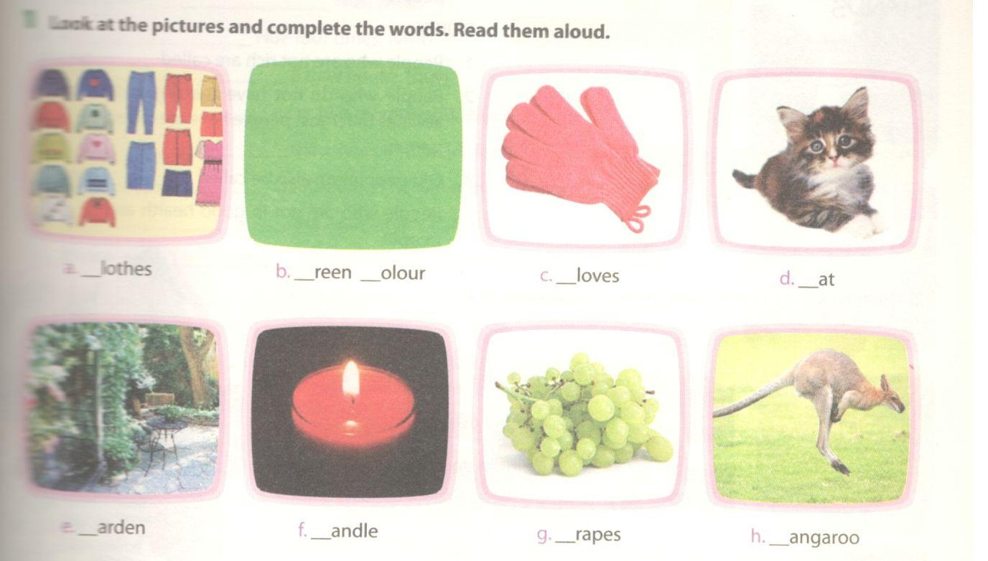
Key - Đáp án:
a. clothes b. green cofcxr c. gloves d. cat
e. garden f. candle g. grapes h. kangaroo
2. Put the following words in the correct columns.
Xếp các từ sau vào đúng cột
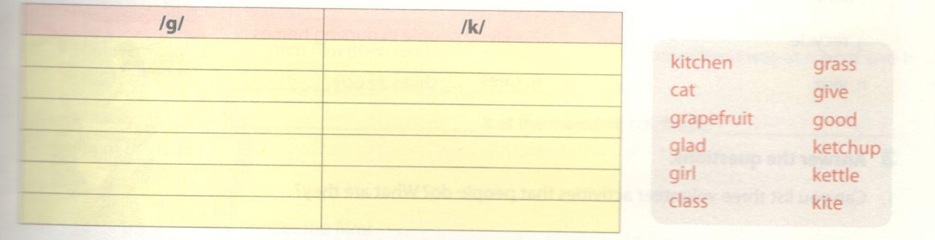
Key - Đáp án:
/g/ | /k/
grass | kitchen
give | cat
grapefruit | ketchup
good | kettle
glad | dass
girl | kite

3. Read the following conversation and pay attention to the words in bold.
Đọc đoạn hội thoại sau và chú ý vào các từ in đậm.
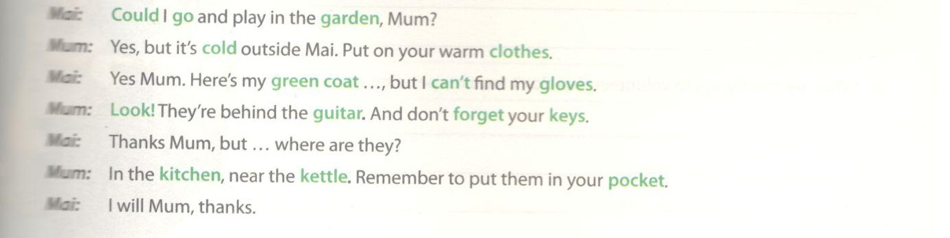
B. Vocabulary & Grammar – trang 18 – Unit 3 – Sách bài tập (SBT) tiếng Anh 7 mới
1. Solve this crossword to describe people in need.
Giải trò chơi ô chữ sau để tìm ra những người cần giúp đỡ.
Key - Đáp án:
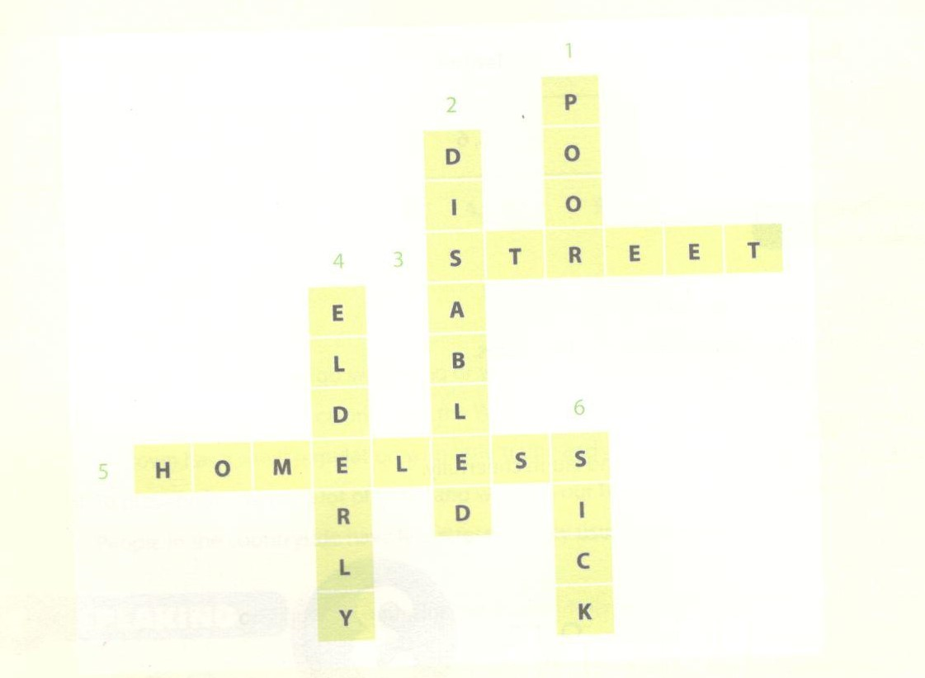
2. Match the verbs in A with the words/phrases in B.
Nối động từ ở cột A với từ/cụm từ ở cột B.
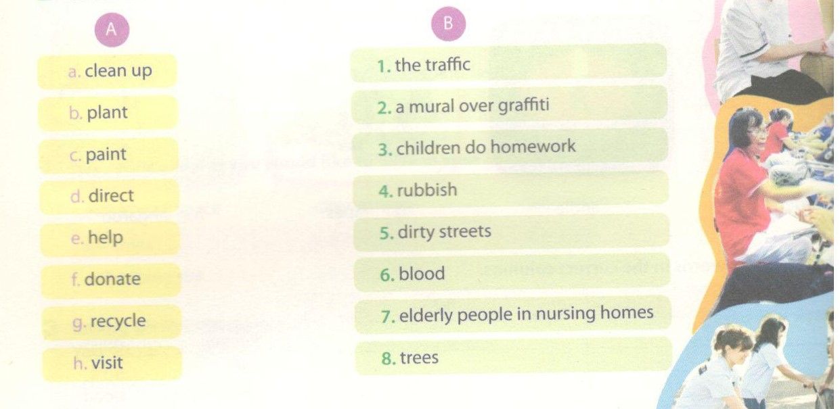
Key - Đáp án:
a.5; b.8; c.2; d.1; e.3; f.6; g.4; h.7
3. Answer the questions.
Trả lời câu hỏi.
1. Can you list three volunteer activities that people do? What are they?
2. What are three ways to volunteer that don't require spending money?
3. Can you list three reasons why, people volunteer? What are they?
Key - Đáp án:
(Sample answers)
Câu trả lời mẫu:
1. They are: cleaning up streets, donating money, raising funds.
2. They are: tutoring younger children, donating books and clothes, helping the disabled to cr the street.
3. Because they want to make a difference; they want to improve the quality of life; they want to n new people.
4. Put the verbs in brackets in either past simple or present perfect.
Chia động từ cho trong ngoặc ở thì quá khứ hoặc hiện tại hoàn thành.
1. Last year I________________________ Hue. (visit)
2. I____________ Hue four times. (visit)
3. They_________________ a new house. (buy)
4. He_________________ a car two months ago. (buy)
5. They_________________ thousands of CDs. (collect)
6. He_________________ stamps when he was a child. (collect)
7. Peter__ the exam again. (fail)
8. Yesterday I________ to the supermarket but it was closed. (go)
9. They________ to that supermarket three times. (be)
Key - Đáp án:
1. visited; 2. have visited ; 3. have bought; 4. bought;
5. have collected ; 6. collected; 7. has failed; 8. went; 9. have been
5. Complete the dialogue with the correct tense of the verbs (present continuous, present perfect, past simple).
Hoàn thành đoạn hội thoại sau với thì đúng của động từ( hiện tại tiếp diễn, quá khứ hoàn thành, quá khứ đơn).
John:______________ you (1. watch)___________________ 'Pride and Prejudice' on TV yesterday?
Mai: Yes, I (2. watch)__________ that film three times. I (3. read)___________ the book when I was at school and I
liked it so much. __________ you(4. read) __________ it yet?
John: Actually I (5. read)_____________________ it at the moment. I (6. finish) __________half of the book.
Mai: How do you like it?
John: To tell you the truth, I prefer the film!
Key - Đáp án:
1. Did you watch; 2. have watch
3. read; 4. Have you read
5. am reading; 6. have finished
6. Finish the sentences.
Hoàn thành các câu sau.
1. Last week I_______________ .
2. Have you _______________ ?
3. I have already _______________ .
4. She has _______________ several times.
5. Patrick_______________ when he was a boy.
Key - Đáp án:
(Sample answers)
Câu trả lời mẫu
1. Last week I met her in the library.
2. Have you ever worked with the disabled?
3. I have aldready washed the dishes.
4. She have been to the ocean several times.
5. Patrick loved climbing trees when he was a boy.
C. Speaking – trang 20 – Unit 3 – Sách bài tập (SBT) tiếng Anh 7 mới.
1. Look at the problems the people or the community is having. Give two ideas about the ways volunteers could help.
Nhìn vào các vấn đề con người và xã hội đang gặp phải. Đưa ra 2 ý tưởng tình nguyện viên có thể giải quyết các vấn đề đó.
1. 'The lakes are full of rubbish. Nobody wants to go there.’
2. 'We are cold and hungry. We have to live on the street this winter.'
3. 'We can't read or write, but we can't go to school because we have to work during the day.'
4. 'The hurricane was terrible. Our houses were destroyed.'
Key - Đáp án:
(Sample answers)
Câu trả lời mẫu
1. We can clean them up. We can plan: more trees and flowers beside the lakes.
2. We can cook meals and b' ng them to these homeless people. We can ask people to donate warm clothes for them.
3. We can organise evening classes for these street children. We can collect books for them.
4.We can ask people to donate money for them. We can volunteer to help them rebuild their houses.
2. Look at the Mai's blog and talk about her volunteer work, using past simple and present perfect.
Nhìn vào blog của Mai và nói về công việc tình nguyện của cô ấy, sử dụng thì quá khứ và hiện tại hoàn thành.
Example: I began working for 'Green Summer' in 2011.1 have cleaned up streets.
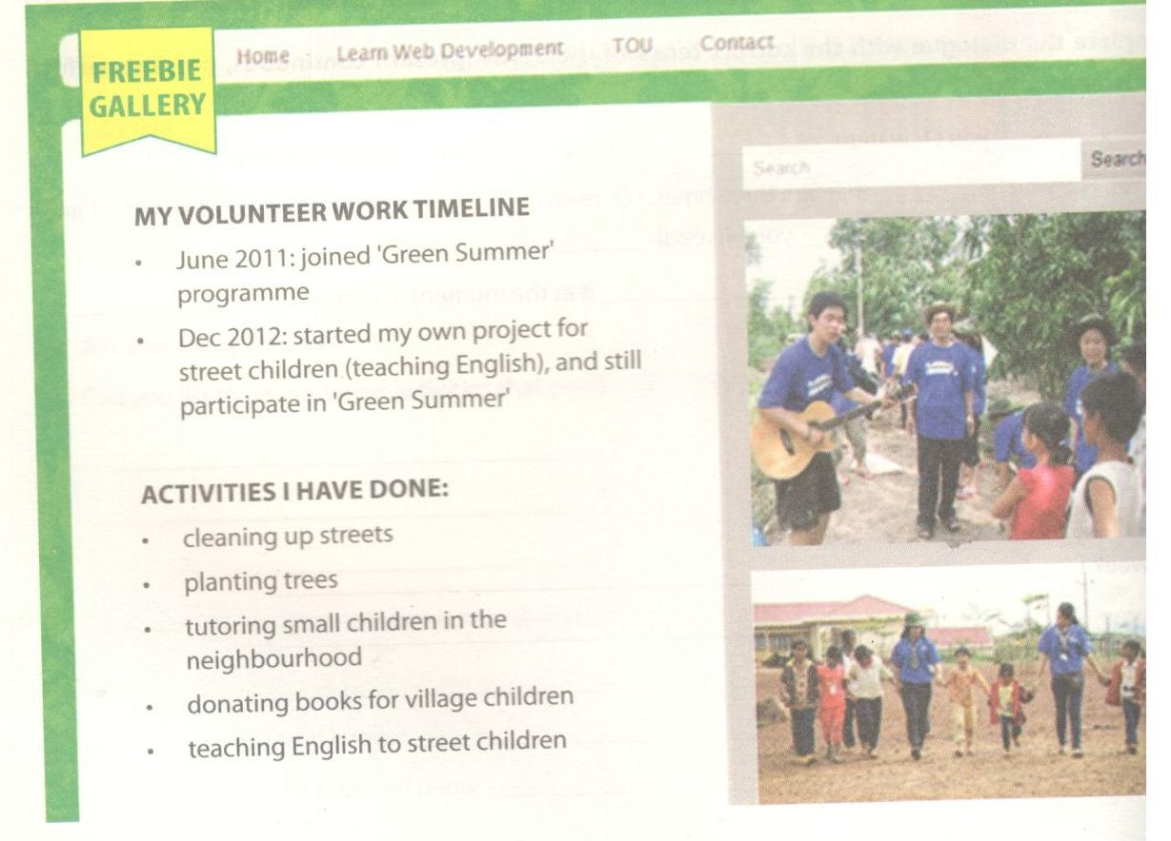
Key - Đáp án:
(Sample answers)
Câu trả lời mẫu
I began working for 'Greer Sturner' in 2011. I have cleaned up streets. I have planted trees. I have tutored small children in my neighbourhood. I have also donated books for village children. In 2012 I started my own project to help street children. I have taught them to speak English.
D. Reading - trang 21 – Unit 3 – Sách bài tập (SBT) tiếng Anh 7 mới
1. Read the following text and answer the questions.
Đọc đoạn văn sau và trả lời câu hỏi.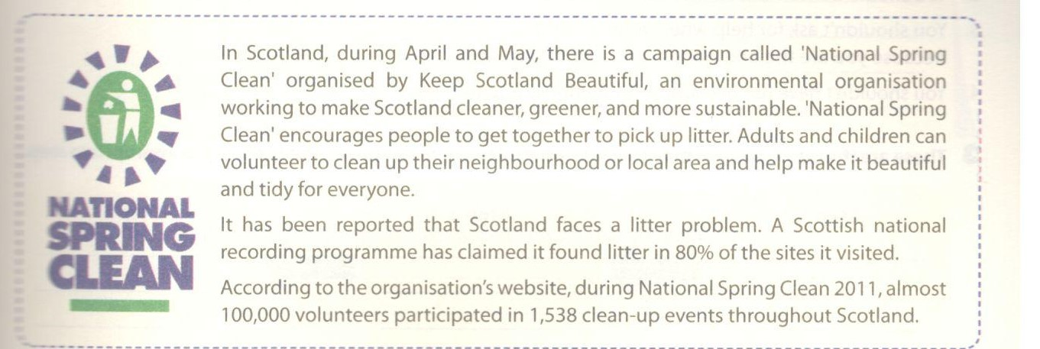
1. What is 'Keep Scotland Beautiful'?
2. What is 'National Spring Clean'?
3. What is the environmental problem that Scotland faces?
4. What happened in 'National Spring Clean 2011 '?
Key - Đáp án:
Suggested answers:
Câu trả lời đề nghị:
1. 'Keep Scotland BeautifuT is an emiiRMnenral organisation. It works to make Scotland cleaner, greener, and more sustainable.
2. 'National Spring Clean’ is a canpaipi in Upland lftajE.lt encourages people to get together to
pick up litter.
3. Scotland faces a litter problem. A Scoflidi national rocndng programme has daimed rt found litter
in 80% of the sites it visited.
4. In 'National Spring Gean 2011', almost 100,000 volunteers participated in 1,538 dean-up events throughout Scotland.
2. Read the flyer and do the tasks.
Đọc mẩu tin sau và làm nhiệm vụ.
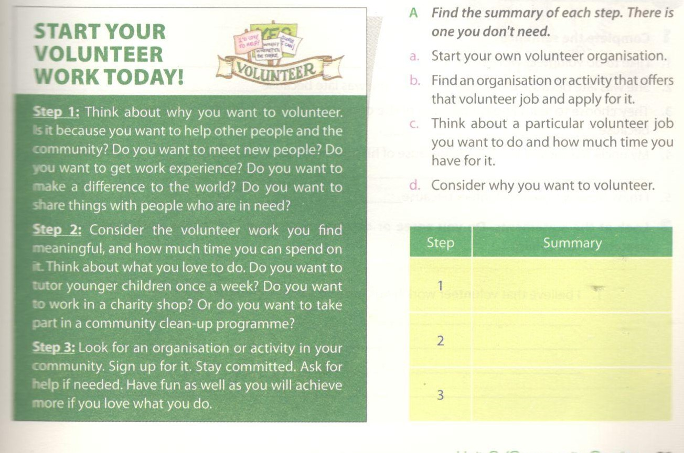
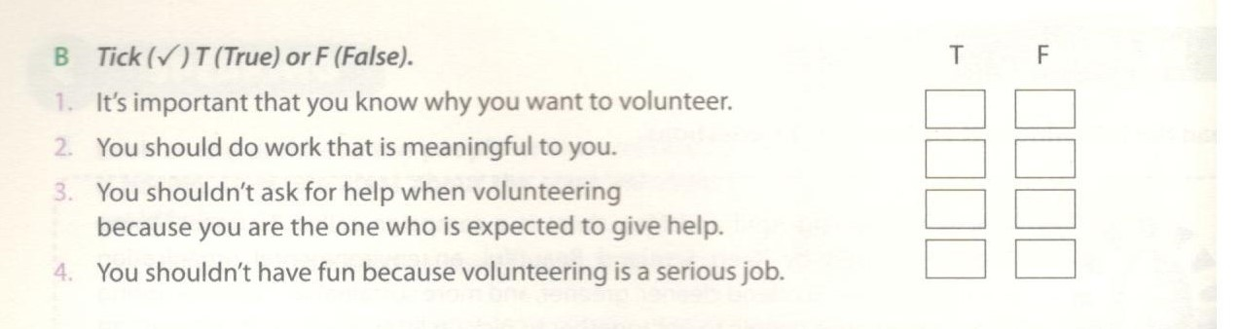
Key - Đáp án:
A.
Step | Summary
1 | d
2 | c
3 | b
B.
1.T; 2.T; 3. F (You can ask for help if needed).
4. F (You should have fun because you will achieve more if you love what you do).
3. These are the questions you may consider when starting to volunteer. Put them in the appropriate step.
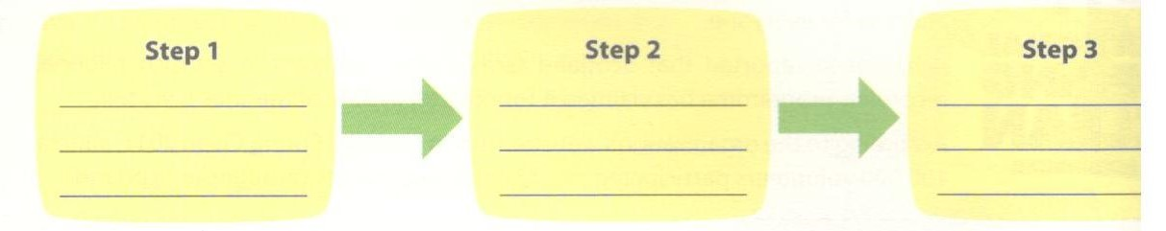
a. Is there any organisation in my community that helps disabled people?
b. Do I like working with elderly people or with children?
c. Can I give four hours a week for this job?
d. Which Internet website can give me useful information about the local volunteer organisations?
e. Do I want to meet new people? Or do I want to learn new skills?
f. Do I like working indoors or outdoors?
g. Why do I want to volunteer?
Key - Đáp án:
Step 1: e,g
Step 2: b,c,f
Step 3: a,d
E. Writing – trang 22 – Unit 3 – Sách bài tập (SBT) tiếng Anh 7 mới
1. Complete the sentences.
Hoàn thành các câu sau.
- I like to do volunteer work because___________________________________________________ .
- She was late because of the heavy rain. —»She was late because______________________________
- They choose to learn English because of the opportunities it may bring. —> They choose to learn English because_____________________ .
- My uncle has moved to Da Nang because of his job. —► My uncle has moved to Da Nang because ______________________
- I think Nova is a great volunteer because____________________________________________ .
Key - Đáp án:
1. I like to do volunteer work because I can meet new people.
2. She was late because it was raining heavily.
3. They choose to learn English because it may bring them opportunities.
4. My uncle has moved to Da Nang because he was offered a job there.
5. I think Nova is a great volunteer because she really loves working with children.
2. Look at the statements. Do you agree or disagree with them? Why/Why not? Write two or three sentences to explain.
Nhìn vào các ý kiến sau. Bạn đồng tình hay không đồng tình với các ý kiến đó? Viết hai hoặc ba câu để giải thích.
1. I believe that volunteer work helps me to make new friends.
____________________________________________
2. I believe everybody should do volunteer work.
____________________________________________
3. I think the government should pay for the work that volunteers do.
____________________________________________
Key - Đáp án:
Suggested answers:
Câu trả lời gợi ý:
1.1 believe that volunteer work helps me to make new friends. I can go to different places and the people in need can be helped. We can also meet other volunteers and make friends with
2.1 believe everybody should do volunteer work. Volunteer work can improve things and he r problems the community faces. It can also change people's lives by giving them help when need it. It can make you feel good too.
3.1 don't think the government should pay for the work that volunteers do. We volunteer want to help others, and not for money. If you want to be paid then the meaning voluntarily been lost.
3. Think about a problem that your community is having. Write a short paragraph to propose a volunteer activity to help solve the problem.
- What is the problem?
- What are the negative consequences of that problem?
- What do you want to do to help solve that problem?
- How are you going to do it?
Suggested answers:
There are not many trees and plants in the public places in my community. This makes it
attractive. I want to plant more trees in places like lake sides, and flowers in the square. I can
school can help us organise a campaign and make the community greener.

