Giải bài tập SBT Tiếng Anh lớp 7 mới Unit 4 - Music and Arts

A. Phonetics - trang 28 - Unit 4 – Sách bài tập(SBT) tiếng Anh 7 mới
1. Find the word which is pronounced differently in the part underlined.
Tìm từ có cách phát âm khác với những từ còn lại.
1. | A. traditional | B. essential | C. audition | D picture
2. | A. attract | B. actor | C. guitarist | D gallery
3. | A. delicious | B. special | C. musical | D physician
4. | A. usually | B. composer | C. leisure | D. version
5. | A. prefer | B. perform | C. painter | D. concert
Key - Đáp án:
1. D; 2. C; 3. C; 4. B; 5. A

2. Single-underline words having sound /ʃ/ and double-underline words having sound /ʒ/ following sentences. Then read them aloud.

Gạch một gạch dưới các từ có chứa âm /ʃ/ và gạch hai gạch dưới các từ có chứa âm /ʒ/ trong những câu sau. Đọc to các từ đó.
1. The comedy show last night was a success.
2. There is a live show of rock and roll on television.
3. Can you lend me your measuring tape, please?
4. She is now polishing her shoes.
5. It was a pleasure to watch the musical performance.
Key - Đáp án:
1. The comedy show last night was a success.
2. There is a live show of rock and roll on television.
3. Can you lend me your measuring tape, please?
4. She is now polishing her shoes.
5. It was a pleasure to watch the musical performance.
B. Vocabulary & Grammar – trang 29 – Unit 4 – Sách bài tập(SBT) tiếng Anh 7 mới
1. Fill each blank with a word from the box to complete the sentences.
Điền vào chỗ trống các từ cho trong khung để hoàn thành những câu sau.
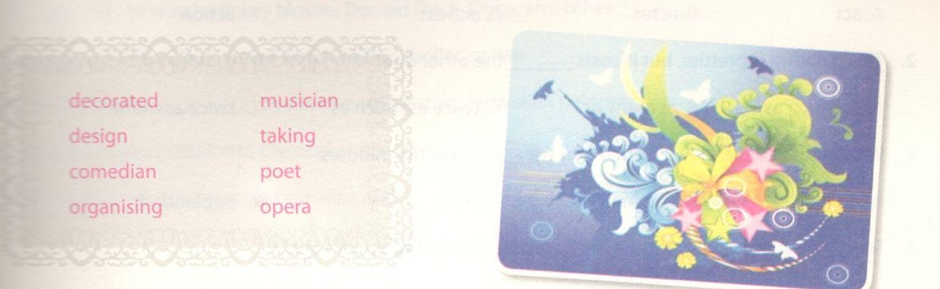
1. Her hobbies are_______________photographs and collecting coins.
2. A funny man or woman in a film is a_______________.
3. - What should we do to help the poor in the neighbourhood?
- I suggest _______________ a show to raise money.
4. A person who wirtes poem is called a_______________.
5. A_______________is a person who plays a musical instrument or writes music especially as a job.
6. The temples at Angkor were__________________ by artists with stone carvings.
7. Graphic_______________is a very interesting form of arts.
8. Viet Nam has some kinds of traditional_______________ such as 'Chèo' or 'Cải lương'.
Key - Đáp án:
1.talking; 2. comedian; 3. organising; 4.poet
5. musician; 6. decorated; 7. design; 8. opera.
2. Match the famous Vietnamese people in A with their occupations in B.
Nối nhân vật nổi tiếng của Việt Nam ở cột A với nghề nghiệp của họ ở cột B.

A | B
1. Nguyen Du | A. painter
2. Bui Xuan Phai | B. singer
3. Thu Hien | C. actress
4. Trinh Cong Son | D. poet
5. Pham Thi Thanh | E. musician
6. Tra Giang | F. drama diretor
Key - Đáp án:
1.D; 2.A; 3.B; 4.E; 5.F; 6.C
3. Choose the correct answer A, B, C, or D to complete the sentences.
Chọn đáp án đúng A, B, C hoặc D để hoàn thành các câu sau.
1.His daughter wants to become a well-known______but she has no talent at all.
A. act B. actor C. actress D action
2. This painting is prettier, but it costs______the other one.
A. so much as B. as many as C. twice as much as D twice as many
3. We all enjoyed the play so much that we______ for ten minutes.
A. smiled B. screamed C. cried D. applauded
4. To_______ successfully, they have to practise the play again and again.
A. perform B. play C. sing D. dance
5. Turn TV off. The show is______ .
A. exciting B. peaceful C. tiring D. boring
6. Mozart was one of the most famous_____ of classical music.
A. actors B. composers C. artists D. makers
7. -What are you doing with all that paper and glue, Giang?
- I'm trying to______a collage.
A. do B. play C draw D. make
8. Because I was sitting in the back row of the theatre, I could hardly see the___ .
A. painters B. musicians C composers D. writers
Key - Đáp án:
1.C; 2.C; 3.D; 4.A
5.D; 6.B; 7.D; 8.B
4. Complete the following sentences by putting a word in each gap.
Hoàn thành các câu sau bằng cách thêm từ vào chỗ trống.
1. I don't sing as_________ as my sister. She is the best singer in her class.
2. My sister's personality is very different_________ mine.
3. - I don't like the new soap opera on VTV6 now.
- I don't like it_________ .
4. The music festival will be at the_________ time as last year.
5. Please eat__________ much___________ you like.
6. Duong can draw animals, and Duy can do it________ .
7. Paintings and drawings are not the same thing.They are quite________.
8. Each one of the children has been given a piece of paper and a crayon. They are________pictures in the painting room.
Key - Đáp án:
1. well/beautifully; 2. from; 3. either; 4. same
5. as - as; 6. too; 7. different; 8. drawing

5. Fill each of the blanks with one suitable word.
Example: Alison has dogs, cats, goldfish and many other pets .
1. My sister likes to watch Mickey Mouse, Donald Duck, Oggy, and other________.
2. I like science fiction, but I never watch horror, thriller, or war__________
3. My aunt collects_____________ by nineteenth-century Australian painters.
4. Old people enjoy traditional, classical or country_____________ .
5. Chris is a very good pianist, and can also play a number of other musical________.
Key - Đáp án:
1. cartoons; 2. films; 3. paintings; 4. music; 5. instruments

6. Use the words/phrases below to write complete sentences.
Sử dụng các từ/cụm từ dưới đây để hoàn thành câu.
1. my friend/enjoy/the Children's Painting Exhibition/l/too.
2. performance/she/give/last night/marvellous.
3. each/my three sisters/be/very different/the others.
4. painting/he/make/recently/much/same/old one.
5. the children/rehearse/play/school/celebration/moment.
Key - Đáp án:
1. My friends enjoy the Children's Painting Exhibition, and I do too./
My friends enjoyed the Children's Painting Exhibition, and I did too.
2. The performance she gave last night was marvellous.
3. Each of my three sisters is very different from the others.
4. The painting he (has) made recently is.. 'ch the same as the old one.
5. At the moment, the children are rehearsing the play for the school celebration.
D. Reading – trang 32 – Unit 4 – Sách bài tập(SBT) tiếng Anh 7 mới.
1. Fill each blank in the passage with a word from the box. You do not need to use all of the words.
Điền vào chỗ trống trong đoạn văn sau. Sử dụng các từ cho trước. Bạn không cần sử dụng hết các từ.
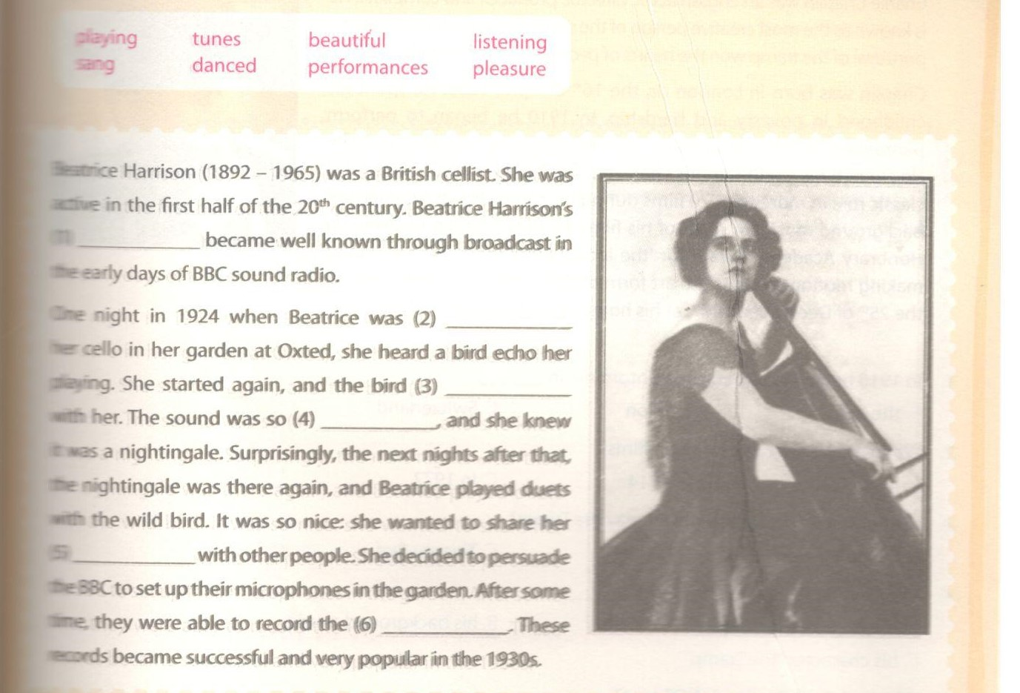
Key - Đáp án:
1. perfomances; 2. playing; 3. sang
4. beautiful; 5. pleasure; 6. tunes
2. Choose the correct answer for each gap in the following passage.
Artists who (1)_____pictures on the pavement with chaft used to be a common sight in London, but
there (2)_____ only a few left now. Sometimes the pictures are very good. This is proved by the fact that one of the (3)_____ favourite tridks is to draw a five-pound note and see a lot of people trying to (4)________ it up. The police usually treat pavement artists kindly and there is nothing in the law against drawing on the pavement (5)_________ the artist is so good that he gets a large (6)_______ aroundi him, and this prevents other people from passing freely along the street.

. A. draw | B. paint | C. take | D. print
2. A. is | B. are | C. was | D. were
3. A. artist | B. artist’s | C. artist | D. artist’s
4. A. pick | B. hold | C. bring | D. get
5. A. if | B. although | C. unless | D. because
6. A. meeting | B. collection | C. gathering | D. crowd
Key - Đáp án:
1. A; 2. B; 3. D; 4. A; 5. C; 6. D
3. Read the passage and choose the correct answer to each question below.
Đọc đoạn văn và chọn đáp án đúng cho mỗi câu hỏi dưới đây.
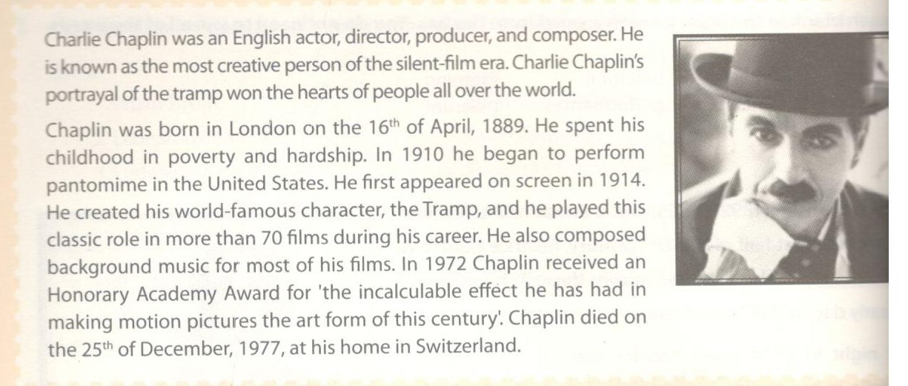
1. In 1910 he began to perform pantomime in____
A. the US B. London C. Switzerland
2. When did he start appearing in films?
A. In 1910 B. In 1914 C. In 1972
3. In about how many films did he play the Tramp?
A. Seventy B Seventeen C. Twenty-five
4. Charlie Chaplin is very famous for________ .
A. his stage performance
B. His background music

C. his character "the Tramp"
5. Which of the following is NOT true?
A. Charlie Chaplin was an English artist.
B. He played classical music
C. He received an award in 1972.
Key - Đáp án:
1.A; 2.B; 3.A; 4.C; 5.B
C. Speaking – trang 32 – Unit 4 – Sách bài tập(SBT) tiếng Anh 7 mới.
1. What did these famous people do? Use the words in the three lists to talk about them with a partner.
Những người nổi tiếng này làm nghề gì? Sử dụng các từ trong ba liệt kê dưới đây để nói về họ với bạn của mình.
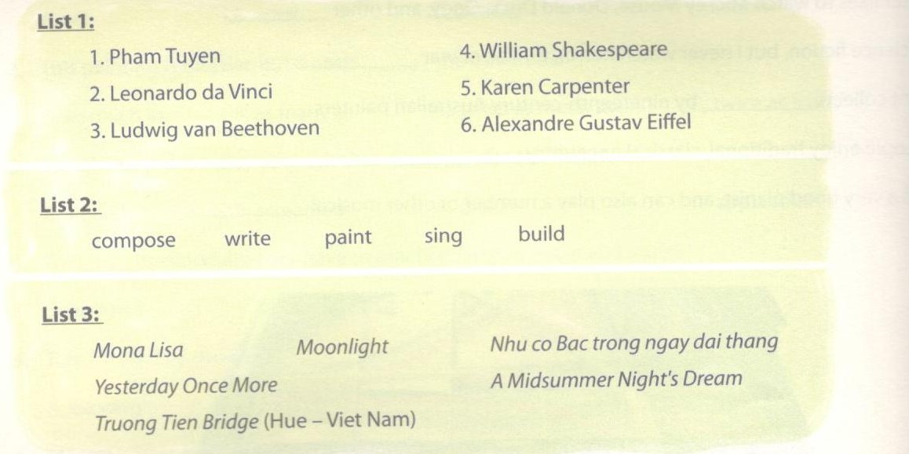
Example: Pham Tuyen composed the song Nhu co Bac trong ngay dai thang.
Then you can talk about other artists you know.

Tiếp tục nói về nghệ sĩ khác bạn biết.
Key - Đáp án:
(Sample answers)
1. Như mẫu
2. Leonardo da Vinci painted 'Mona Lisa'.
3. Ludwig van Beethoven composed 'Moonlight'.
4. William Shakespeare wrote 'A Midsummer Night's Dream'.
5. Karen Carpenter sang the song 'Yesterday Once More'.
2. Read the following opinions about music and arts.
Đọc các ý kiến sau về âm nhạc và nghệ thuật.
1. Art education improves students' life skills.
2. Students who study arts are more attentive at school than those who do not.
3. Students who study arts do better in academic subjects like maths and science.
4. Learning music helps students achieve higher results in maths and reading.
5. Music promotes creativity, social development, and personality.
Talk with a partner. Give your opinion on each of the above.
Nói với bạn của mình. Đưa ra ý kiến của bản thân về mỗi quan điểm trên.
Example:
A: I quite agree with number one. I've seen a lot of people who are good artists and they are very successful in life.
B: You are right. I think so too.
E. Writing – trang 34 – Unit 4 – Sách bài tập( SBT) tiếng Anh 7 mới
1. Rewrite the sentences, so that their meaning stays the same, using the beginning given for each.
Viết lại các câu sau sao cho nghĩa không đổi, sử dụng phần đầu đã cho ở mỗi câu.
1. The tickets to the show are too expensive for us.
- The tickets to the show cost________________________________.
2. Khanh is a better painter than Giang.
- Giang can't_______________________________.
3. Charles Dickens' novels attract a lot of children.
- A lot of children_______________________________.
4. Her book is not the same as mine.
- Her book is_______________________________.
5. We can get to the art gallery in half an hour.
- It only_______________________________.
Key - Đáp án:
1. The tickets to the show cost too much for us.
2. Giang can't paint as well as Khanh.
3. A lot of children are attracted by Charles Dickens' novels.
4. Her book is different from mine.
5. It only takes half an hour to get to the art gallery.
2. Write an invitation to one of your friends or relatives, using the following:
- To: Live show of The Finger Family
- Time: 8 o'clock, Saturday night
- Place: The Big Theatre
- Time to meet: 7.45 p.m
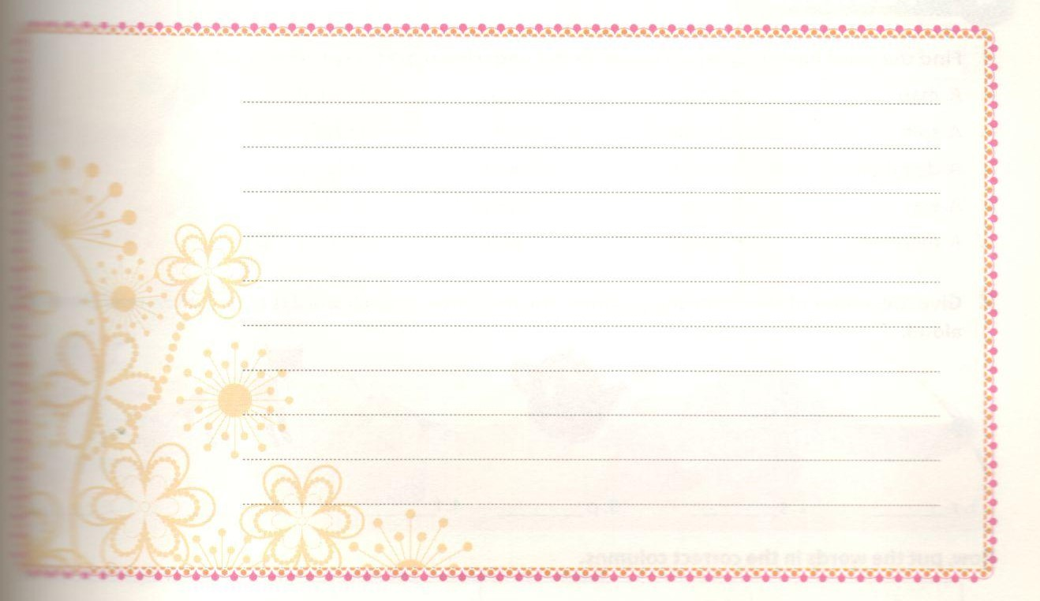
Key - Đáp án:
(Use Duong's letter in the textbook as example)
Xem mẫu thư của Dương.
3. Read the following facts and write a paragraph about Michael Jackson.
Đọc các chi tiết sau và viết một đoạn văn về Michael Jackson.
1. born: August 29,1958, Gary, Indiana, the US
___________________________________________
2. 1964 joined band "the Jackson Brothers".
___________________________________________
3. Began his solo career.
___________________________________________
4. called 'the King of Pop', got a lot of awards, including 13 Grammy Awards and 26 American Music Awards.
___________________________________________
5. 'Earth Song' - one of his most successful songs.
___________________________________________
6. died June 25, 2009, Los Angeles, California, the US.
___________________________________________
Key - Đáp án:
(Sample answers)
Đáp án gợi ý:
Michael Jackson was born on August 29, 1958, in Gary, Indiana, the United States. In 1964, Michael joined the band 'the Jackson Brothers'. He began his solo career in 1971. He was called 'the King of Pop', and in his career, he got a lot of awards, including 13 Grammy Awards and 26 American Music Awards. 'Earth Song' is one of his most successful songs. He died on June 25, 2009 in Los Angeles, California, the US.

