A. Phonetics - trang 43 - Unit 6 – Sách bài tập(SBT) tiếng Anh 7 mới
1. Make words with the sounds / tʃ/ and / dʒ/ . Then read them aloud.
Tạo thành từ có âm / tʃ/ và / dʒ/ . Đọc to các từ đó.
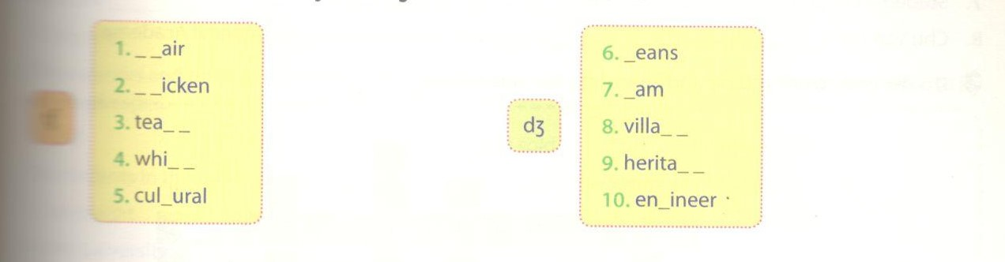
Key - Đáp án:
/ tʃ/ | / dʒ/
1. chair | 6. jeans
2. chicken | 7. jam
3. teach | 8. village
4. which | 9. heritage
5. cultural | 10. engineer

2. Practise reading the dialogues, paying attention to the words with the sounds / tʃ/ and / dʒ/ .
Thực hành đọc đoạn hội thoại, chú ý đến các âm / tʃ/ và / dʒ/ .
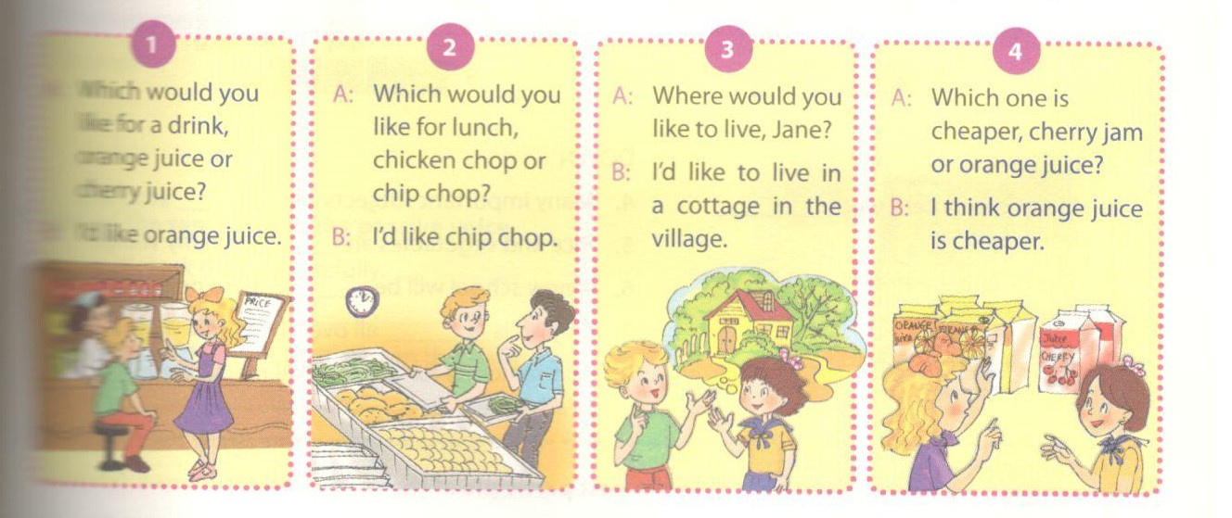
B. Vocabulary & Grammar – trang 43 – Unit 6 – Sách bài tập(SBT) tiếng Anh 7 mới
1. Circle one odd word A, B, C, or D. Then read them aloud.
Khoanh vào từ khác biệt A, B, C, hoặc D. Đọc to từ đó.
1. A. temple | B. tomb | C. pagoda | D. culture
2. A. for | B. in | C. behind | D. between
3. A. located | B. visited | C. grown | D. surrounded
4. A. teach | B. education | C. learn | D. study
5. A. center | B. culture | C. historical | D. architectural
6. A. juice | B. cheap | C. jam | D. chop
7. A. kept | B. taken | C. educated | D. done
8. A. recognize | B. regard | C. consider | D. founder
Key - Đáp án:
1. D; 2. A; 3. C; 4. B;
5. A; 6. B; 7. C; 8. D.
2. Complete each of the sentences with one appropriate word. You can use the words in 1.
Hoàn thành các câu sau với từ thích hợp. Có thể sử dụng các từ ở bài 1.
1. Universities should be in the centre of.____________________ .
2. The Imperial Academy was built_____ Emperor Lý Nhân Tông.
3. Many kinds of flowers are____________________ in Da Lat.
4. Children usually receive their early_________________________ at home.
5. Their house is located in the_________________________ of the city.
6. It is________________________ to buy fruit juice in the rural areas.
7. Students in our universities are very well__________________________ .
8. Chu Van An is__________________________one of the first teachers at the Imperial Academy.
Key - Đáp án:
1. culture; 2. by; 3. grown; 4. education
5. centre; 6. cheap; 7. educated; 8. considered
3. Do the crossword puzzle and complete the sentences.
Giải ô chữ và tìm ra câu hoàn chỉnh.
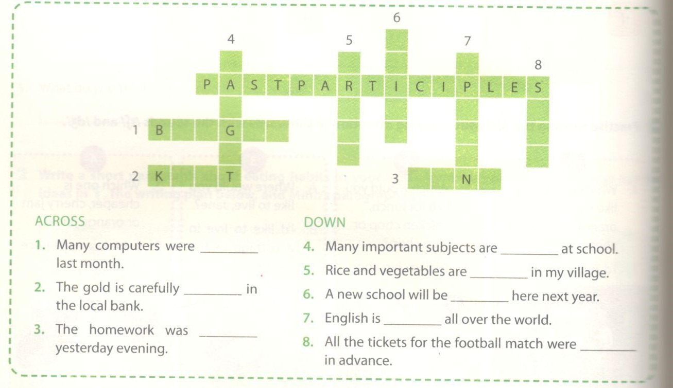
Key - Đáp án:
1. bought; 2. kept; 3. done; 4. taught; 5. grown; 6. built; 7. spoken; 8. sold
4. Complete the passive sentences, using the past participle of the verbs given.
Hoàn thành các câu sau, sử dụng thì quá khứ của động từ đã cho.
1. Bach Ma National Park in Hue_______________close to the sea. (situate)
2. Khleang Pagoda in SocTrang____________wood in 1533. (make of)
3. Da Nhim Lake___________in 1962. (build)
4. Many kinds of fruits___________at the floating market in Can Tho. (sell)
5. Tan Ky House in Quang Nam_____________very well. (preserve)
6. Oxford University__________________ as the oldest university in the English speaking world. (regard)
7. Many flowers and trees in my school___________________ every year. (grow)
8. Cambridge University_______________second after Harvard in the USA. (rank)
Key - Đáp án:
1. is situated; 2. was made of; 3. was built; 4. are sold
5. has been preserved; 6. is regarded; 7. are grown; 8. is ranked
5. Choose the best answer A, B, C, or D to complete each sentence.
1. All the tickets for the trip to the Temple of Literature____________________ .
A. sold B. sold C. were sold D. is sold
2. Look! The trees and flowers___________________ care of by the gardeners of the Temple of Literature.
A. are being taken B. is taken C. taken D. were taken
3. My father____________________the headmaster of Chu Van An Lower Secondary School.
A. choose B. is chosen C. are chosen D. chose
4. My sister_______________________ a scholarship to Cambridge University.
A. may offer B. will offer C. is offered D. offered
5. The souvenirs and postcards inside the Temple of Literature______________to you at a higher price by the shopkeeper.
A. sold B. sell C. was sold D. were sold
6. The students in the university__________________________ by famous lecturers and tutors.
A. are taught B. are learned C. are studied D. are played
7. A new university___________________________ in my town in the near future.
A. is built B. will be built C. was built D. has been built
8. The government_________________ these people the right to settle near the university.
A. is given B. will be given C. was given D. has give
Key - Đáp án:
1. C; 2. A; 3. B; 4. C; 5. D; 6.A; 7. B; 8. D
6. Rewrite the sentences in the passive voice.
Viết lại các câu sau ở dạng bí động.
1. We usually lock the safe carefully.
The safe_______________________________ .
2. We keep the safe in the bedroom on the second floor.
The safe_________________________________________ .
3. Yesterday the theives stole everything in it.
Yesterday everything in it______________________ .
4. We told the police about it.
The police_______________________.
5. The police checked everything in the house.
Everything in the house_____________________.
6. Tne police questioned everybody in the house.
Everybody_________________________________ .
7. The police surrounded the house.
The house________________________________.
8. The police did not think that they caught the thieves.
The police did not think that the thieves___________________.
Key - Đáp án:
1. The safe is usually locked carefully.
2. The safe is kept in the bedroom on the second floor.
3. Yesterday everything in it was stolen.
4. The police were told about it.
5. Everything in the house was checked (by the police).
6. Everybody in the house was questioned.
C. Speaking – trang 46 – Unit 6 – Sách bài tập(SBT) tiếng Anh 7 mới.
1. Match the questions (1-6) with the answers (A-F). Then practise them with your partner.
Nối câu hỏi từ 1-6 với đáp án A-F. Thực hành với bạn bè.
1. Where would you like to go for a picnic? | A. Next month.
2. When would you like to go? | B. By coach.
3. How would you like to travel? | C. Ha Long Bay.
4. Who would you like to go with? | D. With my parents.
5. What would you like to take? | E. Food and drink.
6. What would you like to play? | F. Football.
Key - Đáp án:
1. C; 2. A; 3. B; 4. D; 5. E; 6. F.

2 Make conversations with your partners, using the following suggestions.
Nói chuyện với bạn bè, sử dụng các gợi ý sau.
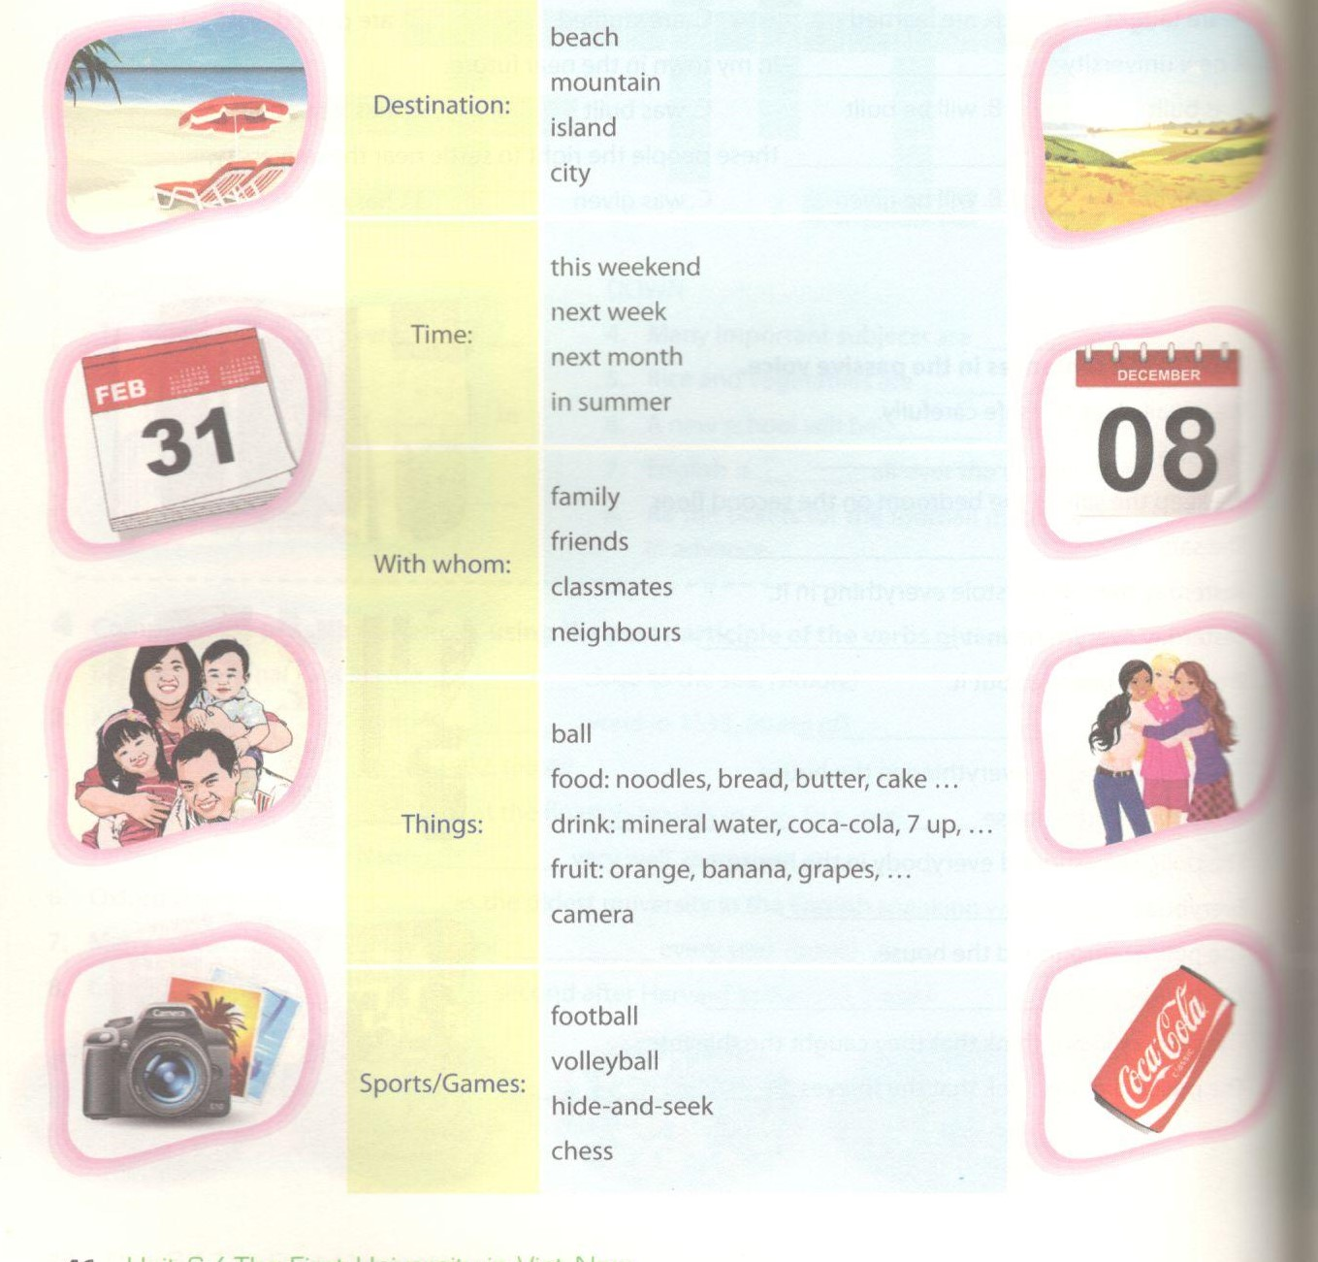
D. Reading - trang 47 – Unit 6 – Sách bài tập( SBT) tiếng Anh 7 mới
1. Complete the blanks (1-7) of the dialogue with the appropriate phrases (A-G).
Hoàn thành chỗ trống từ (1-7)của đoạn hội thoại với các cụm từ (A-G).
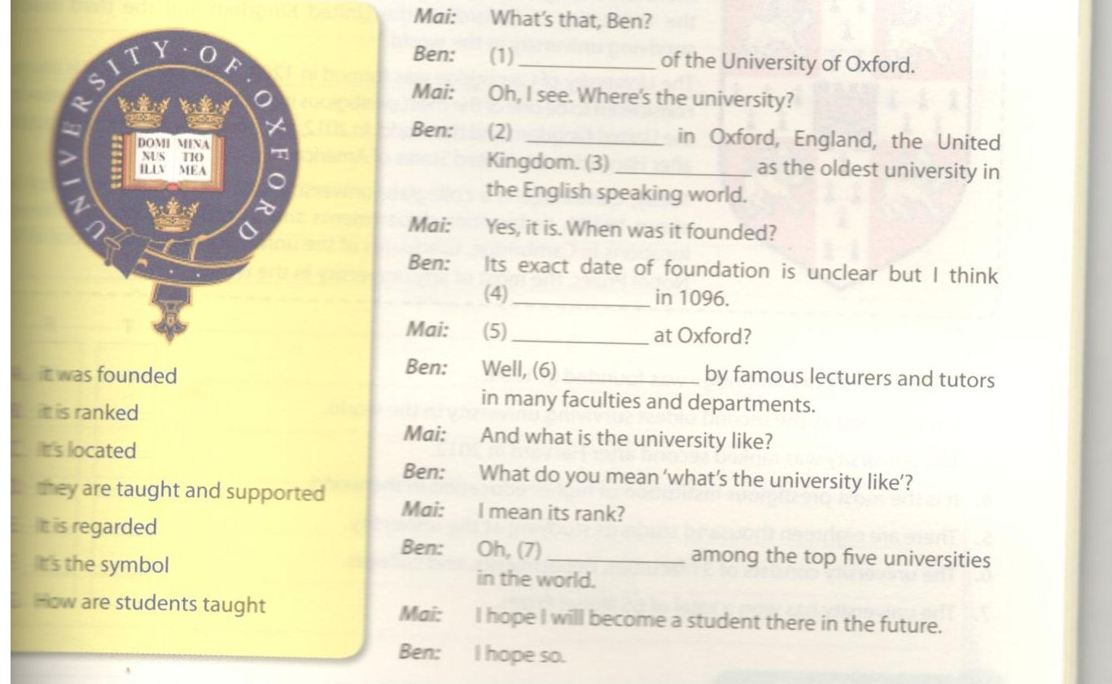
Key - Đáp án:
1. F; 2. A; 3. B; 4. D; 5. E; 6. F
2. Read the passage and tick statements with T for true and F for false.
Đọc đoạn văn và đánh dấu tick vào cột T với câu đúng, vào cột F nếu câu sai.
The University of Cambridge is a public university. It is located in Can the United Kingdom. It is regarded as the second oldest university( after the University of Oxford) in the United Kingdom and the third oldest surviving university in the world.
The University of Cambridge was formed in 1209. Over the years, it i considered to be one of the most prestigious institutions of higher education in the United Kingdom and the world. In 2012, the university was ranked second after Harvard in the United States of America.
Today, Cambridge is a collegiate university with a student popul about 18,000. Its faculties, departments and 31 colleges occupy different locations in Cambridge. Graduates of the university have won a total of 65 Nobel Prizes, the most of any university in the world.

 | T | F
- The University of Cambridge was founded in 1209.
- It is regarded as the second oldest surviving university in the world.
- The university was ranked second after Harvard in 2012.
- It is the most prestigious institution of higher education in the world.
- There are eighteen thousand students studying at the university.
- The university consists of 31 faculties, departments, and colleges.
- The university has won a total of 65 Nobel Prizes.

Key - Đáp án:
1. T; 2. F; 3. T; 4. F; 5. T; 6. F; 7. F.
E. Writing – trang 48 – Unit 6 – Sách bài tập( SBT) tiếng Anh 7 mới
1. Write the answers to the questions about your school.
Viết câu trả lời về trường bạn.
- What is the school named/ called?
- Where is it situated/ located?
- When was it founded/ built?
- What can be seen in the schoolyard?
- What is grown in the school garden?
- How are the classrooms decorated?
- Where are the teachers' motorbikes and students' bikes kept?
- What is your school surrounded by?
2. Write a paragraph about your school, using the information in 1.

