A. Phonetics - trang 29 - Unit 10 – Sách bài tập(SBT) tiếng Anh 7 mới
1. Find the word which has a different stress pattern from the others. Say them aloud.
Tìm từ có trọng âm khác với các từ còn lại. Đọc to các từ đó.
1. A. dangerous | B. plentiful | C. another | D. limited
2. A. easily | B. consumption | C. energy | D. negative
3. A. different | B. expensive | C. abundant | D. convenient
4. A. petroleum | B. advantage | C. enormous | D. tendency
5. A. attention | B. holiday | C. pollution | D. effective
Key - Đáp án:
1. C; 2. B; 3. A; 4. D; 5. B
2. Read the following sentences and mark (') the stressed syllable in the underlined words.
Đọc các câu sau và đánh dấu (') vào trọng âm của các từ gạch chân.
1. The potential of alternative sources of energy is not only plentiful but also clean and safe.
2. We are looking for cheap, clean, effective sources of energy. These types of energy won't cause pollution or waste natural resources.
3. I think nuclear power is not only expensive but also dangerous to our environment.
4. Petroleum is limited. It will be replaced by another source of renewable energy.
5. We will reduce energy consumption as much as possible.
Key - Đáp án:
1. The po'tential of alternative sources of 'energy is not only 'plentiful but also clean and safe.
2. We are looking for cheap, clean, e'ffective sources of energy. These types of energy won't cause po'llution or waste natural resources.
3. I think nuclear power is not only ex'pensive but also 'dangerous to our environment.
4. Pe'troleum is 'limited. It will be replaced by a'nother source of renewable energy.
5. We will reduce 'energy con'sumption as much as possible.
B. Vocabulary & Grammar – trang 30 – Unit 10 – Sách bài tập(SBT) tiếng Anh 7 mới
1. Do the crossword puzzle and complete the sentences.
Giải ô chữ và hoàn thành các câu dưới đây.
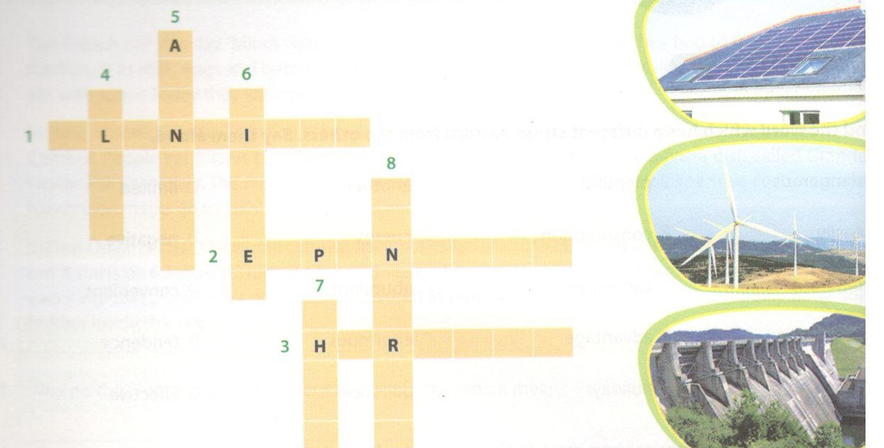
ACROSS
1. Solar energy is_______ and it can be replaced easily.
2. Hydro power is_______ because dams and lakes should be built.
3. Fossil fuels are non-renewable energy sources. They are____ to the environment.
DOWN
4. The alternative sources of energy like the sun and the wind are not only plentiful but also and safe.
5. Wind power is convenient and_______ .
6. Coal is_______ and it will be replaced by another renewable source.
7. For many people living in rural areas, biogas is a____ energy source available.
8. Nuclear energy can provide enough electricity for the world's needs, but it is___ .
Key - Đáp án:
1. plentiful; 2. expensive; 3. harmful; 4. clean
5. abundant; 6. limited; 7. cheap; 8. dangerous

2. Match the verbs in column A with the words/ phrases in column B.
Nối động từ ở cột A với từ/ cụm từ ở cột B.
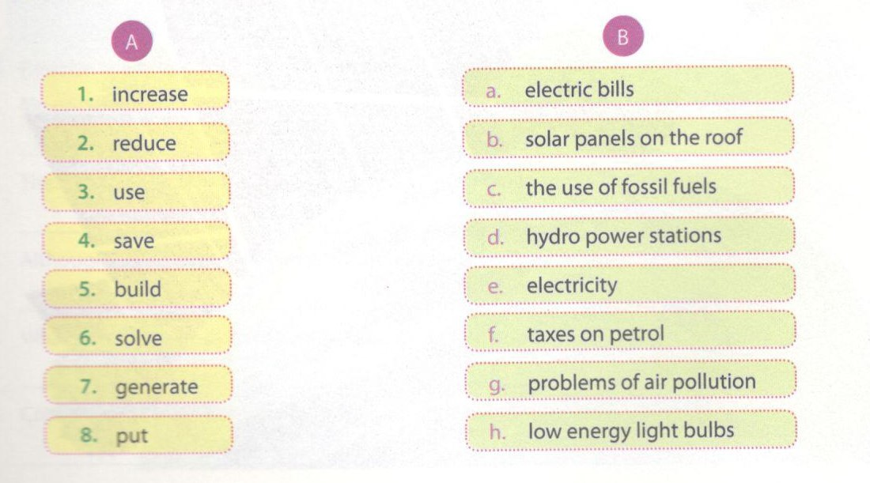
Key - Đáp án:
1. f; 2. c; 3. h; 4. a; 5. d; 6. g; 7. e; 8. b

3. Underline the correct word or phrase in each sentence.
Gạch dưới từ hoặc cụm từ đúng trong mỗi câu.
1. This time next year my father will work/ will be working in the hydro power station.
2. Don't forget to turn off the lights before you're leaving/ you leave.
3. My brother and I will cycle/ will have cycled to school to cut air pollution.
4. By the year 2020, people in my village will use/ will be using energy from the sun.
5. What will we do/ will we be doing to save electricity?
6. What will happen/ will be happened to us when the non-renewable energy sources run out?
7. Wind power is a renewable source because it can be replaced/ can replace easily and quickly.
8. The students in my school will be put/ will be putting low energy light bulbs in the school.
9. Alternative sources of energy will be developed/ will develop quickly.
10.The energy consumption will be reduced/ will reduce as much as possible.
Key - Đáp án:
1. will be working; 2. you leave; 3. will cycle; 4. will be using
5. will we do; 6. will happen; 7. can be replaced; 8. will be putting
9. will be developed; 10. will be reduced
4. Choose the best option (A, B, C, or D) to complete each sentence.
Chọn đáp án đúng (A, B, C hoặc D) để hoàn thành các câu sau.
1. The boys______ home for lunch because they are planning to visit the hydro power station.
A have not come Edo not come C. will not be coming D. is not coming
2. It is going to rain any minute now. The children___ in the rain.
A. is being caught will be caught C. is caught D. are caught
3. They_______ a test tomorrow; we don't want to disturb them.
A. will be having will have C. have D. had
4. They_______ that we have gone without telling them.
A. thought are thinking C. will be thinking D. think
5. ______ you_______ up this book for me, please?
A. Are ... going to wrap Will... be wrapping C. Will... wrap D. Have ... wrapped
6. We_______ solar panels in the schoolyard while you are checking cracks in the water pipes.
A. have put £ will be putting C. will put D. put
7. At 7.00 tomorrow, you__________ to school.
A. cycle will cycle C. will be cycling D. will be cycled
8. Solar energy_______ by many countries in the world in the future.
A. use i will use C. will be using D. will be used
Key - Đáp án:
1. C; 2. B; 3. A; 4. D; 5. C; 6. B; 7. C; 8. D

5. Change the sentences into the passive voice.
Chuyển câu dưới đây sang thể bị động.
1. We will use less electricity in the future.
Less electricity_________________________________________.
2. The students in my school will use public transport when travelling long distances.
Public transport________________________________________.
3. I will turn off the lights when leaving a room or going to bed.
The lights____________________________________________ .
4. Wind power will offer a great deal of energy next century.
A great deal of energy,___________________________________.
5. We will use sources of energy more effectively for our future.
Sources of energy______________________________________.
6. People in the countryside will increase the use of biogas for cooking.
The use of biogas___________________________________________ ,
7. They will build a hydro power station in the North of the country next decade.
A hydro power station__________________________________________ .
8. We will solve the problem of energy shortage by using solar energy.
The problem of energy shortage_____________________________________.
Key - Đáp án:
1. Less electricity will be used in the future.
2. Public transport will be used by the students in my school when they travel long distances.
3. The lights will be turned off when I leave a room or go to bed.
4. A great deal of energy will be offered next century.
5. Sources of energy will be used more effectively for our future.
6. The use of biogas will be increased (by people in the countryside) for coot
7. A hydro power station will be built in the North of the country next decade
8. The problem of energy shortage will be solved by using solar energy.

6. Reorder the words/ phrases to make complete sentences.
Sắp xếp lại các từ/ cụm từ sau để tạo thành câu hoàn chỉnh.
1. this time tomorrow/ English/ They/ will be learning.
2. to save/ will reduce/ our energy/ the use of electricity/ We.
3. in our country/ source of energy/ a renewable/ will be/ Wind.
4. will be replaced/ Coal/ renewable source/ by another.
5. biogas/ is/ cooking and heating/ l think/ for/ abundant and cheap.
6. Solar energy/ in the world/ by many countries/ will be used.
7. because/ a non-renewable energy source/ to replace it/ Petroleum is/ it takes a long time.
8. effectively/ sources of energy/ in our country/ will be developed/ Alternative.
9. we use/ travelling long distances/ public transportation/ Will/ when?
10. of energy/ are/ the wind and the sun/ Why/ alternative sources/ called?
Key - Đáp án:
1. They will be learning English this time tomorrow.
2. We will reduce the use of electricity to save our energy.
3. Wind will be a renewable source of energy in our country.
4. Coal will be replaced by another renewable source.
5. I think biogas is abundant and cheap for cooking and heating.
6. Solar energy will be used by many countries in the world.
7. Petroleum is a non-renewable energy source because it takes a long time to replace it.
8. Alternative sources of energy will be developed effectively in our country.
9. Will we use public transportation when travelling long distances?
10. Why are the wind and the sun called alternative sources of energy?
C. Speaking – trang 33 – Unit 10 – Sách bài tập(SBT) tiếng Anh 7 mới.
1. Mai and Nam are talking about energy sources. Choose a-e to complete their conversation.
Mai và Nam đang nói về nguồn năng lượng. Chọn các đáp án a-e để hoàn thành đoạn hội thoại.
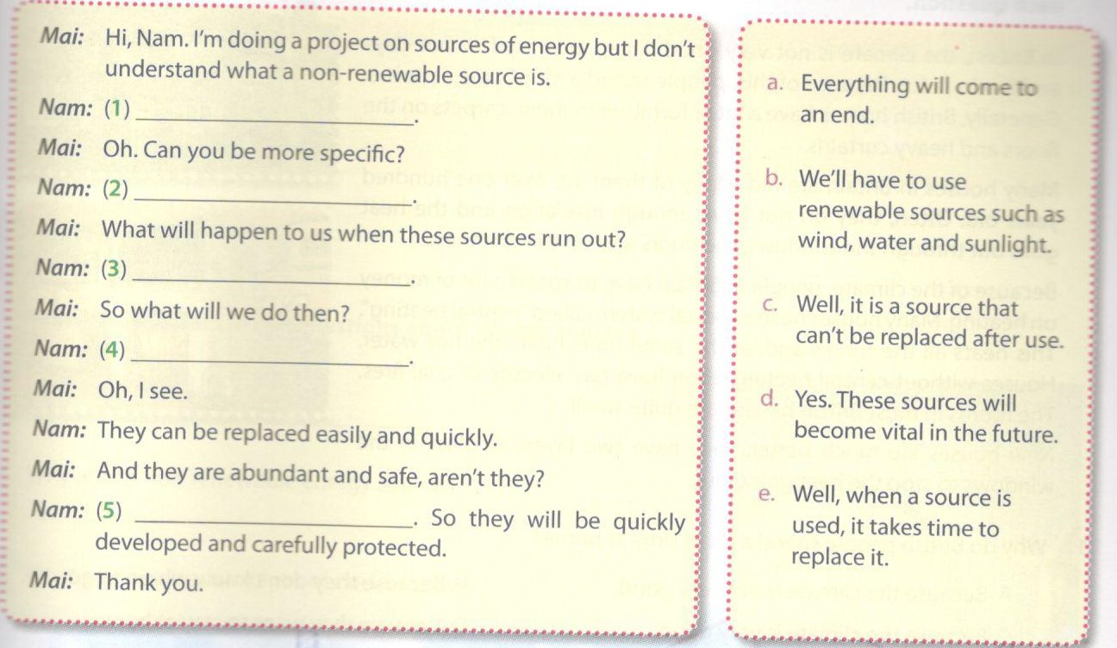
Key - Đáp án:
1. c; 2. e; 3. a; 4. b; 5. d
2. Complete the network. Then ask and answer questions about renewable and non-renewable energy sources.
Hoàn thành sơ đồ. Hỏi và trả lời về nguồn năng lượng có thể tái tạo và nguồn năng lượng không thể tái tạo.
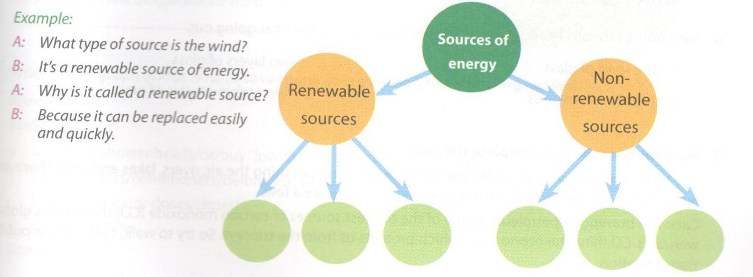
D. Reading - trang 34 – Unit 10 – Sách bài tập( SBT) tiếng Anh 7 mới
1. Read the passage and choose the best answer (A, B, C, or D) to each question.
Đọc đoạn văn sau và chọn đáp án đúng nhất cho mỗi câu hỏi.
In Britain, the climate is not very good. There are very few hot days and it rains a lot. Because of this, people spend a lot of time at home. Generally, British homes have a lot of furniture in them, carpets on the floors and heavy curtains.
Many houses in Britain are old. Many of them are over one hundred years old. Often, they do not have enough insulation and the heat goes out through the windows, the doors and up the chimney.
Because of the climate, people in Britain have to spend a lot of money on heating. Many houses have a special system called "central heating". This heats all the rooms and, at the same time, heats the hot water. Houses without central heating often have gas, electric or coal fires. The rooms in most British houses are quite small.
New houses are much better. They have two layers of glass in the windows to stop the heat going out.
1. Why do British people spend a lot of time at home?
A. Because the climate is not very good.Why do British people spend a lot of time at home?
B. Because they don't know where to go.
C. Because the climate is very good.
D. Because they want to stay at home.
2. The heat goes out of the houses through_____ .
A. the doors and up the chimney B. the windows and up the chimney
C. the windows, the doors and up the chimney D. the walls and up the chimney
3. Because of______ , people in Britain have to spend a lot of money on heating.
A. cold weather B. cool weather
C. hot weather D. bad weather
4. Houses without central heating often have_____ .
A. only coal fires B. gas or coal fires
C. electric or coal fires D. gas, electric or coal fires
5. New houses usually have______ in the windows to stop the heat going out.
A. one layer of glass B. two layers of glass
C. three layers of glass D. two or three layers of glass
Key - Đáp án:
1. A; 2. C; 3. A; 4. D; 5. B

2. Read the passage and complete the table.
Đọc đoạn văn và hoàn thành bảng dưới đây.
Our environment is in trouble. People and industries are polluting the air, rivers, lakes and seas. There are many things you can do to help the environment. Here are a few.
Car: The burning of petroleum is one of the biggest sources of carbon monoxide(CO) that causes global warming. CO thins the ozone layer, which protect us from sunrays. So try to walk, cycle, or use public transportation.
Energy: The biggest use of home energy is for heating and cooling homes. It costs a lot of money. So turn the t down, especially at night. Replace regular light bulbs with low energy light bulbs, which use less energy.
Water: Showers use a lot of water. Buying a special "low-flow" shower head or taking shorter showers can cut this use in half.

Problems | Solutions
Cars
Energy
Water

Key - Đáp án:
 | Problems | Solutions
Cars | The burning of petroleum produces carbon monoxide that causes global warming.  CO thins the ozone layer. | Try to walk, cycle, or use public transportation.
Energy | The use of home energy costs a lot of money. | Turn the heat down.  Replace regular energy light bubs
Water | Showers use a lot of water. | Buy a special 'low-flow' shower head. Take shorters showers.
E. Writing – trang 35 – Unit 10 – Sách bài tập( SBT) tiếng Anh 7 mới
1. Write the answers to the questions about energy sources.
Viết câu trả lời cho câu hỏi về nguồn năng lượng.
1. What is a carbon footprint?
___________________________
2. Why is oil a non-renewable energy source?
___________________________
3. What are the disadvantages of nudear power?
___________________________
4. Why should we save energy?
___________________________
5. What should we do to reduce our electric bills?
___________________________
6. What should the goverment do to reduce the use of petrol?
___________________________
7. What type of energy source will be used in Viet Nam in the future?
___________________________
8. Why do you think biogas will be used in the future?
___________________________
Key - Đáp án:
Đáp án gợi ý:
1. It s me negative effects we have on the environment.
2. Because it takes a long time to replace it.
3. It is expensive and dangerous.
4. Because it's important in everyone's life.
5. We should use low energy light bulbs in our houses or turn off the lights before going to bed.
6. The government should increase the tax on petrol.
7. Hydro power and solar energy will be used.
8. Because it's abundant and clean.

2. Write a paragraph about how to save home energy, using the following outline.
Introduction
Body
- use/ short shower head/ or/ buy''low-flow' shower/ use less baths
- turn off/ lights/ conditioners/ before/ leave home/ whenever/ not in/ rooms
- keep/ refrigerator doors/ closed
- go/ school/ bike
Conclusion
Key - Đáp án gợi ý:
Good morning/ afternoon ladies and gentlemen,
My name is Nam. Today I'm going to tell you how to save home energy.
Most people use too much electricity and water at home. You can reduce the amount of energy by
-using short shower heads or buy ’low-flow' showers;
-turning off the lights and air conditioners before leaving home or whenever you are not in your rooms.
-keeping the refrigerator doors closed.
-going to school by bike.
If you take my advice, you won't have to pay so much for your bills, and you can save necessary energy.
Thanks for listening.

