A. Phonetics - trang 36 - Unit 11 – Sách bài tập(SBT) tiếng Anh 7 mới
1. Practise the following questions.
Thực hiện các câu hỏi sau.
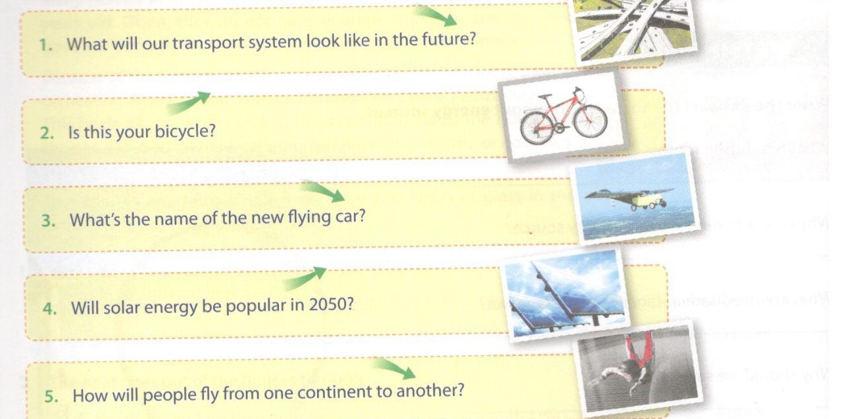

2. Put the questions into the correct category, then practise saying them.
Xếp mỗi câu hỏi sau vào đúng cột và luyện nói các câu hỏi đó.
1. What will you do when you grow up?
2. Do you want to be a millionaire?
3. How eco-friendly will cars be in the next 20 years?
4. Could you check the weather forecast for me? Will it rain tomorrow?
5. Which transport will be most popular in the future?

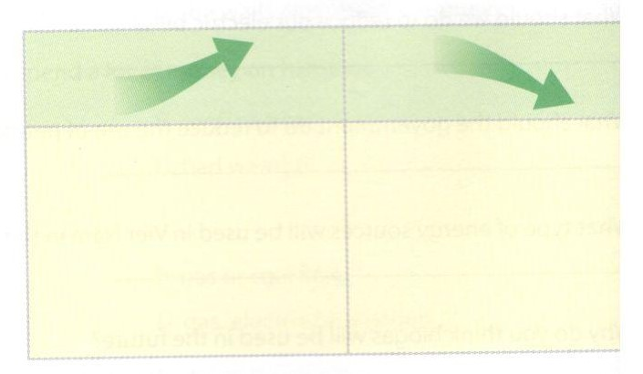
Key - Đáp án:
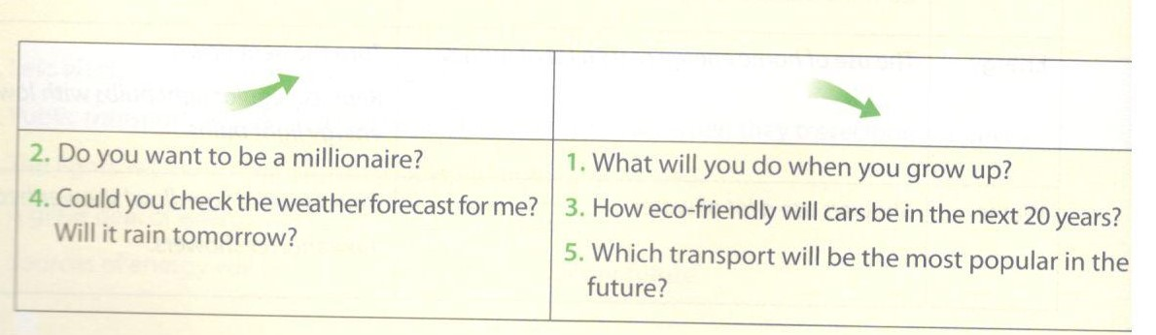

3. Practise the following conversation.
Luyện tập đoạn hội thoại sau.
Phong: Have you got a bike, Tuan Anh?
Tuan Anh: Yes, I have. I bike to school every day.
Phong: Do you think it's the best way to move around?
Tuan Anh: Well... I don't know. Sometimes it's quite slow, especially when I'm already late. But it's eco-frie Do you have one, Phong?
Phong: Yes, but I wish I could use it more often. Do you think we need special lanes for bikes?
Tuan Anh: Yes, I think so. There're too many motorbikes. So how do you go to school?
Phong: I take the bus. I think we will soon have tubes in our city as well.
B. Vocabulary & Grammar – trang 37 – Unit 11 – Sách bài tập(SBT) tiếng Anh 7 mới
1. Match the means of transport with their descriptions.
Nối tên phương tiện với mô tả của nó.
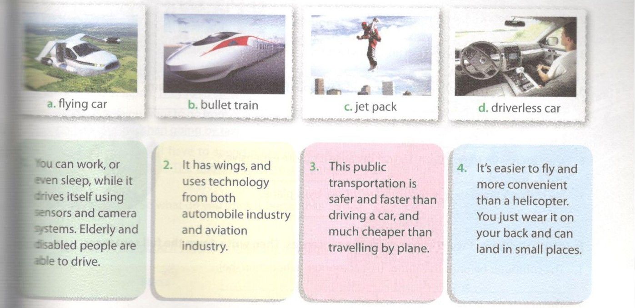
Key - Đáp án:

1. -d. driverless car | 2. | a. flying car | 3. -b. bullet train | 4. -c jet pack
2. Choose the correct words from the box to fill the gaps.

Eco-friendly | supersonic | Wind-powered | High-speed | driverless | underwater

1. I think in the future we will be able to go to the Moon in a_____ spaceship that travels faster than the speed of sound.
2. You can read a newspaper while in a______car because it is automated.
3. Imagine in the future we will take_____________ trains and enjoy watching fish swimming around us when we are travelling.
4. Solar energy is___________.
5. ____________ships use wind as their energy for sailing.
6. 'Bullet train' is a type of _________train that first came from Japan.
Key - Đáp án:
1. supersonic  4. eco-friendly | 2. driverless  5. Wind-powered | 3. underwater  6. high-speed
3. Choose the correct option.
1. Look at the photo! You're____
A. driving B. flying C. riding
2. It's really difficult to__________ a bicycle up the hill.
A. pedal B. drive C. fly
3. You can_____________ easily on the Dead Sea. Why? Because it's so salty!
A. fly B.walk C. float
4. She is a frequent customer of that airline. She has to_____________ every month for work.
A. drive B. fly C. ride
5. Will you_____________ a taxi or a train?
A. fly B. walk C. take
6. He______________in a white sport car.
A. walks B. drives C. takes
Key - Đáp án:

1.C | 2. A |  | 3. C | 4. B | 5. C | 6.B

4. Choose the correct word to complete the sentences. Then write down the full sentences.
1. She came to the stadium (in, on, by) bus.
_________________________________
2. They go to work (in, on, by) train.
_________________________________
3. I usually read books while I am (in, on, by) a train.
_________________________________
4. We went to Gothenburg last summer and it was our first time (in, on, by) a tram.
_________________________________
5. He often travels (in, on, by) his car.
_________________________________
6. They prefer not to go (in, on, by) car because it's more expensive.
_________________________________
7. My children often sleep while they are (in, on, by) a plane.
_________________________________

Key - Đáp án:

1. by  5. in | 2. by  6. by |  | 3. on  7. on | 4. on
5. Circle the correct word to complete the sentences. Then write down the full sentences.
Khoanh vào từ đúng để hoàn thành câu sau. Viết lại câu hoàn chỉnh.
1. The computer belongs to Nhung. That computer is (hers/her/she).
2. Their car is red. (We/Our/Ours) car is grey.
3. The books are all (me/mine/my).
4. What happened to him? He has broken (him/his/he) arm.
5. (Mine/My/Me) keys are here on the table. Where are (your/yours/us)?
6. Is this chair (you/your/yours)?
Key - Đáp án:

1. hers | 2. Our |  | 3. mine | 4. his | 5. My, yours
6. yours
6. Put the words in brackets in correct forms. Pay attention to the positive/negative form.
Cho dạng đúng của động từ trong ngoặc. Chú ý vào các dạng chủ động/bị động của động từ.
I think in the future cities (1. be)__________________ more crowded and the traffic (2.get)______________________________worse. People (3. use)_____________ more cars and air pollution (4.become)_________a big problem. There (5. be)__________enough space for trees and lakes and buildings (6. rise)_____________ everywhere. Perhaps less people (7. ride)_____their bicycles. The price offuel (8.increase)___________ . Life (9. be)_____________ easy at all!
Key - Đáp án:

1. will be  6. will rise | 2. will get  7. will ride | 3. will use  8. will increase | 4. will become  9. won't be | 5. wont be
C. Speaking – trang 39 – Unit 11 – Sách bài tập(SBT) tiếng Anh 7 mới.
1a. Read the conversation, look at the underlined statements. Which statements are facts? Which ones are opinions?
Đọc đoạn văn sau, nhìn vào các câu được gạch chân. Câu nào là thật, câu nào là ý tưởng?
Anna: I think rail travel is the best transport method for the future. What do you think Mai?
Mai: Well... I don't know. It's perhaps quite uncomfortable. Look at the trains in Japan. They're so crowded.
Anna: But it's fast if you want to go from one place to another in a city. And it's cheaper than going by taxi.
Mai: Yes, I agree you will have to spend more money if you take a taxi. But is it faster? The trains in Sweden are delaved quite often.
Anna: Yes, that's right. So what do you think is better than trains?
Mai: Maybe bicycles?
Anna: Perhaps they're good if you don't have any luggage.

Facts | Opinions

Key - Đáp án:
Facts | Opinions
They're so crowded.  And it's cheaper than going by taxi.  The trains in Sweden are delayed quite often. | I think rail travel is the best transport method for the future.  It's perhaps quite uncomfortable.  Perhaps they’re good if you don’t have any luggage.
b. Look at the Opinions Box. Do you agree with these opinions? Say why you do or why you don't.
Nhìn vào cột ý tưởng. Bạn có đồng ý với các ý tưởng này không? Tại sao có và tại sao không?
Key - Đáp án:
 | Agree | Disagree
Rail travel is the best transport method for the future. | It's cheap and can help reduce pollution. | Bicycle are even cheaper and more eco-friendly.
Travelling by train is quite uncomfortable. | It's crowded and there can be delayed. | You can work or even take a nap on a train.
Travelling by bicycle is good if you don't have any luggage. | If you have suitcases you should go by car, or by train. | You can just put your things in a backpack and wear it.
2. This is Huong and some information about herself. Can you predict her future? Choose one option and say your predictions. Explain your choice.
Đây là Hương và một vài thông tin về cô ấy. Bạn có thể dự đoán tương lai của cô ấy không? Chọn một đáp án và nói lên dự đoán của bạn, giải thích.
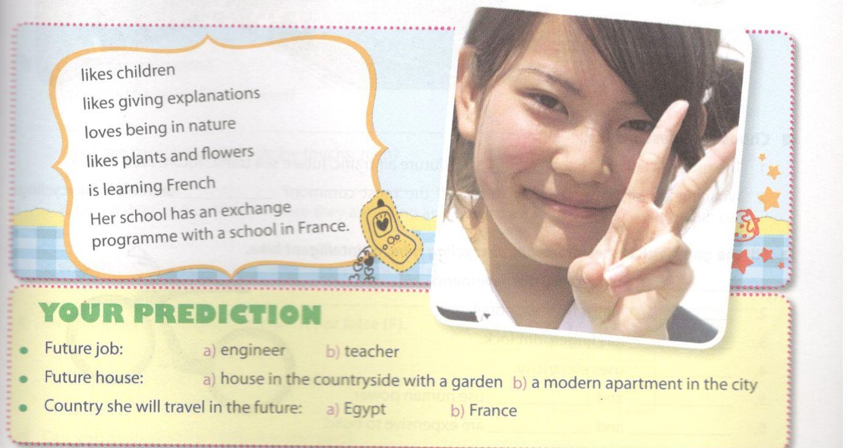
Key - Đáp án:
Huong will become a teacher because she Boesctifldpen and Hoes giving explanations.
She will live in a house in the countryside with a ggden because she Bees plants and flowers and she loves being in nature.
She will travel to France in the future because her school has an exchange programme with a school in France and she can speak French.
D. Reading - trang 40 – Unit 11 – Sách bài tập( SBT) tiếng Anh 7 mới
1. Read the conversation and do the following tasks.
Đọc đoạn hội thoại sau và làm các nhiệm vụ dưới đây.
Mai: ... That was about future air travelling. Now we'll talk about future road transport with slidewalks, skycycling, and bicycles.
Veronica: Slidewalks are similar to moving walkways in airports. When slidewalks replace our pavements they'll help us move faster.
Phuc: Skycycling tubes hang from monorails and you can cycle while watching the city from above.
Veronica: Intelligent bikes have foldable roof for rainy weather. They'll never be stolen because they use fingerprint lock.
Mai: All of them are environmentally friendly. Slidewalks use electricity, while skycycling and intelligent bikes use human power. But in our opinion intelligent bikes will be the most common, because building slidewalks and skycycling system can be expensive.
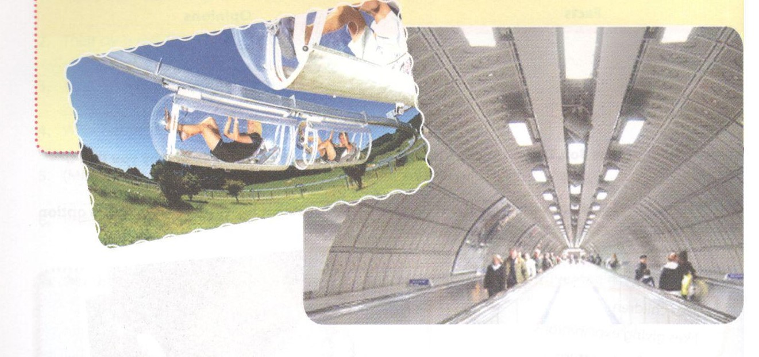
a. Choose the best answer.
1. The group is talking about__________(future air traffic/future sea traffic/future road traffic).
2. What means of transport they think will the most common?______(Slidewalks/Skycyclii/Intelligent bikes).
b. Fill the gaps with either slidewalk, skycycling tube, or intelligent bike.
1. _____________ can replace the pavements.
2. _____________hangs from monorail.
3. _____________ has fingerprint lock.
4. _____________ uses electricity.
5. _____________and______________ use human power.
6. _____________and______________ are expensive to build.
Key - Đáp án:
1a. 1. future road traffic; 2. intelligent bikes
1b. 1. Slidewalks; 2. Skycycling tube; 3. An intelligent bike; 4. Slidewalk; 5. Skycycling/intelligent bikes
6. Slidewalk/skycycling

2. Read the text and answer the question, then do the following tasks.
URBAN TRANSPORT PODS
The people living in Milton Keynes, a town about 70 kilometres northwest of London, have been introduced to a new transport experience when they use'pods' to travel on certain routes.
The pods are a kind of driverless cars which travel at 19km/h and are able to transport two people and their luggage. There is a touchscreen in the windshield of the pods where passengers select their terminal. During the trip they can also read the news, check e-mails or play video games on the screen. Powered by electric motors, the pods have ultrasonic sensors and a GPS system that help themselves know where they are go?ng and how to avoid obstacles along the way. People can use a smartphone app to hail a pod in :ne street.
Do you think this way of transport will appear in cities in Viet Nam soon?
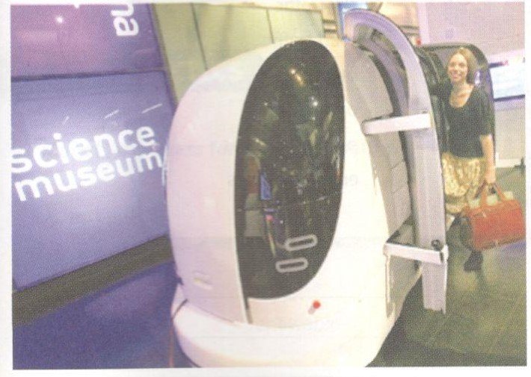
a. Find in the text words that have similar meanings with these words/phrases.
Tìm từ đồng nghĩa với từ và cụm từ dưới đây.
1. pathways between two particular places
2. destination
3. travellers
4. blocks
5. get
b. Answer the questions.
Trả lời các câu hỏi sau.
1. Where is the project introduced?
2. What can passengers do with the touchscreen?
3. What enables pods to -tere they are going and how to avoid obstacles?
4. Why should you need the smartphone app for pods?
c. Decide if the staments are true (T) or false (F).
Các câu dưới đây đúng (T) hay sai (F).

 | T | F
1. Pods are a type of robot car
2. You can use pods to travel to any place you want.
3. Pods are eco-friendly.
d. Can you answer the question in the text?
Bạn có thể trả lời câu hỏi trong đoạn văn trên không?
Key - Đáp án:
2a. 1. routes; 2. terminal; 3. passengers; 4. obstacles; 5. hail
2b.
1. In Milton Keynes, a town about 70 kilometres northwest of London.
2. They can select their terminal, read the news, check e-mails or play video games.
3. The ultrasonic sensors and the GPS system.
4. People can use a smartphone app to hail a pod in the street.
2c.
1. T (The pods are a type of driverless cars.)
2. F (You can only use the pod to travel on certain routes.)
3. T (The pods are powered by electric motors.)
E. Writing – trang 42 – Unit 11 – Sách bài tập( SBT) tiếng Anh 7 mới
1. Write five sentences to describe the picture about cities and transport in 2100. You may use suggestions if needed.
Viết năm câu để mô tả thành phố và các phương tiện giao thông trong năm 2100. Có thể sử dụng các gợi ý nếu cần.
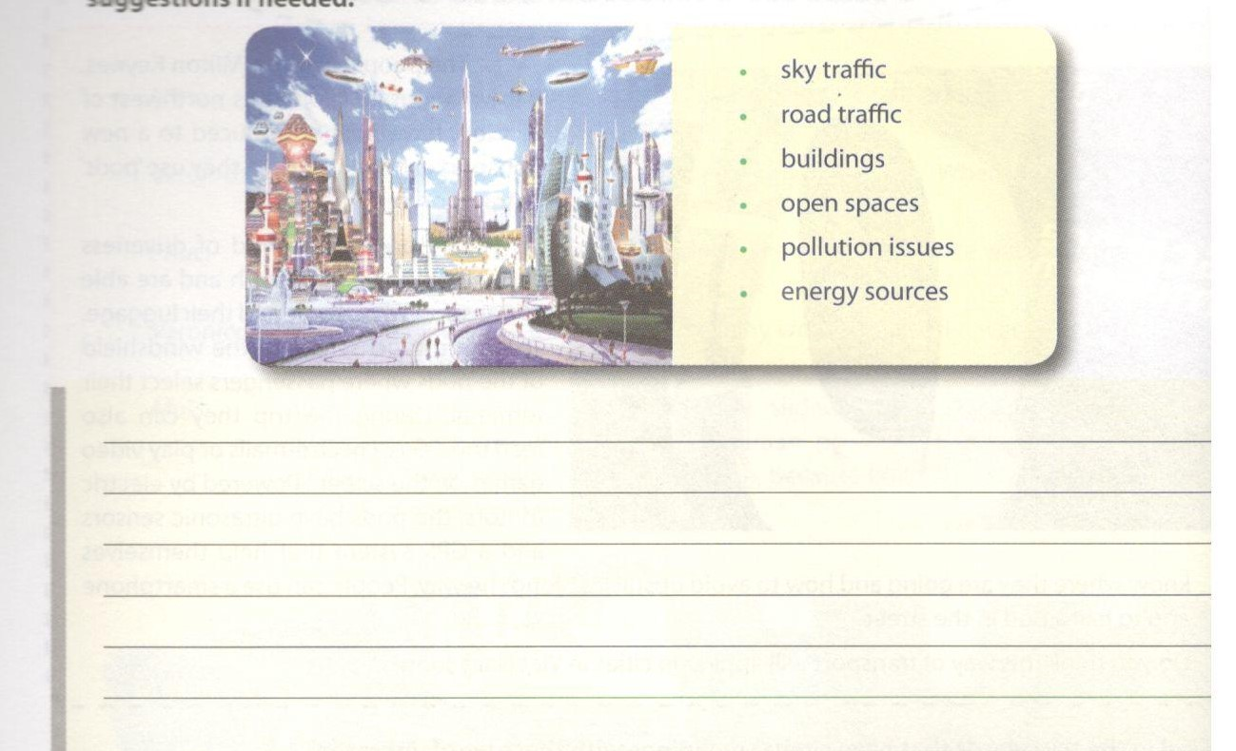
Key - Đáp án:
In the future people will use flying cars and supersonic buses. On the ground there will be no car traffic. You will just walk and there will be places to land your flying vehicles. There will be many open spaces where we enjoy beautiful fountains and green trees. Buildings will be constructed with solar panels. Most of our engines will be solar-powered.

2. How do you go to school every day? On foot, by bicycle, by bus, by boat, or in a car? What are things you like about it? What are the things you don't like about it? Do you want to make your travelling better? Write at least three ideas in these boxes and present them to the class if possible.
Hằng ngày bạn đến trường bằng phương tiện gì? Đi bộ, xe đạp, xe bus, tàu hay ô tô? Bạn cảm nhận thế nào về các phương tiện đó? Bạn thích phương tiện đó ở điểm gì? Bạn có muốn một phương tiện tốt hơn? Viết ít nhất 3 ý trong số trên và nói trước lớp nếu có thể.
