A. Phonetics - trang 43 - Unit 12 – Sách bài tập(SBT) tiếng Anh 7 mới
1. Mark (') the stress for the words below.
Đánh dấu (') vào trọng âm của các từ dưới đây.
resource  poverty  stressful  gather | serious  littering  suppose  renewable | describe  recycle  pollution  disease
Key - Đáp án:
re'source  'poverty  'stressful  'gather | 'serious  'littering  su'ppose  re'newable | des'cribe  re'cycle  po'llution  di'sease
2. Mark (') the stress for the underlined words. Then practise saying them.
Đánh dấu (') vào trọng âm của các từ gạch chân. Đọc các từ đó.
1. There are more problems in the slums than in the wealthy areas.
2. The beaches in the south of Brazil are so peaceful.
3. Which citv in vour country is the most expensive?
4. Our city will have to find a solution to reduce traffic jams.
5. People move to big cities for a better standard of living.
Key - Đáp án:
1. 'problems, 'wealthy
2. Bra'zil, 'peaceful
3. 'country, ex'pensive
4. so'lution, 'traffic
5. 'People, 'standard
B. Vocabulary & Grammar – trang 44 – Unit 12 – Sách bài tập(SBT) tiếng Anh 7 mới
1. Look at the puzzle and find ten adjectives which can be used to describe an area. The words can go down, forward, or diagonally.
Nhìn vào bảng chữ sau và tìm ra 10 tính từ sử dụng để mô tả một khu vực. Các từ có thể đọc từ trên xuống, từ dưới lên hoặc chéo.
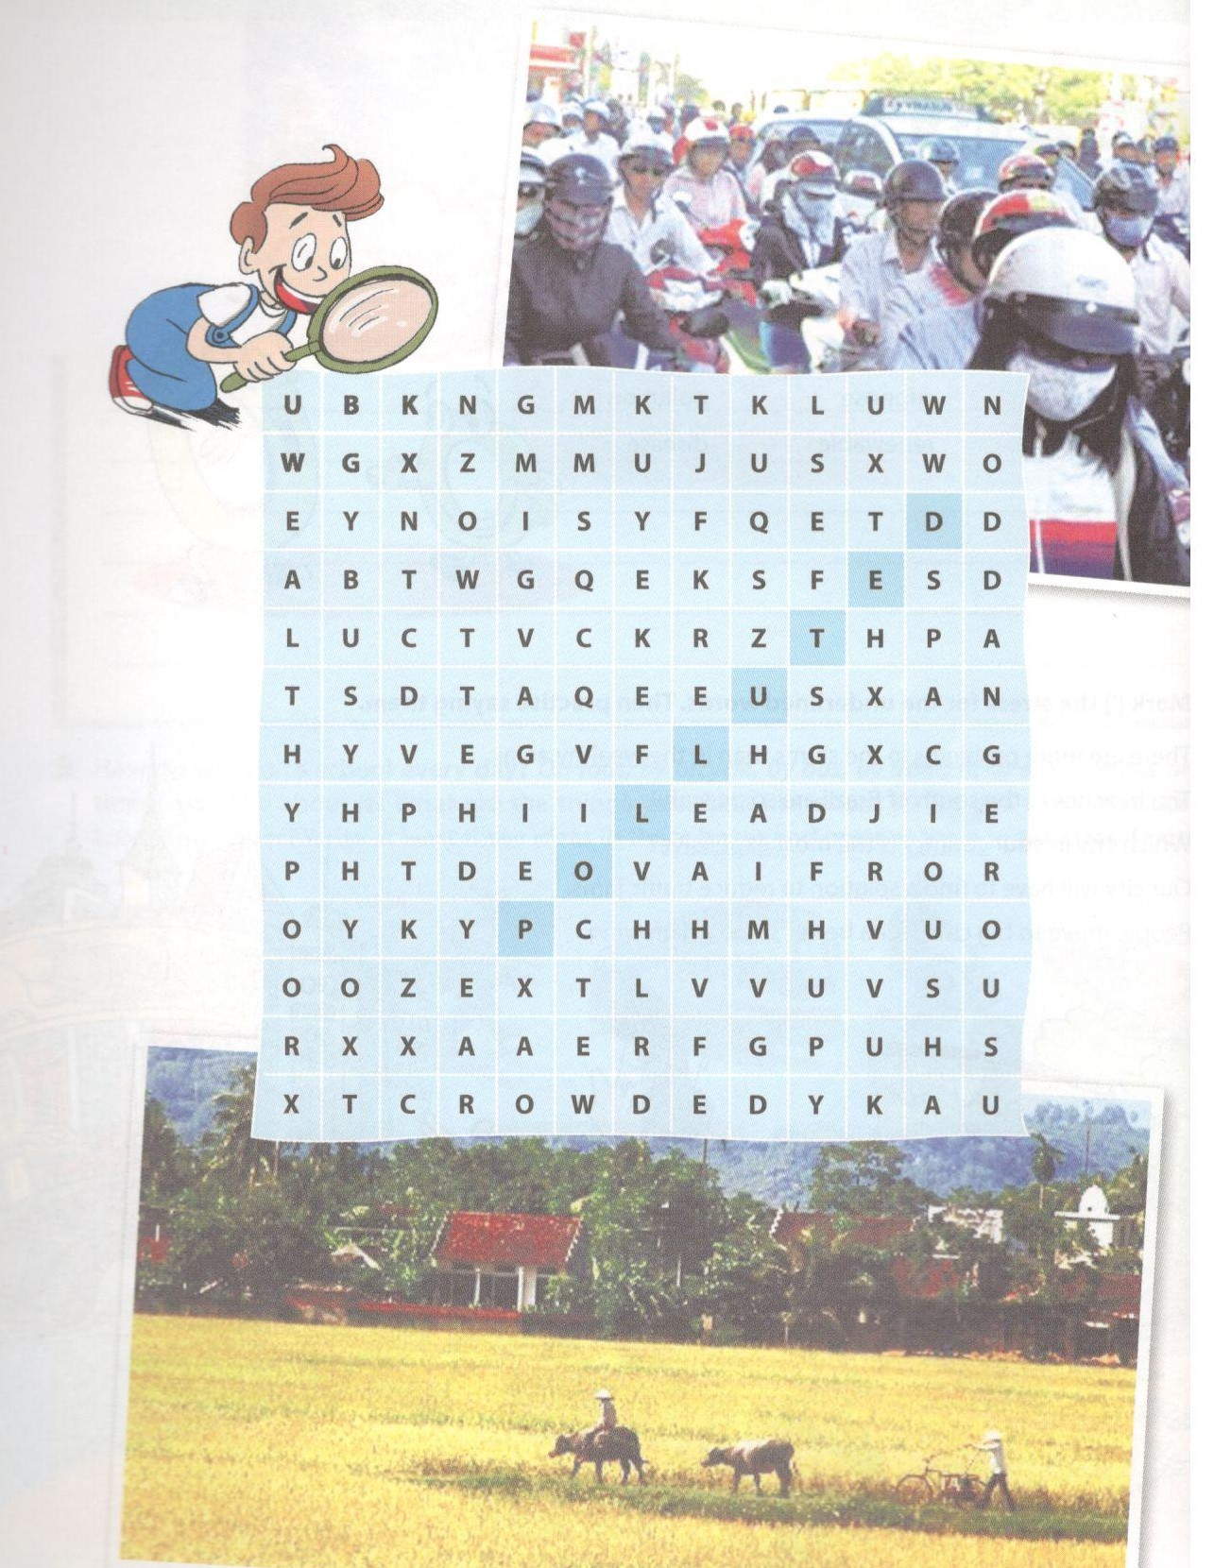
Key - Đáp án:
•SPACIOUS
•CROWDED
•PEACEFUL
•BUSY
•WEALTHY
• DIVERSE
• POOR . DANGEROUS
•POLLUTED
•NOISY
2. Choose the direct effects from the box below for each cause. There can be two or three effects one cause.
Chọn hậu quả trực tiếp của mỗi nguyên nhân cho trong bảng. Một nguyên nhân có thể có 2 hoặc 3 hậu quả.

erty | loss of crops disease | disease | crime
high death rate | malnutrition | homelessness | little schooling

Cause | Effect
1. Shortage of food
2. floods
3. no job
4. poor healthcare
5. child labour

Key - Đáp án:
Cause | Effect
1. Shortage of food | Malnutrition, crime
2. floods | Loss of crops, homelessness, disease
3. no job | Poverty, crime
4. poor healthcare | Disease, high death rate
5. child labour | Little schooling, high death rate
3. Choose a word/phrase in the box in 2 to complete the sentences. There can be more than one correct answer.
Chọn từ/cụm từ ở bài 2 để hoàn thành các câu sau. Có thể có hơn một đáp án đúng.
1. In Mongolia, over 30% of the population live in________.
2. A poor healthcare is the major cause of________.
3. Children who suffer from_____________ can have a lot of diseases.
4. ____________ may happen when people do not have money or food.
5. __________ is quite popular in an overcrowded city. You can see people sleeping in a park or under a bridge.
6. ______ is one result of poverty. Poor children have to stop their studies to help in the house.
Key - Đáp án:
1. poverty; 2. high death rate; 3. malnutrition
4. Crime 5. Homelessness 6. Little schooling

4. Complete each pair of sentences with ONE of the words below.
Hoàn thành mỗi cặp câu sau với một từ dưới đây.

healthcare | overcrowded | peaceful | crime

1 | a. ________is not a problem in the slums only, isn't it?  b. Some people commit______________ when they have no money and no food.
2 | a. I don't want to five in an_________area. There is not enough space for us to play.  b. So many people are moving to cities, making them______________ .
3 | a. - What's'_____________ mum - It's a system to take care of people's health.  b. Poor people die because they do not have good__________
4 | a. We enjoy living in a_______ neighbourhood which is free of noise and crime.  b. The photo is fantastic. The countryside looks so________.

Key - Đáp án:
1. Crime; 2. overcrowded; 3. healthcare; 4. peaceful

5. What do you want the world around you to be like in the future? Complete the sentences below with your wishes, using 'more', 'less' and 'fewer'.
Bạn muốn thế giới xung quanh trong tương lai như thế nào? Hoàn thành các câu dưới đây sử dụng 'more', 'less' và 'fewer'.
Example:
There will be more places for children to play.
There will be no more slums.
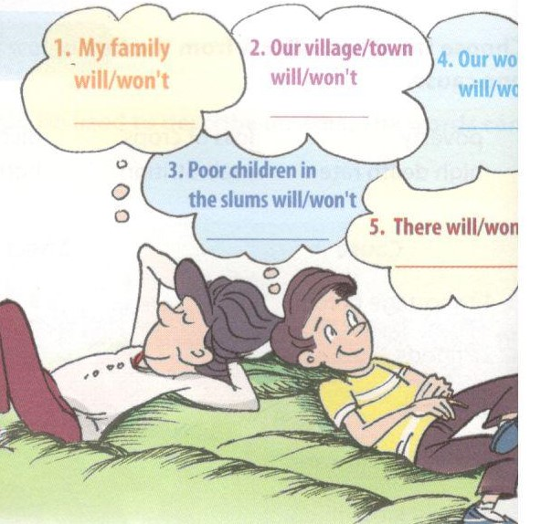

6. Change the following statements into tag questions.
Chuyển các câu dưới đây về câu hỏi đuôi.
Example:
Shanghai is the largest city in population.
-> Shanghai is the largest city in population, isn't it?
1. There will be a new cinema in our village.
__________________________________
2. The city is working on a project to provide the slums with clean water
__________________________________
3. We have seen The Slumdog Millionaire.
__________________________________
4. Everybody can tell the difference between a city and a megacity.
__________________________________
5. We don't really know the cause of this disease.
__________________________________

Key - Đáp án:
1. There will be a new cinema in our village, won't there?
2. The city is working on a project to provide the slums with clean water, isn't it?
3.We have seen The Slumdog Millionaire, haven't we?
4. Everybody can tell the difference between a city and a megacity, can't they?
5. We don't really know the cause of this disease, do we?

7. You are spending a day out with your friend. Read each situation and write a tag question, basing on the suggested words/phrases.
Bạn đã có một ngày dã ngoại với bạn bè. Đọc các câu sau và viết các câu hỏi đuôi dựa vào các từ/cụm từ gợi ý.
Example:
The air is fresh and the sun is shining, (it - be - beautiful day)
-> It's a beautiful day, isn't it?
1. You are watching a street painter painting a beautiful picture of a boy embracing a dog. (painter - have - great talent)
2. You are reading an advertisement of a circus coming to town, we-will go-circus).
3. A street vendor is selling doughnuts and you feel like eating them. [doughnuts - smell - delicious).
4. You see a one-wheel bike for rent and you want to try it. (we - can try - it).
Key - Đáp án:
1. This painter has great talent, doesn't he?
2. We will go and see this circus, won't we?
3. The doughnuts smell delicious, don't they?
4. We can try this bike, can't we?
C. Speaking – trang 47 – Unit 12 – Sách bài tập(SBT) tiếng Anh 7 mới.
1. Fill each gap with one suitable word to complete the conversation. Then practise saying it.
Điền từ thích hợp vào chỗ trống để hoàn thành đoạn hội thoại. Luyện tập với bạn bè.
Nam: Phong, I learn: a- 'te'erring word from school today,'megacity'
Phong: 'Megacity', like in the (1)_________ 'megabyte'or'megadeath'?
Nam: Right. A (2)________ is a very large city with big population.
Phong: Is our city a megacity?
Nam:No, I think it's too (3)______to be called 'megacity'.
Phong: Can you name some?
Nam: My teacher named some. (4)______are Manila, TOkyo, London...
Phong: And New York, and Shanghai, and ...
Nam: How do you know them?
Phong: I read about the (5) _______ cities in the world. But I don't know they are called megacities.
Key - Đáp án:
1. word; 2. megacity; 3. small; 4. They; 5. largest

2. Choose one of the words below and make a mini talk, in which the word is used.
Chọn một trong những từ dưới đây và luyện nói ngắn có sử dụng từ đó.

Overcrowded | Diverse | Crime | Healthcare
Spacious/space | Major | Poverty | Megacity
Example:
More and more parents to their children to our school because it's a good school in the area. I don't want it to become overcrowded.
D. Reading - trang 47 – Unit 12 – Sách bài tập( SBT) tiếng Anh 7 mới
1. Look at the photos only and answer the questions.
Nhìn tranh và trả lời câu hỏi.
1. Do you know what place it is?
2. If yes, what do you know about this place?
3. If no, what do you want to know about this place?
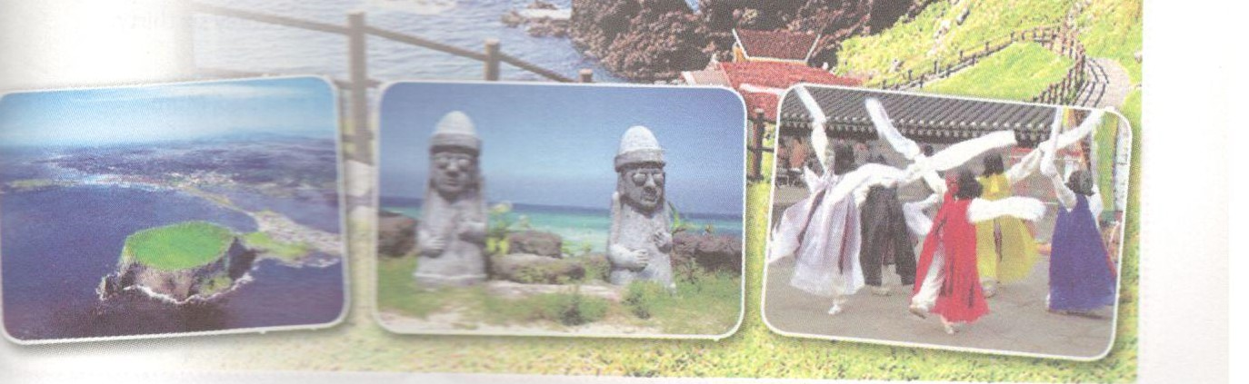

2. Minjun, a friend from Jeju in South Korea is showing Phong photos of his island. Read the conversation and choose the correct answer A, B, or C.
Phong: Your island looks so peaceful!
Minjun: It is, Phong. Look! This is a crater lake, the only one in South Korea, and this vast field of flowers...
Phong: Minjun, what is a crater lake?
Minjun: It's a lake which is formed from the mouth of an erupted volcano.
Phong: Interesting, and I do not see many people.
Minjun: No, Phong. Jeju has only half a milion. We live in spacious houses ...
Phong: So you do not have to share rooms with others.
Minjun: No. Each of us has our own room. Not very big, but comfortable enough.
Phong: Great. And you have many places you can comfortably spend a day out, don't you?
Minjun: Yes, we do.
Phong: I love it. Does Jeju have poor people?
Minjun: I do not see many. If you are hard-working, you can usually find a job. My dad says that poven is not a problem here.
Phong: Your living standard must be high.
Minjun: I suppose so. And the goverment spends a lot on schools, on healthcare.
Phong: It sounds great. I'd love to visit your Jeju one day.
1. South Korea has__________
A. a lot of crater lakes
B. only one crater lake
C. no crater lake
2. The population of Jeju is_____ .
A. about 500,000 people
B. about 1,000,000 people
C. more than 1,000,000 people
3. Which sentence below is NOT correct about Jeju?
A. The government on this island takes care of * recoe
B. It's hard to find a job on Jeju.
C. The people on Jeju enjoy high living standarc
4. Which word below describes Phong's feeling when he listens to Minjun?
A. Bored
B. Surprised
C. Excited
Key - Đáp án:
1. B; 2. A; 3. B; 4. C

3. Complete the conversation below with sentences a-f.

Key - Đáp án:
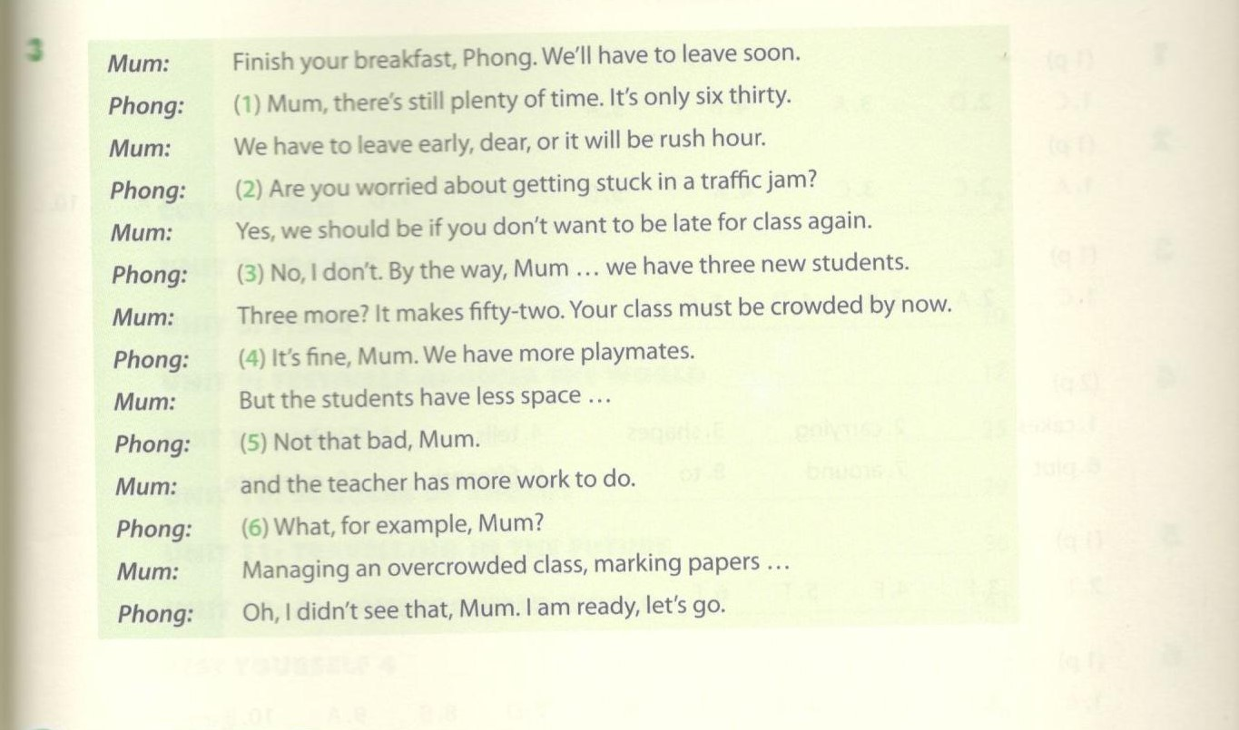
E. Writing – trang 49 – Unit 12 – Sách bài tập( SBT) tiếng Anh 7 mới
1. Do you agree or disagree with the statements below? Write two or three sentences to explain.
Bạn đồng ý hay không đồng ý với các quan điểm dưới đây. Viết hai đến ba câu để giải thích.
Example:
Statement: People are poor because they do not work hard.
Response: I don't agree. For example, farmers work hard, but a drought or flood can destroy all their crops.
1. Overpopulation does not affect your family.
2. Living in a large city is wonderful.
3. Overcrowded places have a lot of problems.
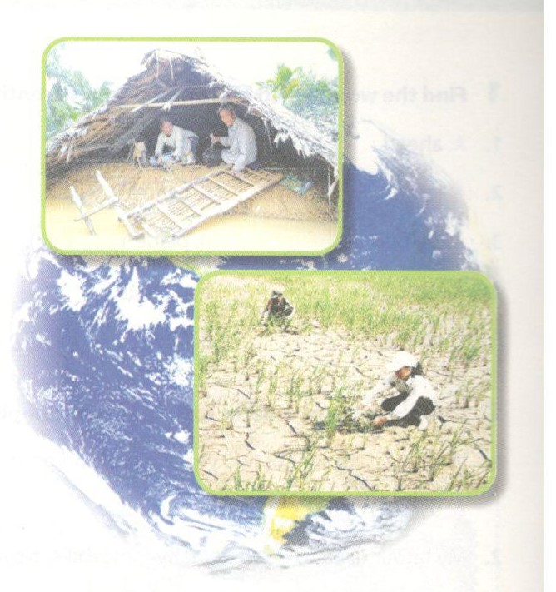

2. Look at the information about one of the most densely populated cities on earth, the Capital City of Manila in the Philippines. Write a short paragraph about it.
Nhìn vào thông tin dưới đây về một trong những thành phố đông dân nhất thế giới, thủ đô Manila của Philippines. Viết một đoạn văn ngắn về những điều đó.
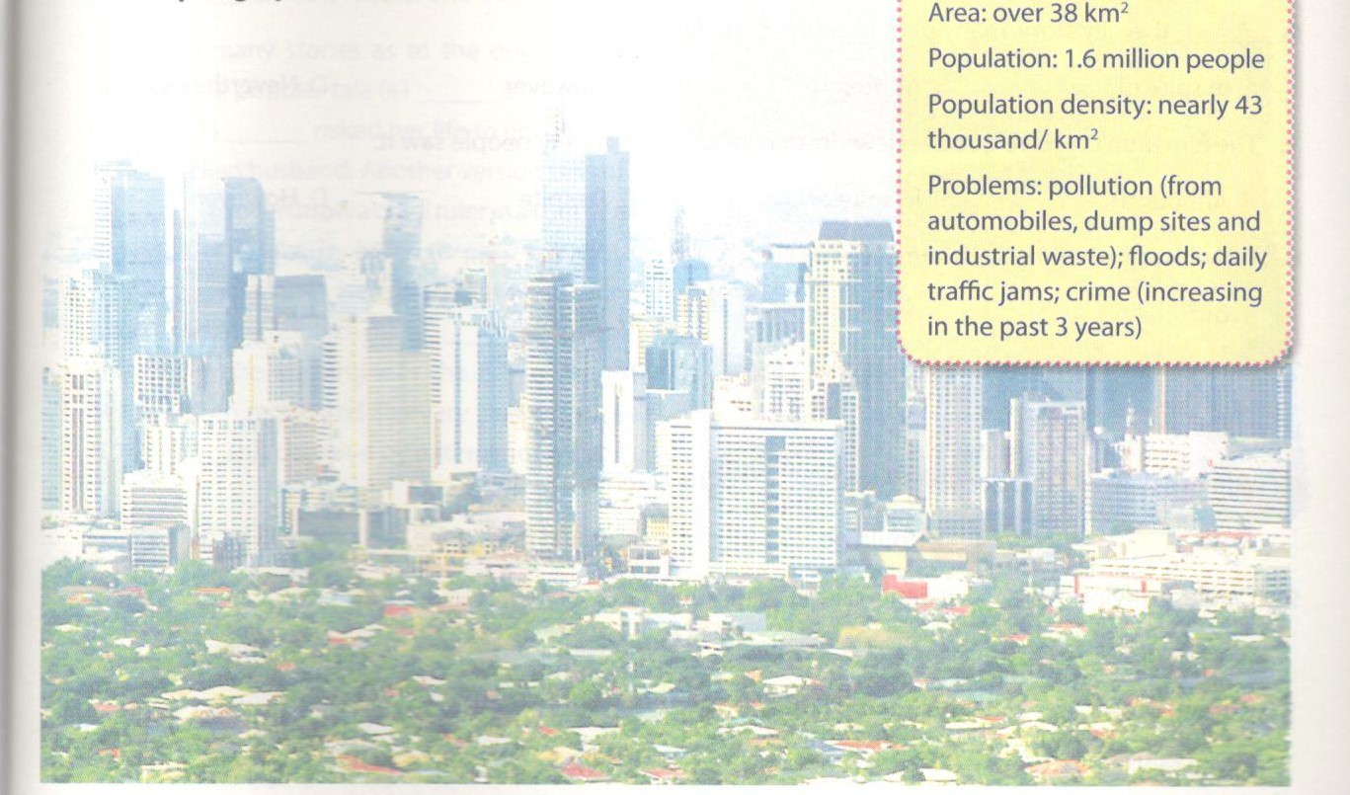
Key - Đáp án:
The Capital City of Manila in the Philippines is over 38 square kilometres large.
It has a population of 1.6 million. This means that there are nearly 43 thousand people in a square kilometre.
Manila has many problems. A big problem is pollution. Automobiles, dump sites and industrial waste pollute the air and the land. Other problems are floods and daily traffic jams. Crime has also increased in the past 3 years.

