Giải bài tập SBT Tiếng Anh lớp 8 Unit 2 Making Arrangements
1. Write sentences about what these people are going to be. Use the words in the box.(Trang 15-16 sách Bài tập Tiếng Anh 8)
a. Lan is going to be a dancer.
b. Hoa is going to be a teacher.
c. Tom and John are going to be pilots.
d. Nam is going to be a lawyer.
e. Bob is going to be an actor.
f. Peter is going to be a chef.
g. Loan is going to be an interpreter.
h. Linda is going to be an athlete.
i. Thu is going to be a singer.
2. Make up questions for the following statements. Use the words in brackets. (Trang 16-17 sách Bài tập Tiếng Anh 8)
a. What are you going to eat?
b. What are you going to see?
c. What is he going to study?
d. What are you going to cook?
e. What are they going to buy?
f. When is he going to have exams?
g. Are you going to have a birthday party?
h. Is she going to go by bus?
i. Are you going to have a meeting on Saturday?
3. Look at the things Ba has prepared for his summer activities and complete the sentences about his plan. (Trang 18 sách Bài tập Tiếng Anh 8)
This summer Nam's going to listen to music.
a. He's going to play football.
b. He's going to read books.
c. He's going to go swimming.
d. He's going to watch TV.
e. He's going to play chess.
f. He's going to play tennis/ pingpong.
g. He's going to play computer games.
4. Match the sentence in (I) with the appropriate response in (II). (Trang 19 sách Bài tập Tiếng Anh 8)
a. D | b. A | c. B | d. F | e. E | f. C
5. Read each of the following sentences and put I for Intention, P for Prediction.(Trang 19-20 sách Bài tập Tiếng Anh 8)
a. I | b. I | c. P | d. I | e. P
f. P | g. I | h. P | i. I | j. I
6. Complete the sentences, using the appropriate adverbs in the box. (Trang 20 sách Bài tập Tiếng Anh 8)
a. upstairs | b. downstairs | c. there
d. inside | e. here | f. outside
7. Write sentences about your plan for this summer. You may use the following ideas.(Trang 21 sách Bài tập Tiếng Anh 8)
Gợi ý:
- This summer I'm going to visit my relatives in the countryside.
- This summer I'm going to attend a summer course of English.
- This summer I'm going to help my parents with some work.
- This summer I'm going to go for a picnic with my friends.
- This summer I'm going to play some sports.
- This summer I'm going to read my favourite books.
- This summer I'm going to go to the movies.
- This summer I'm going to listen to music.
8. Put the following words into 3 groups of arts, crafts, and outdoor activities. (Trang 21 sách Bài tập Tiếng Anh 8)
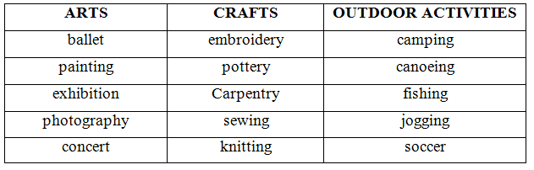
9. Read the passage and fill in each gap with a suitable word. Circle A, B, C or D. (Trang 22 sách Bài tập Tiếng Anh 8)
1. A | 2. B | 3. D | 4. C | 5. A | 6. B
7. B | 8. A | 9. C | 10. B | 11. D | 12. B
10. Read the passage and answer the multiple-choice questions. (Trang 23-24 sách Bài tập Tiếng Anh 8)
a. B | b. C | c. C | d. B | e. D | f. B

