Giải bài tập SGK Tiếng Anh lớp 8 Unit 2: Making arrangements
Getting started trang 18 Tiếng anh 8
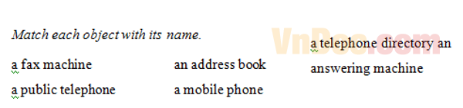
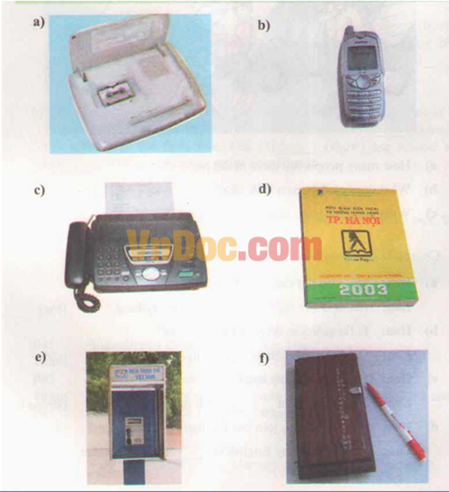
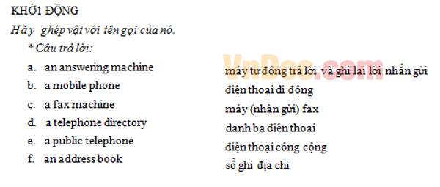
Listen and read - Nghe và đọc - trang 19 Tiếng Anh 8
LISTEN AND READ
Hoa: 3 847 329
Nga: Can I speak to Hoa, please? This is Nga.
Hoa: Hello, Nga.
Nga: I’m going to see the movie Dream City at 6.45 this evening. Would you like to come?
Hoa: Of course, but wait a minute. I have to ask my aunt and she’s downstairs. Hold on... OK, Nga. Aunt Thanh says I can go. Oh, where's it on?
Nga: At Sao Mai Movie Theater. It’s a bit far from your house, I'm afraid.
Hoa: Well, I know where it is, but I’m using my cousin’s bike tonight.
Nga: OK, Hoa. Let’s meet outside the theater.
Hoa: Is 6.30 all right?
Nga: That’s fine. See you at 6.30.
Hoa: Bye Bye, Nga.
1. Practice the dialogue with a partner.
2. Read the dialogue again. Decide who did and said each of the following things. Then ask a partner these questions to check your answers.
Who:
a) made the call?
b) introduced herself?
c) invited the other to the movies?
d) arranged a meeting place?
e) arranged the time?
Dịch:
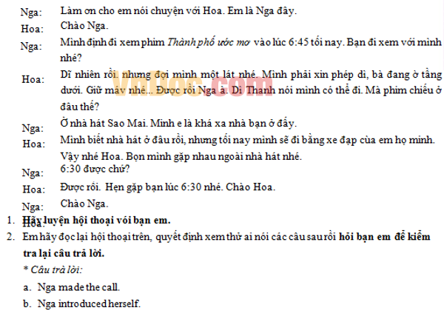
Speak - Nói - trang 20 Tiếng Anh 8
SPEAK.
1. Put the sentences below in the correct order to make a complete conversation.
a) I’m fine. I’m going to a pop concert at the City Concert Center tonight. Would you like to come?
b) Hello. 9 210 752
c) It’s The Kids in Town. You like it, don’t you?
d) Bve.
e) Yes. What time can we meet?
f) Hello. Can I speak to Eric, please? This is Adam.
g) That’s fine. See you at 7.15. Thank you, Adam.
h) Bye, Eric.
i) Which band is it?
j) Hello. Adam. How are you?
k) Is 7.15 OK? The concert starts at 7.45. Let’s meet inside the center, at the café comer.
Đáp án:

1 - b
2 - f
3 - j
4 - a
5 - i
6 - c
7 - e
8 - k
9 - g
10 - h
11 - d

2. Complete the dialogue. Ba and Bao are making arrangements to play chess. Practice the dialogue with a partner. Then make simila
Ba: Hello. 8 257 012
Bao: .........................
Ba: Hello Bao. How are you?
Bao: .........................
Ba: Great. Me too.
Bao: ........................?
Ba: I'm sorry . I can’t play chess tonight I'm going to do my homework.
Bao: ........................
Ba: Yes. Tomorrow afternoon is fine.
Bao: ........................
Ba: At the Central Chess Club? OK. Let’s meet at die front door.
Bao: .......................
Ba: Great. See you tomorrow afternoon at 2.00 o'clock.
