Unit 7: My Neighborhood
Getting Started (Trang 53 SGK Tiếng Anh 8)
Match the names of places found in a neighborhood with the pictures.
(Em hãy ghép tên một nơi ở trong vùng với tranh thích hợp.)
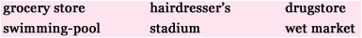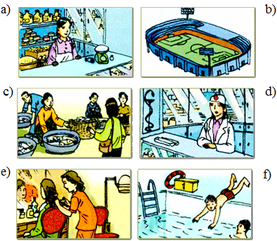
Gợi ý:
a. grocery store: cửa hàng tạp hóa
b. stadium: sân vận động
c. wet market: chợ cá
d. drugstore: hiệu thuốc
e. hairdresser's: hiệu làm tóc
f. swimming pool: hồ bơi
Listen and Read (Trang 63-64 SGK Tiếng Anh 8)
Nam: Hi. My name's Nam.
Na: Hello. Nice to meet you. Nam. I'm Na.
Nam: Are you new around here?
Na: Yes. We've been here since last week.
Nam: I'm sure you'll like this neighborhood.
Na: I hope so. How long have vou lived here?
Nam: Oh, we've lived here for about 10 years.
Na: You must know the area very well.
Nam: I do.
Na: Is there a restaurant close by? My mother is too tired to cook tonight.
Nam: There is one just around the comer.
Na: What is the food like?
Nam: It's very good. We like to eat there. It serves Hue food and the pancakes are delicious. You should try them.
Na: I will. Thanks.
Hướng dẫn dịch
Nam: Chào bạn. Mình tên là Nam.
Na: Chào bạn. Rất vui được gặp bạn. Mình tên là Na.
Nam: Bạn mới đến đây à?
Na: Ừ. Mình đã ở đây từ tuần trước.
Nam: Mình tin chắc bạn sẽ thích vùng này cho mà xem.
Na: Hy vọng là mình sẽ thích. Bạn sống ở đây bao lâu rồi?
Nam: Ô, mình sống ở đây chừng 10 năm rồi.
Na: Chắc bạn biết vùng này rất rõ.
Nam: Mình biết chứ.
Na: Gần đây có nhà hàng nào không nhỉ? Mẹ mình quá mệt không thể nấu cơm tối nay được.
Nam: Có một nhà hàng ở ngay góc đường đằng kia thôi.
Na: Thức ăn ở đó như thế nào?
Nam: Rất ngon. Chúng tôi thích ăn ở đó. Ở đó phục vụ món ăn Huế và bánh khoái thì rất ngon. Bạn nên ăn thử.
Na: Mình sẽ ăn. Cảm ơn bạn nhé.
1. Practice the dialogue with a partner.
(Hãy luyện hội thoại với bạn em.)
2. Complete the sentences. Use the words from the dialogue.
(Hãy hoàn thành các câu sau, dùng các từ từ đoạn hội thoại trên.)
a. Na is new to the neighborhood.
b. She and her family arrived last week.
c. Na's mother is very tired.
d. There is a restaurant in the area.
e. The restaurant serves food from Hue.
f. Nam thinks the pancakes are tasty.
Speak (Trang 64-65 SGK Tiếng Anh 8)
1. Practice the dialogue with a partner.
(Hãy luyện hội thoại với bạn em.)
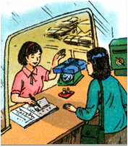
Clerk: Next, please!
Mrs. Kim: I want to send this parcel to Quy Nhon.
Clerk: Do you want to send it airmail or surface mail?
Mrs. Kim: I' m not sure. How much is airmail?
Clerk: I'll have to weigh the parcel first. Mmm. Five kilograms. That'll be 32,500 dong.
Mrs Kim: Oh! That's expensive.
Clerk: Surface mail is much cheaper. It's only 19.200 dong.
Mrs. Kim: That's better. I'll send it surface.
Clerk: All right.
2. Look at the following brochure and the information in the box. Make similar dialogues.
(Em hãy xem cuốn tập quảng cáo và những thông tin sau cho ở trong khung và làm các hội thoại tương tự.)
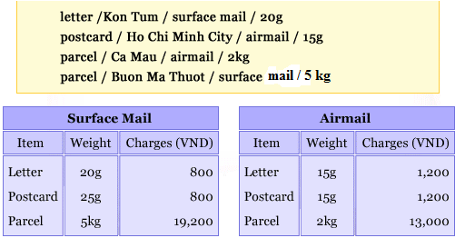
Kon Tum
Clerk: Can I help you?
You: I'd like to send this letter to Kon Tum.
Clerk: Do you want to send it airmail or surface mail?
You: I'm not sure. How much is surface mail?
Clerk: I'll have to weigh the letter first. Well, 20 grams. That'll be 800 dong.
You: OK. I'll send it surface mail.
Clerk: All right.
Ho Chi Minh
Clerk: Next, please.
You: I want to send this postcard Ho Chi Minh City.
Clerk: Do you want to send it airmail or surface mail?
You: I'm not sure. How much is airmail?
Clerk: I'll have to weigh the postcard first. Well, 15 grams. That'll be 1,200 dong.
You: OK. I'll send it airmail.
Ca Mau
Clerk: Can I help you?
You: I'd like to send this pareel to Ca Mau.
Clerk: Do you want to send it airmail or surface mail?
You: I'm not sure. How much is airmail?
Clerk: I'll have to weigh the pareel first. Mnn. Two kilograms. That'll be 13,000 dong.
You: Ok! That's not very expensive. I'll send it airmail.
Buon Ma Thuot
Clerk: Can I help you?
You: I'd like to send this pareel to Buon Me Thuot.
Clerk: Do you want to send airmail or surface mail?
You: I'm not sure. How much is airmail?
Clerk: I'll have to weigh the pareel first. Mmm, five kilograms. That'll be 32,000 dong.
You: Oh! That's expensive.
Clerk: Surface mail is much cheaper. It's only 19,200 dong.
You: That's better. I'll send it surface.
Clerk: All right.
Listen (Trang 65-66 SGK Tiếng Anh 8)
Na is new to the neighborhood. She's talking with Nam about what she going to do on the weekend. Look at the advertisement of 'What is on this week'.
(Na là người mới ở vùng này. Cô ấy đang nói chuyện với Nam về những gì cô ấy sắp làm vào ngày nghỉ cuối tuần này. Hãy xem quảng cáo về 'Cái gì được chiếu tuần này'.)
1. Listen to the conversation. Then fill the blank in each of the advertisement with one phrase from the box.
(Em hãy nghe hội thoại rồi điền vào mỗi chỗ trống trong quảng cáo sau một cụm từ thích hợp cho trong khung.)
Gợi ý:
Millennium Cinema: (1) The Newcomer
Soccer: (2) Town Grounz
(3) English Speaking Contest
Photo Exhibition: (4) Culture House
Nội dung bài nghe
Na: Hi, Nam.
Nam: Hello, Na. What are you going to do this weekend?
Na: I'm not sure. I just don't know what to do and where to go in this new neighborhood.
Nam: Why don't we look at 'What's on this week?' in the newspaper.
Na: Good idea. Can you suggest what I should?
Nam: Do you like movies? There's a new film at the Millennium Cinema.
Na: What's that? The New Comer, Australian film.I've seen this film before. I saw it on Star Movies.
Nam: You did?
Na: Yes. Here, the photo exhibition at the Culture House sound exciting!
Nam: But it dose not open during the weekend. And you can not go to the English Speaking contest either. It is on Thursday. Ah, yes. Here, soccer, a match between Le Do school and Quang Trung school, the best U15 teams in our province. I will definitely go and see it with Ba and Minh.
Na: Where do they play?
Nam: At the Town Ground. This is a very special event in town, I can tell you. Do you like to join us?
Na: Oh, yes. I'd love to. I've never been to a soccer match before. It must be fun to watch a real match at the stadium. And I'd like to visit the Town Ground, too.
Nam: Great. I'll tell Minh and Ba to come to your home and we all go together. Remember the match starts at 4 pm, but we must be there by 3.30 if we don't want to miss the opening show.
2. Listen to the conversation again and check (V) the correct box for True, False or No Information.
(Hãy nghe lại hội thoại và đánh dấu (V) vào cột True (đúng), False (sai) hoặc No Information (Không có thông tin).)
