Giải bài tập SGK Tiếng Anh lớp 8 Unit 8: Country Life and City Life
Getting Started (Trang 72 SGK Tiếng Anh 8)
Work with a partner. Make a list of the differences between the countryside and the city. The words in the box may help you.
(Em hãy cùng với bạn em đưa ra sự khác biệt giữa nông thông và thành thị. Những từ trong khung có thể giúp em.)
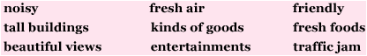
Gợi ý:
kinds of goods: nhiều loại hàng hóa
traffic jam: tắc đường
lack of entertainment forms: ít phương tiện giải trí
Listen and Read (Trang 72-73 SGK Tiếng Anh 8)
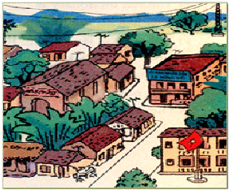
Hoa: Hi, Na. Have you been away?
Na: Yes. I went to the countryside for the weekend.
Hoa: Where did you go?
Na: I went to Kim Lien. It's a village. Some of my relatives live there.
Hoa: I've heard it's a beautiful place.
Na: It is. And it's very quiet and peaceful. I had a really nice weekend, but I don't want to live there permanently.
Hoa: Why not?
Na: It's too quiet. There is nothing to do.
Hoa: Yes. but things are changing in the countryside.
Na: Such as?
Hoa: Many remote areas are getting electricity. People can now have things like refrigerators and ...
Na: And TV.
Hoa: That too. TV is bringing not only information but also entertainment. And medical facilities are more easily accessible too. Life in the provinces is definitely changing for the better.
Na: But the city has so much more to offer.
Hoa: In many ways, I prefer the countryside. Life is simple, people are friendly and the air is clean.
Hướng dẫn dịch:
Hoa: Chào Na. Bạn vừa mới đi xa về à?
Na: Ừ. Mình về quê nghỉ cuối tuần.
Hoa: Bạn đi đâu?
Na: Mình đến làng Kim Liên. Một vài người bà con của mình sống ở đó.
Hoa: Mình nghe nói làng đó rất đẹp.
Na: Đúng thế. Nó rất yên tĩnh và thanh bình. Mình đã có một ngày cuối tuần thật sự vui, nhưng mình không thích sống luôn ở đó.
Hoa: Sao thế?
Na: Nó quá yên tĩnh. Không có gì để làm cả.
Hoa: Đúng vậy, nhưng ở thôn quê nhiều thứ cũng đang thay đổi.
Na: Chẳng hạn như?
Hoa: Nhiều vùng xa xôi hẻo lánh đang dần có điện. Bây giờ người ta có những thứ như tủ lạnh và ...
Na: Và tivi.
Hoa: Đúng vậy. Tivi không những mang lại thông tin mà còn để giải trí nữa. Và các phương tiện y học cũng dễ dàng sử dụng hơn. Cuộc sống ở các tỉnh nhất định sẽ thay đổi tốt hơn.
Na: Nhưng thành phố lại có nhiều thứ hơn.
Hoa: Về nhiều phương diện mình vẫn thích thôn quê hơn. Cuộc sống thật giản dị, người dân lại thân thiện và không khí thì trong lành.
1. Practice the dialogue with a partner.
(Hãy luyện hội thoại với bạn em.)
2. Answer the questions.
(Hãy trả lời các câu hỏi.)
a) Where has Na been?
=> Na has been to Kim Liên village/ the countryside.
b) How long was she there?
=> She was there for one day.
c) What is her opinion of the countryside?
=> She thinks the countryside is quiet and peaceful and there is nothing to do there.
d) Na says, 'There is nothing to do.' What does she mean by this?
=> Maybe she means that the countryside lacks facilities such as movie theatres, zoos, supermarkets, etc ...
e) What are some of the changes that Hoa mentions?
=> Many remote areas are getting electricity. People can now have things such as refrigerators and television, and medical facilities are more easily accessible.
f) Do you prefer the city or the countryside? Why?
=> I prefer the city because life in the city is more comfortable than the country. There are more entertainment, more schools, more libraries and more facilities.
=> I prefer the countryside because it's quiet and peaceful. Life in the country is simple, people are friendly, the air is clean and the traffic is light.
Speak (Trang 73-74 SGK Tiếng Anh 8)
1. Work with a partner. Look at the two pictures and talk about the changes of the own. The word prompts in the box may help you.
(Hãy làm việc với bạn em. Em hãy quan sát hai bức tranh và nói về những thay đổi của thành phố này. Những từ gợi ý trong khung có thể giúp em.)
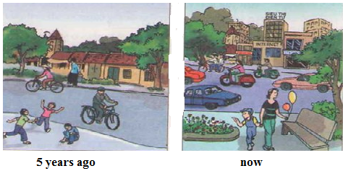
busy tall beautiful modern noisy dirty expensive
Gợi ý:
- The town is becoming busier and noisier.
- The traffic is becoming busy.
- The buildings are becoming taller, more beautiful and modern.
- The streets are getting dirty.
- Things are getting more expensive.
2. Work with a partner. Talk about changes in your hometown.
(Em hãy cùng với bạn em nói về những thay đổi ở quê hương em.)
Gợi ý:
Nam Dinh, my home town, has changed a lot in some recent years. The city is becoming busier and more modern. The traffic is becoming busy. The streets are getting newer and cleaner. The houses are becoming taller, more beautiful and comfortable. More schools, clinics, hotels and office buildings are being built and modernised. There are more playgrounds for children, and more entertainment and sports centers for all kinds of people. Almost every village has been electrified. Now, every house has electricity. Our life is becoming easier and easier.
Listen (Trang SGK Tiếng Anh 8)
Fill in the missing words.
(Điền vào chỗ trống từ còn thiếu.)
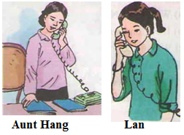
Lan: Hello.
Aunt Hang: Hello. Is (1) that Lan?
Lan: Yes. Who is (2) this?
Aunt Hang: (3) It's Aunt Hang. How are you?
Lan: I'm fine. (4) Where are you phoning from?
Aunt Hang: Hue. I'm calling to tell you uncle Chi and I are (6) coming to visit you next (7)week.
Lan: Great! When are you (8) arriving?
Aunt Hang: On (9) Thursday. We're arriving in Ha Noi in the (10) late (11) afternoon.
Lan: OK. Do you want to (12) speak to (13) my Mom?
Aunt Hang: Yes, please.
Lan: Hold on a moment and I'll (14) get her.
Read (Trang 75 SGK Tiếng Anh 8)
Many people from rural areas are leaving behind their traditional way of life and moving to the city. They believe that well-paying jobs are plentiful in the city.
At home on the farm, life is always a straggle with nature. Typhoons, floods or droughts can easily destroy a harvest and leave the farmer with little or no money until the following year. Often farmers look for other work when they need more money for their family.
The increase in population, however, has led to overcrowding in many cities. This puts a strain on schools and hospitals, as well as water and electricity supplies. Increased pollution is another unpleasant result.
There is also a human side to this tragedy. Families sometimes have to live apart. In these cases, children may live at home with relatives, while their parents so and live in an urban area.
Governments all over the world are trying to provide facilities for these migrants, but it can be quite a problem.
Hướng dẫn dịch
Nhiều dân quê đang bỏ lại đằng sau lối sống truyền thống của họ và chuyển đến thành phố. Họ tin rằng ở thành phố có nhiều công việc được trả lương hậu hĩnh.
Trên nông trại ở quê nhà, sống luôn là là một cuộc vật lộn với thiên nhiên. Bão tố, lụt lội hay hạn hán có thể dễ dàng phá hỏng cả vụ mùa và đẩy nông dân vào cảnh trắng tay cho đến năm sau. Thường thì nông dân kiếm việc khác khi họ cần nhiều tiền hơn để nuôi sống gia đình.
Tuy nhiên sự gia tăng dân số đã dẫn đến tình trạng quá đông đúc ở nhiều thành phố. Điều này gây sức ép rất lớn cho trường học, bệnh viện cũng như các nguồn cung cấp điện và nước. Sự ô nhiễm ngày càng gia tăng là một hậu quả chẳng mấy dễ chịu khác.
Con người cũng góp phần vào bi kịch này. Gia đình đôi lúc phải sống xa nhau. Trong những trường hợp như thế này, trẻ con có thể sống ở nhà với bà con trong lúc bố mẹ chúng đến sống ở thành phố.
Các chính phủ trên thế giới đang cố gắng cung cấp các phương tiện sinh hoạt cho những người dân di cư này, nhưng việc này là cả một vấn đề.
1. Complete the summary. Use information from the passage.
(Hoàn thành tóm tắt sau, dùng thông tin từ đoạn văn trên.)
People from the countryside are (1) leaving their (2) home to go and live in the (3) city. Farming can sometimes be a difficult life and these people from (4) urban areas feel the (5)city offers more opportunities. However, many people coming to the city create (6)problems. There may not be enough (7) schools or (8) hospitals, while water and electricity supplies may not be edequate. This is a (9) problem facing governments around the (10) world.
2. Find the word in the passage that means:
(Hãy tìm từ trong đoạn văn mà có nghĩa là:)
a. of the countryside: rural (thuộc vùng nông thôn)
b. as many as needed: plentiful (phong phú, dồi dào)
c. become greater or larger: increase (tăng)
d. a great pressure: strain (sức ép)
e. a terrible event: tragedy (bi kịch)
f. of the city or city life: urban (thuộc thành thị)
Write (Trang 76 SGK Tiếng Anh 8)
1. Put the outline for an informal letter in the correct order. If you don't remember, refer to the writing exercises in Unit 5.
(Em hãy xếp đề mục của một bức thư thân mật theo trật tự đúng của nó. Nếu em không nhớ thì hãy xem lại bài tập luyện viết ở bài học 5.)

Gợi ý:
- Heading:
+ Writer's address
+ Date
- Opening
- Body of letter
- Closing
2. Write a letter to a friend about your neighborhood. These questions may help you.
(Em hãy viết thư cho bạn em kể về vùng em ở. Những câu hỏi này có thể giúp em.)
Where do you live?
What does your house look like?
What can you see from your bedroom window?
How far is it from your house to school?
How do you get to school?
What kind of facilities are there in your neighborhood?
What things in your neighborhood do you like best?
Why?
Gợi ý:
Dear Phuong,
I live in Hue, a beautiful city in the Central of Viet Nam. Our home town is small and still poor, but it has enough facilities such as schools, hospitals, supermarkets, movie theatres, hotels, restaurants, stadiums, swimming-pools and so on. The thing makes me love my home town best is its charming beauty at night, especially on moon nights. The city looks more peaceful and poetic in the moonlight.
My family and I live in a small house beside the Huong River. My house is small but very comfortable. My room overlooks the river, so it's very cool in the summer.
My school is the most beautiful and famous of all in Hue. I don't live far from it, so it takes me only 15 minutes to ride there.
I hope you'll like Hue as well as my school when you come here next summer. I'll be your best tourist guide.
Write to me as soon as you can and tell me about your city and your life there.
Please send my best regards to your parents.
Warmest regards,
Thuy Mai.
Language Focus (Trang 77-79 SGK Tiếng Anh 8)
1. Read the dialogues.
(Đọc các đoạn hội thoại sau.)
a)
Mrs. Vui: Is the boat to Dong Hoi leaving at 10.25?
Clerk: Is that Lady of the Lake?
Mrs. Vui: That's right.
Clerk: I'm very sorry, madam, but it's been delayed.
Mrs. Vul: Oh, no!
Clerk: Now, it's leaving at 10.40.
b)
Mr. Hung: Is the boat from Hai Phone arriving at 10.30?
Clerk: Are you talking about Bright Sky?
Mr. Hung: Yes.
Clerk: It's arriving on time, sir.
Now make similar dialogues. Use the shipping information.
Hãy làm các hội thoại tương tự, sử dụng bảng thông tin về giờ tàu chạy.
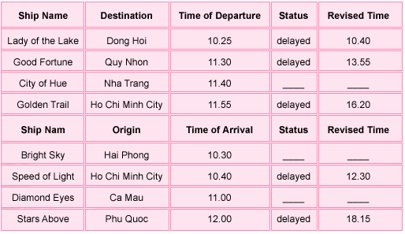
Gợi ý:
Good Fortune
You: Excuse me! Is the boat to Quy Nhon leaving at 11.30?
Clerk: Is that Good Fortune?
You: That's right.
Clerk: I'm sorry but it's been delayed.
You: Oh, no!
Clerk: Now, it's leaving at 13.55.
You: Thank you.
City of Hue
Mrs. Hoa: Excuse me! Is the boat to Nha Trang leaving at 11.40?
Clerk: Are you talking about City of Hue?
Mrs. Hoa: Yes.
Clerk: It's leaving on time, madam.
Mrs. Hoa: Thank you.
Golden Trail
You: Is the boat to Ho Chi Minh City leaving at 11.55?
Clerk: Is that Golden Trail?
You: That's right.
Clerk: I'm sorry, the boy, but it's been delayed.
You: Oh, no!
Clerk: Now, it's leaving at 16.20.
Speed of Lights
Mr. Vu: Is the boat from Ho Chi Minh City arriving at 10.40?
Clerk: Are you talking about Speed of Lights?
Mr. Vu: Yes.
Clerk: I'm sorry, sir, it's been delayed.
Mr. Vu: Oh, no!
Clerk: It's arriving at 12.30.
Diamond Eyes
You: Excuse me! Is the boat from Ca Mau arriving at 11.00?
Clerk: Are you talking about Diamond Eyes?
You: Yes.
Clerk: It's arriving on time.
You: Thank you.
Stars Above
You: Excuse me! Is the boat from Phu Quoc arriving at 12.00?
Clerk: Is that Stars Above?
You: That's right.
Clerk: I'm very sorry it's been delayed.
You: Oh, no!
Clerk: It's arriving at 18.15.
2. Complete the diologues. Use the verbs in the present progressive tense.
(Hoàn thành các đoạn hội thoại. Dùng động từ ở thì hiện tại tiếp diễn.)
a) Nam: What are you doing tonight?
Bao: I'm playing (0) table tennis.
b) Uncle Thach: Would you and Lan like to go to the movies?
Hoa: Sorry, we can't. We (1) are doing home work.
c) Mrs. Vui: Are you watching the seven o'clock news?
Mr. Nhat: No, I (2) am watching a program on rainforests.
d) Hoa: I'm going to the beach on Saturday.
Lan: Lucky you! I (3) am going to my violin lesson.
e) Mrs. Thoa: Are you free on Sunday afternoon?
Na: No, Mom and I (4) are cleaning the house.
f) Nga: Can you fix my computer on Friday afternoon?
Mr. Lara: I'm afraid not. I (5) am having a meeting that afternoon.
3. Complete the sentences. Use the verbs and adjectives in the boxes.
(Hoàn thành câu. Sử dụng động từ và tính từ cho trong hộp.)
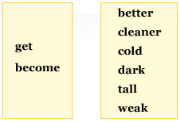
a) The boys are getting tall.
b) The old men are getting weak.
c) We should go home. It's getting dark.
d) The weather is becoming cold.
e) The students are becoming better.
f) The school yard is becoming cleaner.
4. Make comparisons between the city and the country about these things. The adjectives in the box will help you.
(Hãy so sánh về thành thị và nông thôn về những điều sau. Các tính từ trong khung sẽ giúp em.)

- The food in the city is more expensive than the food in the countryside.
= The food in the countryside is cheaper than the food in the city.
- The traffic in the city is busier than the traffic in the countryside.
- The transport in the city is easier than the transport in the countryside.
- The air in the countryside is fresher than the air in the city.
= The air in the city is more polluted than the air in the countryside.
- The entertainments in the city are better than the entertainments in the countryside.
= The entertainments in the countryside is poorer than the entertainments in the city.
- The medical facilities in the city are more accessible than those (= the medical facilities) in the countryside.
- The schools in the city are better than the schools in the countryside.
- The electricity in the city is better than the electricity in the countryside.
5. Look at the advertisements. Compare the house, the villa and the apartment. Use the adjectives in the box.
(Hãy xem các quảng cáo sau. Em hãy so sánh nhà ở, biệt thự với căn hộ. Dùng tính từ cho trong khung.)
The house is more expensive than the apartment.
The apartment is smaller than the villa.
The villa is the oldest home.
expensive old small beautiful big hot
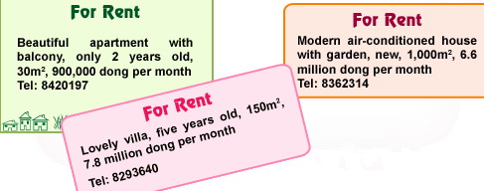
expensive
- The house is more expensive than the apartment.
- The house is not as expensive as the villa.
- The villa is the most expensive of all.
old
- The apartment is older than the house.
- The house is not as old as die villa.
- The villa is the oldest of all.
small
- The apartment is smaller than the villa.
- The villa is smaller than the house.
- The apartment is the smallest of all.
beautiful
- The villa is more beautiful than the apartment.
- The villa is not as beautiful as the house.
- The house is the most beautiful of all.
big
- The villa is bigger than the apartment.
- The villa is not as big as the house.
- The house is the biggest of all.
hot
- The apartment is hotter than the villa.
- The villa is hotter than the house.
- The apartment is the hottest of all.

