Giải bài tập SBT Tiếng Anh lớp 8 Unit 9 A FIRST-AID COURSE
1. Underline and rewrite the misspelt words. (Trang 78 sách Bài tập Tiếng Anh 8)
a. A boy fell of his bicycle and became unconscious. a) unconscious
b. An ambulence came to take him to the hospital. b) ambulance
c. He was taken to the emmergency unit. c) emergency
d. There, doctors and nerses took care of him. d) nurses
e. After two hours the boy revived and he feeled pain e) feltin his head.
2. Underline and write the inappropriate words. (Trang 78 sách Bài tập Tiếng Anh 8)
a. When you get burns you should ease the pain a) cold
with warm water packs.
b. When a person gets shocked, don't give him (her) b) alcoholic
any soft drink or alcohol.
c. In a fainting case, you should give the patient c) water/ tea
a glass of wine when he/ she revives.
d. You should cover the wound of a dog bite with d) bandage/ handkerchief
a clean, dry shirt.
e. When you get cut, use a handkerchief to cover the e) woundpain.
3. List the words in the box under the appropriate headings. Then you can and more words that you know to the headings. (Trang 79 sách Bài tập Tiếng Anh 8)
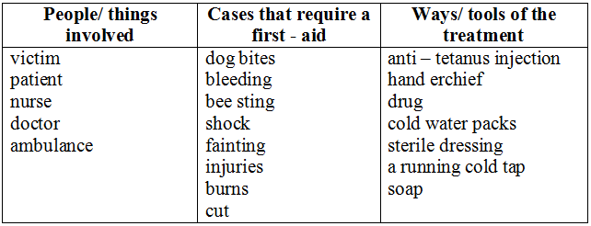
4. Choose the best word in the box for each blank. (Trang 79 sách Bài tập Tiếng Anh 8)
1. accident | 2. Conscious | 3. Emergency | 4. Ambulance | 5. bleeding
6. Wound | 7. Pressure | 8. Awake | 9. victim | 10. First-aid
5. Read the following situations. Think of a purpose to explain the people's actions. Use in order to/ so as to with to-infinitive and the cues in brackets. (Trang 80 sách Bài tập Tiếng Anh 8)
a. Perhaps she went to another store in order to/ so as to/ to get better milk of lower price.
b. She called at a flower shop in order to/ so as to/ to buy flowers for her friend's birthday.
c. She decided to go by bicycle in order to/ so as to/ to keep fit.
d. He called an ambulance in order to/ so as to/ to take the victim to the hospital.
6. Complete these dialogues with expressions for requests, offers, promises orinstructions. (Trang 80-81 sách Bài tập Tiếng Anh 8)
a. Could I open the window, please?
b. Shall I get you something to eat?
c. I will get better marks next month.
or I will work harder to get better marks next month.
d. I will bring it back before 6.30 pm.
e. Can I help you?
f. Could you call an ambulance, please?
g. You should try to stop the bleeding by holding a piece of cloth over the wound.
h. You should give him or her some cold drink.
7. Complete the sentences with will, 'll, or won't. (Trang 81 sách Bài tập Tiếng Anh 8)
a. will let/ 'll let e. will have/ 'll have
b. will lend/ 'll lend f. will take/ 'll take
c. will do/ 'll do g. will help/ 'll help
d. will take/ 'll take h. won't stay.
8. Using going or will with a suitable word from the box to complete the sentences.(Trang 82 sách Bài tập Tiếng Anh 8)
a. Sorry to keep you waiting. I won't be long.
b. I am going to have a party next week. Would you like to come?
c. Nguyen is going to be a dentist.
d. Will you open the window, please?
e. Will you get me a cup of coffee, Sinh?
f. Mom is going to buy a new dress this afternoon.
g. I will be ready in a minute.
h. Are you going to see a movie this afternoon?
9. In what situations should we do the followings? Match a situation with a suitable what to do list. (Trang 82-84 sách Bài tập Tiếng Anh 8)
1. Nose bleeding 2. Burns 3. Bleeding4. broken bones 5. Tooth 6. Bites and Scratches.
10. Read the passage and answer the multiple choice questions. (Trang 84-85 sách Bài tập Tiếng Anh 8)
a. B | b. D | c. C | d. C | e. D

