Giải bài tập SGK Tiếng Anh lớp 8 Unit 9: A First-Aid Course
Getting Started (Trang 80 SGK Tiếng Anh 8)
Work with a partner. What would you do in these situations which require first-aid? The pictures will help you.
(Hãy làm việc với bạn em. Em sẽ làm gì trong những tình huống cần sự sơ cứu này. Các bức tranh này sẽ giúp em.)
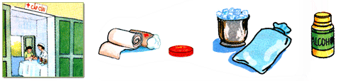
Gợi ý:
a girl has a burn on her arm
=> I'll use cold water to ease the pain and then take her to the nearest clinic/ hospital if necessary.
a girl has a nose bleed
=> I'll leave her lying flat and stuff her nose with cotton – wool to stop the bleeding.
a bou has a bad cut on his leg
=> I'll wash the cut with bactericide. Then I'll bandage the cut to stanch it.
a boy has a bee sting
=> I'll apply lime to the area around the sting to stop the sting from being swollen.
Listen and Read (Trang 80-81 SGK Tiếng Anh 8)

Bệnh viện Bạch Mai - Hà Nội
Nurse: Bach Mai Hospital.
Lan: This is an emergency. Please send an ambulance to Quang Trung School. A student is hurt.
Nurse: Calm down. Can you tell me what happened?
Lan: She fell off her bike and hit her head on the road.
Nurse: Is she conscious?
Lan: Yes, but she had a bad cut on her head. It's bleeding quite badly.
Nurse: Try to stop the bleeding. Use a towel or a handkerchief to cover the wound. Then put pressure on it. Hold it tight.
Lan: Will you hurry, please?
Nurse: Of course. What is the address of the school?
Lan: Ngo Si Lien Lane. It's between Quang Trung Street and Tran Hung Dao Street.
Nurse: The ambulance will be there in about 10 minutes. She mustn't fall asleep.
Lan: All right. I promise I'll keep her awake.
Hướng dẫn dịch:
Y tá: Bệnh viện Bạch Mai xin nghe.
Lan: Có cấp cứu. Xin cô cho xe cứu thương đến trường Quang Trung. Có một học sinh bị thương.
Y tá: Bình tĩnh nào. Em có thể cho cô biết chuyện gì đã xảy ra không?
Lan: Bạn ấy ngã xe đạp va đầu xuống đường cô ạ.
Y tá: Bạn ấy còn tỉnh không?
Lan: Còn tỉnh ạ, nhưng mà bạn ấy bị một vết cắt ở trên đầu. Máu ra nhiều lắm cô ạ.
Y tá: Cố cầm máu cho bạn nhé. Hãy dùng khăn lau hoặc khăn tay để băng vết thương lại. Sau đó đè mạnh lên vết thương và giữ thật chặt nhé.
Lan: Cô làm ơn nhanh lên cô nhé.
Y tá: Dĩ nhiên rồi. Trường cháu ở đâu?
Lan: Đường Ngô Sĩ Liên, ở giữa đường Quang Trung và đường Trần Hưng Đạo, thưa cô.
Y tá: Trong vòng 10 phút nữa xe cứu thương sẽ đến đó. Bạn cháu không được mê đâu nhé.
Lan: Dạ. Cháu hứa sẽ giữ cho bạn ấy tỉnh.
1. Practice the dialogue with a partner.
(Hãy luyện hội thoại với bạn em.)
2. Select the topics covered in the dialogue.
(Hãy chọn các chủ đề đã được đề cập đến trong cuộc hội thoại.)
a) describing the condition of the injured person: mô tả tình trạng của người bị thương
b) asking for the address: xin địa chỉ
c) asking about the condition of the injured person: hỏi về tình trạng của người bị thương
d) asking for advice: xin lời khuyên
e) giving first-aid instructions: hướng dẫn sơ cứu
f) arranging for an ambulance: cho xe cứu thương đến
g) saying the injured person's name: cho biết tên người bị thương
Các chủ đề được đề cập đến trong cuộc hội thoại là: a, b, c, e, f.
Speak (Trang 81-82 SGK Tiếng Anh 8)
Work with a partner. Look at the phrases and the pictures. Take turns to make and respond to requests, offers and promises.
(Hãy làm việc với bạn em. Hãy đọc những cụm từ và xem tranh cho dưới đây rồi luân phiên nhau đưa ra và đáp lại các yêu câu, đề nghị và lời hứa hẹn.)
Gợi ý:
a)
Girl: Could you give me a bandage, please?
Father: Sure. Here you are.
b)
Sister: I have a bdd headache. Could you give me an aspirin, mom?
Boy: Sure. Here you are.
c)
Boy: I was bitten by a snake. Could you help me to hold the wound tight?
Friend: Of course. I'll do it right now.
d)
Daughter: Oh, you have a high temperature. Can I get you some paracetamols?
Mother: Yes, please.
e)
Boy: You broke the vase, Nam. I hope you won't do it again.
Mother: I promise I won't.
Listen (Trang 82 SGK Tiếng Anh 8)
Match the letters A, B, C, D, E or F to the correct words in the box. Then put them in the correct order as you hear.
(Em hãy ghép tranh A, B, C, D, E hoặc F với từ mô tả tranh đúng cho trong khung rồi xếp chúng theo trật tự đúng khi em nghe băng.)
ambulance | crutches | scale | stretcher | wheelchair | eye chart
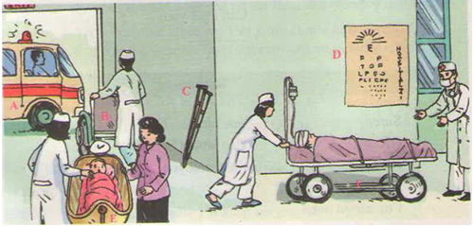
Ghép tranh:
A - ambulance: xe cứu thương
B - wheelchair: ghế đẩy
C - crutches: cái nạng
D - eye chart: bảng đo thị lực
E - scale: cái cân
F - stretcher: cái cán thương
Thứ tự xuất hiện:: F - B – A – D – E – C
Nội dung bài nghe:
There is the emergency room in a large hospital. A paramedic is wheeling a patient on a stretcher into the emergency room where a doctor is waiting to treat the patient. The patient doesn't look well. His head is bandaged and his eyes are closed.
A nurse is pushing an empty wheelchair towards the exit. She is probably taking it to a patient in the ambulance.
The eye chart on the wall is used to check people's eyesight. The chart consists of the about 28 letters ranging in size from about 5 centimetres in height at the top of chart to about 1 centimetre at the bottom.
A doctor is trying to weigh a crying baby on the scale. The baby's mother is standing nearby. She's trying to stop her child from crying.
The crutches, which are for someone with a broken leg, are leaning against the wall.

Read (Trang 83-84 SGK Tiếng Anh 8)
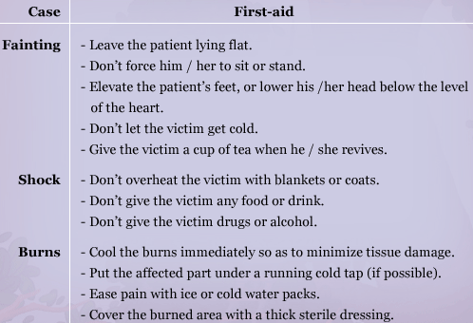
Hướng dẫn dịch:
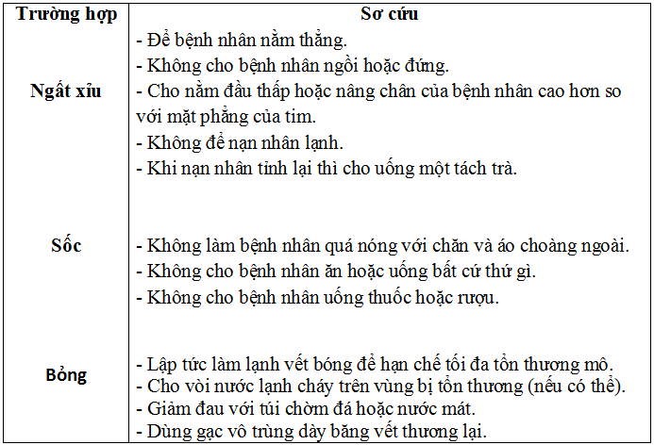
Choose a correct case for each of the following treatments.
(Hãy chọn trường hợp cấp cứu đúng cho mỗi cách điều trị sau đây.)
a) The victim should not sit or stand.
=> A (Fainting)
b) Victim cannot drink wine or beer.
=> B (Shock)
c) The victim’s head should be below the level of the heart.
=> A (Fainting)
d) You should ease the pain with ice or cold water packs.
=> C (Burns)
e) The victim should drink a cup of tea when reviving.
=> B (Fainting)

Write (Trang 84-85 SGK Tiếng Anh 8)
1. Complete the thank-you note Nga sent to Hoa after she left the hospital. Use the correct tense forms of the verbs in brackets.
(Em hãy hoàn thành thư cám ơn Nga gửi Hoa sau khi cô ấy rời viện. Chia động từ trong ngoặc ở thì đúng.)
Dear Hoa,
Thank you very much for the flowers you sent me while I (1) was in the hospital. They (2)were beautiful and they really (3) helped to cheer me up. I (4) came out of the hospital on Monday morning.
Now I (5) am very bored. Will you come over to my lace on the weekend? I'd love to see you.
I (6) will phone you on Friday afternoon.
Your friend,
Nga.
2. Write a thank-you note to a friend. Invite your friend to go on a picnic with you. Arrange to contact your friend. Use the following questions to guide your writing.
(Em hãy viết thư cảm ơn bạn em và mời bạn đi chơi và ăn uống ngoài trời. Em hãy thu xếp để gặp bạn. Những câu hỏi gợi ý sau giúp hướng dẫn cho em viết.)
Gợi ý:
Dear Mai,
Thanhk you very much for the books you sent me while I treated my disease at home. They were very interesting and helped me relax a lot. I loved reading them very much.
Now, I have got over and felt very sad. I want to go out to enjoy the fresh air.
Do you want to go on a picnic with me this Sunday? If yes, I'll come and pick you up.
I'm looking forwards to hearing from you.
Your friend,
Hoang.
3. Use the same format to write another letter to another friend for other occasions.
(Sử dụng cùng mẫu thư trên, hãy viết một bức thư khác cho một người bạn khác của em nhân một dịp khác.)
Gợi ý:
Dear Nam,
Thank you very much for the doll you sent me on my 14th birthday. It was/ is really lovely. I liked/ like it very much.
Are you free this weekend, Tu? Do you want to take a boat trip to Ha Long Bay with me and my family on Sunday? We'll pick you up at your home at 6 am if you can join us.
Write to me as soon as possible and let me know about your decision.
Please send my love to Uyen, your younger sister.
Love,
Phuong
Language Focus (Trang 86-88 SGK Tiếng Anh 8)
1. Match one part of a sentence from column A with another part in column B. Then write a complete sentence by using in order to/so as to.
(Em hãy ghép một phần câu ở cột A với một phần câu ở cột B, sau đó viết câu hoàn chỉnh bằng cách dùng in order to/so as to)
Example:
I always keep the window open in order to/so as to let fresh air in.
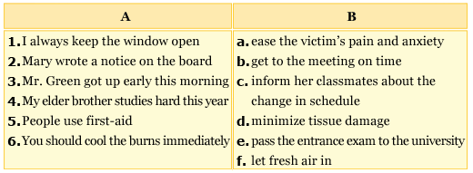
Gợi ý:
1. I opened my umbrella in order to/ so as to protect myself from the rain.
2. Mary wrote a notice on the board in order to/ so as to inform her classmates about the change in schedule.
3. Mr. Green has to get up early this morning in order to/ so as to get to the meeting on time.
4. My elder brother is studying very hard in order to/ so as to pass the final exam.
5. People use first aids in order to/ so as to ease the victim's pain and anxiety.
6. You should cool the burns immediately in order to/ so as to minimize tissue damage.
2. Ba is talking to his mother about his aunt Mai. Complete the dialogue. Use the correct word or short form.
(Ba đang nói chuyện với mẹ cậu ấy về dì Mai. Em hãy hoàn thành hội thoại sau, dùng từ đúng hoặc dạng rút gọn.)
Ba: What time (0) will aunt Mai be here?
Mrs. Nga: She (1) will be be here in two hours.
Ba: (2) Will uncle Sau be with her?
Mrs. Nga: No, he (3) won't. He has to stay in Ho Chi Minh City.
Ba: (4) Shall I come to the airport with you?
Mrs. Nga: OK. It (5) will be be a nice trip for us both.
Ba: Great, I (6) will be ready in two minutes.
3. Nga is helping her grandmother. Look at the pictures and complete the sentences. Use the words under each picture and will.
(Nga đang giúp bà của cô. Em hãy xem tranh và hoàn thành các câu sau, sử dụng từ cho dưới mỗi bức tranh và will.)
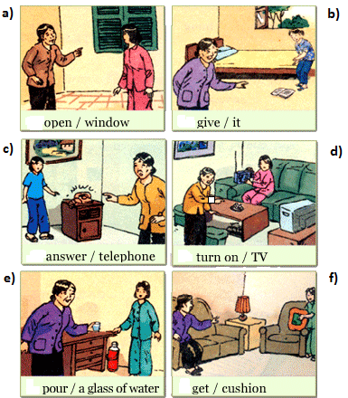
a) Nga: Are you hot, Grandma?
Mrs. Tuyet: Yes. Will you open the window, please, Nga?
b) Mrs. Tuyet: My book is on the floor. Will you give it to me, please?
c) Mrs. Tuyet: Will you answer the telephone, please?
d) Nga: Do you want to listen to the radio?
Mrs. Tuyet: No, thanks. I always watch the news at 7 pm. Will you turn on the TV, please, Nga?
e) Mrs. Tuyet: I'm thirsty. Will you pour a glass of water for me?
Nga: Of course.
f) Nga: Are you comfortable?
Mrs. Tuyet: No, I'm not. Will you get me a cushion, please?
4. Work with a partner, look at the pictures. Make requests, offers or promises. Use the words in the box and will or shall.
(Em hãy cùng bạn em xem bức tranh này rồi đưa ra các lời yêu cầu, đề nghị hay lời hứa, dùng từ cho trong khung và will hoặc shall.)
cut hang carry paint empty study
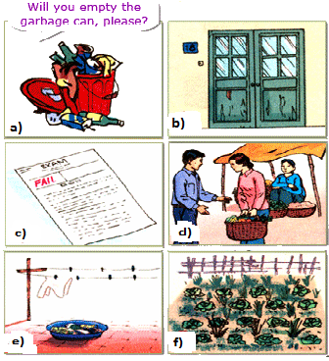
Gợi ý:
a) Will you empty the garbage can, please?
I will empty the garbage right now.
b) Will you paint the door, please?
I will paint the door this afternoon/ tomorrow.
c) Will you study hard, please?
I will study harder.
d) Will you carry the bag for me, please?
I will carry the bag for you.
e) Will you hang the washing, please?
I shall hang the washing for you.
f) Will you cut the grass, please?
I will cut the grass for you.

