UNIT 1

A VISIT FROM A PEN PAL

PERIOD 2

LESSON 1: GETTING STARTED

LISTEN AND READ

I/ The aims:
By the end of the lesson, students will be able to know the famous places in Hanoi, Lan went to visit with Maryam and some activities they took part in together
1. Knowledge:
a. Grammar: -The simple past tense with “Wish”.
The past simple tense:S + Ved + O+ ADV
- Review: Used to + V- infinitive
b. Lexical items: correspond, mosque, pray, impress…..
2. Skill: Listening – Speaking – Reading.
3. Attitude: Students know about Malaysian.
II/ Teaching methods: Work in pair, individual….
III/Teaching aids: Pictures, posters, book, cassette…
IV/ Proceduce:

1.Warm up: * Networks  Guide students to play game about some famous places in HaNoi  Places in Hanoi  Suggested answers:  Ha Noi Opera House  Ho Chi Minh Mausoleum  Temple of Literature  Museum of History  One pillar Pagoda  Explain the meanings of them to Students if they do not know.  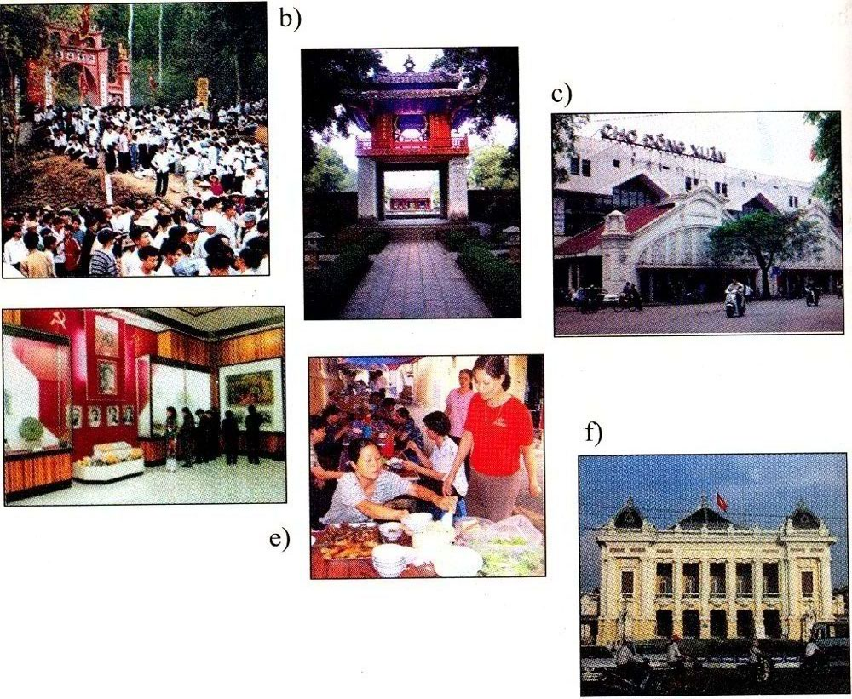  2. Pre reading:  - Ask Ss to listen and answer some questions:  + Do you have any pen pals?  + Where does he come from?  + Have you met her ?  =>If he visits Ha Noi, what will you introduce him?  - Introduce the topic of the lesson and set the scene “Imagine that a foreign pen pal is coming to stay with you for a week. What activities would you like to do during the visit? -the pictures in the book may help you”  - Call on some Ss to speak about places of interest with suggested models:  * Suggested models:  I think I will take my friend to the Ho Chi Minh Mausoleum, the Temple of Literature, and a famous restaurant to help my friend know about history of Vietnam and the famous food: Pho bo & bun cha  - In this lesson, Lan has a pen pal and this is the first time, this friend has come to Ha Noi.  - Explain some new words  * New words:  - Correspond (v): (communicating by mail): trao đổi thư từ  - Be impressed by: (translation): có ấn tượng  - Friendliness ( n) (explanation): sự mến khách  - Mosque (n):nhà thờ hồi giáo  - Peaceful atmosphere ( n): (Translation): bầu không khí yên bình  - Keep in touch (v): giữ liên lạc  - pray (v): cầu nguyện, cầu khấn  + Used to + V infi  Example: Lan used to walk past the mosque on the way to her primary school.  - Checking technique: Rub out and remember  Correct and give marks if necessary  * Prediction:  You predict and decide whether the statements are true or false:  a. Lan,s pen pal comes from Malaysia.  b. Kualar Lumber is a small city.  c. The girls visited Hang Luoc Street on Monday.  d. They will write letters to each other again.  - Collect their predictions and write on the board.  3. While reading:  - Turn on the tape (2 or 3 times)  - Call on some Ss to report their answers in front of class.  - Correct and give correct answers:  1.T 2.F 3. F 4.T  Have Ss read the text and do the exercise below:  - Call on some Ss to report their answers and correct mistakes if any. Then give correct answers:  1. C 2.B 3.D 4. B.  * Model sentences:  I wish you had a longer vacation.  => S + Wish + S + V (past simple )  - Ask them to read the text aloud and correct their pronunciation.  4. Consolidation:  - Ask Ss to practice making sentences with structures  “Used to + V & Wish + pat simple”  - Call on Ss to read their sentences in train. Correct them and explain if they are wrong.  5. Home work:  1. Learn by heart all new words and structures. then make 5 sentences for each one.  2. Prepare the next lesson  * Feedback: | - Play game in groups  Representative of each group demonstrate in the front  - Repeat and copy  - Listen carefully and answer the questions  - Practice speaking based on the models  -Listen carefully  - Guess its meanings and repeat in chorus and individually.  - Copy down  - Give examples with the structures  - Play games in the whole class.  - Work in group to predict.  - Report their predictions.  - Listen and check their predictions.  -Demonstrate  - Repeat and copy  - Read the text independently and do the exercise. Then compare with a friend.  Read the text aloud  Make sentences with models.  - Listen and copy

