PERIOD 3
LESSON 2: SPEAK & LANGUAGE FOCUS 1

I. Aims
By the end of the lesson, students will be able to know how to make and respond to the instructions fluently and listen to recognize specific details (numbers, places …) accurately.
1. Knowledge:
a. Grammar: Structure of instructions
b. Lexical items:
2. Skill: Listening – Speaking.
3. Attitude: Students know how to make and respond to the instructions.
II. Objectives: Work in pair, individual, in group…
III.Teaching aids: Pictures, posters, book, cassette…
IV. Procedure::

1.Warm up:  Chatting about Maryam - Lan,s pen pal  1. 1. What do you know about Maryam?  2. Where is she now?  - Ask Ss to work in pairs and correct the mistakes.  2. Pre- speaking:  - Introduce the situation “Nga and Maryam have not met each other before but they know they will meet each other while waiting for Lan outside her school.  - Ask Ss what they will say if they are Nga or Maryam:  Eg:  S1: Hello, my name is Nga.What is your name?  S2: Hello, my name is Nga. Are you Maryam?  S3: Hi , I am Nga. What is your name?  - Correct the mistakes and give suggested answers:  - Ask them to repeat and write  - Have Ss read the dialogue and put their dialogue in the correct order.  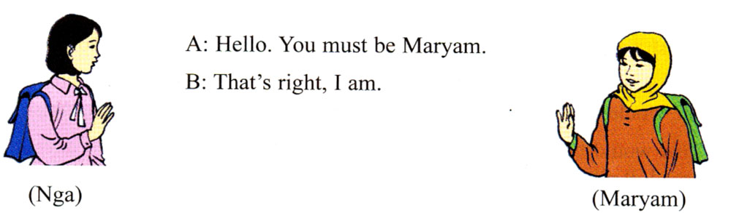  * Note: You must be Maryam  - Call on some pairs to read the complete dialogue.  Correct mistakes and ask some pairs to demonstrate before class. Then Give the right answers:  1- c 4 - d 3 - a 5 - b 2 - e 6 - f  3. While - Speaking:  - Introduce the aims of the exercise b  - Ask Ss to work in pairs.  - Call on some pairs to practice  - Remark and correct if any.  4. Post - speaking:  Review the past simple tense: LF 1/11  - Ask Ss to look at the dialogue in the book and guide  “These above are dialogues between two Ss talking about things Ba did last week” and tell them to work in pairs, study the table and make similar dialogue about Nga, Lan, Hoa,s weekend.  - Call on some pairs to read the dialogues aloud.  - Remark and correct the mistakes. Then give correct answers:  Nga  A: What did Nga do on the weekend?  B: She went to a concert performed by Ha Noi singers  A: When did she go to see it?  B: She saw it on Saturday evening at 8 pm.  5. Home work:  1. Learn by heart the models.  2. Copy down the complete dialogue.  3. Write about the three friend of Maryam.  4. Prepare the section: listen and LF 2,3  * Feedback: | - Answer the questions  - Listen carefully.  Practice in group of 3 Ss  - Copy down.  - Work in pairs  - Practice in front of class.  - Repeat and copy down.  - Work in pairs.  - Practice in front of class.  - Work in groups to tell about Maryam ,s friends.  - demonstrate in the front.  - Write down  - listen and practice in pairs.  -Read and practice in pairs to make dialogues.  - some pairs speak aloud in front of the class.  - Teacher listens and corrects the mistakes.

