PERIOD 4
LESSON 3: LISTEN & LANGUAGE FOCUS 2, 3

I. Aims: Listen for the specific information and further practice in past simple with wish
II.Objectives: By the end of the lesson, Ss will be able to listen and choose the correct pictures you have heard & to use the past simple with wish
III. Teaching aids: Text book, cassette, chalk.
VI. Procedure:
1. Warm up:  Chatting some questions about Ss’ wishes.  Eg: You are not very white.  -> I wish I were whiter.  2. Pre- listening  * Set the scene: “Tim Jone,s Mexican pen pal, Carlo, is visiting the USA.”  - Ask Ss to look at the book and the pictures then find the differences by answering the questions:  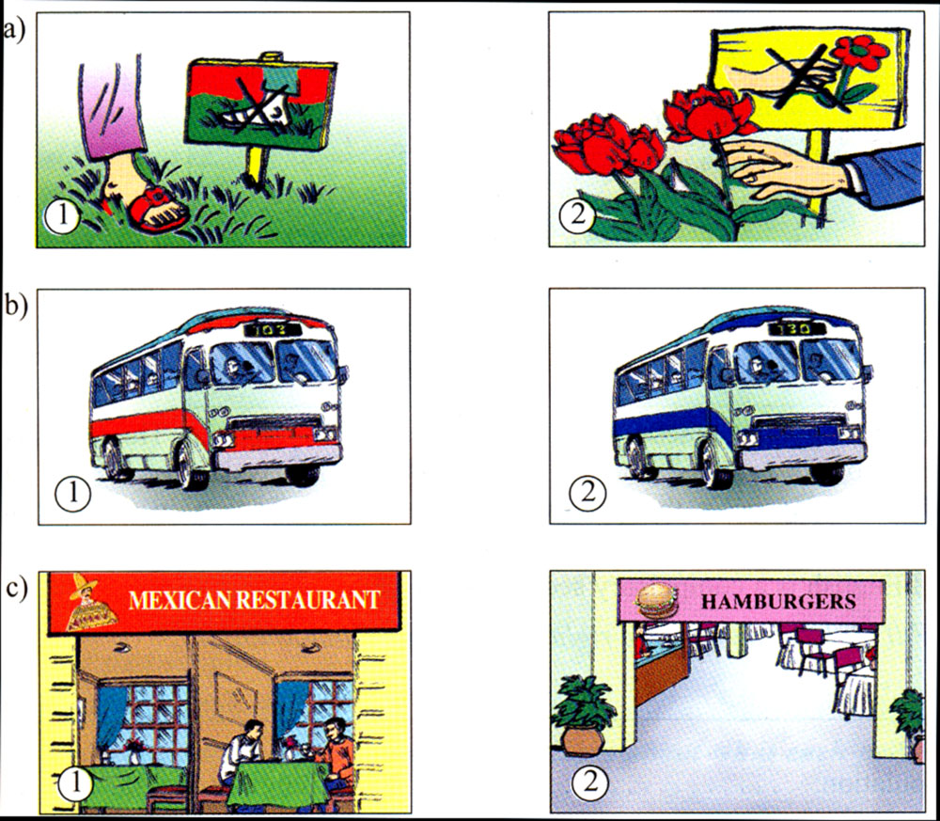  1. What is the difference between Picture 1 and 2 in a?  (In picture 1, we are not allowed to walk on grass. In picture 2, we are not allowed to pick flowers.)  2. What is the difference between picture 1 and 2 in b?  (In picture 1, the bus is red and its number is 103. In picture 2, the bus is blue and its number is 130.)  3. What is the difference between picture 1 and 2 in c?  (In picture 1, it is the Mexican restaurant. In picture 2, it is the American one – Hamburgers)  - Call on some pairs to answer the questions.  * Open prediction:  Tell Ss that Tim is taking Carlos to visit some places. Ask them to think of 3 things that Tim & Carlos are doing.  Possible answers:  + They are going to the park.  + They are taking the bus.  + They are going to the restaurant.  - Remark and correct mistakes if any.  Now listen to their conversation and check stick the numbers of the correct pictures. The above differences may help you.  3. While - listening:  - Turn on the tape (2 or 3 times)  - Ask Ss to exchange their results to compare them.  - Call on some Ss to read the answers aloud.  - Correct and give correct answers:  a) 1 b) 2 c) 2  4.Post - listening:  1. Language focus 2/ 12:  Introduce “ Lan and her friends are holding a farewell party for Maryam  - Write the things they did for the party, Using the pictures and the words in the boxes to help you.  - Call on some Ss to read the answers aloud.  - Remark and correct mistakes if any.  - Give the correct answers:  1. baked a cake  2. hung colorful lamps on the wall in the room.  3. bought flowers  4. painted a picture of Ha Noi  5. went shopping  - Ask them to write the answers.  2. Conditional sentence type 2 used with Wish (LF3/12  - Introduce the conditional sentence type 2 used with Wish:  * S + wish + S + past simple  Example: - You are not very old. (That is the fact and you can not change it)  - I wish I were younger.  Now work with a partner and write the wishes with the situations in the lesson.  - Call on some Ss to read them aloud, correct mistakes and give correct answers:  b) I wish I were in the swimming pool now.  c) I wish I had a computer.  d) I wish I lived close to school.  e) I wish I had a sister.  f) I wish I drew well.  g) I wish I had my friend’s phone number.  h) I wish I knew many friends.  i) I wish it rained so often in my home town.  j) I wish there were rivers and lakes in my hometown  - Call on some pairs to read them aloud.  - Correct mistakes if any.  5.Homework:  1. Copy the complete dialogue.  2. Do Exercises (1, 2) in workbook.  3. Prepare the next lesson.  * Feedback: | - Greeting !  - Answer some questions  - Listen carefully.  - Work in pairs to discuss answering these questions.  - Report in the front.  - Listen carefully  - Listen to the tape and do the exercise by checking stick the numbers of the correct pictures.  - Compare their results with a friend.  - Demonstrate in front of class.  - Copy down.  - Work in pairs to complete the dialogue. (May be, listen to the tape again)  - Demonstrate in front.  - Write down  Work in pair to discuss the answers.  - Call some Ss to say out the answers.  - Correct the answers  Copy down

