PERIOD 5
LESSON 4: READ

I.Aims: Reading the text for detail about the Malaysia
II. Objectives: By the end of the lesson, Ss will be able to know some basic information about Malaysia, a member country of ASEAN and some new words as tropical climate, Unit of currency, national language, Islam...
III.Teaching aids: Books, cassette, chalk and Malaysia’s map.
IV. Procedure:

1. Warm up:  Guessing Game about some ASEAN countries.  a) What country is it?  1. This country borders with Laos and Cambodia.  2. It has many tourist attractions.  3. The major cities are Bangkok, Chiang Mai  b) What country is it?  1. It is considered to be one of the cleanest country in the world.  2. The country and the capital city share the same name.  3. Its population is about 3 million people.  c) What country is it?  1. It is a country in Asia.  2. It has the Petronas Twin Towers.  3. The capital city is Kuala Lumpur.  - Remark and correct mistakes.Then lead in the new lesson.  - Let Ss see the map of Malaysia  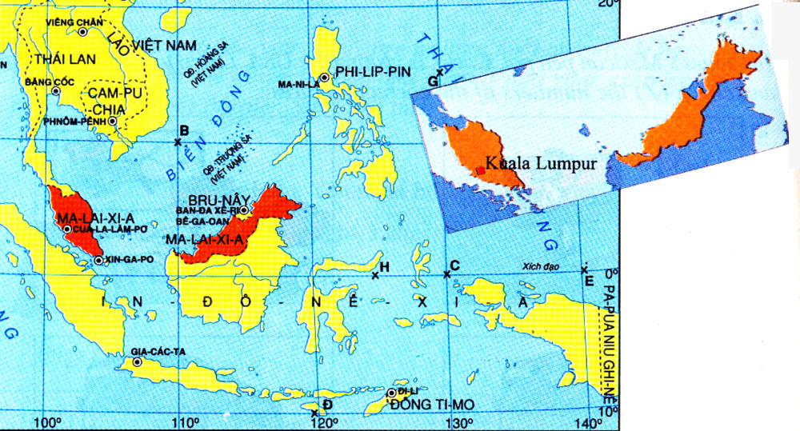  2. Pre Reading: Introduce the aims and basic contents of the lesson to Ss. Then present some new words:  * Vocabulary pre teach:  - ASEAN = Association of South East Asian Nations hiệp hội cac quốc gia Đông Nam Á  - Comprise (v): = Consist: bao gồm, gồm co  - divide (v) = separate (v)  - Tropical climate (n): (Translation): khi hậu nhiệt đới  - Unit of currency (n): (Explanation): đơn vị tiền tệ  - Islam (n): (translation): đạo hồi  - Primary language (n): (Translation): ngụn ngữ đầu tiên  - compulsory (adj): bắt buộc  Checking technique: What and where  *Introduce the contents of the lesson: “Today we will learn about Malaysia, a member country of ASEA.  *Filling the gap prediction:  Before reading the text, you work in groups and complete the table with the information you already know about Malaysia. I you do not know, just discuss with group members and have a guess.  Malaysia  Area: 329,758  Population: over 22 million  Climate: tropical climate  Unit of currency: the ringgit  Capital: Kuala Lumpur  Official religion: Islam  National language: Bahasa Malaysia  Compulsory second language: English  - Have Ss guess the information about Malaysia.  3. While reading:  - Ask Ss to read the text and compare their guess with the information in the book.  - Call on some Ss to read their results aloud.  - Correct mistakes and give correct answers:  - Ask Ss to read the text aloud and do the exercise b independently.  - Call on some Ss to read the answers and correct mistakes. Then give the right answers:  1.T 2.F 3.F 4.F 5. F  4. Post reading: Matching  Match the name of the capitals with appropriate countries  - Ask Ss to do the exercise individually.  - Call some Ss to read their results aloud.  - Correct and give right answers  5.Home work:  1. Learn by heart new words and make 2 sentences with each one.  2. Summarize main points of the text.  3. Prepare the next lesson. | - Work in groups to predict the results.and read them aloud.  a) Thailand  b) Singapore  c) Malaysia  Look at the map of Malaysia.  - Listen and write the title of the lesson in  their note books.  - Repeat in chorus and individually.  - Guess its meanings and give examples.  - Copy down.  - Play game  -Listen carefully and do the exercise in groups.  - Read their predictions.  - Read the text again and check their results.  - Demonstrate in front of class.  - Copy down  - Read the text again and do the exercise b.  - Report their answers.  - Copy down.  - Work in group  - Match the name of the capitals with appropriate countries.  - Demonstrate the answers in front of class.  - Repeat and write the results in their notebooks.  - Copy.
  A | B
  1. Viet Nam | - Bangkok
  2. Malaysia | - Kuala Lumpur
  3. Singapore | - Phnom Penh
  4. Indonesia | - Jakarta
  5. Philippines | - Singapore
  6. Laos | - Bandar Seri Begawan
  7. Cambodia | - Vientiane
  8. Myanmar | - Manila
  9. Thailand | i. Yangun
  10. Brunei | - Ha Noi

