UNIT 2

CLOTHING
PERIOD 7- LESSON 1: GETTING STARTED

LISTEN AND READ

A / Aims: Reading the text for details

B/ Objectives: By the end of the lesson, students will be able to know something about traditional dress and the Ao dai.

C/ Language content:

+ Vocabulary: traditional dress, long silk tunic, material, fashion and designer

+ Skills: Reading and answering the questions.

D/ Teaching aids: Textbooks, cassette, chalk, boards and some pictures …..

E/ Procedure:

I / Warm up: Show students some pictures about the clothes or fashion models.  II / Presentation:  - Pre- reading : Introduce “Today we will learn about the traditional costumes of some countries. First, you look at the address that some people are wearing. Decide where each person comes from.  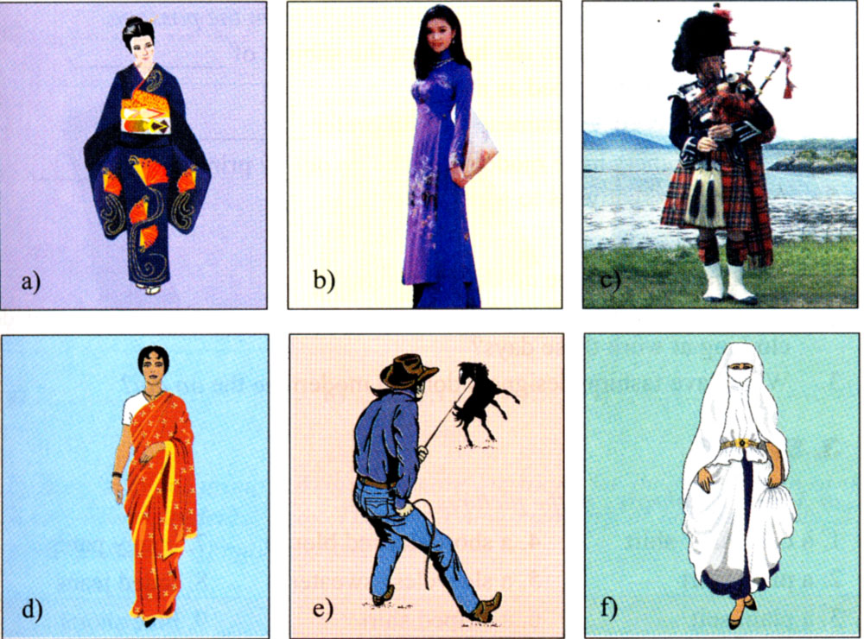  - Call on some students to demonstrate their ideas in front of class  - Correct and give the right answers:  + She comes from Japan. She is wearing a Kimono.  + She comes from Viet Nam. She is wearing an Ao dai  + He comes from Scotland. He is wearing a kilt.  + She comes from India. She is wearing a Sari.  + He comes from the USA. He is wearing a Cowboy.  + She comes from Arabia.She is wearing a Veil.  - Explain some costumes to students.  - Elicite about Ao dai of Vietnam and ask some questions:  1. What do you know about Ao dai?  2. What material is Ao dai often made from?  3. Who wears the Ao dai?  4. Is modern Ao dai different from the old one?...  - Remark and explain some new words.  2. New words:  + Poet (n): nhà thơ  Ex: To Huu is a great poet.  + Musician (n): nhạc sĩ  Ex: Trinh Cong Son is a great Musician.  + Long silk tunic (n):(Translation): áo lụa dài rộng  + Loose pant ( n) Translation: quần ống rộng  + Ethnic minorities (n) Explanation: các dân tộc thiểu số.  + Traditional designs (n): thiết kế truyền thống  + inspiration (n) Translation: cảm hứng, hứng khởi  + Slit (v) acting: xẻ  - Checking technique: What and Where  3. While reading:  - Now look at “Listen and Read” and turn on the tape. Then complete the sentences in (a), using the information from the passage.  - Call on some students to read their answers aloud  - Correct and give the correct answers:  1. …poems, novels and songs.  2.... long silk tunic with slits up the sides worn over loose pants.  3.... To wear modern clothing at work.  4. ….lines of poetry on it.  5.... Symbols such as suns, stars, crosses and stripes  - Ask them to read the text aloud in front of class.  - Have student read the text again and answer the questions in (b)  - Ask them to exchange their results and compare with a friend.  Get students play game: LUCKY NUMBERS to answer the Qs in (b)  - Call some students in each group to answer the Qs.  1. Q1 5. LN  2. LN 6. Q3  3. LN 7. Q4  4. Q2 8. Q5  - Listen and correct mistakes if any.  - Give correct answers:  1. Traditionally, men and women used to wear the Ao dai  2. Because it is more convenient.  3. They have printed lines on poetry on it or have added symbols such as suns, stars, crosses, and stripes to the Ao dai.  4. Post - reading:  - Get Ss to work in pairs to ask and answer the questions about the Ao dai.  - What color is popular with Ao dai?/ with students at high school? / with the middle- aged?  - Go around and help them if necessary.  - Call on some pairs to practice in font of class.  - Remark and correct mistakes.  III / Homework:  - Learn by heart new words and make some examples with each one.  - Redo the exercises and copy down.  - Prepare the next lesson.  THE END | Watch and give the comment  - Listen carefully  Listen & speak about the countries of the people in these pictures come from.  - Demonstrate their ideas in front of class.  - Listen and copy down.  - Practice answering the questions.  - Listen and repeat in chorus and individually.  - Guess its meanings and give examples.  - Write down  - Play games  - Listen and complete the sentences.  - Read the complete sentences loudly.  - Copy down  - Read the text loudly  - Read the text and answer the questions in groups.  - Practice in the front.  - Write down  - Work in groups  - Practice in the front.  - Listen and copy down.
  1 | 2 | 3 | 4
  5 | 6 | 7 | 8

