PERIOD 8

LESSON 2: SPEAK

A / Aims: To ask and respond to questions on personal references.

B/ Objectives: By the end of the lesson, Ss will be able to know the name of some costumes in English such as Colorful T shirt, plaid skirt, plain suit, blue shorts and ask & respond to questions on personal references.

C/ Language content:
- Vocab: a colorful T-Shirt, faded jeans, a sleeveless sweater, a short-sleeved blouse, a striped shirt, baggy pants, a plaid skirt, a plain suit, a striped shirt

- Grammar: The present simple tense to present about the clothe that Students like wearing and the indirect speech.

D/ Teaching aids: Text books, chalk and some pictures

E / Procedure:

I / Warm up: Noughts and Crosses  Remark and lead in the new lesson.  II / Pre speaking  - Introduce “In the last lesson, we got some information about Ao dai the traditional dress of Viet Nam. Today we will learn about the casual clothes that we wear daily.  - Guide Ss to do the exercise a and explain the aims of it.  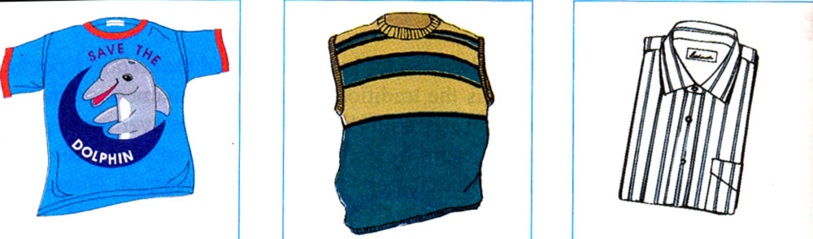  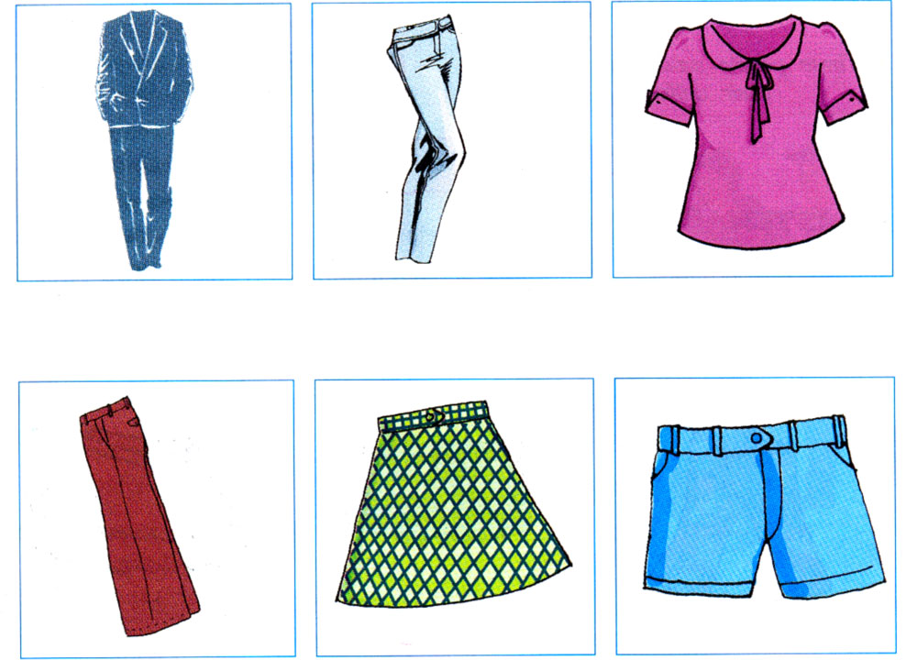  - Ask Students to do the exercise and compare with a friend.  - Call on some Students to read their results aloud.  - Correct and give the right answers. (Using the subordinate board) and tell Students to read the new words and copy.  * Checking the vocabulary: Kim’s game  III / While speaking:  - Introduce “Now work in groups to discuss and write two more questions for the last section of the survey.”  Suggested questions:  - What type of clothing do you wear on Tet holiday?  - What do you wear when you go to the party?  - Now use the questions in the survey to interview members of another group. The words in section a may help you.  + Go around class and provide help if necessary.  - Call on some Students to report in front of class.  - Remark and correct mistakes.  IV / Post speaking:  - Now report the results they have interviewed in front of class as examples in the book.  - Call on some representatives to demonstrate.  - Correct and give the suggested answers:  Huong said that she liked to wear faded jeans on the weekend because she felt very comfortable.  Lan said that a colorful T –shirt was his favorite type of clothing.  People aid that the blue uniforms of their school were very beautiful and comfortable.  V / Home work:  - Learn by heart new words.  - Do exercises in workbook.  - Prepare the next lesson. | - Play game in groups  - Listen and copy the title of the lesson.  - Work individually  - Compare with their friends.  - Read their results in front of class.  - Look at the subordinate board to repeat all the new words and copy.  - Play the game in groups  - Listen carefully.  - Look at the table in the book and work in pairs to answer the questions.  - Demonstrate in the front.  - Read the example in the book aloud.  - Work individually and report the results in the front.  - Repeat the suggested answers  - Listen and copy
  1. Traditional | 2. Poet | 3. Wear
  4. Special | 5. Designers | 6. Pants
  7. Convenient | 8. Use | 9. Take
  A - 1.a colorful T-Shirt  Áo phông màu | E- 8.faded jeans  Quần bò mài
  B-5. a sleeveless sweater  Áo len cộc tay | F-4. a short-sleeved blouse  áo cộc tay nữ
  C-6. a striped shirt  Áo sơ mi kẻ sọc | G-7. baggy pants  quần thụng
  D-3. a plain suit  Bộ quần áo comple | H- 2. a plaid skirt  Váy kẻ ô
  I- 9. blue shorts
  quần sooc xanh

