PERIOD 9

LESSON 3: LISTEN

A / Aims: To listen for specific information.

B/ Objectives: By the end of the lesson, Ss will be able to grasp vocabulary about casual clothes in the lesson & listen for specific information, describe what people are wearing

C/ Language content:

- Vocab: vocabulary of clothes.

- Grammar: The present progressive tense.

- Skill: listening comprehension.

D / Teaching aids: text book, cassette, chalk, pictures on page 16

E / Procedure:

I / Warm up: Networks  (This game is about the kinds of clothes they have learnt )  Names of clothes  - Call on students to write the words they have found  - Correct mistakes if any  II / Pre-reading:  - Introduce: “In this lesson, you will hear a public announcement about a lost little girl called Mary. First you name the clothes in the pictures.  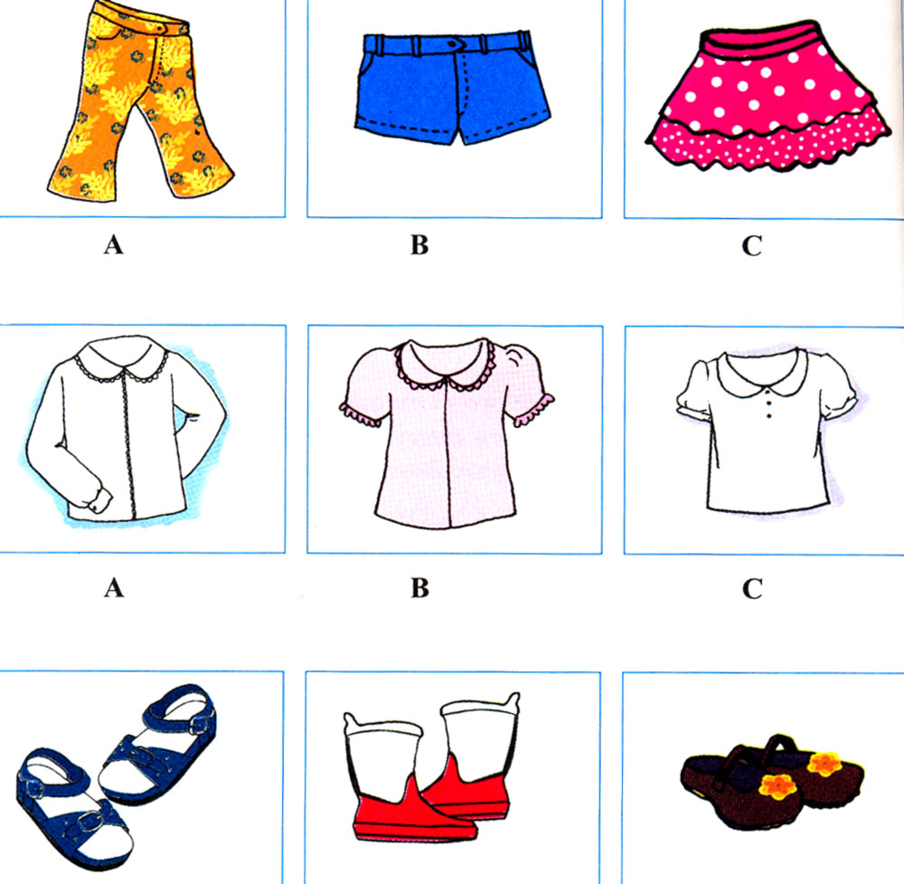  - Explain the clothes in the pictures:  a) A: floral pants B: blue shorts C: polka dot skirt  b) A: long - Sleeved white blouse B: short - sleeved pink shirt C: short - sleeved white shirt  c) A: Sandals B: boots C: shoes with flowers.  - Have student read all of them aloud and copy.  - Ask them to predict Mary’s clothes.  - Write the predictions on the board.  III / While - listening:  - Turn on the tape (2 or 3 times)  - Ask students to compare the answer they have heard with their partners.  - Call on some students to read the answers aloud.  - Correct and give correct answers:  a) B: she is wearing blue shorts.  b) A: She is wearing a long – sleeved blouse.  c) C: She is wearing brown shoes.  - Turn on the tape again and ask students to check their  results.  IV / Post - listening:  Guide students to play game “Who is she / he?”  - Call on 1 Student to describe one of their classmates and ask others to predict.  - Have Ss retell the students they have described  * Exercise: Clothes – Phrasal verbs and idioms:  Match sentences 1-10 with a-j  - Call on students to read their answers. Correct and give the right answers.  V / Home work:  1. Learn by heart all the clothes they have learnt.  2. Copy the exercise “match”.  3. Prepare the next lesson: Write | - Play games in groups  - Write the words they have found on the board.  - Read them aloud  - Listen carefully.  - Repeat all the new words and copy.  Work in groups to predict what Mary is wearing  - Read their predictions aloud.  - Listen to the tape carefully and check their prediction.  - Exchange their answers and compare with a friend.  - Report their answers.  - Read the correct answer  - Listen again and check their answers  - Play games  - Do the exercise individually  - Read the answers aloud. Copy the correct answers.  - Write down.
  A | B
  1. Can I try it on? | a. It is the same color.
  2. Hang your coat up | b. Breakfast is on the table
  3. It does not fit | c. You can not go to school in those shorts
  4. It suits you | d. It is a formal occasion
  5. It matches your eyes | e. I am not sure if it is the right size
  6. Get dressed | f. They are dirty.
  7. Go and get changes | g. It is cold outside
  8. We have to dress up this evening | h. Red is your color
  9. Take off your shoes | i, I need a bigger size.
  10. Put on a scarf. | j. Do not leave it there

