PERIOD 18

LESSON 4: WRITING

A / Aims: Practice writing a passage.

B / Objectives: By the end of the lesson, Students will be able to complete simple sentences to write a passage telling the things which happened in a picnic to the countryside.

C / Language content:

- Vocab: Picnic site, Lay out, Blanket, Blind man’s bluff, Gather

- Grammar: The simple past tense

D / Teaching aids: Text book, chalk and extra- boards, picture.

E / Procedure:
Stages | Teacher’s activities | Students’ activities
Warm up  (7 mins)  Presentation  8 mins  Practice  18 mins  Produc-  tion  10 mins  Home- work  2 mins | Chatting:  - Ask some questions about going on a picnic:  + Have you ever gone a picnic?  + When did you go?  + Where did you go/  + How did you get there?  + What did you do/  + When did you come back home?  + Did you enjoy it?  - Remark and lead in the new lesson.  Lead in: “As we know, narrative writing is a very familiar in English. In this period, we will further practice this kind of writing.  1. Pre writing:  - Have students look at the pictures and introduce some new words:  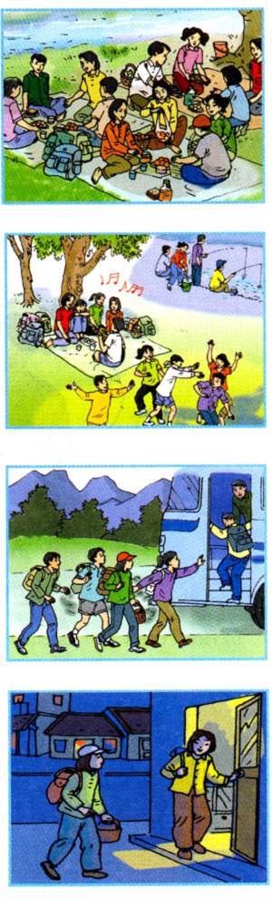  + Picnic site (n): Translation  + Lay out (v): Explanation: trải ra  + Blanket (n): Picture; thảm  + Blind man’s bluff (n): Picture chơi bịt mắt  + Gather (v): Real action: tụ họp  Checking technique: What and Where  2. While - writing:  - Introduce the aims of the lesson and ask Students to write a passage , beginning with:  It was a beautiful day …….  - Go around and provide help if any.  - Tell them to exchange their writings and correct mistakes.  - Call on some Students to read their writings aloud  - Correct common mistakes and give suggested writing  It was a beautiful day, my friend and I decided to go on a picnic. We took a bus to the countryside and them we walked about 20 minutes to the picnic site next to the river. We put down the blankets and laid out the food. After the meal we played the games …. What song is it? and blind man ,s bluff. Late in the afternoon we went fishing. We enjoyed our picnic. When we looked at the time, it was nearly 6.30 pm. We hurriedly gathered our things and ran to the bus stop. we were luckily to catch the last bus and we arrived home very late that evening.  - Call on some Ss to read the suggested writing again.  3. Post - writing:  * Games: What song is it?  * Exercise: Find and correct mistakes in the following sentences:  1. We were enough lucky to catch the last bus yesterday.  2. Many people enjoy go a picnic to the countryside.  3. They have carefully arrangements for the holiday.  4. It took us 30 minutes getting to the airport.  - Call on some Students to read the correct answers and give the correct answers:  1. lucky enough 2. going  3. careful arrangements 4. to get.  - Copy their writing  - Do the exercises in workbook.  - Prepare the next lesson. |  | The whole class  listen and answer the questions.  Listen and copy the title of the lesson.  Look at the pictures  Repeat in chorus and individually  Guess its meanings and copy.  Play game  Listen and write individually  Exchange their writings and correct mistakes.  Read the writing aloud.  Read the correct writing aloud  Play games in 4 groups.  Work in groups to complete the sentences.  Read them aloud  Repeat and copy.  Write down.

