PERIOD 19

LESSON 5: LANGUAGE FOCUS

A / Aims: Further practice the past simple with wish

B / Objectives: By the end of the lesson, Students will be able to grasp and consolidate the preposition of time, and how to use Wish with modal verb “could” and Adverbs clauses of result

C / Teaching aids: Text books, chalks and boards

D / Procedure:

Stages | Teacher’s activities | Students’ activities
Warm up  6 mins  New lesson  9 mins  15 mins  13 mins  Home work  2 mins | Hang man  (Using some learned words)  - Lead in the new lesson.  1. Modal Could with Wish:  - Explain the use of Wish used with “could”: Expressed the unreality in the present.  Example: Ba wishes he could have a new car.  (This is Ba’s wish because he does not have a new car now.)  - Ask Students to look at the pictures and the suggested words Discuss what these people wish. Then complete the wishes.  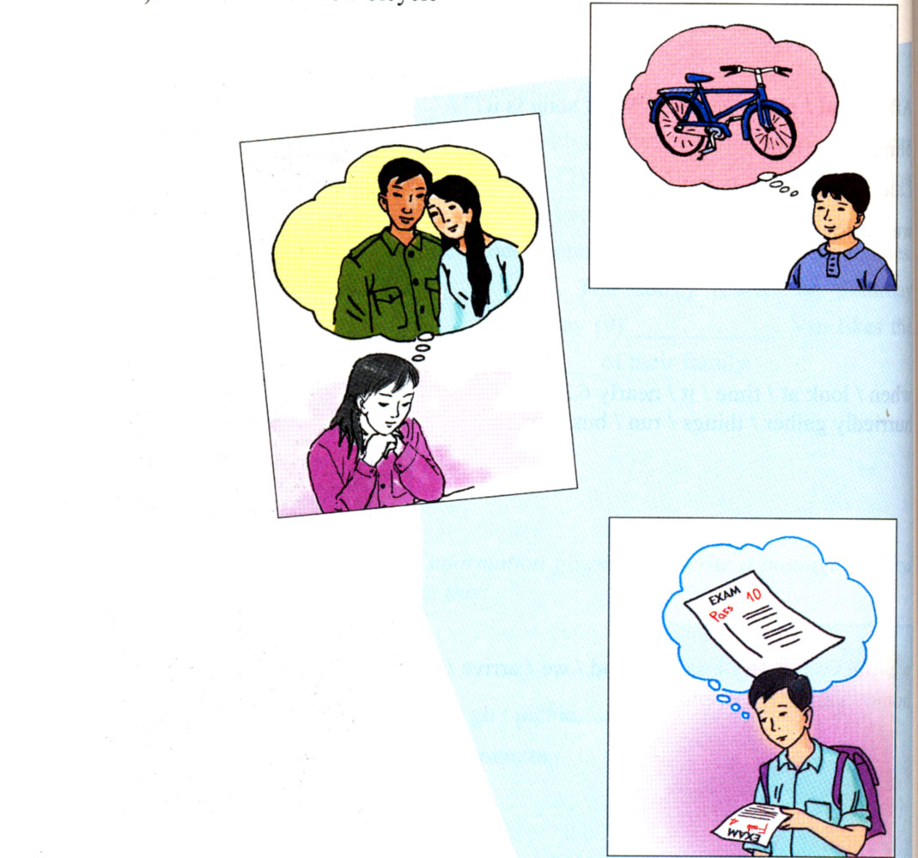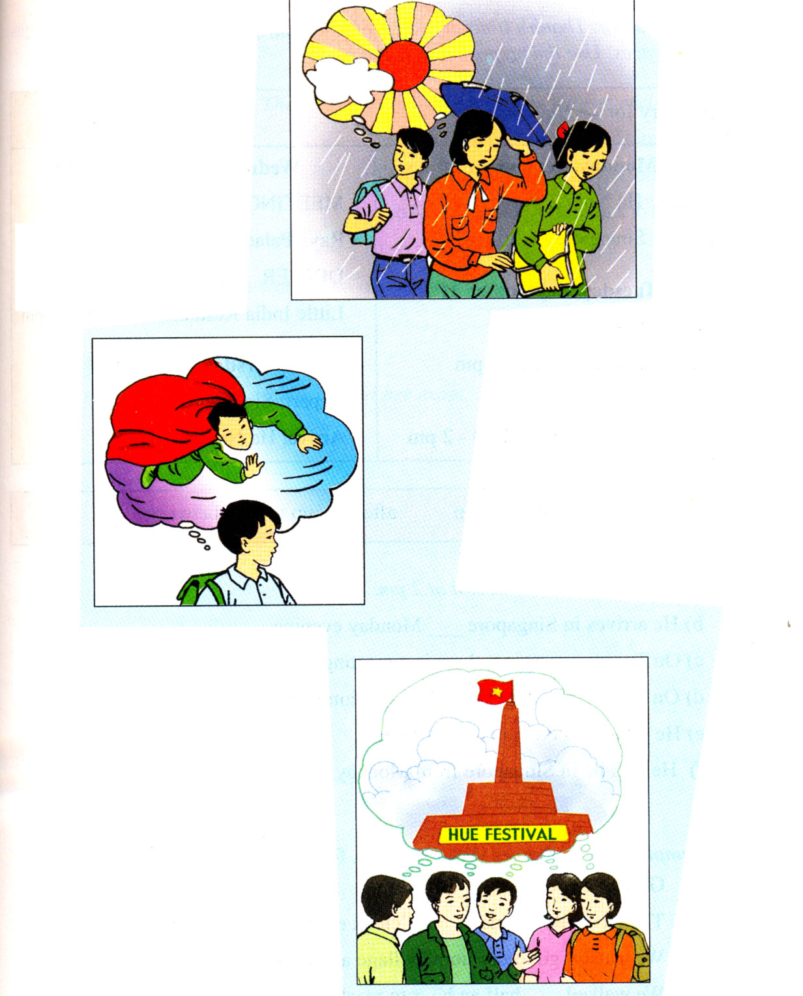  - Call on some students to read the completed sentences aloud.  - Correct mistakes and give the correct answers:  Ba wishes he could have a new car.  Hoa wishes she could visit her parents.  I wished I passed the exam.  We wish it did not rain.  He wishes He could fly  They wish they stayed in Hue.  2. Preposition of time:  - Introduce and ask Students to look at Mr. Thanh’s itinerary for his business trip to Singapore. Base on the information in the itinerary, complete the sentences in a) by using the prepositions in the box.  - Have Students compare with a friend and read their completed sentences aloud.  - Correct mistakes if any and give the right answers:  1. at 2. on 3. between 4. till 5. after 6. to  Now revise the use of some prepositions of time by doing exercise 3. Complete the sentences with on, at, in and for  - Call on some Students to read the completed sentences aloud. Correct and give answers:  a. on b. at c. in d. for e. in f. at  3. Adverb clauses of result.  - Ask Students to read the example aloud:  Hoa worked hard , so she passed her exam.  - Tell Students to explain the links between clause 1 and clause 2. Then introduce SO  + So (vì vậy, nên): Từ nối giữa hai mệnh đề chỉ kết quả - Now you match the half – sentences in A with the ones in B  - Call on some Students to read the completed sentences aloud.  - Correct and give answers:  1-e , 2-a , 3-d , 4-b , 5-c  - Redo all the exercises and copy.  - Do the exercises in workbook.  - Prepare the next lesson. | Play games  Listen and copy down  Read the example aloud  Work individually and compare with a friend.  Read the answers aloud  Repeat and copy  - Listen carefully and do the exercise.  Compare with a friend.Read the correct answers loudly  Repeat and copy.  Complete the sentences with a suitable preposition  Read the correct answers  Write down  Read the example loudly.  Explain the use of So  Copy down  Work individually and compare with a friend  Read the correct answers aloud  Copy down  Listen and write down.

