UNIT 4

LEARNING A FOREIGN LANGUAGE

PERIOD 20

LESSON 1: GETTING STARTED

LISTEN AND READ

A / Aims: - Revise and get acquainted with learning a foreign language topic.

- Read a dialogue for details about the questions in an exam.

B / Objectives: By the end of the lesson, Students will be able to revise and get acquainted with learning a foreign language topic.

C / Language content:

- Vocabulary: Examiner (n), Examinee ( n), Aspect of learning English, Written examination >< Oral examination (n)

- Grammar: The reported speech.

- Skill: pair work, group work

D / Teaching aids: Text books, cassette, chalk, pictures and some boards.

E/ Procedure:
Stages | Teacher’s activities | Students’ activities
Warm up  8 min  New lesson  39 mins  Consolidation  Homework  3 min | Brainstorming:  Ways of learning English  - Summarize their ideas and introduce the getting started to students and ask Students to make some examples with each way of learning English.  - Correct mistakes and lead in the new lesson.  1. Pre - reading:  - Introduce the situation and ask some questions.  1. Have you ever had an oral examination in English?  2. If yes, What did teacher ask you?  - Now look at the Listen and Read and introduce “Lan is talking to Paola about the oral examination she has had”.  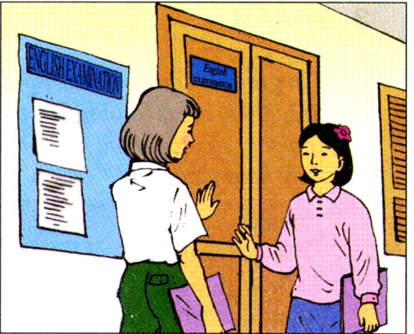  - Present some new words:  * New words:  + Examiner (n): a person who examine the exam.  + Examinee (n): a person who take part in the exam  + Aspect of learning English: Translation  + Written examination >< Oral examination (n)  * Checking technique: What and where  2. While - reading:  - Ask Ss to listen to the tape and find out the questions which the examiner asked in the conversation.  - Repeat the reported speech.  - Ask Ss to work in pairs to practice the dialogue.  - Call on some Pairs to read the dialogue again. Correct pronunciation.  - Have Ss read the conservation again and see what exactly the examiner asked Lan. Look at the list of questions and check the boxes.  - Call on Students to read the correct answers aloud.  - Correct and give the answers:  1. What is your name?  2. Where do you come from?  6. Why are you learning English?  7. Do you speak any other languages?  8. Hoe did you learn English in your country?  9. How will you use English in the future?  10.What aspect of learning English you find the most difficult?  14. Read this passage.  3. Post - reading:  - Ask Students to study the list of the questions and work in pairs.  - Call on some pairs to demonstrate in front of the class.  - Correct mistakes  1. Write the questions and change them into the reported speech  2. Prepare the next lesson. | Play games in groups.  Listen and copy. Then give some examples.  Listen carefully and answer the questions.  Listen and repeat in chorus and individually.  Copy down  Play games in groups.  Listen and work in groups to find out the questions  Listen and copy.  Work in pairs to practice the conservation  Read the dialogue again and check the boxes.  Read them aloud  Repeat all the correct questions  Work in pairs  S1: Examiner  S2: Examinee  (Exchange)  - Demonstrate in front of class.  Listen and write down.

