PERIOD 21

LESSON 2: SPEAK

A / Aims: Practice speaking to persuade some one to do something.

B / Objectives: By the end of the lesson, Ss will be able to persuade their partners to attend an English language summer course abroad.

C / Language content:

- Structures: I think………….

Why do not we…………..?

We should ……..

Let’s …………….

- Skill: Speaking and writing.

D / Teaching aids: Text book, chalks and boards.

E/ Procedure:
Stages | Teacher’s activities | Students’ activities
Warm up  7 min  Presentation  12 min  15 min  Consolidation  18 min  Homework  3 min | Hang man  (Using the words in the last lesson)  - Lead in the new lesson.  1. Pre- speaking:  - Ask Students to look at the “speak” and set the scene of the lesson “Thu, Tam and Kim have been awarded a scholarship of US $2,000 to attend and Eng language summer course abroad.”  - In the lesson there are some new words, I will introduce.  * New words:  + Dormitory (n): a place where Ss live: ký túc xá  + on campus: trong trường học  + persuade (v): thuyết phục  + Reputation ( n): = Fame: danh tiếng  + Western culture(n): Translation: văn hoá phương tây  + Beautiful scenery (n): Picture: quang cảnh đẹp  + native speaker: Translation: người bản xứ  *Checking technique: Rub out and remember  - Remind Students of the expression that they can use to persuade someone to something.  + I think…………  + what do you think…….?  + I agree/ disagree because……..  + I don’t understand……….  + Why don’t we/ you……….  + I need……./ We can………  + We should………..  + Let’s…………..  2. While speaking  - Ask Students to work in group of three, play the role of Thu, Tam and Kim and persuade you partner to attend the school you would like to study.  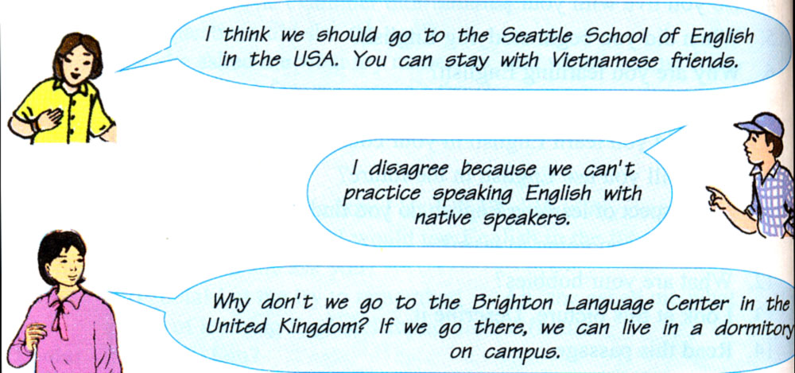  - Go around and provide help if necessary.  - Call on some groups to demonstrate in front of class.  - Correct and give some suggested dialogues (Using the subordinate boars)  3. Post speaking:  - Have Students prepare the speech about the school which they have attention to study.  Model:  Hi everybody. I am Lan. It is my pleasure to tell you about the Bright language Center. It is in the UK. Students who study here can live in dormitory on campus so it is a good chance to mix up with students from different country living in one room. The school has an excellent reputation and it is one of the best language schools in the UK.  - Call on some Students to read their speech aloud.  - Learn by heart new words.  - Write down their writings.  - Do exercises in workbook .  - Prepare the next lesson. | Play games  Listen carefully  Repeat in chorus and individually.  Guess its meanings and give examples.  Copy down.  Play games.  Listen and copy  Work in group of three to make the conversation  Demonstrate in front of class.  Listen and make a speech  Demonstrate their short talk in front of class.  Listen and copy.

