A. Phonetics - trang 3 - Unit 1 – Sách bài tập(SBT) tiếng Anh 9 mới
Look at the sentences below. Put the underlined words into the correct column according to whether they are normally stressed or unstressed in a sentence. Nhìn vào các câu dưới đây. Xếp các từ gạch chân vào đúng cột nếu chúng được nhấn mạnh hay không nhấn mạnh trong câu.
1. Look at the sentences below. Put the underlined words into the correct column according to whether they are normally stressed or unstressed in a sentence.
Nhìn vào các câu dưới đây. Xếp các từ gạch chân vào đúng cột nếu chúng được nhấn mạnh hay không nhấn mạnh trong câu.
1. My village is famous for making drums
2. Hand-embroidered tablecloths are very expensive.
3. What is your favourite place of interest in the city?
4. This park isn't attractive to young people.
5. When will you finish weaving the basket?
6. The artisans are carving the eggshells carefully.

 | Stressed | Unstressed
1.
2.
3.
4.
5.
6.
Key - Đáp án:
 | Stressed | Unstressed
1 | village, famous, making | for
2 | tablecloths, expensive | are
3 | What, favourite | the
4 | isn't, people | This, to
5 | When, weaving | will
6 | artisans, carefully | are
2. Underline the conten words in the sentences. Practise reading the sentences aloud.
Gạch chân các từ chính trong mỗi câu sau. Đọc to các câu đó.
1. My carpets were woven by a famous artisan.
2. In his free time, my brother often goes for a walk in the park.
3. They didn't make this table by hand.
4. People love going to museums to widen their knowledge.
5. Where can I find similar vases?
6. We changed the design of our traditional products to attract more customers.
Key - Đáp án:
1. My carpets were woven by a famous artisan.
2. In his free time, my brother often goes for a walk in the park.
3. They didn't make this table by hand.
4. People love going to museums to widen their knowledge.
5. Where can I find similar vases?
6. We changed the design of our traditional products to attact more customers.
B. Vocabulary & Grammar - trang 3 - Unit 1 - Sách bài tập(SBT) tiếng anh 9 mới
Complete each sentence with a word/ phrase from the box. There is one extra word/ phrase. Hoàn thành các câu sau với một từ/cụm từ đã cho. Có một từ không sử dụng.
1. Complete each sentence with a word/ phrase from the box. There is one extra word/ phrase.
Hoàn thành các câu sau với một từ/ cụm từ đã cho. Có một từ không sử dụng.
paintings; pottery; drum; silk; lacquerware; conical hats; baskets
1. These products are called__________because they are decoratively covered with lacquer.
2. These______are made of thin bamboo strips that are woven together.
3. To play this ____________ you should use your hands, not sticks.
4. This vase is a beautiful piece of______. It's made from clay dug from our river banks.
5. Lots of Vietnamese girls like wearing_________and ao dai.
6. When I go somewhere on holiday, I usually buy_____as souvenirs because I love works of art.
Key - Đáp án:
1. lacquerware; 2. baskets; 3. drum
4. pottery; 5. conical hats; 6. paintings
2. Choose A, B, C, or D to complete each sentence.
Chọn các đáp án A, B, C hoặc D để hoàn thành mỗi câu sau.
1. The fiower was.......... out of a single piece of valuable wood.
A. carved B. moulded C cast D. given
2. In this town, they_____ all the frames in steel.
A. make B. have C. mould D. cast
3. She is skilled at ____ cloth.
A. giving B. weaving C doing D. carving
4. If you like, I can_____ flowers on the cushion covers for you.
A. grow B. make C. embroider D. knit
5. Is it true that you.......... this woollen hat yourself?
A. knitted B. wove C did D. carved
6. The doll has been.......... out of clay.
A. embroidered B. cast C. woven D. moulded
Key - Đáp án:
1. A; 2. D; 3. B; 4. C; 5. A; 6. D
3. Complete the passage by filling each blank with the correct form of the word in brackets.
Điền vào chỗ trống các từ đã cho để hoàn thành đoạn văn sau.
Some people ask me if I like living in my hometown. The answer is certainly ‘yes’. The simple reason is that it has lots of (1. interest) _________ places. If you want to widen your knowledge of the past, you can go to the museum. It's a (2. history)............... building, with a big collection of valuable artefacts. There is also acraft village in my hometown. There, the (3. village)____________ make drums. Their drums are not only famous in the (4. local)_______, but also nationwide. You can visit the old workshop, where drums are still made in the traditional way. Some of them are huge! Another (5.attract) _______ in my hometown is the local library. It's an (6. educate) ______ place where anyone can borrow books and take them home to read. Besides, it also has a (7. read) .................. club. I'm one of its members, and we gather once a week to discuss what we've read together. My hometown is also a (8. culture)..................... centre, with many traditional festivals and activities. I love it very much.
Key - Đáp án:
1. interesting; 2. historical; 3. villagers; 4. locality
5. attraction; 6. educational; 7. reading; 8. cultural
4. Choose A, B, C, or D to complete the sentences.
Chọn A, B, C hoặc D để hoàn thành các câu sau.
1. I love going to this place _____ it's the quietest place in the city.
A. so B. though C. so that D. as
2. They keep changing the decoration of the shop_______ they can attract more young people.
A. so that B. because C. although D when
3. She's young, she's the most famous artisan in the village.
A. When B. Although C. Whereas D. In order to
4. Do you know who's______ his pottery workshop?
A. bring out B. taking over C. passing down D. turning down
5. I've_______ the product catalogue and decided to buy this table.
A. found out B. closed down C. looked through D. lived on
6. This scorts centre is so small that it cannot______the demands of local residents.
A. keep up with B. face up to C. deal about D. setup
Key - Đáp án:
1. D; 2. A; 3. B; 4. B; 5. C; 6. A
5. Make a complex sentence from each pair of sentences. Use the subordinator provided in brackets and make any necessary changes.
Viết lại thành một câu từ hai câu cho trước. Sử dụng gợi ý đã cho và thay đổi bất cứ gì nếu cần thiết.
1. There are modern knitting machines. The artisans in my village like using traditional looms( although)
________________________________
2. Many children like to go to Bat Trang Ceramic village. They can make their own pottery there. (as)
________________________________
3. We have to follow more than ten stages. We can make a simple conical hat. (so that)
________________________________
4. Sinh paintings are special. They are burned after worship. (since)
________________________________
5. We'll have to phone you first. Then we'll organise the trip. (before)
________________________________
6. We were visiting an old building. They were going to a traditional market. (while)
________________________________
Key - Đáp án:
1. Although there are mordern knitting machines, the artisans in my village like using traditional looms.
2. Many children like to go to Bat Trang Ceramic village as they can make their own pottery there.
3. We have to follow more than ten stages so that we can make their own pottery there.
4. Sinh painting are special since they are burned after worship.
5. We'll have to phone you first before we organise the trip.
6. We were visting an old building while they were going to a traditional market.

6. Complete each sentence using a verb from A in the correct form and a particle from B. You can use any particle more than once.
Sử dụng dạng đúng của động từ ở cột A với giới từ ở cột B để hoàn thành các câu sau. Có thể sử dụng bất cứ giới từ nào hơn một lần.
A | B
Find turn bring close get deal | Out down with up
1. What time does your mother usually____________ in the morning?
2. We must____________ the train times so that we can take the earliest train to Hai Phong.
3. My favourite writer has..................... another best-seller.
4. We're____________ lots of complaints from customers about the quality of these shirts.
5. Why did you___________ your workshop? I thought that it was running quite well.
6. I had to___________ their invitation to take part in the trip because my father didn't allow me to go.
Key - Đáp án:
1. get up; 2. find out; 3. brought out
4. dealing with; 5. close down; 6. turn down

C. Speaking - trang 6 - Unit 1 - Sách bài tập (SBT) tiếng anh 9 mới
1. Complete the conversation below with the statement (A-G). Then practise it with a friend. Hoàn thành cuộc đối thoại dưới đây với những đoạn văn (A-G). Rồi thực hành với một người bạn.
1. Completethe conversation below with the statements (A-G). Then pratise it with a friend.
Hoàn thành cuộc đối thoại dưới đây với những đoạn văn (A-G). Rồi thực hành với một người bạn.
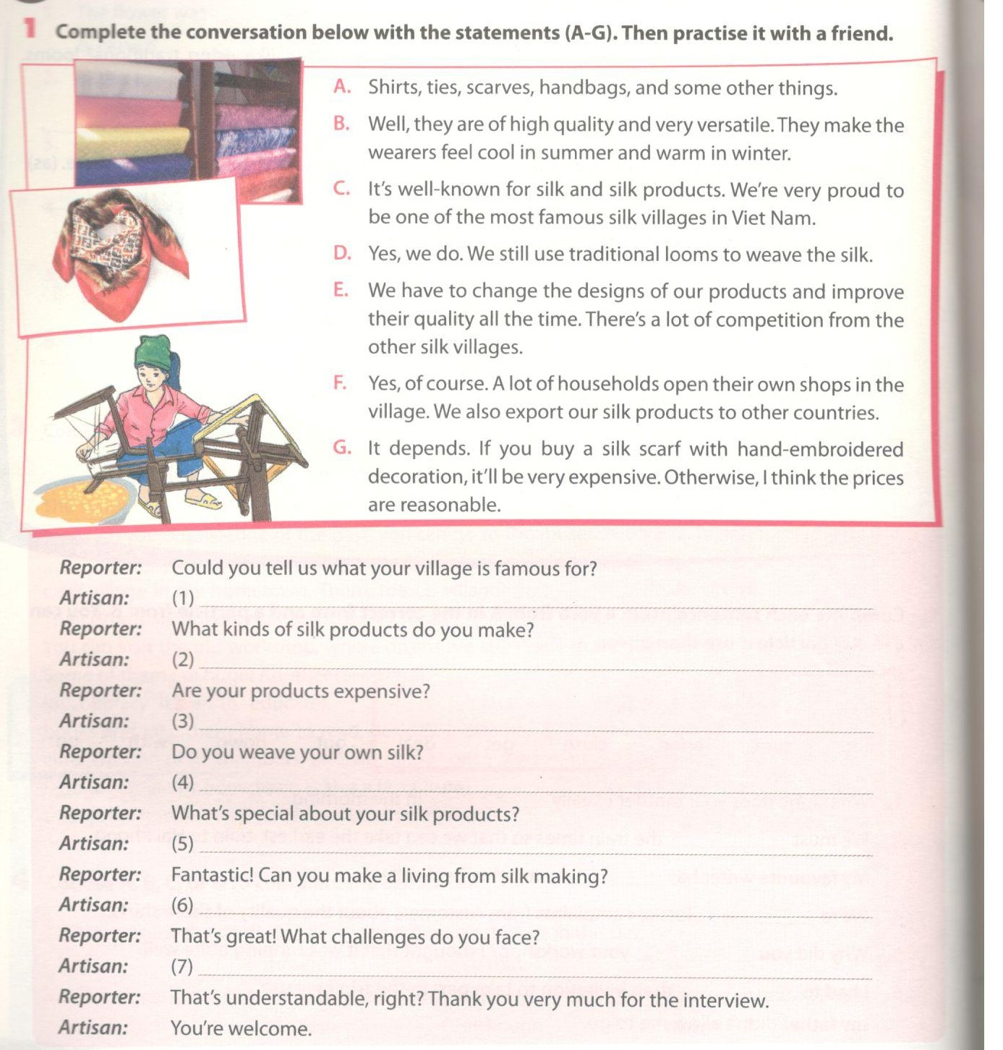
Key - Đáp án:
1. C; 2. A; 3. G; 4. D; 5. B; 6. F; 7. E

2. Now think about a famous product made in your local area or a famous product you know about. Work with another student and make up a similar conservation to the one in 1. Focus on:
Hãy nghĩ tới một sản phẩm nổi tiếng được làm từ địa phương em hoặc sản phẩm mà em biết. Họp nhóm với học sinh khác và tạo ra một cuộc đối thoại như bài 1. Tập trung vào :
- the name of the product
- reasons why it is famous
- its special characteristics
- any challenge it faces
- whether people can live on producting/ making it
D.Reading-trang 7-Unit 1- Sách bài tập (SBT) tiếng anh lớp 9 mới
1. Choose the correct answer A,B,C or D to complete Mi's email to her new friend, Elisa. Chọn câu trả lời đúng A,B,C hoặc D để hoàn thành email của Mi gửi tới người bạn mới của cô ấy, Elisa.
1. Choose the correct answer A,B,C or D to complete Mi's email to her new friend, Elisa.
Chọn câu trả lời đúng A,B,C hoặc D để hoàn thành email của Mi gửi tới người bạn mới của cô ấy, Elisa.
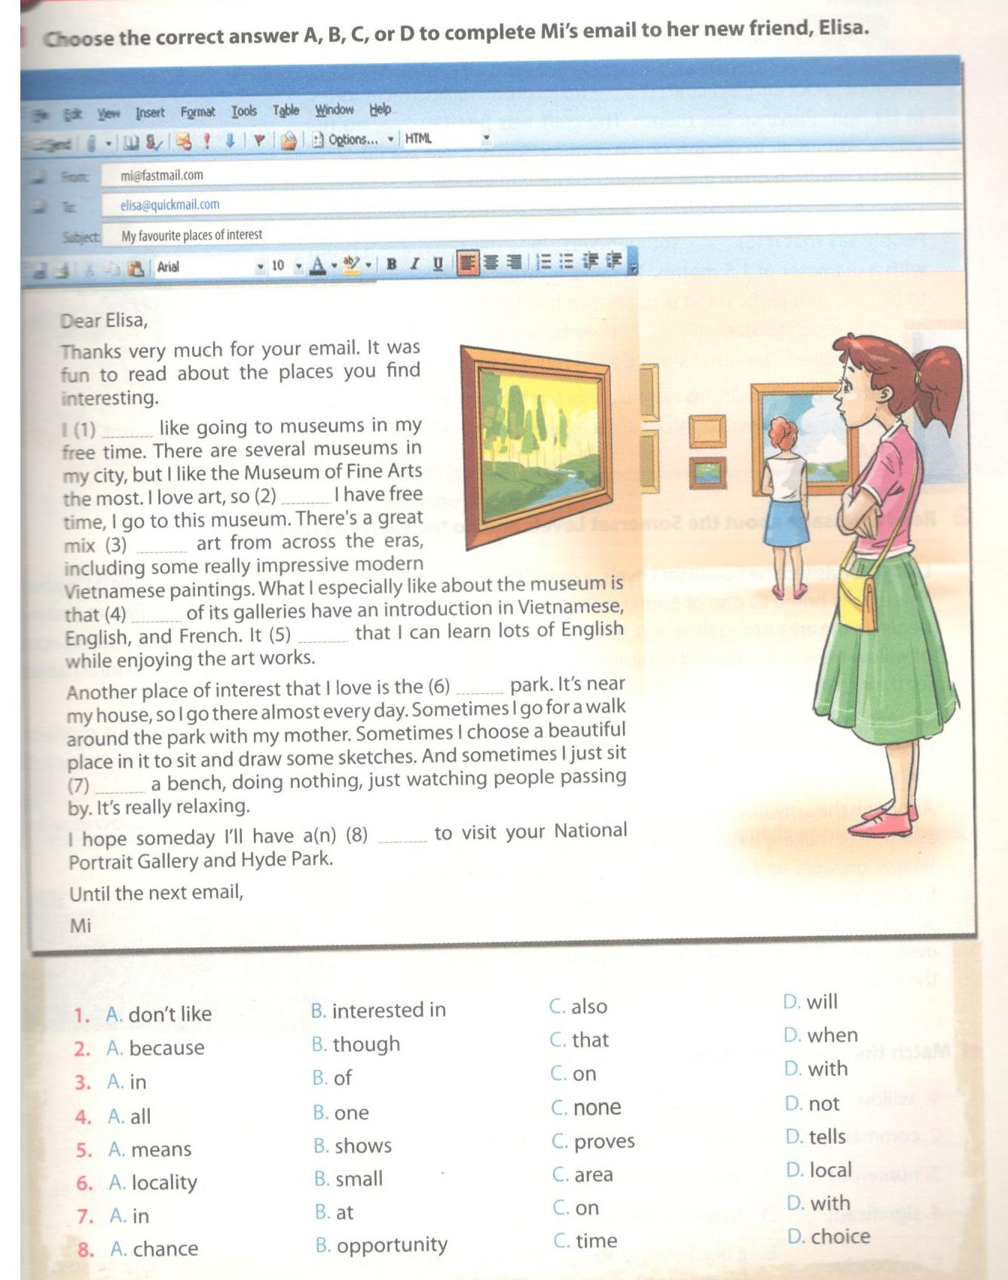
Key - Đáp án:
1. C; 2. D; 3. B; 4. A; 5. A; 6. A; 7. C; 8. A

2.Fill each blank with a suitable word from the box to complete a passage about Doi Tam Drum-making.
Điền vào mỗi chỗ trống dưới đây với một từ thích hợp trong bảng để hoàn thành đoạn văn về Doi Tam-làng nghề làm trống.
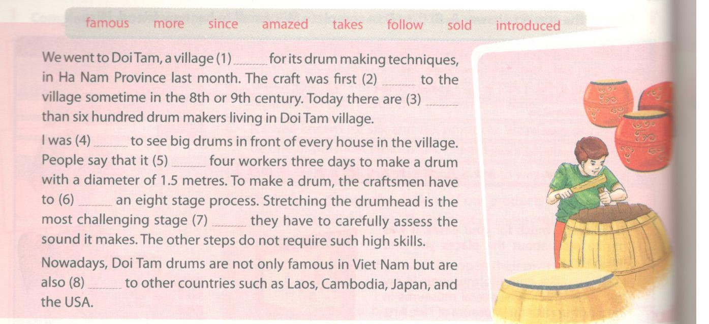
Key - Đáp án:
1. famous; 2. introduced; 3. more; 4. amazed
5. takes; 6. follow; 7. since; 8. sold

3. Read a passage about the Somerset Levels and do the exercises that follow.
Đọc đoạn văn nói về Somerset Levels và làm bài tập dưới đây.
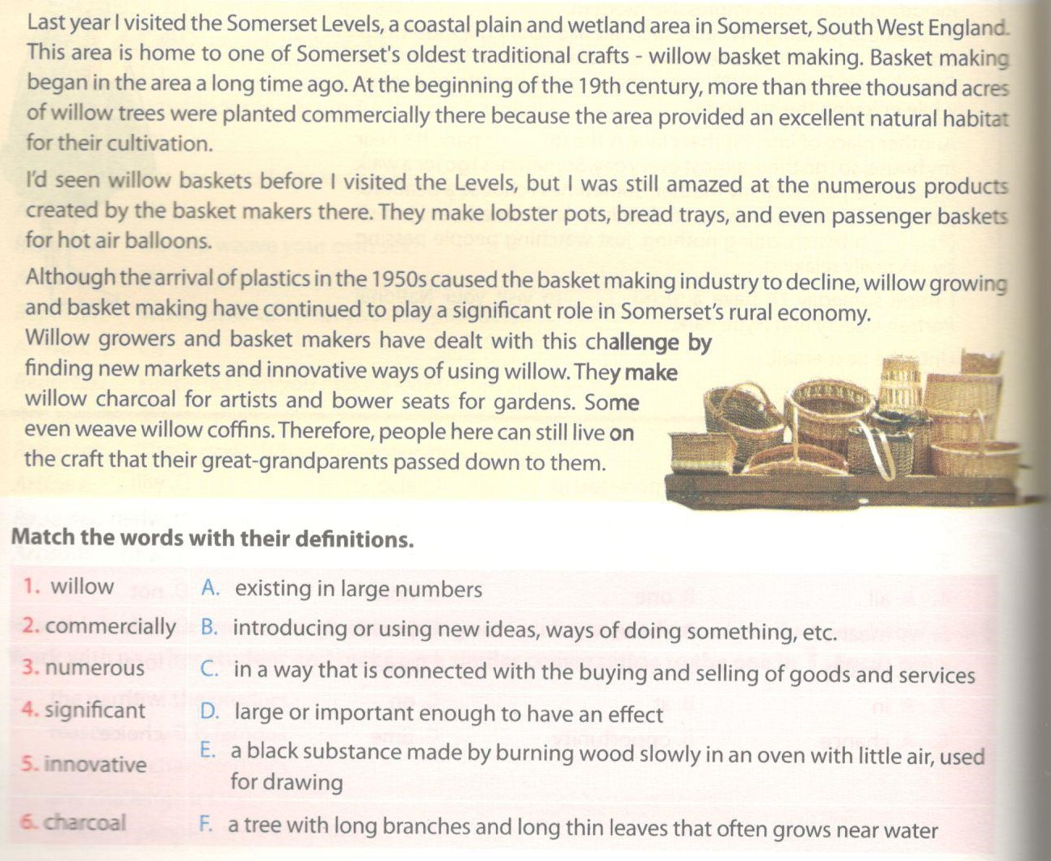
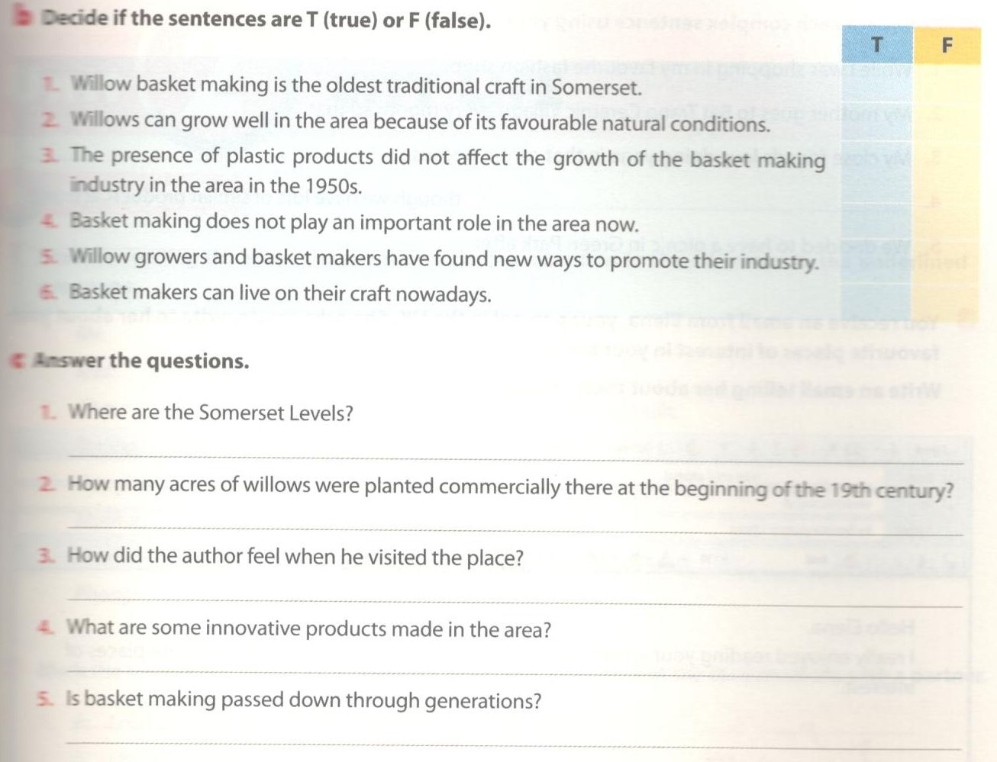
Key - Đáp án:
3a. 1.F; 2.C; 3.A; 4.D; 5.B; 6.E
3b. 1.F (It's one of the oldest.)
2.T
3.F
4.F (It's still plays an important role in the area now.)
5.T
6.T
3c. 1. They're in South West England.
2. More than three thousand acres.
3. He was amazed by the numerous products created by the basket makers.
4. Charcoal for artists, bower seats for gardens, lobster pots, balloon baskets, or willow coffins.
5. Yes, it is.
E-Writing -trang 9-Unit 1- Sách bài tập (SBT) tiếng anh lớp 9 mới
1. Make sentences using the words and phrases below. You can add extra words or make changes. Viết câu có sử dụng từ và cụm từ dưới đây. Em có thể thêm từ hoặc thay đổi.
1. Make sentences using the words and phrases below. You can add extra words or make changes.
Viết câu có sử dụng từ và cụm từ dưới đây. Em có thể thêm từ hoặc thay đổi.
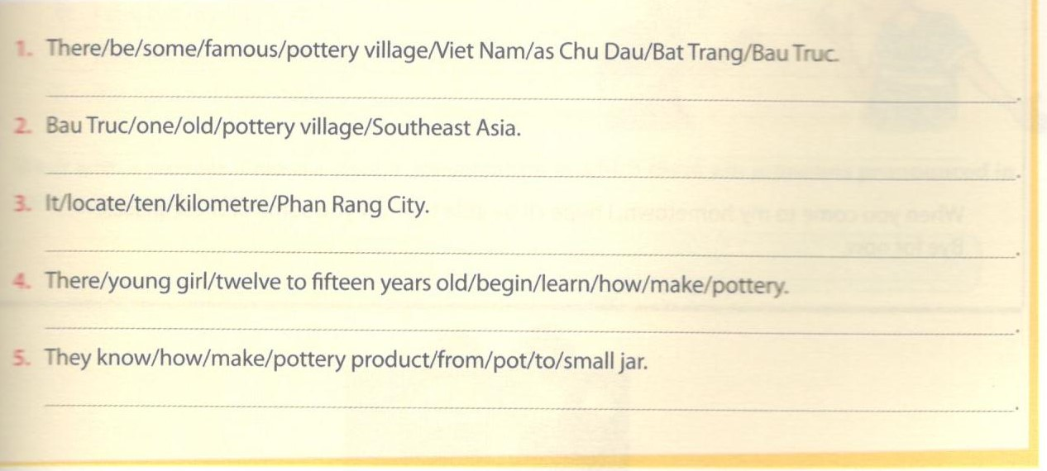
Key - Đáp án:
1. There are some famous pottery villages in Viet Nam such as Chu Dau, BatTrang, and Bau True.
2. Bau True is one of the oldest pottery villages in Southeast Asia.
3. It is located about ten kilometres from Phan Rang City.
4. There, young girls from twelve to fifteen years old begin to learn how to make pottery.
5. They know how to make pottery products from pots to small jars.

2. Complete each complex sentences using your own ideas.
Hoàn thành những câu sau theo ý tưởng của em.
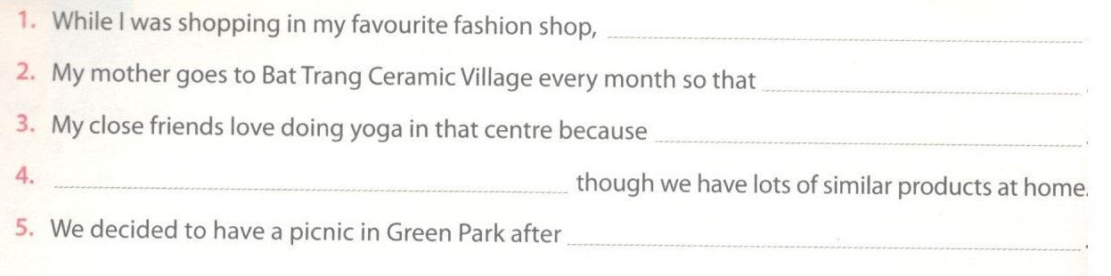
3. You reeceive an email from Elena, your pen pal in the UK. She asks you to wrrite to her about your favourite places of interest in your area.Writing an email telling her about these places.
Em nhận được email từ Elena, bạn tâm thư ở Anh. Cô ấy bảo bạn hãy viết thư kể cho cô ấy về những địa điểm bạn yêu thích ở nơi bạn sống. Viết một emai kể về những địa điểm đó.
