A-Phonetics-trang 11-Unit 2- Sách bài tập (SBT) tiếng anh lớp 9 mới
1. Practise reading the short conservations, paying attention to the difference in the underlined pronouns.
Luyện đọc những cuộc đối thoại ngắn, chú ý tới những đại từ gạch chân.
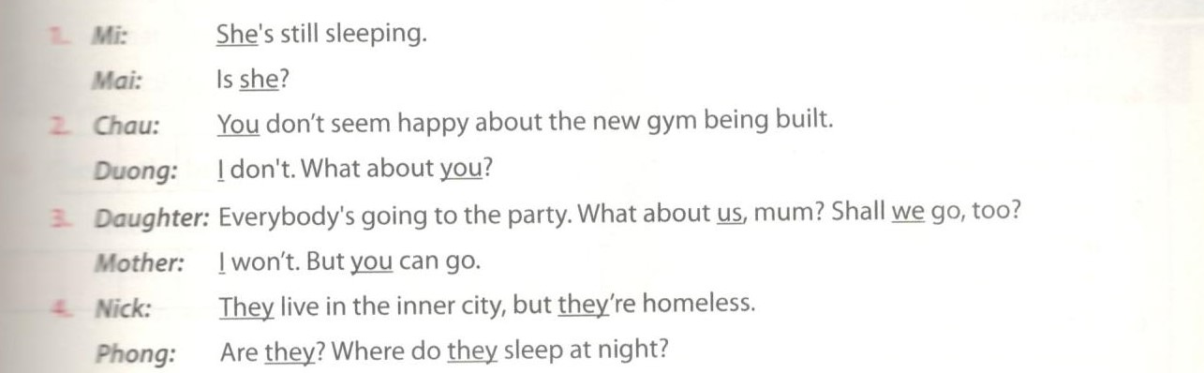
Key - Đáp án:
1. Mi: She’s still sleeping. (she: weak)
Mai: Is she? (she: strong)
2. Chau: You don’t seem happy about the new gym being built. (You: weak)
Duong: I don’t? What about you? (I, you: strong)
3. Daughter: Everybody’s going to the party. What about us, mom? Shall we go, too? (us, we: strong)
Mother: I won’t. But you can go. (I, you: strong)
4. Nick: They live in the inner city, but they’re homeless. (They, they: weak)
Phong: Are they? (they: strong) Where do they sleep at night? (they: weak)

2. Mark the underlined words as W (weak) or S (strong). Then act out the conservations with a partner.
Đánh dấu W (cho những từ không nhấn mạnh) và dấu S (cho những từ nhấn mạnh) cho những từ dưới đây. Rồi thực hiên lại cuộc đới thoại với một người bạn.
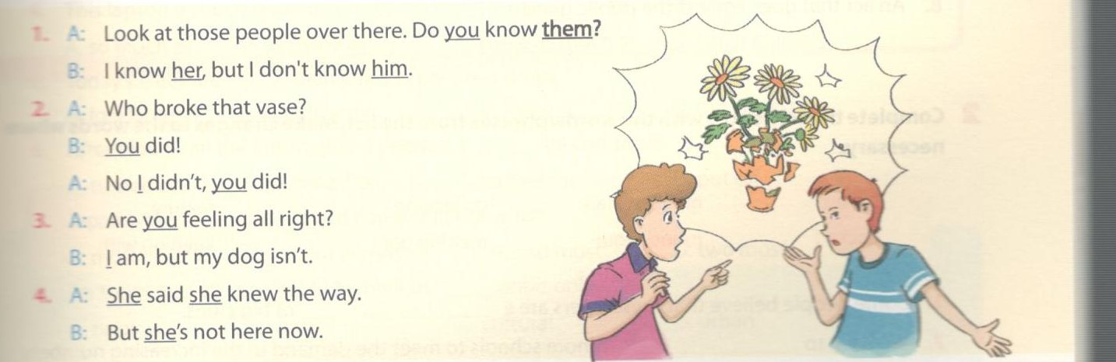
Key - Đáp án:
1. A: Look at those people over there. Do you (W) know them (W)?
B: I know her (S), but I don't know him (S).
2. A: Who broke that vase?
B: You (S) did!
A: No i(S) didn't, you (S) did!
3. A: Are you (W) feeling all right?
B: i (S) am, but my dog isn't.
4. A: She (S) said she (S) knew the way.
B: But she's (S) not here now.

3.Work with a partner. Create a similar conservation in which there are pronous pronounced in strong and weak forms.
Làm việc nhóm với bạn. Tạo một cuộc đối thoại mà có những đại từ nhấn mạnh và không nhấn mạnh.
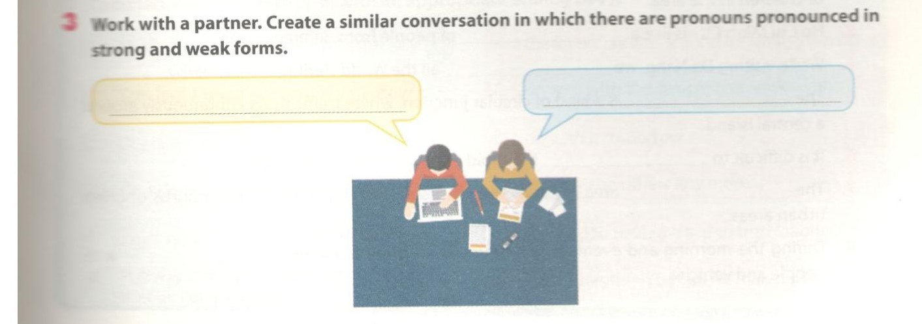
B-Vocubulary&Grammar -trang 12-Unit 2 - Sách bài tập (SBT) tiếng anh lớp 9 mới
1.Complete the following puzzle.
Hoàn thành câu đố sau.
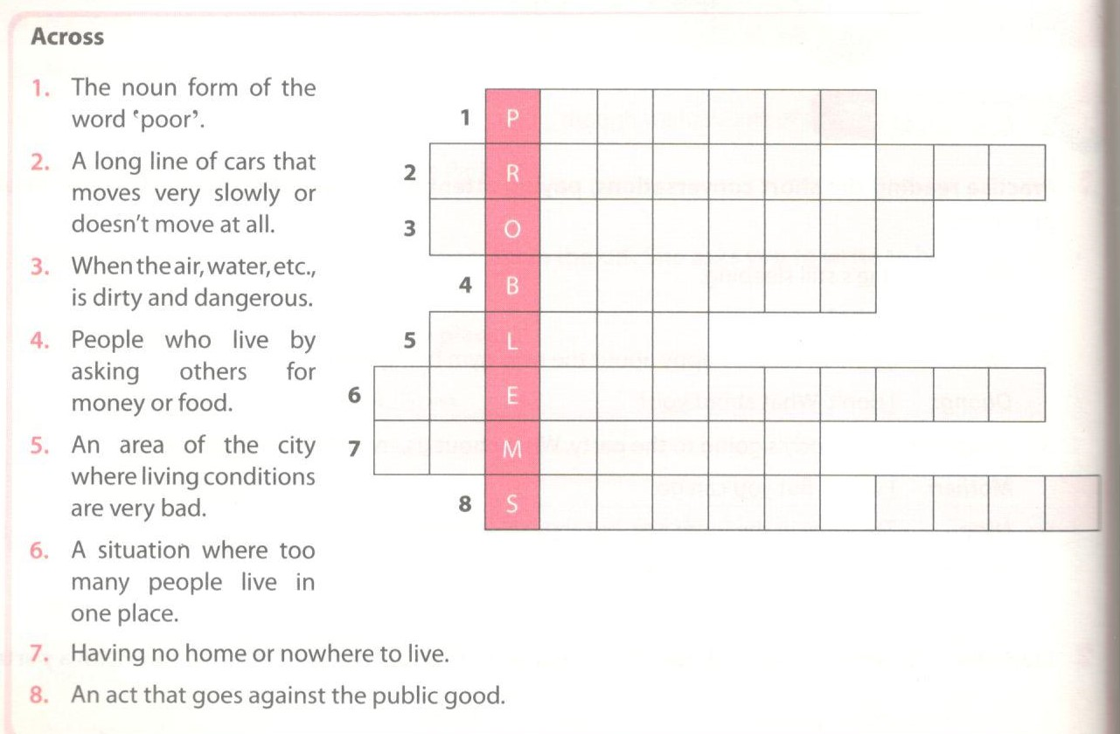
Key - Đáp án:
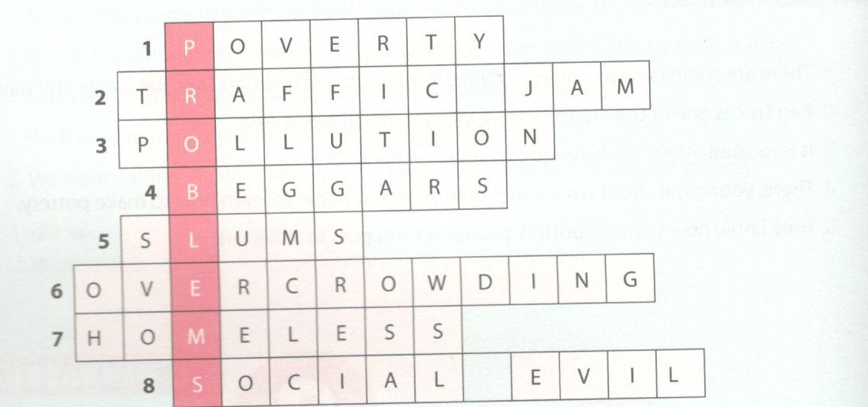

2.Complete the sentences with the words/phrases from the list. Make changes to the words where nessary.
Hoàn thành những câu sau với từ và cụm từ từ danh sách dưới đây. Thay đổi nếu thấy cần thiết.
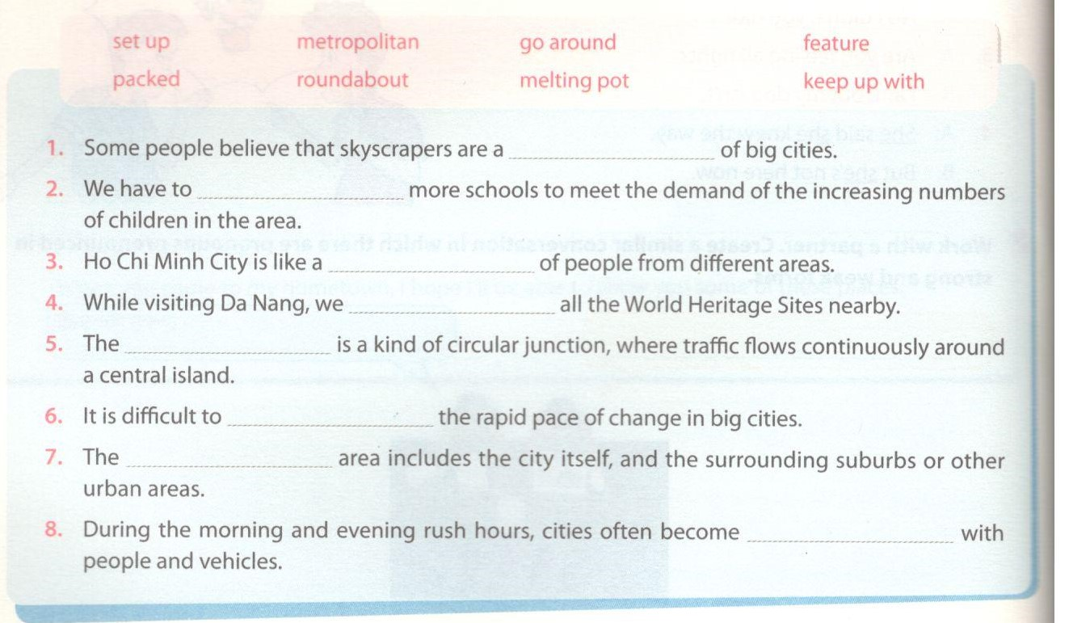
Key - Đáp án:
1. feature; 2. set up; 3. melting pot; 4. went around
5. roundabout; 6. keep up with; 7. metropolitan; 8. packed

3. Use the correct form of the words given in the brakets to finish the sentences.
Sử dụng dạng đúng của từ trong ngoặc để hoàn thành những câu sau.
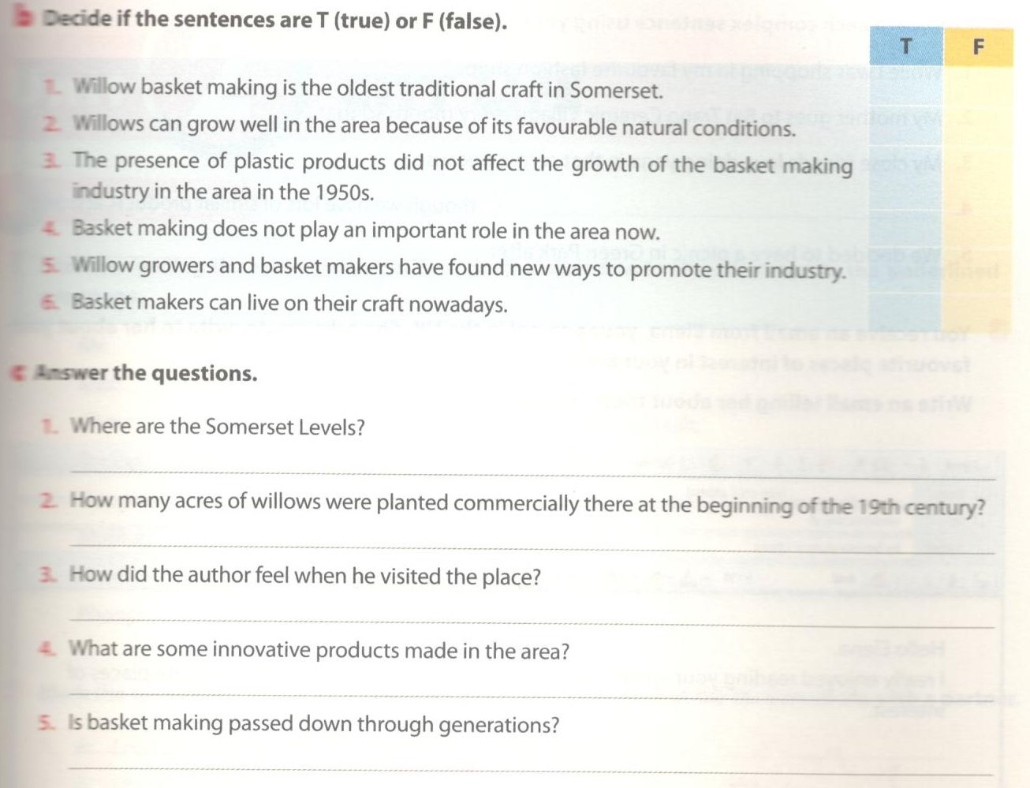
Key - Đáp án:
1. affordable; 2. pleasant - convenient; 3. multiculture
4. more - more - more; 5. smallest

4.Choose the best answer to complete the sentences.
Chọn đáp án đúng để hoàn thành những câu sau.
1. When I turned up, the town hall was already_____ of teenagers.
A. full B. packed C. crowded D. jammed
2. She turned____the new job in New York because she didn't want to move.
A. on B. down C. off D. up
3. This city has one of the most___ underground rail networks in the world.
A. efficient B. fashionable C . cosmopolitan D. fascinated
4. This laptop is much more user-friendly, but it costs________ the other one.
A. so much as B. as many as C. twice as much as D. twice as many
5. Today's cities are____than cities in previous times.
A. lots larger B. much larger C. as large D. the largest
6. After I found all the information I needed, I________the computer.
A. turned off B. switched on C. looked for D. put off
7. Japan is the__________ developed country in the world.
A. most second B. second in most C. second most D. two most
8. Factories and offices should be built in ............................. areas only.
A. rural B. coastal C. culture D. urban
Key - Đáp án:
1. A; 2. B; 3. A; 4. C; 5. B; 6. A; 7. C; 8. D

5. Complete each sentences (1-6) with an appropriate ending (A-F).
Hoàn thành những câu sau (1-6) với phần đuôi thích hợp (A-F).
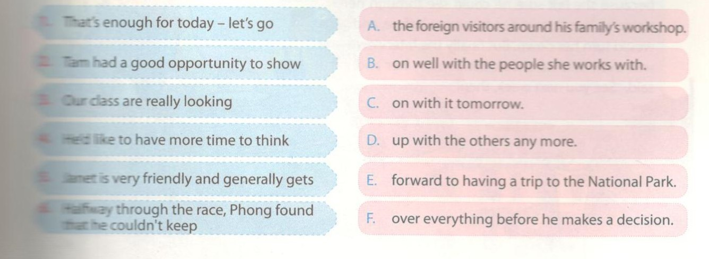
Key - Đáp án:
1. C; 2. A; 3. E; 4. F; 5. B; 6. D

6.Complete each sentences with the correct form of a verb from the box.You don't need to use all of them.
Hoàn thành những câu sau với dạng đứng của từ trong bảng. Bạn không cần phải sử dụng tất cả chúng.
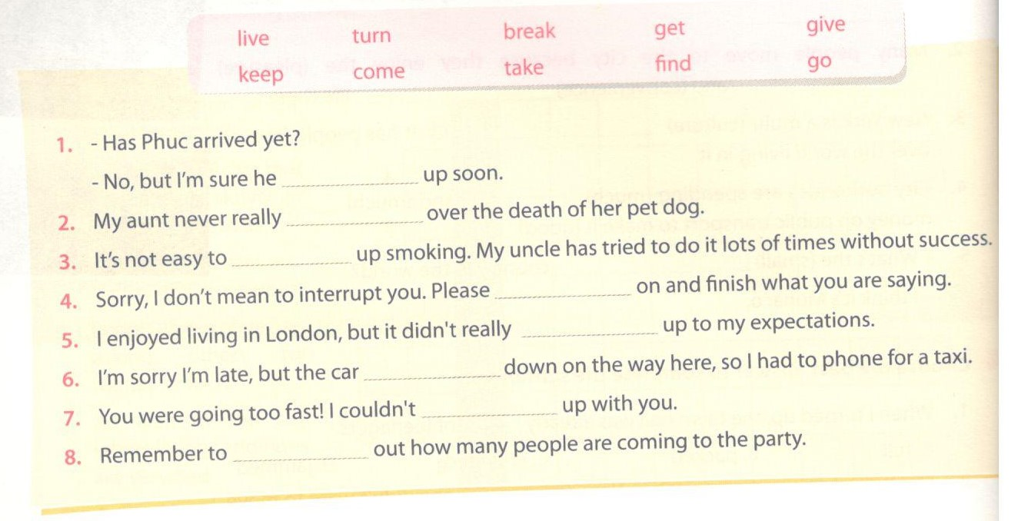
Key - Đáp án:
1. will turn; 2. got; 3. give; 4. go
5. live; 6. broke; 7. keep; 8. find

7. Read the text and underlined the six phrases verbs. Match each of them with a synonym/definition given, according to its meaning in the text.
Đọc đoạn văn sau gạch chân 6 cụm đọng từ. Nối chúng với một từ đồng nghĩa/định nghĩa thông qua đoạn văn sau.
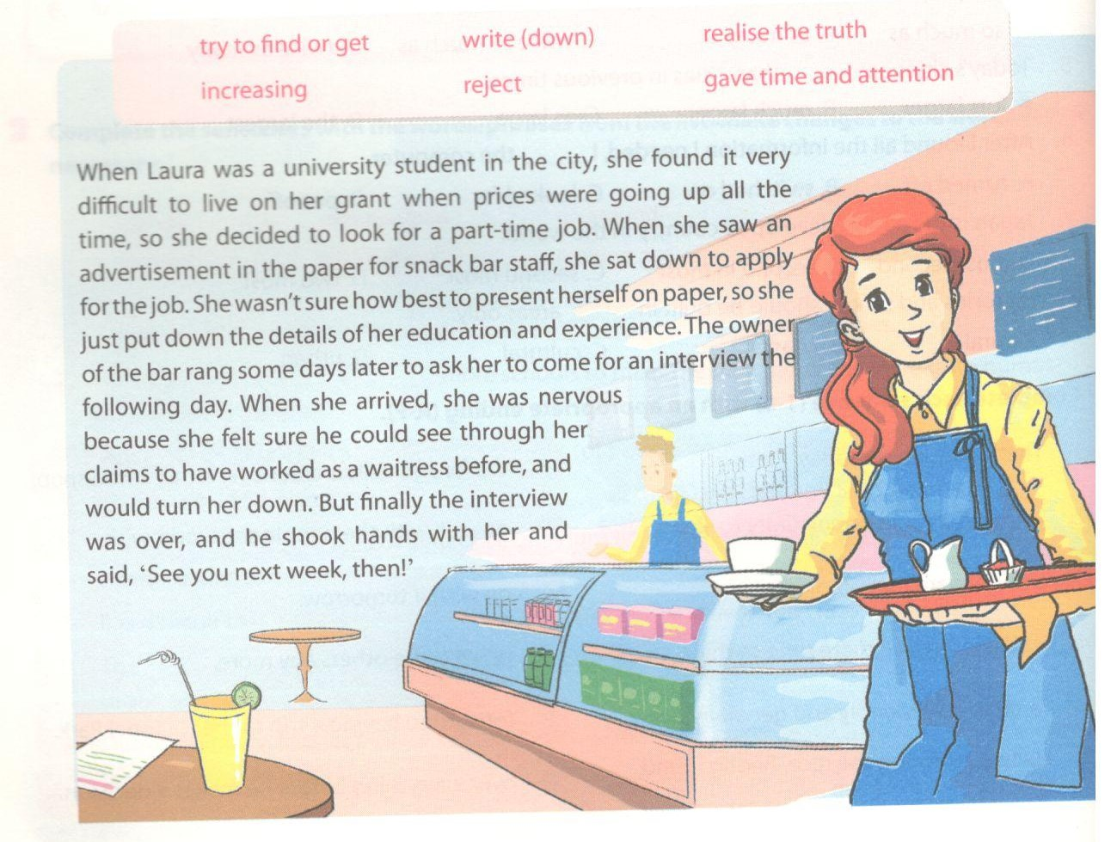
Key - Đáp án:
When Laura was a university student in the city, she found it very difficult to live on her grant when prices were going up all the time, so she decided to look for a part-time job. When she saw an advertisement in the paper for snack bar staff, she sat down to apply for the job. She wasn't sure how best to present herself on paper, so she just put down the details of her education and experience. The owner of the bar rang some days later to ask her to come for an interview the following day. When she arrived, she was nervous because she felt sure he could see through her claims to have worked as a waitress before, and would turn her down. But finally the interview was over, and he shook hands with her and said, ‘See you next week, then!’
- going up: increasing
- look for: try to find or get
- sat down: gave time and attention
- put down: write (down)
- see through: realise the truth
- turn (her) down: reject
C-Speaking -trang 15-Unit 2- Sách bài tập (SBT) tiếng anh lớp 9 mới
1. Word with a partner. Which of the following cities are capitals? What countries are they in ?
Họp nhóm với một người bạn. Những thành phố nào dưới đây là thủ đô? Họ đang sống ở đất nước nào?
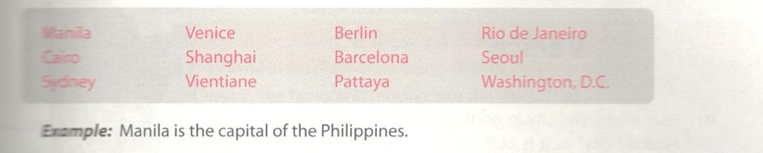
2. Work with a partner to answer the question:
Which of the following are likely to be features of the city life?
Họp nhóm với một người bạn để trả lời câu hỏi:
Sự việc nào dưới đây là đặc trừng của cuộc sống thành thị?
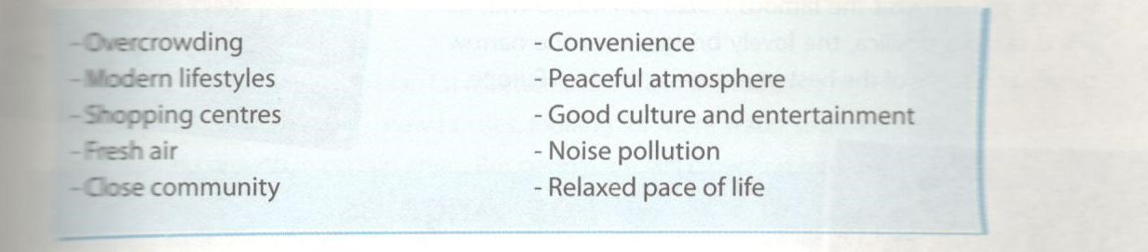
Talk about your city/town, or a city you know, using the features above. Look at the example.
Kể về thành phố/thị trấn của bạn hoặc bạn biết, sử dụng những đặc trưng ở bài trên. Hãy xem ví dụ.
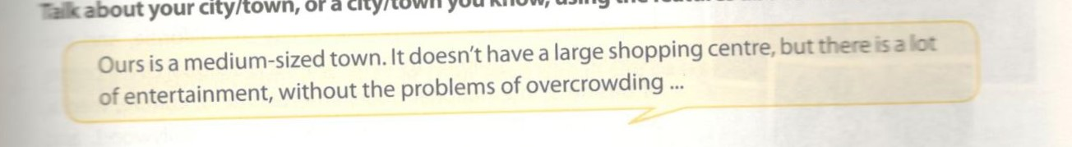
3. Work in pairs. Read the information about Ho Chi Minh City, the largest city in Viet Nam. Then ask and answer questions about it.
Làm việc theo cặp. Đọc thông tin về thành phố Hồ Chí Minh, thành phố rộng lớn nhất Việt Nam. Rồi hỏi và trả lời những câu hỏi về nó.
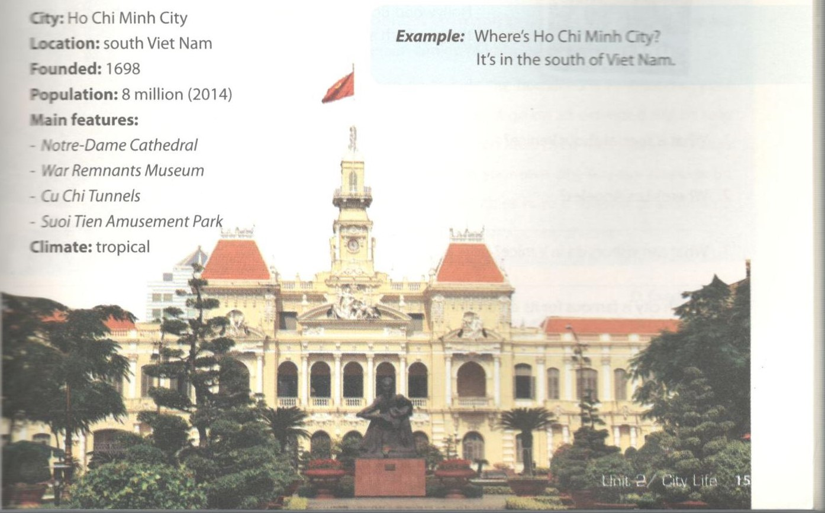
D-Reading-trang 16-Unit 2-Sách bài tập (SBT) tiếng anh lớp 9 mới
1.Read the two passages and answer the questions below.
Đọc hai đoạn văn và trả lời những câu hỏi dưới đây.
Vience
Venice is a beautiful city in northeastern Italy. It is called ‘The Floating City’ as it is built on 117 small islands. This city has no roads. Instead, people use boats to travel along the canals. Flat-bottomed boats were once the main means of transport, but today motor boats are more popular. In Venice, you can visit the famous Piazza San Marco with its world famous basilica, the lovely bridges over the narrow canals, and some of the best museums in Western Europe.
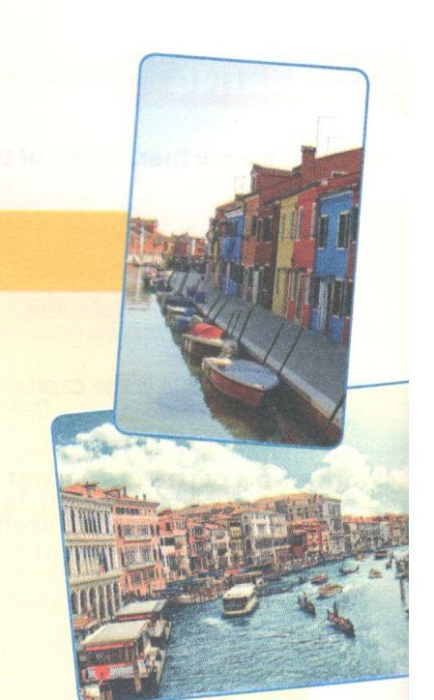
Los Angeles
Los Angeles is the most populous city in California, and the second most populous city in the USA. It is a global city, a centre of business, international trade, entertainment, culture, media, and fashion. The Los Angeles area includes Hollywood, and leads the world in the creation of television productions, video games, and recorded music. The weather here is usually dry and warm. Visitors like to go to the film studios and to drive along Hollywood Boulevard. There are also some good beaches near the city, such as Venice Beach.
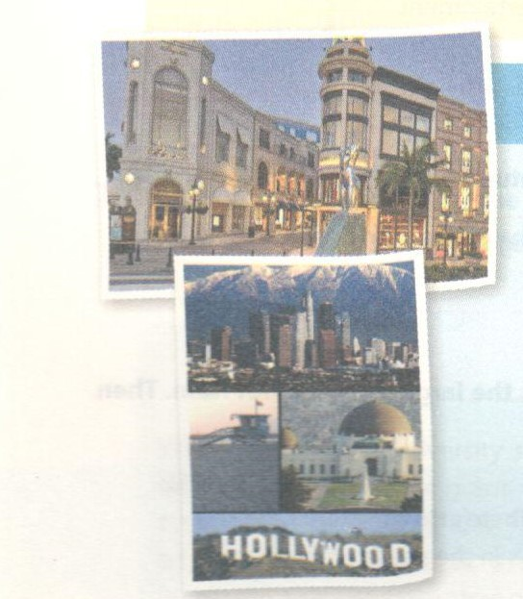
1. What is special about Venice?
2. Where's Los Angeles?
3. What can visitors do in Venice?
4. Which city is famous for its entertainment industry?
5. Which city do you like better? Why?
Key - Đáp án:
1. Built on many islands/has no roads/boats are the main means of transport.
2 In California, USA.
3. They can visit Piazza San Marco/museums.
4. Los Angeles is.
5. (Dependent on students' preference.)

2.Fill each blank with a suitable word to complete the passage.
Điền từ thích hợp để hoàn thành đoạn văn.
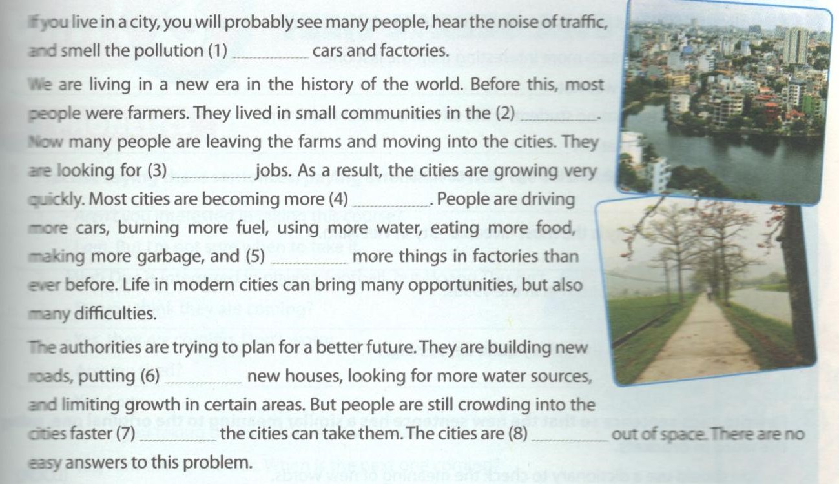
Key - Đáp án gợi ý:
1. from; 2. country; 3. better; 4. crowded
5. producing; 6. up; 7. than; 8. running

3.Choose the correct option A,B,C, or D for each gap in the passage.
Chọn đáp án A,B,C hoặc D cho mỗi chỗ trống dưới đây.
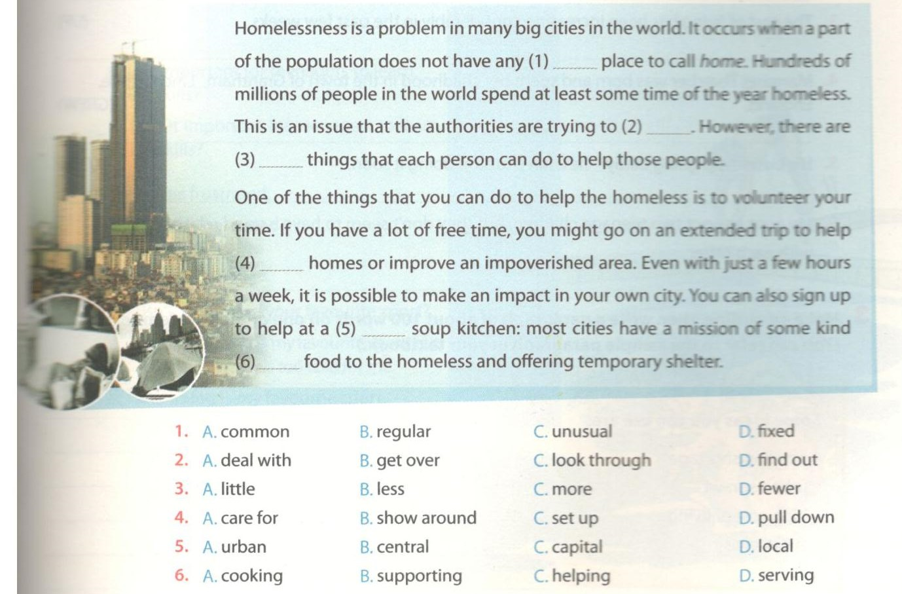
Key - Đáp án:
1. B; 2. A; 3. C; 4. C; 5. D; 6. D
E-Writing-trang 18-Unit 2-Sách bài tập (SBT) tiếng anh lớp 9 mới
1.Complete the second sentences in each pair so that it has a similar meaning to the first sentences.
Hoàn thành câu thứ hai trong mỗi cặp sao cho cùng nghĩa với câu thứ nhất.
1. This exhibition is much more interesting than the last one.
-> The last exhibition was not_______________________________.
2. The teacher says that no student in the school is noisier than I am.
-> The teacher says that I'm_______________________________ .
3. This book is the least interesting I've ever read.
-> I have never________________________________________.
4. I think Vung Tau City is the most ‘liveable’ city in Viet Nam.
-> I think there is no___________________________________.
5. This city is the same as it was in the 1990s.
-> This city hasn't_______________________________________.
6. He found the visit to the gallery quite depressing.
-> He felt ____________________________________________.
Key - Đáp án:
1. The last exhibition was not as interesting as this one.
2. The teacher says that I’m the noisiest student in the school.
3. I have never read a less interesting/more boring book than this one.
4. I think there is no city in Viet Nam (that is) more ’liveable' than Vung Tau City.
5. This city hasn't changed since the 1990s.
6. He felt quite depressed by/about the visit to the gallery.

2.Rewrite each sentences so that the new sentences has a similar meaning to the original one, using the word in brackets.
Viết lại những câu sau sao cho câu mới có nghĩa giống với câu gốc, sử dụng từ trong ngoặc.
1. You should use a dictionary to check the meaning of new words. (LOOK)
_____________________________________________
2. The doctor told my father to stop smoking. (GIVE)
_____________________________________________
3. The cost of living has been increasing considerably in the past few weeks. (UP)
_____________________________________________
4. Margaret Thatcher was born and spent her childhood in the town of Grantham, Lincolnshire, England. (GREW)
_____________________________________________
5. His business is going badly - he'll have to stop doing it soon. (CLOSE)
_____________________________________________
6. My aunt has got two teenage children, but they don't seem to have a good relationship with each other. (GET)
_____________________________________________
Key - Đáp án:
1. You should use a dictionary to look up new words.
2. The doctor told my father to give up smoking.
3. The cost of living has been going up considerably in the past few weeks.
4. Margaret Thatcher was born and grew up in the town of Grantham, Lincolnshire, England.
5. His business is going badly, so he'll have to close it down soon.
6. My aunt has got two teenage children, but they don't seem to get on well with each other.

3. Make an outline, then write a paragragh of about 100 words on one of the problems of city life. The doctor told my father to stop smoking.
(You can refer to the same paragragh in your texbook.)
Làm một dàn bài, sau đó viết một đoạn văn khoảng 100 từ nói về những vấn đề của cuộc sống thành thị.
(Bạn có thể tham khảo đoạn văn trong sách giáo khoa)
Some ideas you can use are:
Một vài ý tưởng bạn có thể sử dụng:
- housing shortage
- urban sprawl
- high cost of living
- social evils

