Test Yourself 1 - trang 27 - Sách bài tập (SBT) tiếng Anh 9 mới
1. Look at the sentences below. Put the underlined words into the correct column according to whether they are stressed or unstressed. (1 p)
Nhìn các câu dưới đây. Xếp các từ gạch chân vào đúng cột.
1. A: They didn't embroider this picture by hand.
2. A: She's still doing her homework.
B: Is she?
3. A: Who broke the window?
B: He did!
4. A: Are you angry?
B: Yes, I am.
Key - Đáp án:
 | Stressed | Unstressed
1 | Didn’t, picture | They
2 | She(B) | She(A), her
3 | Who, he
 | Am | Are

2. Choose the best answer A, B, C, or D to complete the sentences. (1 p)
Chọn đáp án đúng nhất A, B, C hoặc D để hoàn thành các câu sau.
1. Nam didn't know__________to find more information about the course.
A. what B. why C. Where D. while
2. He asked_______it was too early to apply for the course.
A. if B for C. while D. that
3. I couldn't sleep last night____________ the bar nearby played music so loudly.
A. although B. so that C. while D. because
4. _____they moved to the city five years ago, they still remember living in a small town.
A. Although B. Whereas C. While D. In order that
5. The students didn't know to do to deal with the problem.
A. where B. when C.why D. what
6. Lots of people choose to buy houses in the suburbs in the city.
A. although B. when C. so that D. so as
7. Minh is_______ the most successful student in my class.
A. so long B. by how C. by far D. so now
8. My grandfather is the ................ oldest artisan in the village; Ngoc's grandfather is the oldest.
A. first B. second C. most D. one
9. ________was talking to my teacher, my friends were waiting outside the classroom.
A. In order that B. While C. Although D. So that
10. Lan couldn't decide_________ to work with on the project.
A who B. what C. how D. when
Key - Đáp án:
1C; 2A; 3D; 4A; 5D; 6C; 7C; 8.B; 9B; 10.A

3. Complete each sentence using a verb from A in the correct form and a particle from B. You can use any particle more than once. (2 p)
Hoàn thành các câu sau sử dụng động từ ở cột A kết hợp với giới từ ở cột B, có thể sử dụng một giới từ nhiều lần.
A  Turn, bring, deal, live, break,  Set, keep, go, give, run | B  Out, down, with,  up, on, off
1. Don't ............... practising. You're making good progress.
2. Mai_________ her stress by taking up yoga.
3. Hoang was sad because he failed to________ to his parents'expectations.
4. If they _______ cutting down trees, the city will lose its beauty.
5. Our band has just_________ our second album.
6. We missed the beginning of the film since our motorbike_____________ on the way to the cinema.
7. She wanted to knit a scarf, but she________ of wool before she was finished.
8. If you don't_________ with your regular exercise, you'll gain more weight.
9. Their proposal to build another skyscraper in the city has been _______ as it may be dangerous.
10. What time do you want to_________ for Hai Duong?
Key - Đáp án:
1. give up 2. dealt with 3. live up 4. go on
5. brought out 6. broke down 7. ran out 8. keep up
9. turned down 10. set off

4. Complete each sentence with the correct form of the word in brackets. (1 p)
Hoàn thành các câu sau với dạng đúng của động từ cho trong ngoặc.
1. One of the_____in my hometown is the traditional market, which is open every Sunday. (attract)

2. What are the differences between Dong Ho________ and Sinh ones? (paint)
3. This is a very beautiful piece of______ . (embroider)
4. _____is one of the biggest problems in this city. (employ)
5. Photography is strictly ___ in this museum. (forbid)
6. Do you know what is the most________ town in this region? (population)
7. Remember to visit the Ancient Tower as it's the only________building in our area, (history)
8. I feel so________ because I can't run as fast as my friends, (embarrass)
9. _______can help you succeed in many fields, (confident)
10. Find out more about the job so that you can make an_________ choice. (inform)
Key - Đáp án:
1. attractions 2. paintings 3. embroidery 4. Unemployment
5. forbiden 6. populous/populated 7. historic 8. embarrassed
9. Confidence 10. informed

5. Identify a mistake in each sentence and correct it. (1 p)
Tìm ra lỗi sai trong mỗi câu sau và sửa chúng.
1. Mai went to the Student Support Office although she wanted to get some advice.
2. I don't know which one is most ancient: Bat Trang pottery village or Bau True pottery village?
3. Are you sure you can get on your new classmates?
4. If you don't know what to operate the machine, you should read the instruction manual.
5. Ngoc is stressful because she's sitting an important exam tomorrow.
Key - Đáp án:
1. although -> because/since/as 2. most -> more
3. get on-> get on with 4. what -> how 5. stressful -> stressed

6. Read some students'opinions about whether a city should preserve its old, historic buildings or destroy them and replace them with modern buildings. Do the following exercises. (1 p)
NGA
Preserving some of our old and historic buildings for future generation is necessary. We can build modern buildings anytime. However, once old buildings are destroyed, we can bring them back again. We may find these buildings unnecessary at the moment, but in the distant future, they may become very important to our descendants.They may to see those buildings with their own eyes, not just look at pictures, or read descriptions of them.
TRANG
We should preserve historic sites because they are of educational value. To be specific, historic buildings are popular spots for field trips for various schools, ranging from schools to high schools. In fact, my class was taken to the Temple of Literature, the first university in Viet Nam, was in grade five. It was an interesting experience as it help me and my friends understand more about our educational system in the past.
LONG
Old and historic buildings can be interesting tourist attractions. We may be astonished by, and admire, their unusual and distinctive beauty. Local people enjoy experience their country's history, but foreign visitors also want to see those buildings. They come from other and want to enjoy something different.
a. Match the words in A with their definition in B.
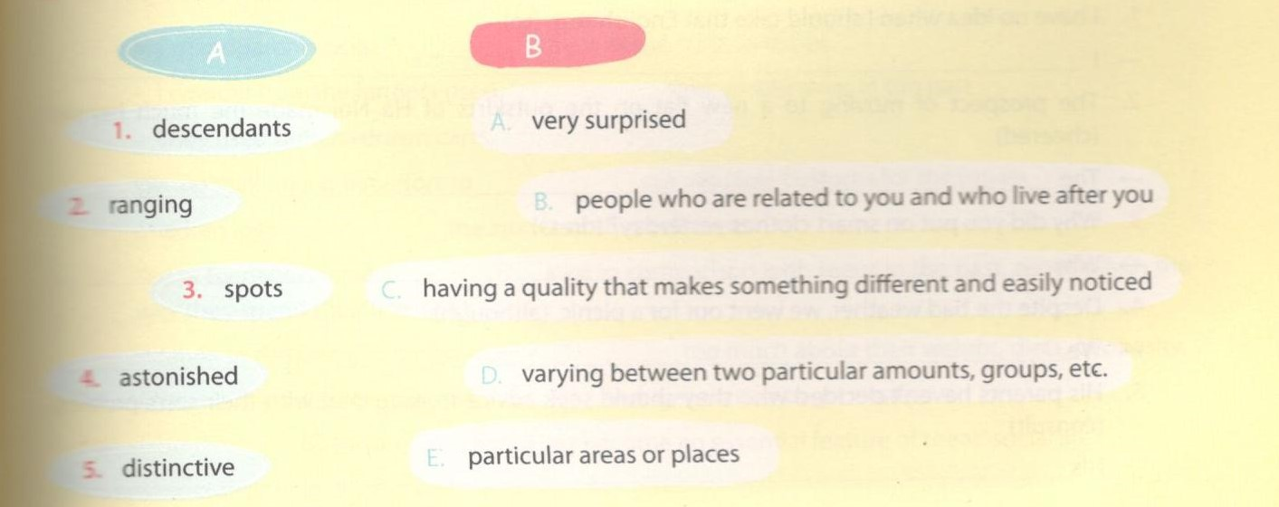
b. Which student Nga, Trang, or Long mentions the following points? Tick () the appropriate boxes.
Nga, Trang hoặc Long đề cập đến những điểm nào? Tích vào trong cột tương ứng.
Which student | Nga | Trang | Long
1. visited a historic site?
2. says foreign tourists may like seeing historic buildings?

3. thinks future generations may be interested in historic buildings?

4. mentions the educational aspect of these buildings?

5. mentions the special beauty of historic buildings?

Key - Đáp án:
a. 1B; 2D; 3E; 4A; 5C
b. 1. Trang; 2. Long; 3. Nga; 4. Trang; 5. Long

7. Put an appropriate word in each gap in the following passage. (2 p)
Điền từ thích hợp vào chỗ trống trong đoạn văn sau.
I've (1)____________ working with teenagers for five years. I've spent time talking to them besides teaching them English. I remember once asked them (2)______ their parents or classmates had influence on their success at school. Some said their parents had (3)__________ influence on their achievement. The (4) _____________ given was that parents usually loved their (5)____________unconditionally, and they definitely would do their best to help and support their children. For (6)___ parents could do all housework so that their children could have(7)_______for studying.
However, some students revealed that their parents were (8) busy to spend time with them. Therefore, it was difficult for parents help their children. In this case, classmates or friends affected their success (9)...................... because they talked to them more and they helped each other to deal (10)____________ any difficulty in studying.
Key - Đáp án:
1. been 2. if/whether 3. most/biggest/greatest 4. reason
5. children 6. example 7. time/opportunity
8. too 9. most 10. with

8. Complete the second sentence so that it has a similar meaning to the first one, using the given. (1 p)
1. I have no idea when I should take that English test, (to)
-> I_____________________________________________
2. The prospect of moving to a new flat on the outskirts of Ha Noi made me much happier. (cheered)
-> The___________________________________________
3. Why did you put on smart clothes yesterday? (dress)
-> Why__________________________________________
4. Despite the bad weather, we went out for a picnic, (although)
-> We___________________________________________
5. His parents haven't decided who they should seek advice from to deal with their son's problem. (consult)
-> His___________________________________________
Key - Đáp án:
1. I have no idea when to take that English test.
2. The prospect of moving to a new flat on the outskirts of Ha Noi cheered me up.
3. Why did you dress up yesterday?
4. We went out for a picnic although the weather was bad.
5. His parents haven't decided who to consult to deal with their son's problem.

