A. Phonetics - trang 48 - Unit 6 - Sách bài tập (SBT) tiếng Anh 9 mới
1. Write the words from the box in the correct part of the table according to the stress pattern, tt read them aloud.
Xếp các từ cho trước vào ô tương ứng với cách nhấn mạnh của từ đó. Đọc to, rõ ràng.
Go away! | Keep working!
Straight ahead! | Don't move!
Try it on! | Think twice!
Watch out! | Turn it off!
Don't forget! | Put it down!
Come closer!

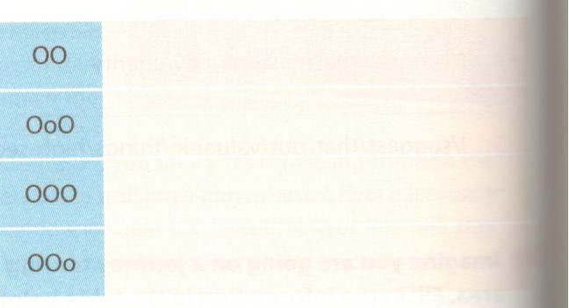
Key - Đáp án:
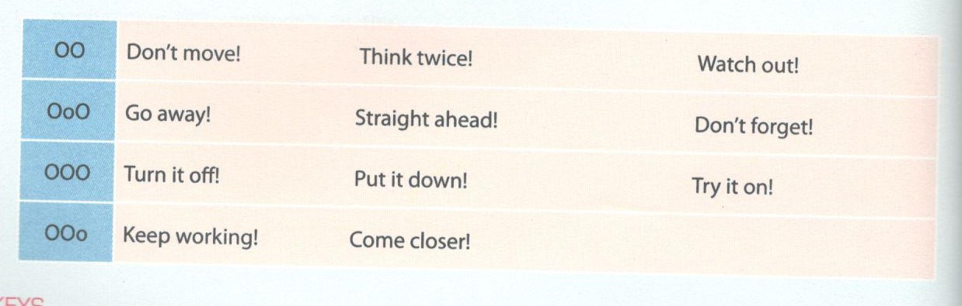

2. What would you say in each situation shown in the pictures? Write an imperative sentence under each picture, then practise reading the sentences aloud.
Bạn sẽ nói gì nếu ở trong các tình huống dưới đây? Viết một câu mệnh lệnh dưới mỗi bức tranh và sau đó đọc to.
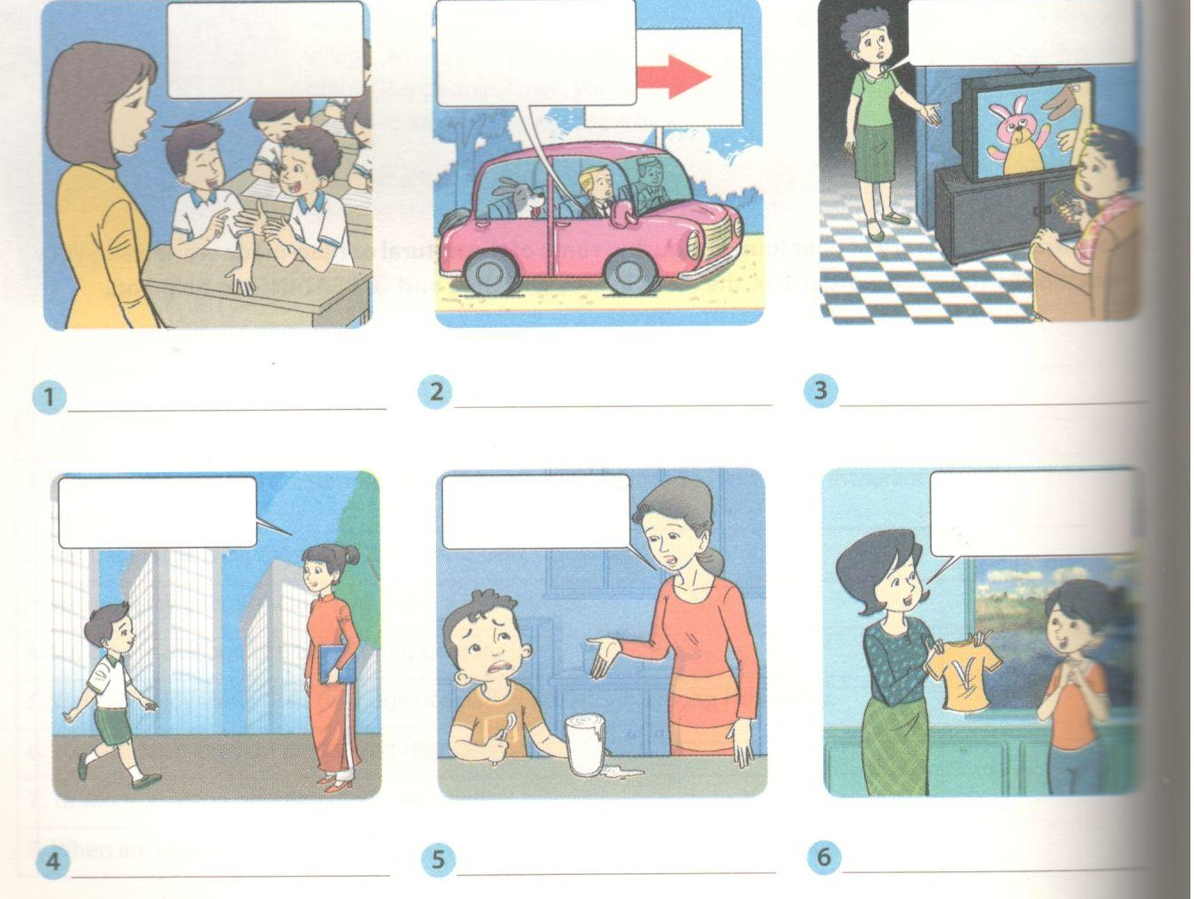
Key - Đáp án:
1. Keep silent! Keep working! OOo
2. Go ahead! Straightahead! OoO
3. Turn it off! OOO
4. Come here! 00 Come closer! Ooo
5. Finish it! Ooo
6. Try it on! 000
B. Vocabulary & Grammar - trang 49 - Unit 6 - Sách bài tập (SBT) tiếng Anh 9 mới
1. Complete the following sentences with the right form of the words/phrases from the box.
Hoàn thành các câu sau với dạng đúng của động từ cho trước.
straw hat tiled roof facility
trench uniform thatched house
1. Fifty years ago, we had very few schools and the rows of classrooms looked like________.
2. During wartime, all around the rows of classrooms there were_______so that children could shelter from bombs.
3. Modern classrooms are well equipped with various_____including bookshelves, cassette players, or computers.
4. In the past, school children didn't often wear__________ like they do today.
5. The only things that made school children in the past look alike were their_____and rubber sandals.
6. In the past, many classrooms in Viet Nam were made of mud and straw and few had______.

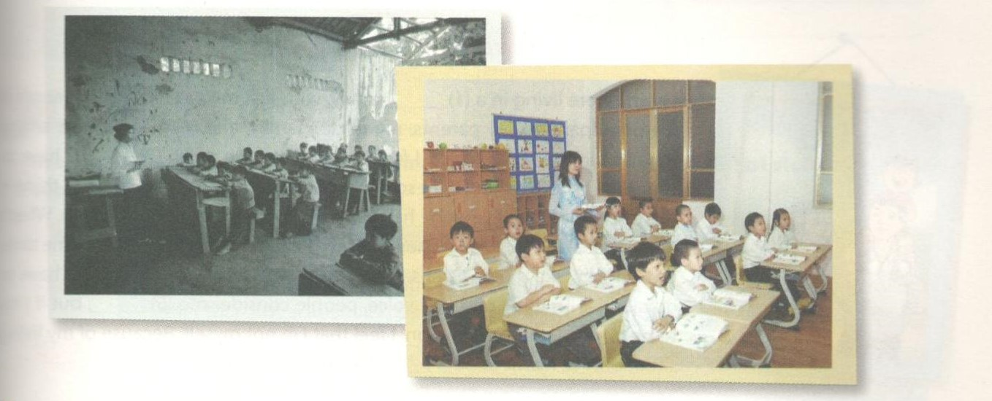
Key - Đáp án:
1. thatched houses 2. trenches 3. facilities
4. uniforms 5. straw hats 6. tiled roofs

2. Rewrite the following sentences using adjectives or adverbs showing degree of change.
Viết lại các câu sau, sử dụng tính từ hoặc trạng từ để thể hiện cấp độ thay đổi.
1. The school facilities have been improved a lot within the last three years.
-> There have been_____________________________________ .
2. There is a minor increase in the number of children going to school this year.
-> The number _____________________________________ .
3. The number of nuclear families in the countryside has risen little by little.
-> The number_______________________________________ .
4. There has been quite a large reduction in the number of poor families in the countryside.
-> There has been________________________________________.
5. The number of students attending university in Viet Nam has grown very much in recent years.
-> There has been a___________________________________ .
6. Though the pace of life in the countryside has not changed as rapidly as in the city, the changes seem significant.
-> In spite of ___________________________________ .
Key - Đáp án:
1. There have been dramatic improvements in the school facilities in the last three years.
2. The number of children going to school this year has slightly increased.
3. The number of nuclear families in the countryside has risen gradually.
4. There has been a considerable reduction in the number of poor families in the countryside.
5. There has been a significant increase in the number of students attending university in Viet Nam, in recent years.
6. In spite of slower changes to the pace of life in the countryside compared to the city, the changes seem significant.

3. Complete the word webs for the different modes of transportation.
Hoàn thành sơ đồ sau bằng các dạng phương tiện giao thông.
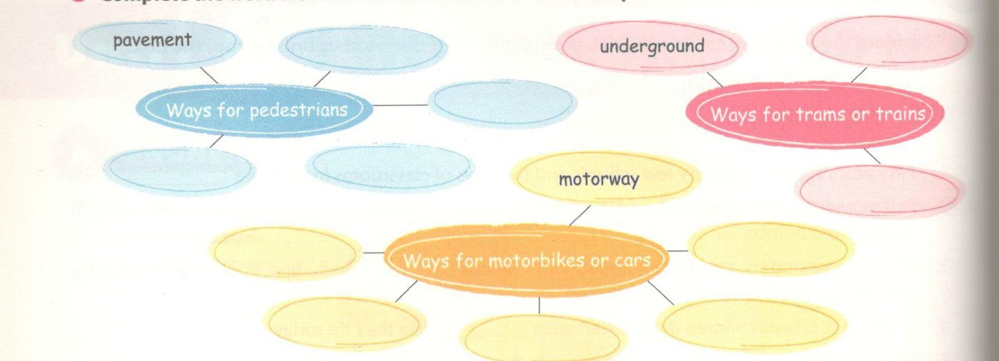
Key - Đáp án:
Suggested answers:
Ways for pedestrians: underpass, elevated walkway, sidewalk, pavement, footpath
Ways for trams or trains: railway, railroad, underground, tube, overground railroad, skytrain
Ways for motorbikes or cars: road, highway, flyover, tunnel

4. Fill each blank with a suitable word from the box to complete the passage.
disobedient cooperation nuclear privacy
tolerant annoying patient
I wish I were living in a (1)_____ family, with just my parents. At the moment my grandparents, my parents, my uncle's family, and my two siblings all together in the same house. I feel that I don't have much (2)______. I have share almost everything with so many people, and the most (3)______thing the television time. Everyone has different ideas about what to watch. more, there is no (4)____ when it comes to decision making. Most of the the elders make the decisions, and the younger family members just have to go along with it. If I raise my voice, people consider me (5)______ , but if to be (6)_____ of the situation, I feel that I'm not myself. Because of my living situation, I've learnt to be (7)___and easy-going.
Key - Đáp án:
1. nuclear 2. privacy 3. annoying 4. cooperation
2. disobedient 6. tolerant 7. patient

5. Complete the second sentence so that it has the same meaning as the first one.
Hoàn thành các câu sau sao cho nghĩa không đổi.
1. She was so unprofessional that she didn't prepare for the presentation.
->It was ______________________________________________________________.
2. It was confident of her to say that she would win first prize.
-> She was_________________________________________________________.
3. Our teacher was relieved when he heard that all of his students had made progress.
-> Our teacher__________________________________________________.
4. It was surprising for me to learn that he is the only child in his family.
-> I was________________________________________________________.
5. They know very well that physical education is an important school subject.
-> They are _______________________________________________________.
6. The mother was happy when she learned that her daughter had enjoyed herself at the party.
-> The mother ___________________________________________________.
Key - Đáp áp:
Suggested answers:
1. It was unprofessional of her not to prepare for the presentation.
2. She was confident that she would win first prize.
3. Our teacher was relieved to hear that all of his students had made progress.
4. I was surprised to learn that he is the only child in his family.
5. They are fully aware that physical education is an important school subject.
6. The mother was happy to know that her daughter had enjoyed the party.

6. Each of the following sentences has a mistake in it. Underline the mistake and correct it.
Mỗi câu sau có một lỗi sai. Gạch chân lỗi sai và sửa lại cho đúng.
1. It was kind to her to consider other people's interests when making decisions.
2. It is hard for a country that develop its economy with poor resources.
3. The students are conscious that they be closely monitored.
4 . They are annoyed that considered the slowest group.
5. Visitors were surprised that find dramatic changes in the country within a very short time.
6. Passers-by are delighted to the new underpass is being built.
Key - Đáp án:
1. to her => of her
2. that develop => to develop
3. be closely monitored => are closely monitored
4. that considered => to be considered
5. that find => to find
6. to the => that the

7. Finish the sentences using your own ideas.
Hoàn thành các câu sau theo ý của bạn.
1. Motorists are happy that ________________________________________.
2. It was courageous of him to _____________________________ .
3. They were delighted that________________________________________ .
4. We are glad to__________________________ .
5. The residents were annoyed that__________________________________________ .
6. I will certainly_________________________.
Key - Đáp án:
Suggested answers:
1. Motorists are happy that they are driving on the new flyover.
2. It was courageous of him to jump down to rescue the boy.
3. They were delighted that the traffic system has been improved considerably.
4. We are glad to have much better working conditions.
5. The residents were annoyed that a new railway track was being built through the village.
6. I will certainly tell you if I need help with my homework.
C. Speaking - trang 51 - Unit 6 - Sách bài tập (SBT) tiếng Anh 9 mới
1. Rearrange the statements to make a complete conversation. The first and last statements have been completed for you.
Sắp xếp lại các câu sau để thành đoạn hội thoại hoàn chỉnh. Câu đầu và câu cuối đã được điền sẵn.
A - So has the school system in your country changed a lot recently?
- The school curriculum, for example. More emphasis is put on developing students' skills, rather than just academic knowledge.
- Classrooms with tiled roofs are no longer only seen in big cities, and each classroom has a good blackboard, much better tables, and proper school desks. In many schools, they even have air conditioning. Many more schools also have good libraries and laboratories.
- That sounds great! Are there any other changes you find significant?
- Sure. Now they pay more attention to physical education, arts, and music. Students also have the chance to work in groups on assigned projects.
- How much better are they?
- In general, they are better-qualified. Moreover, they can enjoy more on-the-job training. - Can you give me an example of that?
- What about the quality of the teachers?
- I think there are considerable changes, the most obvious being the number of better- equipped schools.
K - Wow.That is an amazing change!
Key - Đáp án:
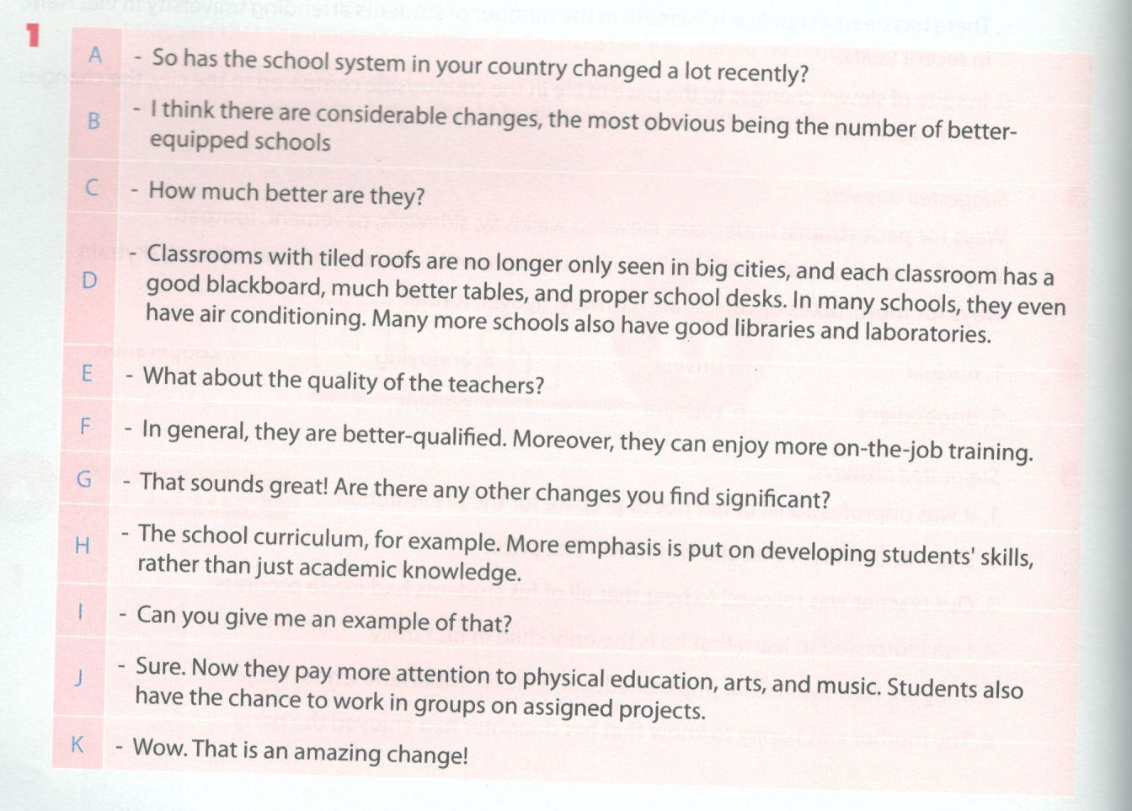

2. Imagine you are going to give a presentation about the changes in the ways Vietnamese people: spend their holidays, and the reasons for those changes. Look at the suggestions, and work with your partner to prepare for the presentation.
Tưởng tượng rằng bạn sẽ thuyết trình về sự thay đổi trong cách nghỉ lễ của người Việt và đưa ra lý do của sự thay đổi đó. Nhìn vào các gợi ý sau và làm việc nhóm.
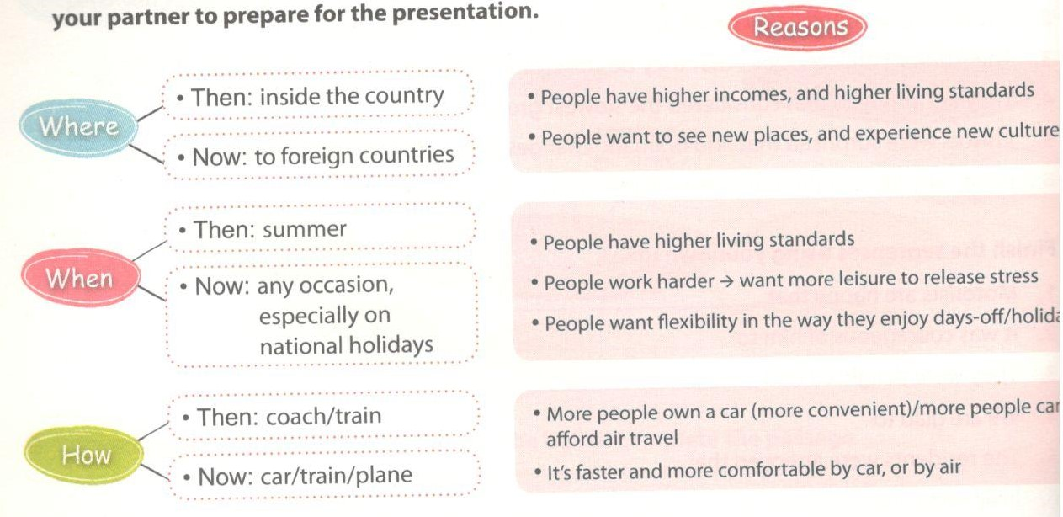
D. Reading - trang 52 - Unit 6 - Sách bài tập (SBT) tiếng Anh 9 mới
1. Read the passage about the train system in Viet Nam and choose the correct answer A, B, C, D for each blank.
Đọc đoạn văn sau về hệ thống tàu hỏa ở Việt Nam và chọn đáp án đúng cho mỗi chỗ trống.
The railway system in Viet Nam was first built in 1899, when Viet Nam was still a French colony. The total (1)_______ of the railroad is over 3,000 km, with the main route being the North-South (2)____ which is 1, 726 km long. This track was considered the backbone of Indochina at the time. Now, the rail sys (3)___35 out of the 63 cities and provinces of Viet Nam.
However, the system was (4)__________ damaged by bombings during the war. In 1975, after reunification of the north and the south, the Vietnamese government decided to (5)_____ system. In the space of a year, hundreds of bridges, tunnels, and stations were restored, along with 660 km of tracks. The new and improved system was (6)_____ the Thong Nhat Express. Thanks to the rail system, travelling from north to south has become much more (7)_____ for tens of thousands of people.
In the past, in order to be able to buy train tickets, people had to wait in long lines. Now, (8)___________ can buy tickets online, or at the central station, without having to wait that long.

1. | A. long | B. length | C. wide | D will
2. | A Railway | B. Road | C. Route | D Way
3. | A uncovers | B. discovers | C. covers | D stretches
4. | A. seriously | B. importantly | C. serious | D very
5. | A. build | B. restore | C. grow | D. upgrade
6. | A. recalled | known | C. considered | D. renamed
7. | A. convenient | uncomfortable | C. harder | D. modern
8. | A buyers | F visitors | C. passengers | D. attendants
Key - Đáp án:
1. B 2. A 3. C 4. A 5. B
6. D 7. A 8. C

2. Read the text about the London Underground transit system, and do the tasks that follow.
Đọc đoạn văn sau về hệ thống tàu điện ngầm ở London và làm bài tập.

The London Underground, or theTube, is the popular public transportation system of London. The concept for the London Underground was firstproposed in the 1830s, by a lawyer called Charles Pearson. However, not until 1863 was the first section of the Underground built, and opened to the public. On its opening day, it transported 38,000 passengers, and within the first year it had been used b> 93 rr ion passengers.
The system has been improved significantly over the past century, and now it includes twelve lines serving Greater London, operating from 5.00 am through to 1.00 am, Monday to Saturday. On Sundays, it operates a reduced service. For the passengers' conveniencer the system is also interconnected with the overground train network which link to other parts of the country outside London.
To enable passengers to get around easiy. London Underground maps are distributed freety at afl stations. Along with a plan of the Tube system, the free maps contain useful tips for safe and efficient travelling. The map itsetf is a design classic, with the various lines indicated in different colours and dearly indicated junctions showing the stations where passengers can change between lines.

a. Match the highlighted words in the passage with the words phrases that have a similar meaning.
Nối các từ in đậm trong đoạn văn với cụm từ có nghĩa tương đương.
1. shown, or otherwise made clear
2. in a way that is important enough to have an effect on something
3. suggested
4. places where roads or lines join up
5. small pieces of advice about something practical
6. connected to, or with, similar things
b. Decide if the sentences are true (T) or false (F).
Các câu sau đúng hay sai.
 | T | F
It was first proposed by a famous London architect.
The system was opened to the public in the 18th century.
The system operates around the clock.
It is convenient to travel on the Tube, because it connects with the rail system above the ground.
London Tube maps are provide free of charge at every station.
There are twelve lines in the Undergound system.
You have to pay for tips about London Tube travelling.
Key - Đáp án:
2a. 1. indicated 2. significantly 3. proposed
4. junctions 5. tips 6. interconnected
2b. 1. F 2 F 3F 4T 5T 6T 7F

3. Read the letters by Duong and Nhi to their pen pals, and choose the best answer A, B, C, or D.
Đọc bức thư sau của Duong và Nhi và chọn đáp án đúng cho mỗi câu hỏi sau.
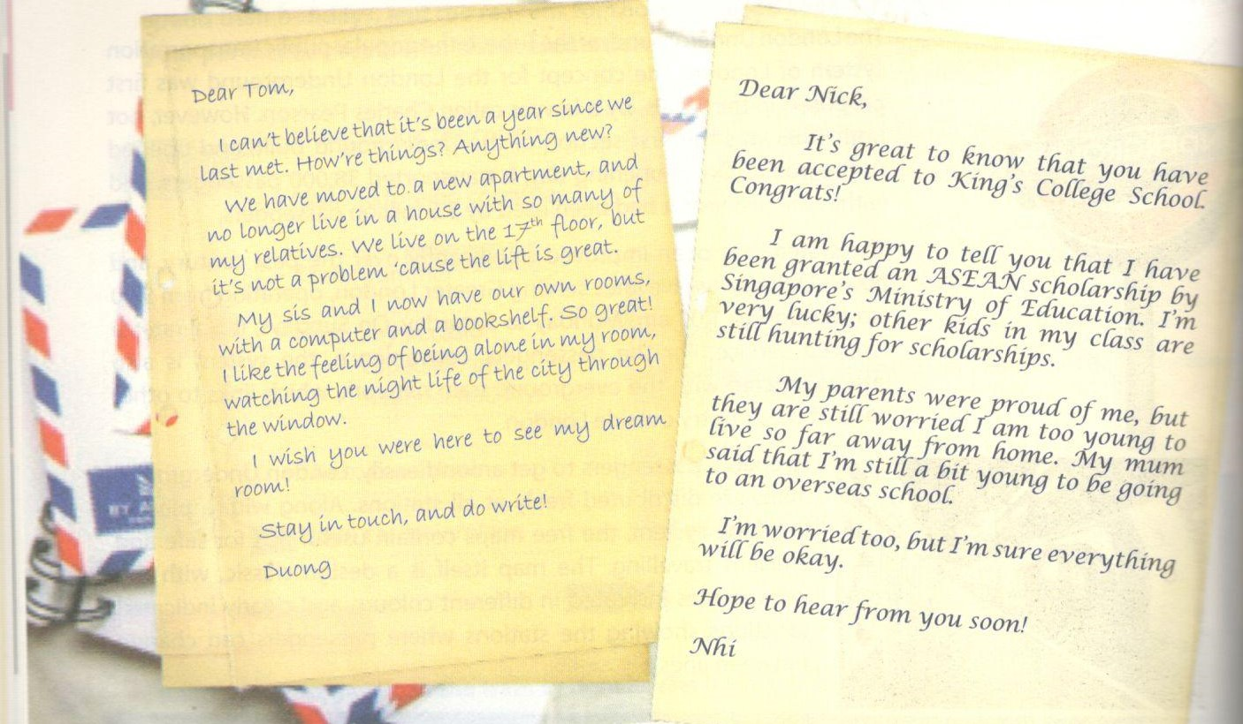

1. The two letters mainly discuss _______.
A Duong and Nhi's pets
B Duong and Nhi's hobbies
C.Duong and Nhi's favourite sports
D. Duong and Nhi's feelings about their recent life changes
2. All of the following are true about Duong EXCEPT .
A. he used to live in a nuclear family
B.he used to live in an extended family
C.he didn't have enough privacy
D. he now lives in a high-rise building
3. What Duong likes most about his new apartment is_______ .
A. the convenient lift
B. a shared room, with a computer and a bookshelf
C. a private room, with his own computer and bookshelf
D. a room with a view of the city
The word 'granted’ in Nhi's letter is close?: meaning to .
A. taken
- assisted
C.supported
D.given
5. The word 'hunting’ in Nhi's letter mostly means
A. ignoring
B. applying
C. searching
D. dropping
6. It can be understood from Nhi's letter that______.
A. she is unwilling to go abroad
B. the scholarship will not pay for her studies
C. her parents are worried about Nhi living abroad
D. Nhi has been accepted by a school close to home.
Key - Đáp án:
1. D 2. A 3.. C 4. D
5. C 6. C
E. Writing - trang 55 - Unit 6 - Sách bài tập (SBT) tiếng Anh 9 mới
1. Rewrite the sentences using the words in brackets.
Viết lại các câu sau sử dụng từ trong ngoặc.
1. There are many benefits of building a skytrain system in the city, (beneficial)
2. It is advantageous to invest more in education, (advantages)
3. The number of well-equipped schools has increased sharply, (sharp
4. The traffic system in the country has gradually been upgraded in the last decade, (gradual)
5. The quality of life of people in the countryside has also been improved significantly. (significant)
6. Recently there has been a considerable rise in investment in school facilities, (considerably)
Key - Đáp án:
1. It would be beneficial to build a skytrain system in the city.
2. There are many advantages of investing more in education.
3. There has been a sharp increase in the number of well-equipped schools.
4. There have been gradual upgrades to the traffic system in the country in the last decade.
5. There has been a significant improvement in the quality of life of people in the countryside.
6. Recently investment in school facilities has risen considerably.

2. Write about three benefits that children in your country can enjoy as a result of the changes to the school system over the last ten years. Use the ideas in , SPEAKING and the suggestions below for your writing. Remember to give examples.
Viết về 3 lợi ích của cải cách giáo dụng mà trẻ em nước bạn được hưởng trong vòng 10 năm qua. Sử dụng gợi ý dưới đây và cho ví dụ.
- If more children go to school, illiteracy can be reduced.
- Better facilities make students more motivated to learn.
- The improvement in teaching means that students learn more.
- Children are allowed to develop both their knowledge and their skills.
- Parents don't need to be worried when their children are at school.
