Test Yourself 2 - Kiểm tra cá nhân 2 - trang 56 - Sách bài tập (SBT) tiếng Anh 9 mới
1. Match the sentences (1-10) with the sentences that have roughly the same meaning (A-J). Underline all the words that are stressed in the sentences (1-10). (2 p).
Nối các câu 1-10 với nghĩa tương ứng A-J. Gạch dưới các từ nhấn mạnh trong câu 1-10.
1 | Who do you take after? | A | He's the man you should consult.
2 | You should take out 'quality'. | B | I really hope you have a good time.
3 | This is the man you have to talk to. | C | Be careful, boy!
4 | You mustn't smoke in here. | D | Don't forget to clean it!
5 | I didn't email him. | E | Who do you resemble?
6 | I do hope you enjoy yourself. | F | Don't keep holding that!
7 | She has finished the essay, but I haven't. | G | I only sent him a text message.
8 | Put that down! | H | The word 'quality’ should be omitted.
9 | Remember to wash it! | I | I am worrying about the essay.
10  L. | Watch out, boy! | J | You are not allowed to smoke in here.
Key - Đáp án:
1. E 2. H 3. A 4. J 5. G 6. B
7. I 8. F 9. D 10. C
1. Who, take, after 2. take, quality 3. the, man, talk, to
4. mustn't, smoke, here 5. didn't, email 6. do, hope, enjoy
7. finished, essay, haven't 8. Put, that, down 9. Remember, to, wash, it

2. Choose the most appropriate answer A, B, C, or D. (1 p).
Chọn đáp án thích hợp.
1. It is important to____the wonders of the world so that future generations can see them their own eyes.
A. destroy B. ignore C. remain D preserve
2. You don't have to go to a supermarket for that. Just wait for a street___________ to go past, and buy
A. person B. vendor C. supplier D. purchaser
3. Production methods in the village are normally_________ from ancestors to the younger generation.
A. passed away B. passed out C. passed up D. passed down
4. It is important to decide if promotion should be based on merit or___________ .
A. gender B. year C. seniority D. weight
5. It's a great experience to be sitting comfortably in a______
streets.
A. bicycle B. rickshaw C. car D. train
6. Working in a place full of hustle and bustle like this, I can’t help missing my tranquil and _______village.
A. picturesque B. modern C. loud D. ugly
7. The scenery is______ when viewed from the mountain top. It feels like your breath is being taken
A. nice B. good C. spectacular D. peaceful
8. _________by the sea, the country has the advantage of having a large coastal area.
A. Situating B. Located C. Locating D. Stood
9. I love it when we go to see plays, and try to_________ when we get back home.
A. play B. role-play C. act them out D. act
10. It is hard for people of different_________ to get along in an extended family.
A. generations B. genders C blood D. families
Key - Đáp án
1. D 2. B 3. D 4. C 5. B
6. A 7. C 8. B 9. C 10. A

3. Choose the underlined word/phrase which is incorrect. (1 p)
Chọn từ bị sai để sửa.
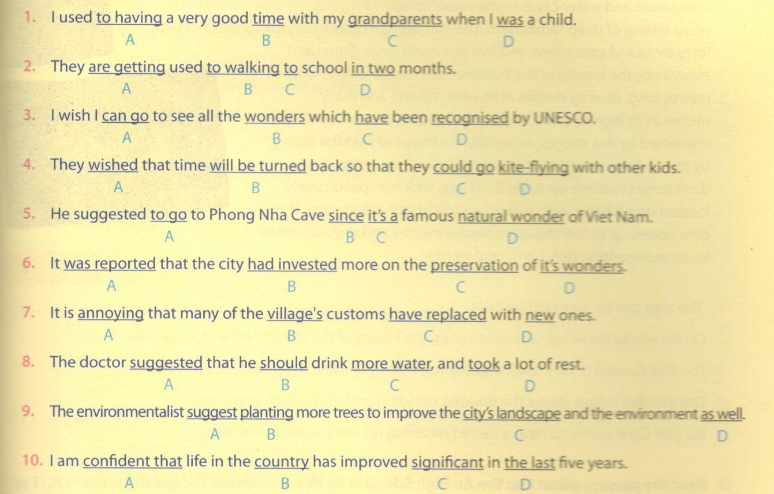
Key - Đáp án:
1. A 2. D 3. A 4. B
5. A 6. D 7. C 8. D 9. A 10. C

4. Put an appropriate word in each gap in the following passage. (2 p)
Điền từ thích hợp vào chỗ trống.
I still remember how we celebrated Tet when I was small. We used to live in an (1)______family, with ourgrand parents and our uncle's family.
Our family (2)________ to make banh chung Tet came. It was a busy, but wonderful, time for all of ú. My aunt used to be the one to clean dong leaves, the (3)______we used to wrap the cakes with. My uncle was the one to get water from the well for (4)________ to do the cleaning. My mom was always (5)______--for the preparation of the filling, which was made of green beans, and pork flavoured with onion and pepper. Normally, my grandfather did the wrapping, and we sat around watching him do it excitedly. We (6)______ also happy to be asked to fetch anything my grandpa needed. When the night fell, we started boiling the cakes, which (7)___________ about eight hours. It was hard to wait so long for them! We stayed up (8)_______________ the night, grilling sweet potatoes, listening to our grandpa's (9) , and playing chess or cards. Now we have grown up, and are often too busy to make banh chung. But it remains a really sweet (10) _____ for us all.
Key - Đáp án:
1. extended 2. used 3. leaves 4. her 5. responsible
6. were 7. took 8. throughout 9. stories 10. memory

5. Read the passage and decide whether the statements are true (T) or false (F).
Welcome to Thung Nham, the Ecotourism Bird Garden!
This area is in Ninh Hai commune, Hoa Lu district, Ninh Binh, north Viet Nam. Come, and you can enjoy a forty-minute boat-ride on the river from Tam Coc, Bich Dong, to the small picturesque valley where the Bird Garden is located. The experience of floating past mangroves and water caves to the astoundingly vast garden will definitely bring you a feeling of deep satisfaction. The Bird Garden boasts forty-six varieties of bird, forty thousand specimens, and five thousand nests. Come and experience the beauty of the Buddha Cave, which is five-hundred metres long, seventy metres at its widest point, and thirty metres at its highest point. Exploring the cave, you will be deeply impressed by the images, especially the image of Buddha sitting by the underground river bringing good luck to visitors. And don't forget to climb up to Vai Gioi Cave, which is spectacularly located on a hill top, eighty-eight metres above the ground.The cave covers up to five thousand square metres, and includes three levels representing Hell, Earth, and Heaven.
1. The area can be accessed by boat.
2. On the way to the valley, visitors can enjoy the beauty of the mangroves and water caves.
3. The Bird Garden is very small and boring, with only a few different types of birds.
4. The Buddha image shows the Buddha standing and giving luck to visitors.
5. Vai Gioi Cave seems to have a sacred meaning for the people of the area.
Key - Đáp án:
1. T 2.T 3. F 4. F 5.T

6. Read the passage about Chu Van An High School in Ha Noi, and answer the questions about it (1p ).
Đọc đoạn văn sau về trường trung học Chu Văn An Hà Nội và trả lời các câu hỏi.
Chu Van An High School is one of the oldest and most prestigious state schools in Viet Nam Established in 1908 by the French, the school was located beside the West Lake, and was origir named after the location it was in. It is a very pleasant, spacious school with great views of the lake 1 the classroom windows.
In 1943, the school was moved to Ninh Binh, and was not moved back to Ha Noi until 1945. In year, the school was renamed Chu Van An, after a famous Vietnamese Confucianism teacher of the Tran Dynasty. Professor Nguyen Gia Tuong became the first Vietnamese principal of the school. Many famous people like ex-Prime Minister Pham Van Dong, Doctor Ton That Ti and poet Xuan Dieu used to be the school's students.
Today the school is still located in the same area, and hi maintained its prestige, as well as its reputation as one the top schools in Ha Noi. It is very difficult to be admr to the school. Every year, there are around three thou applicants but only about five hundred are admitted applicants have to take an entrance examination conducted by the Department of Education and Training of Ha Noi.
a. Choose the best answer A, B, C, or D to each question below.
Chọnđáp án đúng.
1. The passage mainly discusses________ .
A. Chu Van An, the teacher
B. Chu Van An School in the future
C. Chu Van An School over time
D. The difficulty of being admitted to Chu Van An School
2. All of the following are true about the school EXCEPT____________ .
A. the school was originally named after the location it is in
B. the school admits three thousand students every year
C. the school has a view of the West Lake
D. the school is large
3. The word 'principal’ is closest in meaning to___________ .
A. teacher
B. head teacher
C. founder
D. supporter
4. The word 'prestige’ in the passage mostly means_________
A. respect
B. fame
C. status
D. position
5. It can be understood from the passage that___________.
A. students of the school are very smart
B. the school fees are very high
C. only children from prestigious families can enter the school
D. the teachers at the school earn a lot of money

b. Answer the following questions.
Trả lời các câu hỏi sau.
1. When was the school established?
2. How is the school described?
3. Who was Chu Van An?
4. Why is the school prestigious?
5. Why do you think the school is named after Chu Van An?
Key - Đáp án:
6a. 1. C 2. B 3. B 4. C 5. A
b. 1. It was established in 1908.
2. It is a very nice, spacious school with great views of the lake from the class windows.
3. He was a famous Vietnamese Confucianism teacher during the Tran Dynasty.
4. Because it is one of the top schools in Ha Noi. Moreover, many famous people like ex-Prime Minister Pham Van Dong, Doctor Ton That Tung, or poet Xuan Dieu used to be the school's students.
5. I think it is because he used to be a famous and dedicated teacher.

7. Put the following statements in the correct order (A-J) to make a dialogue. (1p).
A: Well, they are taught to be responsible.
B: They tell us again and again that the family is the nucleus of society, so we are supposed to keep it strong.
C: How are children in your village taught to behave?
D: That's a great value!
E: That sounds great! And what are girls supposed to do?
F: To be responsible for what we do, and to care for our loved ones.
G: Yeah. And you are supposed to work harder if you are a boy.
H: What do you mean by responsible?
I: Girls are taught to do the cooking and housework.
J: Really? And what about the value of family?
Key - Đáp án:
The right order: C-A-H-F-D-G-E-I-J-B

8. Complete the second sentences so that it has a similar meaning to the first one, using the words in brackets.
1. It's not a good idea to use the village's land to build new road. (wouldn't)
-> I
2. You should visit the historical places of the area. (worth)
-> It is
3. He suggested seeing Trang An, a natural wonder of our area.( visit)
-> What about
4. The sleepy villages are expected to mushroom into crowded towns within two years.(supposed).
-> The sleepy villages
5. It is important to educate children to preserve traditional values.(nescessary).
-> It is
Key - Đáp án:
1. I wouldn't use the village’s land to build new roads.
2. It is worth visiting the historical places of the area.
3. What about visiting Trang An, a natural wonder of our area?
4. The sleepy villages are supposed to mushroom into crowded towns within two years.
5. It is necessary to educate children to preserve traditional values.

