A. Phonetics - trang 3 - Unit 7 - Sách bài tập (SBT) tiếng Anh 9 mới
1. Mark the questions with the correct tone, using falling or rising arrows. Then practise the tion with a partner.
Đánh dấu các câu hỏi sau theo đúng ngữ điệu, sử dụng dấu lên hoặc xuống. Luyện tập với bạn bè.
Tony: Where's mum, Maya?
Maya: I don't know. I think she's gone to grandma's.
Tony: She's gone to grandma's? But grandma goes to her club every Thursday.
Maya: Oh, then I don't know.
Tony: What's for dinner?
Maya: Chicken salad and fried rice.
Tony: Salad and fried rice? It's the second time this week we've had that.
Maya: I can make something more interesting, if you prefer. Do you like green curry?
Tony: Green curry? Sure.
Maya: Go upstairs and do your homework. Your curry will be ready in twenty minutes.
Tony: I'm starving.
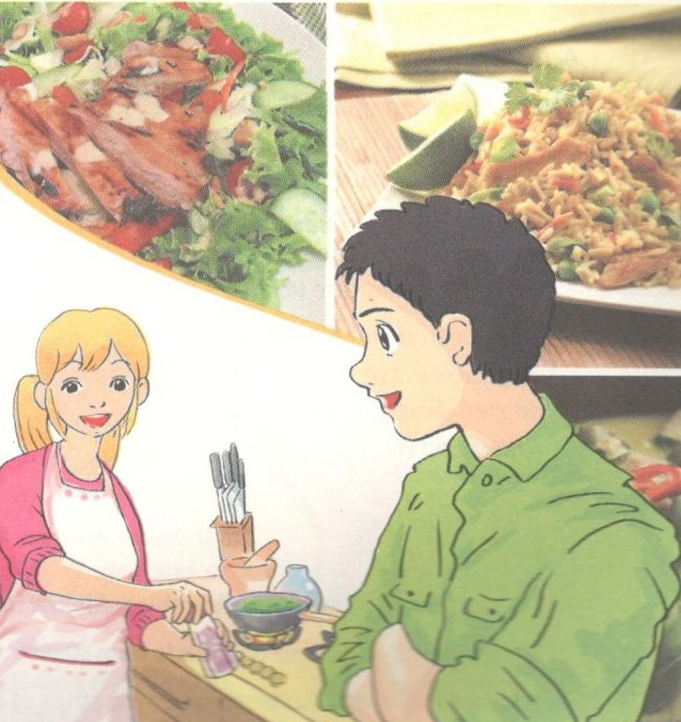
Key - Đáp án:
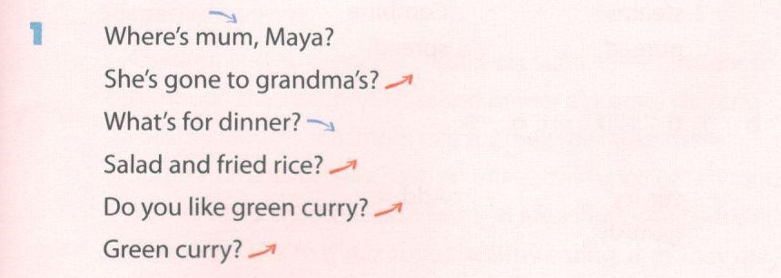

2. Complete the short conversations with suitable statement questions. Then practise them with a partner.
Hoàn thành đoạn hội thoại sau với các câu hỏi thích hợp. Luyện tập với bạn bè.
1. A: What would you like for breakfast, scr'
B: Noodles and beef, please.
A: _________________________________________ ?
B: Yes, it's my favourite.
2. A: You should learn how to cook.
B: _________________________ ? Why?
A: Because you're a girl.
B: I don't think that's a good reason.
3. A: Why do you look so tired?
B: I skipped lunch.
A: _________________________________________ ? You should go out and buy something to eat.
B: I will now.
Key - Đáp án:
1. Noodles and beef?
2. Learn how to cook?
3. You skipped lunch?
B. Vocabulary & Grammer - trang 4 - Unit 7 - Sách bài tập (SBT) tiếng Anh 9 mới
1. Solve the following crossword.
Giải ô chữ sau.
Across:
3. An American garden salad made from chopped salad greens, tomato, bacon, chicken breast, hard-boiled egg, avocado, cheese, and red-wine vinaigrette (4, 5)
5. A Mexican dish of meat and vegetables cut into strips, cooked, and wrapped inside a flatbread (7)
Down:
1. An Indian dish of meat or vegetables, cooked in a spicy sauce, often served with rice (5)
2. A traditional British meat dish made from stewing steak and beef gravy, enclosed in a pastry shell (5,3)
4. A baked Italian dish consisting of wide strips of pasta cooked and layered with meat or vegetables, cheese, and tomato sauce (7)
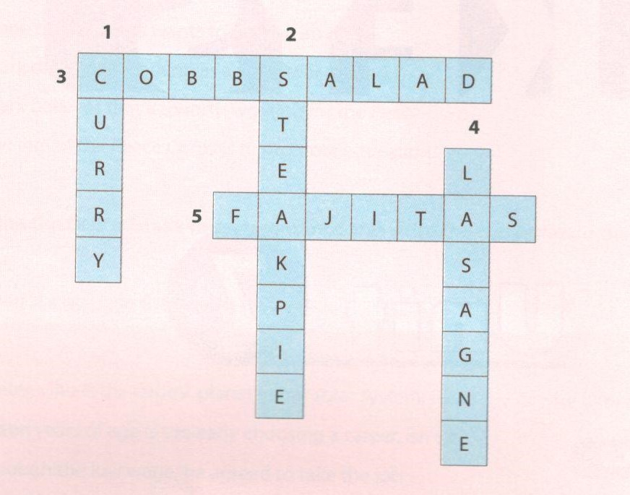

Key - Đáp án:
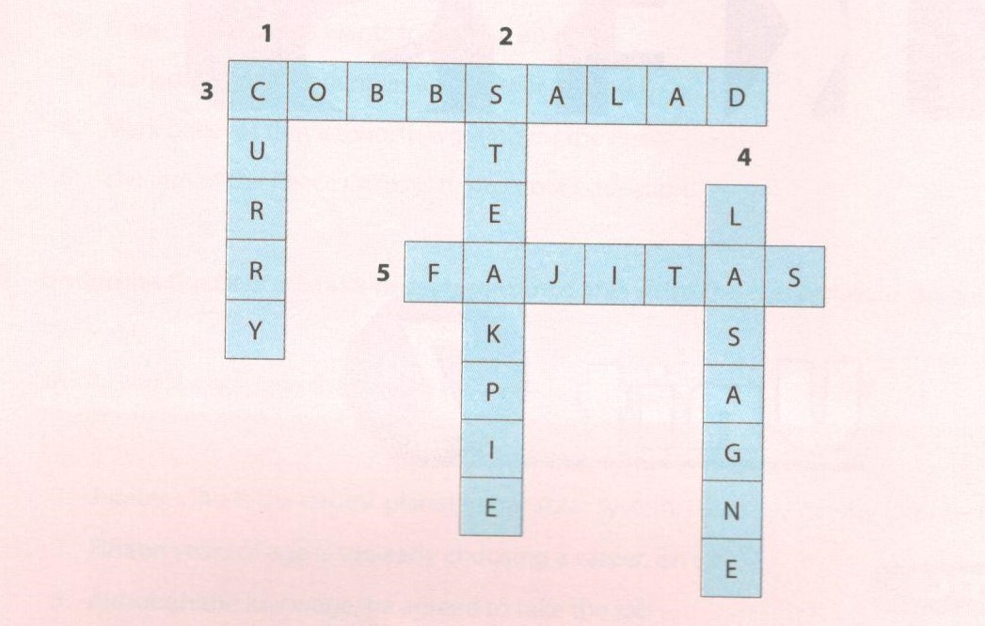

2. Underline the correct word in each sentence.
Gạch chân từ đúng để hoàn thành câu.
1. Cook/ Boil some water, and pour it into the glass.
2. Have you peeled/ taken the potatoes for me?
3. My mother usually steams/ fries fish because she doesn't like oil.
4. Separate/ Combine the celery and shrimp, and mix them well.
5. You should water/ drain the pasta before mixing it with tomato sauce.
6. They usually have a starter/ dessert before having the main course.
7. The first solid food my mother gave my baby sister was sliced/ pureed pumpkin.
8. You should spread/ sprinkle butter on a slice of bread and put it in the oven for two minutes.
Key - Đáp án:
1. Boil 2. peeled 3. steams 4. Combine
5. drain 6. starter 7. pureed 8. spread

3. Match the verb in A with the phrases in B.
Nối từ ở cột A với công thức ở cột B.
A B
1. slice | a. | the carrot and mix with the sliced cucumber
2. grate | b. | the duck in the oven until it gets brown
3. chop | c. | the squid in the batter, then drop it into the hot oil
4. dip | d. | the beef for two hours before serving
5. roast | e. | the onion as thinly as possible
6. stew | f. | the sausages over strong heat for 10 minutes
7. grill | g- | the broth gently for 15 minutes
8. simmer | h. | the spring onion into small pieces
Key - Đáp án:
1.e 2.a 3.h 4.c
5.b 6.d 7.f 8.g

4. Fill each blank in the text with a word from the box. A word may be used more than once.
Điền từ thích hợp vào chỗ trống từ các từ cho trước. Một từ có thể sử dụng nhiều lần.
heat divide add garnish
tender slice grams stir-fry
HOW TO MAKE BEEF EGG NOODLES
Cook the egg noodles in boiling salted water just (1)____. Drain, place in a bowl, and set aside (2)_____ a frying pan until very hot. Add a splash of oil then (3 ) _______the beef slices with the sliced gariic, ginger, and chillies until just cooked. (4)________the bean sprouts, a tablespoon of soy sauce, and lime juice for the last 30 seconds of cooking.
Put all the cooked contents into a large bowl, including all the juices. Put the pan back on the heat, and add some oil.Then add the cooked noodles and toss well over the heat.
(5)______ the fried noodles between four plates. Return the beef and juices to the pan and (6) until heated through. Arrange the beef on top of the noodles and (7)______ with a lettuce leaf and some coriander.
Key - Đáp án:
1. tender 2. Heat 3. stir-fry 4. Add
5. Divide 6. stir-fry 7. garnish

5. Fill each blank in the conversation with a, an, some, or any.
Hoàn thành đoạn hội thoại sau với các từ a, an, some hoặc any.

Nick: | Let's discuss what to prepare for our picnic.
Mi: | You and 1 have been assigned to buy (1) | _______ fruit and drinks.
Nick: | I think it would be better to buy fruit which are easy to pee such as bananas or mandarins.
Mi: | (2) kilo of mandarins and (3) | bunch of bananas are enough, I think.
Nick: | Should we buy (4) ____ snacks such as crisps?
Mi: | That's fine. Let me write it down: (5) | big packet of potato crisps.
Nick: | What: about drinks? Should we buy soft drinks?
Mi: | I don't think that's a good idea. Just buy (6) | bottles of mineral water.
Nick: | My mother told me that she could bake (7) | apple pie for us.
Mi: | Oh. that's great!
Key - Đáp án:
1. some 2. A 3. a 4. any/ some
5. a 6. some 7. an

6. Complete the conversation with suitable food quantifiers.
Hoàn thành đoạn hội thoại với lượng thức ăn thích hợp.

A: Can you go to the supermarket and buy me some things?
B: OK. What do you want?
A: We've run out of milk, so buy two (1) ...................... of milk, please.
B: What about bread?There's only one (2) _______left in the fridge.
A: Yes, you can buy a (3) ______________ of bread. We also need a (4)___________ of cauliflower and a (5) _____ of celery. I will make some salad.
B: Do you need some bacon for the salad?
A: Good idea. Just buy 200 (6)______of bacon.
B: Anything else?
A: That's enough for today.

Key - Đáp án:
1. cartons/ bottles 2. slice 3. loaf
4. head 5. stick 6. grams

7. Match the first half of the sentence in A with the second half in B.
Nối thành câu hoàn chỉnh.
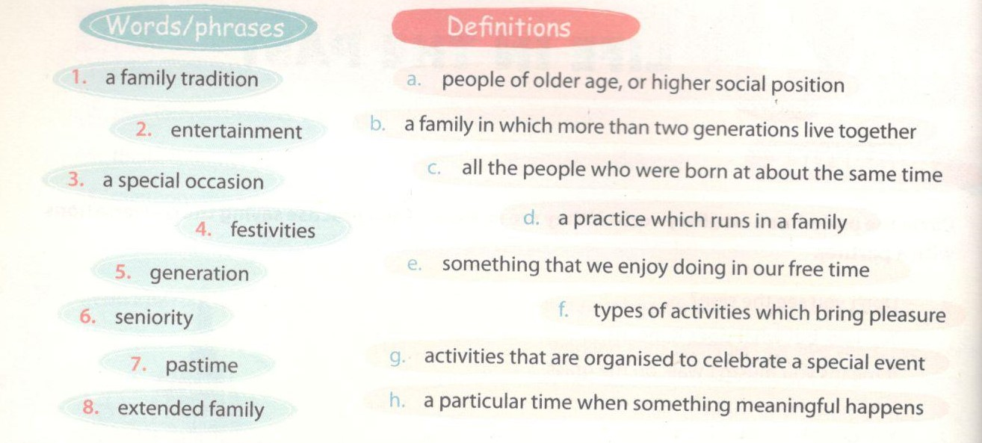

Key - Đáp án:
1.d 2.f 3.a 4.b 5.h
6.c 7.e 8.g
C. Speaking - trang 7 - Unit 7 - Sách bài tập (SBT) tiếng Anh 9 mới
1. Complete the conversation with the responses A-G.
Hoàn thành đoạn hội thoại sau với các đáp án từ A-G.
Kitty: There's nothing left in the fridge. Let's eat out tonight.
Kevin: That's a good idea. Shall we go to Pizza King?
Kitty: (1) ________
Kevin: What about Little Italy? It's more reasonable.
Kitty: (2) ________
Kevin: You can ask them to change the CD for some cool pop music.
Kitty: (3) ________
Kevin: By the way, what is the best type of pizza there?
Kitty: (4) ________
Kevin: I don't fancy pizza with fruit on it. I like seafood.
Kitty: (5)________
Kevin: Sounds delicious! Let's go quickly. I'm starving.
Kitty: (6) ________
Kevin: Are you joking? It's pouring with rain outside.
Kitty: (7) ________
Kevin:Alright.
A. The food there is good, but the music is terrible.
B. I like Hawaiian pizza. It's awesome!
C. Are you kidding? The prices there are higher than any other place.
D. Shall we go by bike?
E. I didn't know that. Let's go to Little Italy then.
F. You can try the seafood pizza then. It includes fish, squid, and shrimp.
G. Let's go by taxi then.
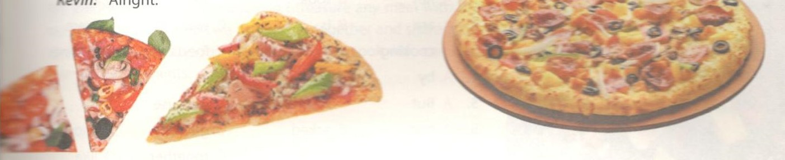
Key - Đáp án:
1. C 2. A 3. E 4. B 5. F 6. D 7.G

2. Imagine you have entered a cooking competition. You receive the following list of ingredients and are required to create a dish using these ingredients. Prepare a short presentation on how to cook the dish.
Tưởng tượng bạn tham gia một cuộc thi. Bạn nhận được danh sách nguyên liệu sau và được yêu cầu chế biến một món ăn từ nguyên liệu đó. Viết một đoạn văn ngắn miêu tả cách nấu món ăn của bạn.
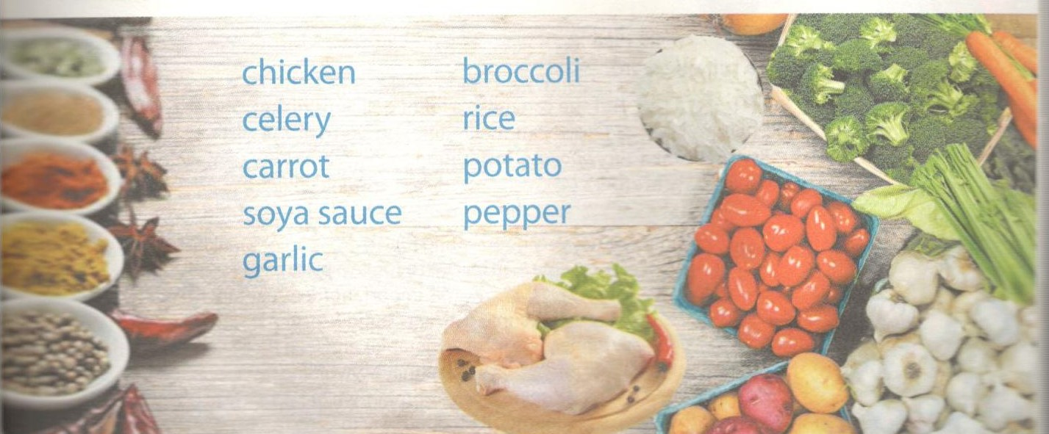
D. Reading - trang 8 - Unit 7 - Sách bài tập (SBT) tiếng Anh 9 mới
1. Read the text below and decide which answer A, B, C, or D best fits each space.
Đọc đoạn văn sau và chọn đáp án đúng để hoàn thành chỗ trống.
Last week I went to an International Food Festival taking place in Hai Phong. Because the festival only (1)___ place for one day, hundreds of people crowded into it. It was the biggest food festival I had eve* seen. There (2) thirty countries participating in the festival. They brought with them traditional fooc specialities which reflected their unique national (3) ___.
I was really impressed (4) the Cobb salad. It is an American garden salad made from chopped salad greens, tomato, bacon, chicken breast, hard-boiled egg, avocado, cheese, and red-wine vinaigrette. (5) ______the salad requires quite a few ingredients, it is quick to make. The American chef at the festival (6) ______me the way to make the salad and it took me only 15 minutes to complete. How amazing! The next day I made Cobb salad (7) _____ my mum for lunch, and she loved it right away.
(8) _____good dish is steak pie, a traditional British meat pie made from stewing steak and beef gravy, enclosed in a pastry shell. Unfortunately, I did not have (9)______ time to listen to the chef give instructions on how to make this dish. However, I tried it and it was brilliant.
Next year (10) _____ there is another food festival, I will definitely join in.
1. A. ran B took C. went D found
2. A. are B. is C. was D. were
3. A. cooking B. food C. foods D. cuisine
4. A. by B. at C. in D. on
5. A. But B. Although C. Because D. So
6. A. said B asked C. gave D. showed
7. A. for B with C. together D. like
8. A. One B. Another C. Second D. Next
9. A. little B. many C.enough D. few
10. A. while B. as C. if D. because
Key - Đáp án:
1.B 2. D 3 D 4. A 5. B
6. D 7.A 8. B 9.C 10.C

2. Fill each blank with a suitable word.
Điền vào chỗ trống với từ thích hợp.
My mother is a good (1)____ and she can make a lot of delicious. She also (2) ______my brother and me how to cook. Now we can make different Vietnamese dishes (3) ____ as fried beef, spring rolls, vegetable soup, pho, etc. In addition, we've leamt how to make pizza, lasagne, sushi, and curry. My brother's (4) _____ dish is lasagne while I like pho and spring rolls
the (5) _____. At the moment, my mother is teaching us how to bake.
My mother has very good eating (6) ________. For breakfast, she usually has a bowl of rice, some lean chicken or pork, a plate of vegetables, and a banana. She never (7)_____ this important meal. For lunch, she has different types of salad, some fish, and some rice. She doesn't eat (8) _______ for dinner, just some vegetable and lean meat. She encourages us to (9) _________ healthily by avoiding fast foods and soft drinks. In addition, every morning we get up early to do (10) ___together. It's a good way to keep fit, isn't it?
Key - Đáp án:
1. cook 2. teaches/ taught 3. such 4. favourite 5. best/ most
6. habits 7. skips/ misses 8. much/ a lot 9. eat 10. exercise/ exercises

3. Read what Mark says about his food memories. Decide if the statements are true (T) or false (F).
Đọc đoạn văn sau Mark nói về ký ức của bạn ấy về đồ ăn. Quyết định thông tin nào là đúng (T) hay sai (F).
WHAT WAS YOUR FAVOURITE FOOD WHEN YOU
WERE A CHILD?
I loved lasagne. It all began when I was three years old. I flew to Australia with my parents on Singapore Airlines. On the plane they served special food for children, and one of the dishes was lasagne. I fell in love with that dish immediately and ate a big portion. Since then, whenever we eat out in an Italian restaurant, I've chosen lasagne.
DID YOU HATE ANY FOOD WHEN YOU WERE A CHILD?
Sure, I really hated fish. My mother loved it, so we had it almost every day. Although she cooked different dishes such as steamed fish, fried fish, or fish soup, I still didn't like the taste, the smell, or anything about it. The strange thing is that I liked fish nuggets at Kuick, and I had them sometimes on Sundays.
WHICH DO YOU PREFER: HAVING MEALS AT HOME
OR EATING OUT?
My job involves travelling a lot, so I treasure any meal with my parents at home. It's our happiest time when we can gather together and share a lot of things. I love eating at home also because my mother is a great cook who can create unusual (fishes with everyday ingredients.
1. When Mark was three, he started to like lasagne.
2. There were special dishes for children on Singapore Airlines planes.
3. The first time he tried lasagne, Mark couldn't eat much.
4. Mark doesn't like lasagne anymore.
5. He never ate fish when he was a child.
6. His family had fish every day.
7. His mother only cooked one kind of fish dish.
8. Mark has to travel a lot in his job.
9. His family has a good time together during their meals.
10. His motier on y uses unusual ingredients when cooking.
Key - Đáp án:
1. T 2.T 3. F 4. F 5. F
6. F 7. F 8.T 9.T 10. F
E. Writing - trang 10 - Unit 7 - Sách bài tập (SBT) tiếng Anh 9 mới
1. Make sentences using the words and phrases below to help you. You can add extra words or make changes.
Hoàn thành các câu sau sử dụng từ và cụm từ dưới đây. Có thể thêm từ để thay đổi.
1 Children/ adolescent/ should/ eat/ sufficient/ nutritious/ foods/ grow/ develop normally.
___________________________________________________________
2. Although/ eat/ breakfast/ dinner/ home/ students/ usually/ have/ lunch/ school.
___________________________________________________________
3. Healthy lunches/ important/ for/ them/ because/ these/ help/ concentrate/ learning.
___________________________________________________________
4. Some/ student/ usually/ have/ unhealthy lunch/ of/ fast food.
___________________________________________________________
5. School aged/ children/ learn/ fast/ and/ be/ influenced/ friends.
___________________________________________________________
6. If/ we/ not talk/ them/ about/ healthy eating/ they/ may/ only eat/ junk food.
___________________________________________________________
7. At home/ parents/ should/ encourage/ children/ prepare/ lunchboxes.
___________________________________________________________
8. They/ should discuss/ healthier/ food choices/ and/ decide/ what/ be/ lunchbox/ with/ children.
___________________________________________________________
Key - Đáp án:
1. Children and adolescents should eat sufficient nutritious foods to grow and develop normally.
2. Although they eat breakfast and dinner at home, students usually have lunch at school.
3. Healthy lunches are important for them because these help them concentrate on learning.
4. Some students usually have an unhealthy lunch of fast food.
5. School aged children learn fast and are influenced by friends.
6. If we don't talk to them about healthy eating, they may only eat junk food.
7. At home parents should encourage their children to prepare their lunchboxes.
8. They should discuss healthier food choices and decide what will be in the lunchbox with their children.

2. Write a paragraph about the eating habits of a member of your family. You can use these questions as cues:
Viết một đoạn văn ngắn về sở thích ăn uống của các thành viên trong gia đình bạn. Có thể tham khảo các câu hỏi sau:
- Does this person have good or bad eating habits?
- What does he/ she eat for breakfast/ lunch/ dinner?
- If this person has bad eating habits, what should he/ she do to be healthier?
My _______ has very _______eating habits.____________________

