A. Phonetics - trang 11 - Unit 8 - Sách bài tập (SBT) tiếng Anh 9 mới
1. Mark the questions with falling or falling-rising arrows, then practise the conversation with a partner.
Đánh dấu các câu hỏi sau với các mũi tên chỉ lên hoặc xuống, luyện tập với bạn bè.
Abe: Today we're going to talk about travelling. Do you like to travel?
Hillary: Yes, of course.
Abe: OK, what places have you visited?
Hillary: I've been to some places in Europe and to New York, and now I'm here.
Abe: Wow, you've been all over. What have been your favorite places so far?
Hillary: Venice in Italy, New York, and probably Tokyo too.
Abe: Wow! One in every continent. And do you take a lot of luggage when you travel?
Hillary: Yeah, if I can. I mean, there are limits.
Abe: Sure. So how many suitcases did you have when you came to Tokyo?
Hillary: Only one, but it's a big one! I think it can hold around 30 kilograms.
Abe: So where would you like to go next?
Hillary: Oh, that's a difficult question. Somewhere in South America, maybe.
Key - Đáp án:
Abe: Today we're going to talk about travelling. Do you like to travel? >*
Hillary: Yes, of course.
Abe: OK, what places have you visited?
Hillary: I’ve been to some places in Europe and to New York, and now I'm here.
Abe: Wow, you've been all over. What have been your favourite places so far?
Hillary: Venice in Italy, New York, and probably Tokyo too.
Abe: Wow! One in every continent. And do you take a lot of luggage when you travel?
Hillary: Yeah, if I can. I mean, there are limits.
Abe: Sure. So how many suitcases did you have when you came to Tokyo?
Hillary: Only one, but it's a big one! I think it can hold around 30 kilograms.
Abe: So where would you like to go next?
Hillary: Oh, that's a difficult question. Somewhere in South America, maybe.

2. Complete the conversation below with the questions from the box. Then practise the conversation with a partner.
Hoàn thành đoạn hội thoại sau với các câu hỏi cho trước. Luyện tập với bạn bè.
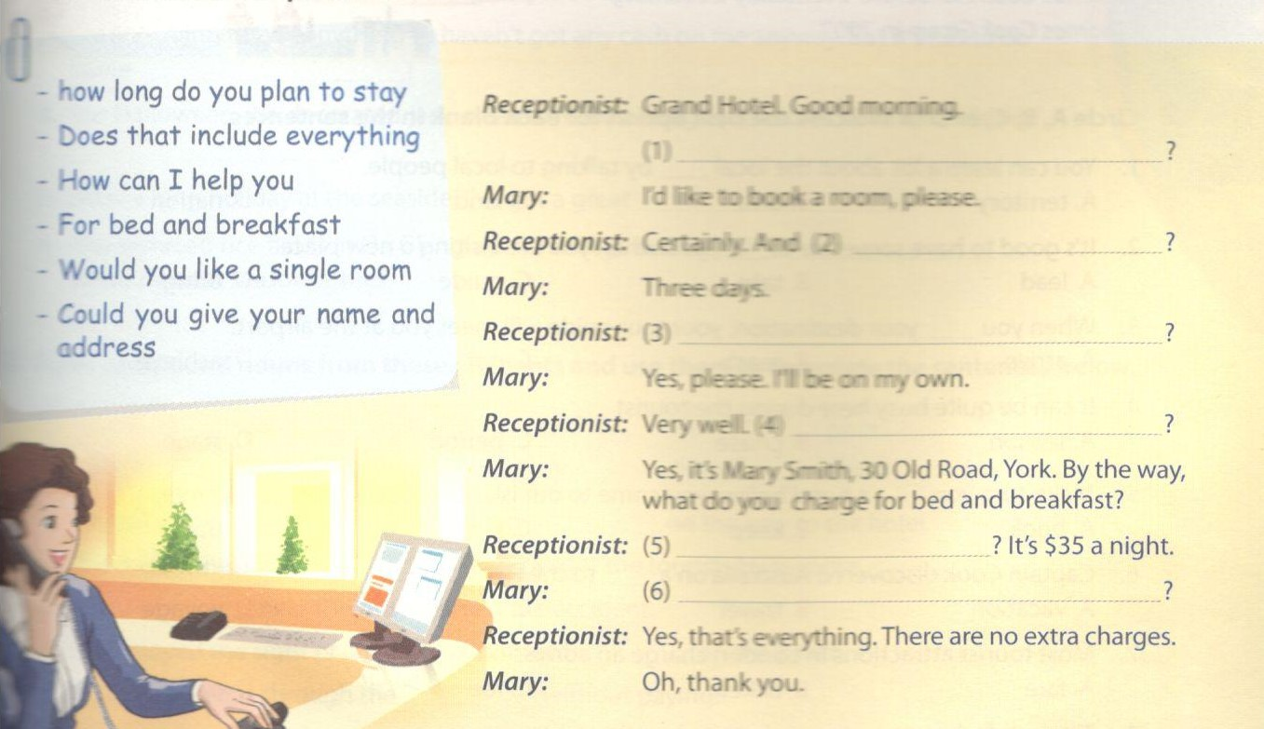
Key - Đáp án:
1. How can I help you
2. how long do you plan to stay
3. Would you like a single room
4. Could you give your name and address
5. For bed and breakfast
6. Does that include everything

3. Make a short conversation which includes a question to find out information that we don't already know, and another which includes a question to check the information. Then practise them with a partner.
Thực hiện một đoạn hội thoại ngắn bao gồm các câu hỏi để tìm ra những thông tin bạn chưa biết và một vài câu hỏi để kiếm tra lại thông tin. Luyện tập với bạn bè.
Example:
A: Will there be a public holiday to mark the Death Anniversary of the Hung Kings this year?
B: Yes, sure.
B. Vocabulary & Grammer - trang 12 - Unit 8 - Sách bài tập (SBT) tiếng Anh 9 mới
1. Insert a suitable word in each numbered gap to complete the passage.
Điền từ thích hợp vào chỗ trống.
Thomas Cook (1808 -1892) is widely considered to be the father of modern mass tourism. He organised the first package (1)____ in history. He arranged for the Midland Counties Railway to charge one shilling per person for a group of campaigners travelling (2) ____ Leicester to a rally in Loughborough, eleven miles away. Cook was paid a share of the fares charged to the passengers, as the railway tickets couldn't (3) ____ issued at his own price. There (4) ____ been railway excursions before, but
this one included entrance to an entertainment held on private grounds, rail tickets, and food during the train (5) ___ . Cook immediately saw the potential of a convenient ‘off-the-peg’ holiday product in which everything was (6) ___ in one cost. Afterwards he pioneered (7)________ holidays both in Britain and on the European continent (where Paris and the Alps were the most popuiar destinations). He founded the (8) _______ agency Thomas Cook & Son ( popularly nicknamed Cook's Tours), which became Thomas Cook AG eventually becoming Thomas Cook Group in 2007.
Key - Đáp án:
1. tour/holiday 2. from 3. be 4. had
5. journey 6. included 7. package 8. travel

2. Circle A, B, C, or D to indicate the best option for each blank in the sentences.
Chọn đáp án đúng cho các câu sau.
1. You can learn a lot about fee local by taking to local people.
A. territory B. area C. land D. nation
2. It's good to have someone to ____ you when you are visiting a new place.
A. lead B. take C. guide D. bring
3. When you _____ your destination, your tour guide will meet you at the airport.
A. arrive B. reach C. get D. achieve
4. It can be quite busy here during the tourist ________.
A. season B. phase C. period D. stage
5. Make sure you a hotel before you come to our island, especially in the summer.
A. book B. keep C. put D. buy
6. Captain Cook discovered Australia on a _______ to the Pacific.
A. vacation B. travel C. cruise D. voyage
7. Most tourist attractions in London charge an admission _______.
A. fare B. ticket C. fee D. pay
8. The hotel where we are ____ is quite luxurious.
A. living B. existing C. remaining D. staying
Key - Đáp án:
1. B 2. C 3. B 4. A 5. A 6. D 7.C 8. D

3. Give the correct form of the words in brackets to complete the passage.
Cho dạng đúng của động từ.
Welcome to wonderful Dana Tours! Come to us and you are sure to find the (1. WIDE) _______ range of holidays! You can pamper yourself at the five-star Vinland Hotel in a well-(2. KNOW)________seaside resort, where the facilities none. If you prefer a more active holiday, you can cruise around the island in a canoe, go diving to see the (3.WONDER)________coral reef, or go trekking to admire the spectacular scenery. (4. ALTERNATE) _______ , you might prefer to take a self-catering apartment in one of the (5. PICTURE) _____ fishing villages. There you can sample the authentic local cuisine, with its famous seafood (6. SPECIAL) ______, and choose from a variety of excursions to places of cultural and (7.ARCHAEOLOGY) ________ interest. Our prices are inclusive of all flights and (8. ACCOMMODATE) ______ , and represent excellent value. Book now, before it's too late!
Key - Đáp án:
1. widest 2. known 3. wonderful 4. Alternatively
5. picturesque 6. specialities 7. archaeological 8. accommodation

4. Fill each blank in the sentences below with a compound noun from the box.
Hoàn thành các câu sau với cụm danh từ đã cho.
suntan window shopping vending machine
lookout sightseers broomsticks
1. Its easy to use the _____________. Enter the code for the item you want, then insert coins equalling the price shown.
2. After the explosion, the guards at the temple have to keep a sharp _______for anything suspicious.
3. I'm not going to buy anything - I haven't got any cash on me anyway. But it's fun to do some _____!
4. Halloween, we decorated jack-o'-lanterns and hung up pictures of witches riding _____.
5. After a long holiday at the seaside, I've got great _______!
6. The terraced rice fields in Ha Giang attract a large number of _______ when harvest season comes.
Key - Đáp án:
1. vending machine 2. lookout 3. window shopping
4. broomsticks 5. suntan 6. sightseers

5. Form compound nouns from these elements and use them to complete the sentences below.
standers sea away out
shells by down take
1. We got something to eat from an Indian _______ on the way to the hotel.
2. The suddenness of the _______ had caught the tourist by surprise.
3. The _______ near the bus stop saw the accident.
4. We enjoyed the sight of children gathering ________ on the beach.
5. You can't just go through the _______ without paying.
6. In comparison with the exotic pictures in the brochure, the resort was a real _________.
Key - Đáp án:
1. take away 2. downpour 3. bystanders
4. seashells 5. checkout 6. letdown

6. Insert a, an, or the in each gap.
Điền a, an, hoặc the vào chỗ trống.
Egypt, (1) ________most populous country in the Arab world, is home to one of (2) _______world's oldest cultures. Modern day Egypt is descended from (3) _____ ancient civilisation that emerged in the 10th millennium BC. (4) _______stunning, colossal monuments of Ancient Egypt never fail to astonish. (5)_____romantic cruise along the Nile - (6) ___ world's longest river - dazzles the senses. Giza Plateau is Ancient Egypt's most famous, fascinating, and mysterious archaeological site for people to explore. No other place has (7)________magic, mystery, and pleasures of Egypt. Travel to Egypt and you will discover (8) ______ world of wonder.
Key - Đáp án:
1. the 2. the 3. an 4. The
5. A 6. the 7. the 8. a

7. Correct the mistakes in the sentences by adding a, an, the or by changing or removing an article that has been used.
Sửa các lỗi sai trong các câu sau bằng cách thêm a, an, the hoặc thay đổi tiêu đề đã cho.
1. We spent little time in Paris seeing some of the sights.
2. We are working for the cleaner environment.
3. The tourists flock to this island every summer.
4. My cousin took a part in the London Marathon. .
5. The sun sets in west.
6. Young don't have much free time to enjoy their childhoods nowadays.
7. Unfortunately, fewer people came to a festival than last year.
8. It is generally believed that an university education will lead to a well-paid job.
Key - Đáp án:
1. We spent a little time in Paris seeing some of the sights.
2. We are working for a cleaner environment.
3. Tourists flock to this island every summer.
4. My cousin took part in the London Marathon
5. The sun sets in the west.
6. The young don't have much free time to enjoy their childhoods nowadays.
7. Unfortunately, fewer people came to the festival than last year.
8. It is generally believed that a university education will lead to a well-paid job.

8. Insert a word/phrase from the box in each blank to complete the sentences.
broaden arrrvai in advance description
journey took timetable exotic places
1. We prefer to go by train, even though the car ______ is a lot quicker.
2. The _________ of flight 382 from Moscow has been delayed by one hour.
3. I've always wanted to be a travel photographer and take pictures of ________.
4. Passengers requiring a special meal during the flight should inform the airline _____.
5. We had plenty of time so we ___________ the scenic route.
6. Travelling to a foreign country really does ________ your horizons.
7. Now, class, I'd like you all to write a ________ of your last holiday.
8. Once we got to the station, I quiddy looked through the _______ to see when the next train was.
Key - Đáp án:
1. journey 2. arrival 3. exotic places 4. in advance
5. took 6. broaden 7. description 8. timetable
C. Speaking - trang 15 - Unit 8 - Sách bài tập (SBT) tiếng Anh 9 mới
1.a Match the names of the famous world landmarks to their countries.
Nối địa danh nổi tiếng sau với đất nước của địa danh đó.
1. Pyramid of Cheops | a. | Viet Nam
2. Taj Mahal | b. | Cambodia
3. Dong Van Stone Plateau | c. | Australia
4. Golden Gate Bridge | d. | the United Kingdom
5. Great Wall of China | e. | France
6. Angkor Wat | f. | Malaysia
7. Petronas Twin Towers | g- | the United States
8. Great Barrier Reef | h. | China
9. Eiffel Tower | i. | Egypt
10. Stonehenge | j- | India
Key - Đáp án:
1.i 2.j 3. a 4. g 5. h
6.b 7.f 8.c 9.e 10.d

b. Choose one of the places in 1a as your holiday destination and talk about it with a partner.
Chọn một địa danh trong bài 1a như điểm đến du lịch của bạn và nói về địa danh đó với bạn bè.

2. Where in Viet Nam do you think foreign tourists would like to visit most? Put a tick next to yam choice, and say why. Add three more interesting places to the list.
Địa danh nào ở Việt Nam bạn cho rằng người nước ngoài yêu thích nhất? Đánh dấu tick vào lựa chọn của bạn. Thêm 3 địa danh yêu thích vào danh sách.
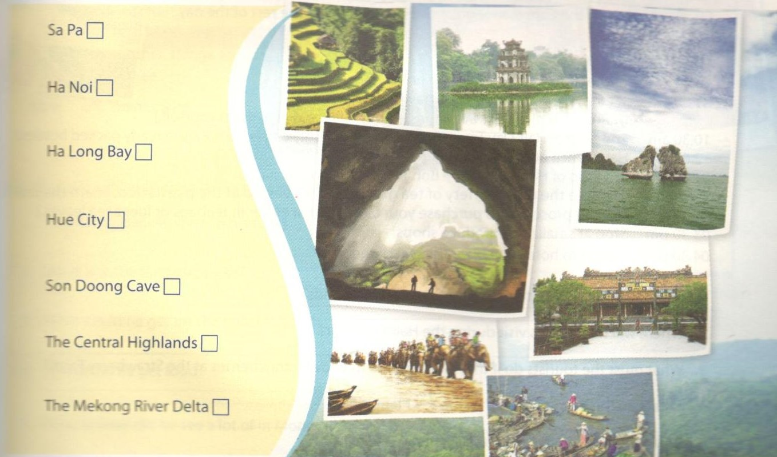

3a. Read the following passage and option the question below.
Đọc đoạn văn sau và chọn câu hỏi ở dưới.
The Uffizi Gallery is one of the world's greatest art museums and a must-do for visitors to Florence. It is also one of the city's busiest attractions, so pre-ordered tickets or passes are HIGHLY recommended during the summer and peak season. Housed largely on the top floor of a 15M A century administrative palace, the collection includes part of the Medici family's acquisitions and commissions. The works are distributed throughout numerous rooms organised by artist, period, and/or place of origin. Visitors can purchase a guide from the bookshop on their arrival to have an idea of where to find the most famous and popular works. Audio guides are also available.
A few good things to know when you visit this place:
- Backpacks, large bags, and umbrellas must be checked in upon entry (no charge.. I
- The use of mobile phones is not allowed.
- Additional ticket prices can apply for the various special exhibits.
- Non-flash photography is now allowed.
- The museum is closed on Mondays, Christmas Day, 1st January, and 1st May.
Question:
What do visitors to the Uffizi Gallery have to do upon entry?
b Give at least 3 tips for visitors to a tourist attraction in your area that only a local person would know.
Đưa ra ít nhất 3 ý tưởng để thu hút khách du lịch đến địa phương của bạn.
D. Reading - trang 16 - Unit 8 - Sách bài tập (SBT) tiếng Anh 9 mới
1. Read the itinerary of the Cameron Highlands Tour and answer the questions.
Đọc lịch trình tham quan Cameron Highlands và trả lời câu hỏi.
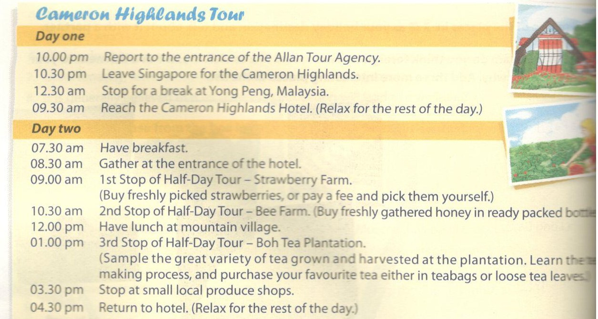
1. How long does it take to reach the Cameron Highlands?
2. Where will the tourists visit during the Half-Day Tour?
3. What must the tourists do if they want to pick their own strawberriers at the Strawberry Farm?
4. What can the tourists do at the Boh Tea Plantation?
5. What does 'local produce' in this itinerary mean?
Key - Đáp án:
1. It takes eleven hours.
2. They will visit the Strawberry Farm, Bee Farm, and Boh Tea Plantation.
3. They must pay a fee.
4. They can sample different kinds of tea, learn the process of making tea, and buy ready-made tea in teabags or loose tea leaves.
5. It means goods that are grown or made in the area.

2. Read the conversation and answer the questions.
Đọc đoạn văn và trả lời câu hỏi.
Nick: Vova, I hear that you took the train across Russia.
Vova: Yes, I started in Moscow, travelled all through Russia and Mongolia, and ended up in China.
Nick: Wow! That's a long way!
Vova: Yes. It took three weeks. I did it as part of a tour with ten other people.
Nick: Cool! What was the landscape like?
Vova: A lot of it was flat and you could see that there was absolutely nothing for miles. As we got into Siberia there were scattered trees, and when we got into Mongol we could see some camels, but besides that there was next to nothing.
Nick: Wow! Wild camels! So how did you eat on this train?
Vova: We stopped several times at stations along the way and on every platform you could buy local food. Every train had hot water on it too, so you could always make noodles if you were desperate.
Nick: Wow! Would you do it again?
Vova: Great question! Yes, I would do it again, but I would wait several years to do it. There are so many other things to do and see.
Nick: OK. Thanks a lot.
1. How many people were in his tour?
2. What was the landscape like?
3. What could he get on the train?
4. Where did he get food?
5. What animal did he see a lot of in Mongolia?
Key - Đáp án:
1. Eleven people.
2. It was flat/empty/featureless/barren.
3. Hot water.
4. On the station platforms.
5. Camels.

3. Read the text below and decide which option (A, B, C, D) best fits each space.
Đọc đoạn văn sau và chọn đáp án đúng cho mỗi chỗ trống.
The tourist industry is considered to be the world's largest industry.The direct (1) __impact of the industry, including accommodation, transportation, entertainment, and attractions, is worth trillions of dollars every year. The statistics show that the number of international tourist (2) __ worldwide reached 1.04 billion in 2012.
Such large (3) ___of tourists, however, are beginning to cause problems. For example, in the Alps the many thousands of skiers are (4)______ the mountains they came to enjoy. Even parts of Mount Everest in the Himalayas are reported to be covered (5) _____ old food tins, tents, and pieces of equipment that have been (6)______ away.
At a time when we have greater freedom to travel (7) _____ ever before, more and more people are asking how they can enjoy their holidays (8) ______ causing damage to their destinations.
Now there is a new holiday guide (9) ___ Holidays That Don't Cost the Earth. It tells you how you can be a responsible tourist by asking your travel agent or your tour (10) _______ the right questions before you book a holiday.
1. A. national B. educational C. economic D. cultural
2. A. arrivals B. deliveries C. comings D. figures
3. A. totals B. numbers C. amounts D. digits
4. A. bending B. destroying C. fixing D. hurting
5. A. for B on C. with D. below
6. A. put B tidied C. given D. thrown
7. A. than B when C. then D. while
8. A. outside B instead C. beside D. without
9. A. called B known C. termed D. described
10. A. advisor B director C. operator D. worker
Key - Đáp án:
1.C 2. A 3. B 4. B 5. C
6. D 7. A 8. D 9. A 10. C
E. Writing - trang 19 - Unit 8 - Sách bài tập (SBT) tiếng Anh 9 mới
1. Rewrite each of the sentences so that it means the same as the one before it.
Viết lại các câu sau sao cho nghĩa không đổi.
1. You spent more money during the trip than I did.
—► I didn't ________________________________________________
2. Have you ever been to Kuala Lumpur before?
—► Is this your ________________________________________________
3. China is a huge tourist attraction: it has many old castles and pagodas.
—► As China ________________________________________________
4. I found this place rather boring.
—► I wasn't ________________________________________________
5. We last went to Spain three years ago.
—► It is ________________________________________________________
6. We visited a magnificent old house on the plateau.
—► The ________________________________________________________
Key - Đáp án:
1. I didn't spend as much money during the trip as you did.
2. Is this your first time in/visit to Kuala Lumpur?
3. As China has many old castles and pagodas, it is a huge tourist attraction.
4. I wasn't very interested in this place.
5. It is three years since we last went to Spain.
6. The old house on the plateau that we visited was magnificent.

2. Complete the second sentence using the word given so that it has a similar meaning to the first sentence. Write no more than five words in each gap. Look at the example.
Hoàn thành các câu sau với từ cho trước sao cho câu có nghĩa giống với câu đã cho. Mỗi chỗ trống điền hơn 5 từ. Tham khảo mẫu cho trước.
Example: We arrived in Budapest two days ago. FOR
We have been in Budapest for two days.
1. I have visited the Stone Forest once before. SECOND
This is the ________ the Stone Forest.
2. I find it hard to go at the same speed as my brother on walking holidays. UP
I find it hard to ______ my brother on walking holidays.
3. Dzung is very fond of travelling and has been everywhere. KEEN
Dzung is ___________ and has been everywhere.
4. We drove away as fast as we could, ready to begin oiradiaaR. FULL
We drove away ______ , ready to begpn avadsemxe.
5. As the storm started, we went towards the old house. DIRECTION
As the storm started, we went ____ the old house.
6. The information I got from the travel agent was very confusing and I didn't know what was going on. GAVE
The travel agent _________ and I didn't know what was going on.
Key - Đáp án:
1. ... second time (that) I have visited ...
2. ... keep up with ...
3. ... very keen on travel
4. ... at full speed,...
5. ... in the direction of...
6. ... gave me very confusing information ...

3. Write a paragraph about the benefits of a tour by bicycle, with the following as the first sentence.
Viết một đoạn văn về lợi ích của việc du lịch bằng xe đạp, tham khảo câu mẫu dưới đây.
There are many good reasons to go on a tour by bicycle.
These deas might be useful to you:
- see beautiful scenery, and meet interesting people on your way.
- it's a good way of getting exercise
- stop and go whenever and wherever you want to

