A. Phonetics - trang 20 - Unit 9 - Sách bài tập (SBT) tiếng Anh 9 mới
1. Do you think the tone of voice goes up or down at the end? Draw rising or falling arrows in the responses (B). Then practise reading the short conversations.
Bạn cho rằng các câu trả lời dưới đây cần lên hay xuống giọng? Đánh dấu bằng các mũi tên lên xuống cho các câu B. Luyện tập với bạn bè.
1. A: This car is slow.
B: I know it's slow, but it's reliable.
2. A: This CD is good.
B: I know it's good, but that one is better.
3. A: This armchair is ugly!
B: I know it's ugly, but it's comfortable.
4. A: This motorbike is fast.
B: I know it's fast, but it's dangerous.
5. A: ThisTVisbig.
B: I know it's big, but the one in the corner is bigger.
Key - Đáp án:


2. In each pair of the following short conversations, the responses are the same but the tones are different. Draw rising or falling arrows in the responses (B) to show if you think the tone of voi goes up or down. Then practise reading the short conversations.
Mỗi cặp hội thoại sau có câu trả lời giống nhau nhưng âm điệu khác nhau. Đánh dấu bằng các mũi tên lên hoặc xuống ở câu B. Luyện tập với bạn bè.

1. | a. | A | The new car ts cheap.
 |  | B: | The second-hand one is cheaper.
 | b. | A: | Why did you buy the seaond-hand car?
 |  | B: | The second-hand one is cheaper.
2. | a. | A: | What time's dinner?
 |  | B: | Dinner is at 8.00 p.m
 | b. | A: | Let's go for a walk at 8.00p.m
 |  | B: | Dinner is at 8.00 pm.
3. | a. | A: | I'd like a gold one.
 |  | B: | They're all gold.
 | b. | A: | Why are these watches so expensive?
 |  | B: | They're all gold.
4. | a. | A: | Where's your father?
 |  | B: | My father's upstairs.
 | b. | A: | Who's upstairs?
 |  | B: | My father's upstairs.
5. | a. | A: | Was the fish delicious?
 |  | B: | The steak was more delicious.
 | b. | A: | Why didn't you have fish?
 |  | B: | The steak was more delicious.
Key - Đáp án:


B. Vocabulary & Grammar - trang 21 - Unit 9 - Sách bài tập (SBT) tiếng Anh 9 mới
1. Choose the best answer A, B, C, or D to complete the sentences.
Chọn đáp án đúng A, B, C hoặc D để hoàn thành các câu sau.
1. Computers offer a much greater degree of __________ in the way work can be organised.
A flexible B. flexibility C. flexibly D. inflexible
2. She spoke English with a(n) _________ that I couldn't understand.
A. accent B. stress C. intonation D. tone
3. Louis is virtually bilingual_________ Dutch and German.
A. on B. in C. for D. with
4. She _______ up some Spanish when she was living in Mexico.
A. took B. looked C. picked D. learnt
5. Teachers provide a model for children to _________.
A. allow B. behave C. change D. imitate
6. Peter can just about get ____________ in German.
A. up B. down C. out D. by
7. Sound symbolism means that we often _________ the meaning of a word from its sound.
A guess B.judge C imagine D. expect
8. I can have a conversation in Italian, but I'm a _______ rusty.
A. bit B. lot C. very D. too
9. Is English a(n) ______ language in your country?
A. mother B. official C. living D. old
10. He spoke a ________ of French the we found hard to understand.
A. slang B. jargon C. dialect D. language
Key - Đáp án:
1.B 2. A 3. B 4. C 5. D 6. D 7.A 8.A 9. B 10.C

2. Match words (1-6) to their definitions (A-F).
Nối các từ từ 1-6 với nghĩa tương ứng từ A-F.
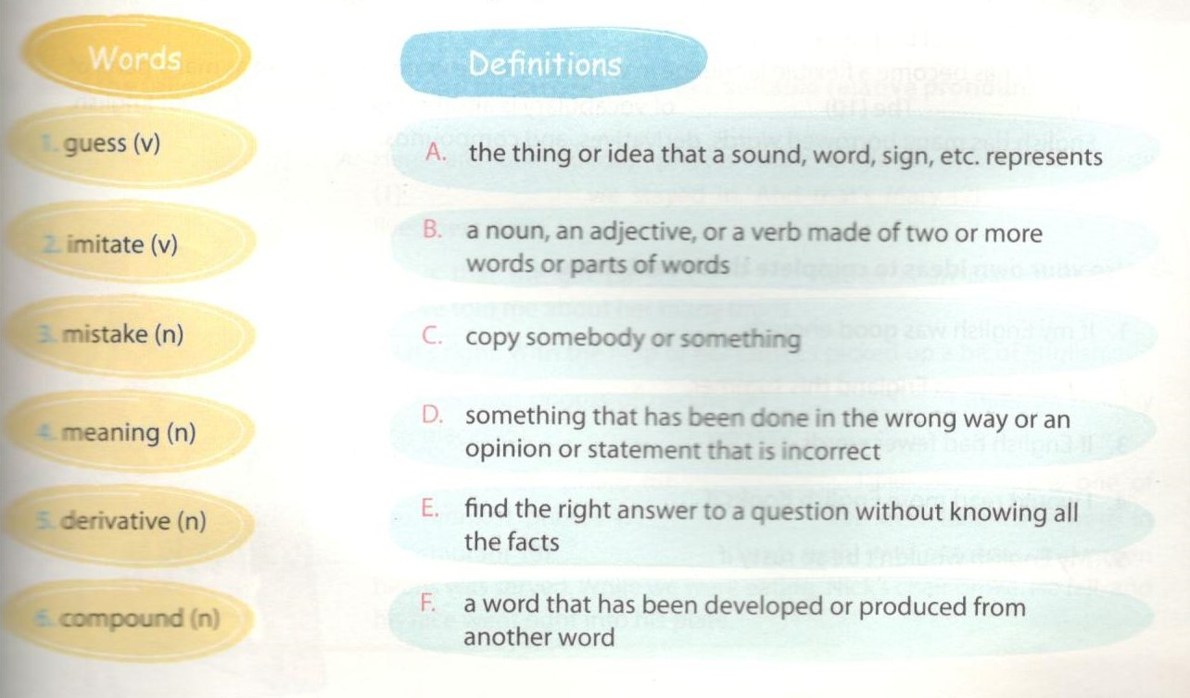
Key - Đáp án:
1.E 2. C 3. D 4. A 5. F 6. B

3. Read the two paragraphs below and fill each blank with a suitable word from the boxes.
global second tongue expansion status

English is the most widely spoken language in the world. It is the people living in Britain, Ireland, the USA, Australia, New Zealand,first language, or mother (1) _________ of around 400 million Canada, and South Africa, and it is spoken as a (2)____________ language by millions more. English is learned by many more people worldwide as a foreign language. English has become a(n) (3) _________ language, or international language, used by people who speak different native languages to communicate with each other. English has achieved the (4) _______ of a world language over a long period of time, and for various historical and cultural reasons. In the 17th century English was spread by settlers going from Britain to America, and in the 18th and 19th centuries by the (5) _______ of the British Empire.

speech simplicity change openness flexibility
English is the language which has the largest vocabulary, with approximately 500,000 words and 300,000 technical terms. One of the basic characteristics of English is the (6) _______ of form. Many English words have been simplified over centuries. Many English words do not (7) according to parts of speech. Another basic English has become a flexible language in which the same word can operate as many parts of (9) ______. The (10) ______ of vocabulary is another basic characteristic of English. English has many borrowed words derivatives, and compounds.
Key - Đáp án:
1. tongue 2. second 3. global 4. status 5. expansion
6. simplicity 7. change 8. flexibility 9. speech 10. openness

4. Use your own ideas to complete these sentences.
Hoàn thành các câu sau theo quan điểm của bạn.
1. If my English was good enough, ______________
2. If I could go to England this summer, ______________
3. If English had fewer words, ______________
4. I would read more English books if ______________
5. My English wouldn't be so rusty if ______________
Key - Đáp án:
Suggested answers:
1. If my English w as good enough, I could find a good job.
2. If I could go to England this summer, I would have the chance to pick up a bit of English.
3. If English had fe.ver words, it would be easier for us to master.
4. I would read more Enc sh books if I had enough time.
5. My English wouldn't be so rusty if I had more chance to communicate with native speakers of English.

5. Complete the sentences by choosing the most suitable ending from the box and making it into a relative clause.
Hoàn thành các câu sau bằng cách chọn từ thích hợp cho trước để tạo thành mệnh đề quan hệ.

1. English has borrowed many words ____________________________.
2. There are several reasons ____________________________.
3. I often look up new words in the dictionary ____________________________.
4. The French couple ____________________________can get by in Vietnamese.
5. The new girl in our class ____________________________ is reasonably good at English.
6. Many people come to England and English-speaking countries ____________________________.
Key - Đáp án:
1. English has borrowed many words which/that come from other languages.
2. There are several reasons why I don't like English.
3. I often look up new words in the dictionary which/that has just been published by Oxford University Press.
4. The French couple who/that live next door can get by in Vietnamese.
5. The new girl in our class, whose name is Mai, is reasonably good at English.
6. Many people come to England and English-speaking countries, where they can learn English in the all-English environment.

6. Read the following conversation and fill each blank with a suitable relative pronoun.
Đọc đoạn hội thoại sau và điền từ thích hợp vào chỗ trống.
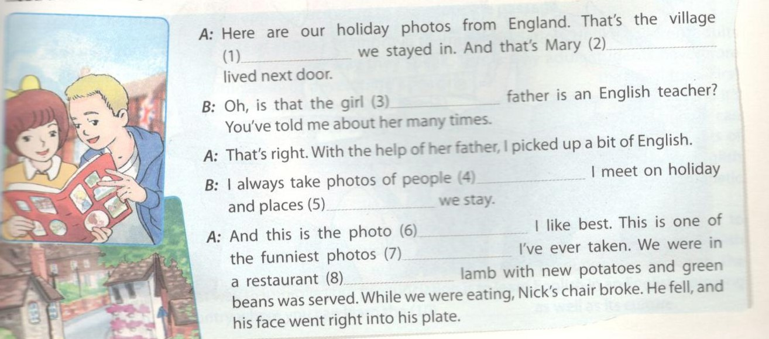
Key - Đáp án:
1. which/that 2. who 3. whose 4. who/whom/that
5. where 6. which/that 7. that 8. where
C. Speaking - trang 24 - Unit 9 - Sách bài tập (SBT) tiếng Anh 9 mới
1. Choose correct statement (A-F) to complete the following conversation. Practise the conversati with your partner.
Chọn đáp án đúng từ A-F để hoàn thành đoạn hội thoại sau. Luyện tập với bạn bè.
A. What does that word mean?
B. How do you pronounce this?
C. Did I pronounce that correctly?
D. Sure, what do you want to know?
E. If you talk to your American friends every day, you'll improve quickly.
F. Do you understand?

Mary: Duong, do you like studying English?
Duong: I do like studying English, and I can read it well, but speaking can be difficult.
Mary: It's not that hard. (1) ____________
Duong: I have my book from class here. How do you s this word?do like studying English, and I can read it w< but speaking can be difficult.
Duong: Can I ask you a question?
Mary: (2) ____________
Mary: It's pronounced microwave.
Duong: Sorry, I don't understand. (3) ____________
Mary: A microwave is a type of oven that cooks or he< food very quickly using electromagnetic wav rather than heat. (4) ____________
Duong: Yes, I think so. Can you say it again?
Mary: Microwave.
Duong: Microwave. (5)______________
Mary: Yes, that's right. That's very good.
Duong: Thank. And this word? (6)
Mary: That word is pronounced iron.
Duong: Thanks so much.
Key - Đáp án:
1.E 2. D 3. A 4. F 5. C 6. B
D. Reading - trang 25 - Unit 9 - Sách bài tập (SBT) tiếng Anh 9 mới
1. Read the paragraph and choose the most suitable answer A, B, C or D for each of the gaps.
Đọc đoạn văn sau và chọn đáp án đúng điền vào chỗ trống.
I started (1) _______ English when I was 14 years old after five years of studying Russian. In the (2)_______ I encountered some difficulties learning the language, but I tried my (3) ____ to overcome them. Firstly, my English pronunciation was (4) ______by the way I spoke Russian. To solve this problem, I practised by listening to tapes in English
every day. I played the tape, stopped after each sentence, and (5) ______ the sentence several times. At school, I joined an English speaking club (6) ____________ was organised by a teacher from Britain. She understood my difficulty and helped me very much in improving my pronunciation. Secondly, I found it really hard to learn English vocabulary. In Russian, the way you write the word is the way you pronounce it. However, English spelling is often (7) ____ from its pronunciation. To get over this difficulty I started using the dictionary. Whenever I learnt a new word, I looked it (8) __________ carefully in the dictionary. Then I tried to remember the way to read and write the word. After that, I wrote the word down several (9) ________ in a notebook. Gradually, I got (10)________ to the spelling system of the language. Now I'm confident that my English has become much better.
1. A. getting | B. learning | C. writing | D. reading
2. A. start | B. beginning | C. end | D. begin
3. A. most | B. self | C. best | D. hard
4. A. effected | B. given | C. affected | D. rejected
5. A. said | B. told | C. spoke | D. repeated
6. A. which | B. it | C. and | D. but
7. A. different | B. the same | C. far | D. prefer
8. A. down | B. on | C. out | D. up
9. A. ways | B. times | C. minutes | D. lines
10 .A. used | B. remembered | C. well | D. attracted
Key - Đáp án:
1. B 2. B 3. C 4. C 5. D
6. A 7. A 8. D 9. B 10. A

2. Fill each of the blanks with an appropriate word to complete the passage.
Điền từ thích hợp vào chỗ trống.
It is not easy for adult students of English to improve their pronounciation. Unlike children, adults often find it hard to (1) the way they speak.This is why adult student have more difficulties in developing speaking (2) _______ than children. First
of all, don't worry about not (3) ________ a native-English accent. It's more important to be able to speak (4) ____, so that people can understand you. Then there are several things that international students of English can do to improve (5) ___ pronounciation and to learn English well. An English (6) ______ helps you a lot in that it shows you the phonetic pronunciation of every word, which part of the word is stressed. You (7) ______ also join an English pronunciation class, or practise speaking and (8) ______ to native-English speakers as much as posscwe. etching TV programmes in English is another (9) way of improving your pronunciation. Above all, the best way to improve your prounciation is to learn English in an English-speaking country where you can learn the (10) _____ as well as its culture.
Key - Đáp án:
1. adapt/change 2. skills 3. having 4. clearly 5. their
6. dictionary 7. can 8. listening 9. easy/good 10. language

3. Read the following passage and answer the questions.
Today English is considered a global language or lingua franca. It is said that if you do not know and cannot use it well, you may meet lots of difficulties in the modern world. More and more peopk are learning English for several reasons.
Firstly, they want to improve their knowledge. It is obvious that most of the important sources of information are now in English. We can easily find websites, journals, newspapers, and encyclopedias in English everywhere. If we know English well, we can attend quite a lot of online courses or go abroac to study. Many universities in different countries offer courses in English even though it is not th native language.
Secondly, it is easier to get a well-paid job if you can use English. Most multinational companies require a certain degree of English proficiency from potential employees. Therefore, in order to get a position with a top company, more and more people are learning English. Even local companies now requi their staff to know English. The reason for that is they may have business relationships with companies in other countries which use English as their working language.
These two reasons are the most common ones explaining why people like to, and need to, study English.
1. What is the status of English in the world today?
2. People cannot use English well, what may happen?
3. How can we improve our knowledge if we know English?
4. Do many universities in the countries where English is not their native language provide courses the language?
5. Why are employees learning English?
6. What are your reasons for learning English?
Key - Đáp án:
1. It is considered a global language or lingua franca.
2. They may meet lots of difficulties in the modern world.
3. We can get information from different sources in English and attend courses in English.
4. Yes, they do.
5. Because they want to get a position with a top company, or their companies require them to do so.
6. Students'own answers.
E. Writing - trang 27 - Unit 9 - Sách bài tập (SBT) tiếng Anh 9 mới
1. For each of the sentences below, write a new sentence as similar as possible in meaning to the original sentence, using the given word. This word must not be altered in any way.
Viết lại các câu dưới đây sao cho nghĩa không đổi. Sử dụng từ gợi ý.
1. She learned a few words of German last month. UP
2. Duong's sister can speak Italian very well. | IN
3. She can speak both Vietnamese and English perfectly. | BILINGUAL
4. She can speak basic German. | GET
5. Nam hasn't practised his English for ages. | RUSTY

Key - Đáp án:
1. She picked up a few words of German last month.
2. Duong's sister is fluent in italian.
3. She is bilingual in Vietnamese and Eng sh.
4. She can (just about) get by in German.
5. Nam's English is a bit rusty.

2a. Should we learn English at home or in an English-speaking country? Complete the table below with your own ideas.
Chúng ta nên học tiếng Anh ở nhà hay ở một nước nói tiếng Anh? Hoàn thành bảng sau với ý kiến của bạn.
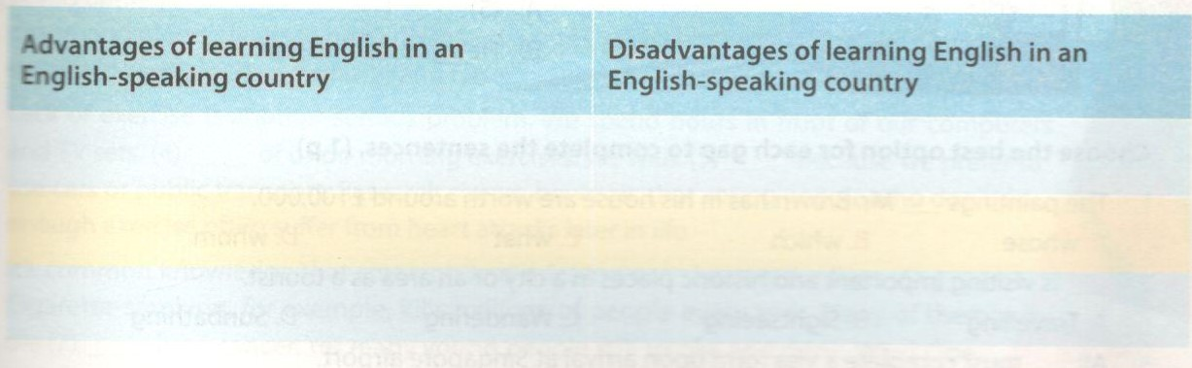

b. Now write about the advantages/ disadvantages of learning English in an English-speaking country (about 100 -120 words). Use the ideas in 2a.
Viết một đoạn văn về những mặt tích cực/ tiêu cực của việc học tiếng Anh ở một nước nói tiếng Anh (khoảng 100-120 từ). Sử dụng các gợi ý ở 2a.

