PHÒNG GIÁO DỤC & ĐÀO TẠO THỐNG NHẤT  TRƯỜNG TIỂU HỌC HOÀNG VĂN THỤ  HỌ TÊN: ………………………………  Lớp: 3 …… |  |  |  |  |  |  | ĐỀ KIỂM TRA HỌC KỲ II  MÔN TIẾNG ANH- LỚP 3  NĂM HỌC 2014-2015  Thời gian: 40 phút
Marks: | Listening |  |  |  |  | Reading and writing |  |  |  |  | Speaking | Total
Marks: | Q.1 | Q.2 | Q.3 | Q.4 | Q.5 | Q.6 |  | Q.7 | Q.8 | Q.9 | Q.10

PART 1: LISTENING (20 minutes)
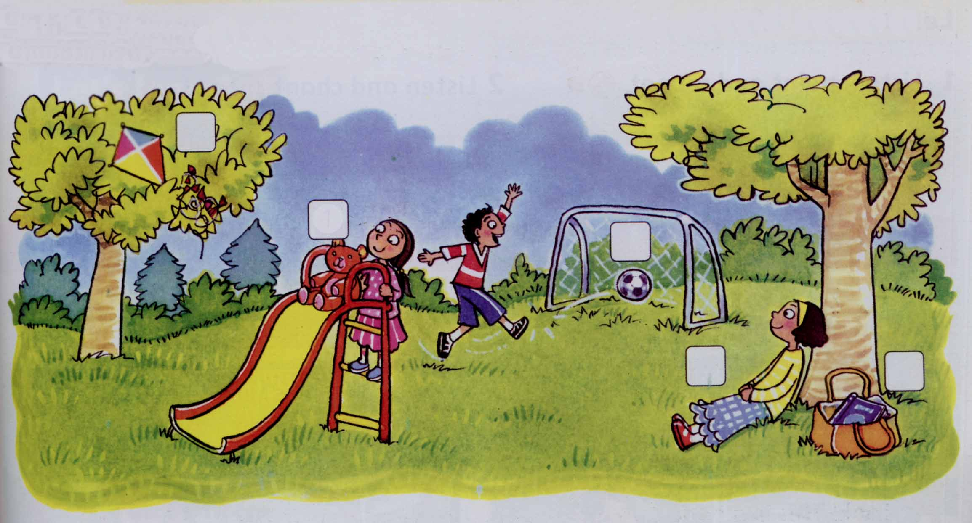
Question 1. Listen and number. (1 pt)
A
B
C
1
D
E
Question 2. Listen and write T (True) or F (False) as examples (1pt).
1. The boy is Oli. | T
2. The family is at the school. | F
3. The family is at the park.
4. It’s is Oli’s kite.
5. The kite is in the net.
6. Oli’s sister is happy now.

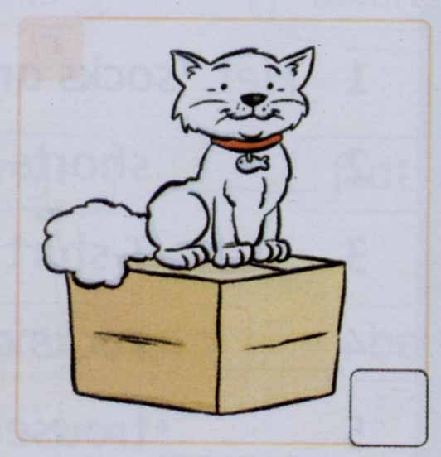
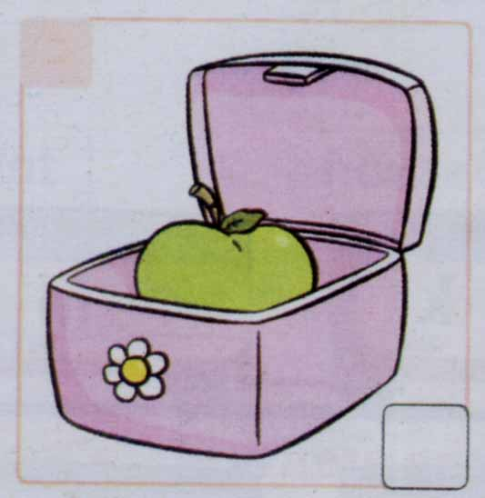
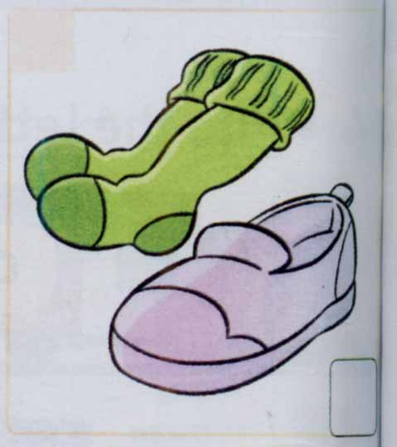
Question 3 Listen and draw the lines.(1pt).
A
B
C
D
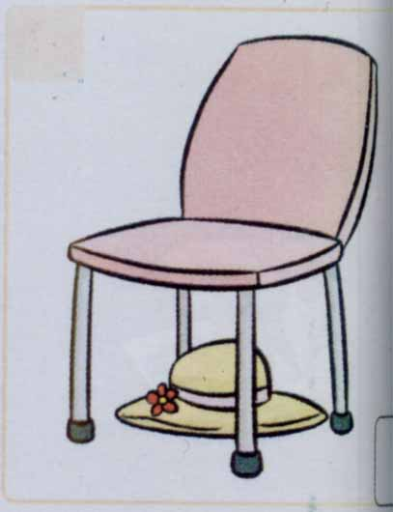

1
2
3
4

Question 4. Listen and tick. (1 pt)
A
B
A
B
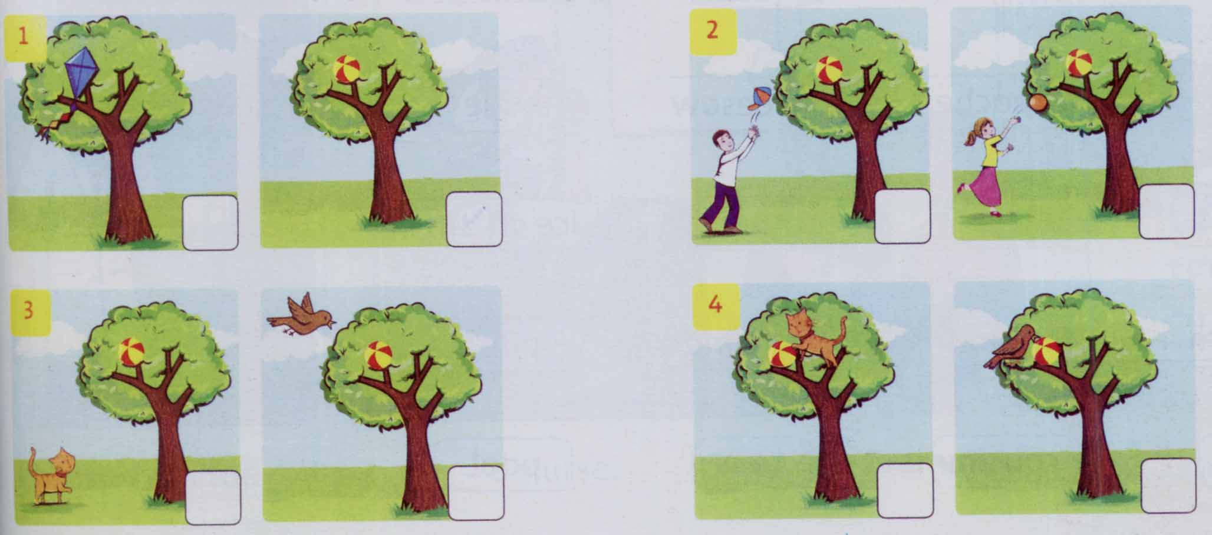
A
B
A
B
Question 5. Listen and complete. (1pt)
1. Max: I like these __________ , Mum.
Mum: Oh Max. They’re __________. All your trousers are orange.
2. Dad: Where’s the ball? Is it under the ___________?
Tim: No, it isn’t.
3. Rosy: Are Dad and Billy in the ___________________?
Mum: No, they aren’t.
4. Rosy: Look! Now I’ve got ten sandwiches and six_______. Please share my lunch.

PART II. READING AND WRITING (15 minutes)
Question 6. Look and read. Put a tick (V) or cross (X) in the box. (1pt).
 | 1. This is pen. | ✓
 | 2. This is a pencil | X
 | 3. This is an apple.
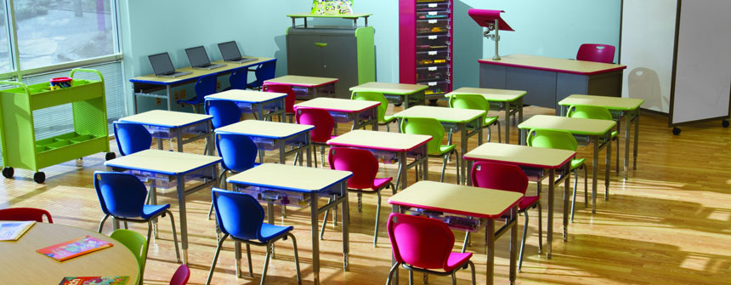 | 4. We are in the classroom.
 | 5. These are shoes
 | 6. I haven’t got my lunch box.  I’ve got a drink.
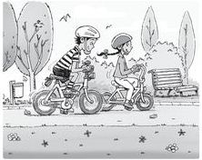
Question 7. Look and read. Write Yes or No (1pt).

Example: They’re Peter and Jenny. Yes
- These are his shorts. 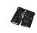 ________
- There are three bikes. ________
- These are his trousers. ______

- They’re on their bikes. ________

Question 8. Look at the pictures. Look at the letters. Write the words .(1 pt)
Example: | npe | → | p e n
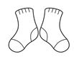 | 1.skocs | → | _ _ _ _ _
 | 2. chunl xob | → | _ _ _ _ _ _ _ _
 | 3. dargen | → | _ _ _ _ _ _
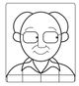 | 4. pandgra | → | _ _ _ _ _ _ _

Question 9. Choose a word from the box and write it next to numbers from 1-4. (1 pt)

My lunch box

Hello. My name’s Hoa. I’m a pupil. This is my (0) ____lunch box____. Let’s look inside. I’ve got two (1) _____________ . One is an egg sandwich. Another sandwich is (2) ______________. I’ve got a (3)__________. It’s orange juice. I’ve got an (4) ______________________and figs and grapes. I haven’t got a biscuit today.
 |  |  |  |  | 
Lunch box | jam | drink | apple | classroom | sandwiches

PART III SPEAKING (1pt) (5’)
Question 10.
1. Listen and repeat | 2. Point, ask and answer
3. Listen and comment | 4. Interview

The End

ANSWER KEY
PART 1: LISTENING (20 minutes)
Question 1. Listen and number. (1 pt)
1. B 2. D 3. A 4. E 5. C
Question 2. Listen and write T (True) or F (False) as examples (1pt).
3. T 4. F 5. F 6. T
Question 3 Listen and draw the lines.There is an example. (1pt).
1. B 2.A 4.D 5.C
Question 4. Listen and tick. (1 pt)
2B 3A 4B 5A
Question 5. Listen and complete. (1pt)
1. Max: I like these trousers , Mum.
Mum: Oh Max. They’re orange. All your trousers are orange.
2. Dad: Where’s the ball? Is it under the seesaw?
Tim: No, it isn’t.
3. Rosy: Are Dad and Billy in the living room?
Mum: No, they aren’t.
4. Rosy: Look! Now I’ve got ten sandwiches and six drinks. Please share my lunch.
PART II. READING AND WRITING (15 minutes)
Question 6. Look and read. Put a tick (V) or cross (X) in the box. (1pt).
3. ✓ 4. X 5. ✓ 6. X
Question 7. Look and read. Write Yes or No (1pt).
1. Yes 2. No 3. No 4. Yes
Question 8. Look at the pictures. Look at the letters. Write the words .(1 pt)

1. Socks 2. Luch box 3. Garden 4. Grandpa

Question 9. Choose a word from the box and write it next to numbers from 1-4. (1pt)

My lunch box

Hello. My name’s Hoa. I’m a pupil. This is my (0) ____lunch box____. Let’s look inside. I’ve got two (1) sandwiches. One is an egg sandwich. Another sandwich is (2)jam. I’ve got a (3)drink. It’s orange juice. I’ve got an (4) apple and figs and grapes. I haven’t got a biscuit today.

