TRƯỜNG TIỂU HỌC LƯƠNG ĐIỀN  Họ tên: .............................................  Lớp: 3.... | ĐỀ KIỂM TRA CUỐI NĂM - MÔN TIẾNG ANH  LỚP 3 - NĂM HỌC: 2015– 2016  Thời gian: 40 phút

MARKS | LISTENING |  |  |  |  | READING AND WRITING |  |  |  | SPEAKING | Total
MARKS | Q.1 | Q.2 | Q.3 | Q.4 | Q.5 | Q.6 | Q.7 | Q.8 | Q.9 | Q.10

Chữ kí giám thị coi thi: …………………… Chữ kí người chấm thi: ………………..
PART 1. LISTENING
Question 1: Listen and number. (1pt).
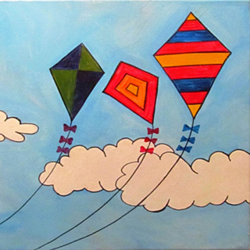
a
b
c

d
e
0

Question 2: Listen and color. There is an example for you. (1 pt)
0.  1. 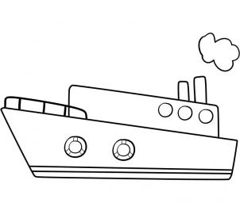2.  | 3.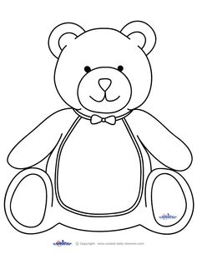 4.
Question 3: Listen and draw the lines. There is an example for you. (1 pt)

0. Tom 1. Mai 2. Mary 3. Peter 4. Nam

Question 4: Listen and tick (). (1pt).

- a. b. c.



1. 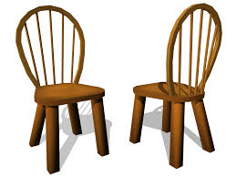  

a. b. c.

2. 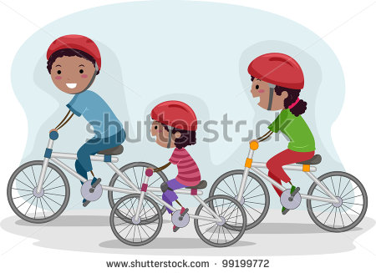 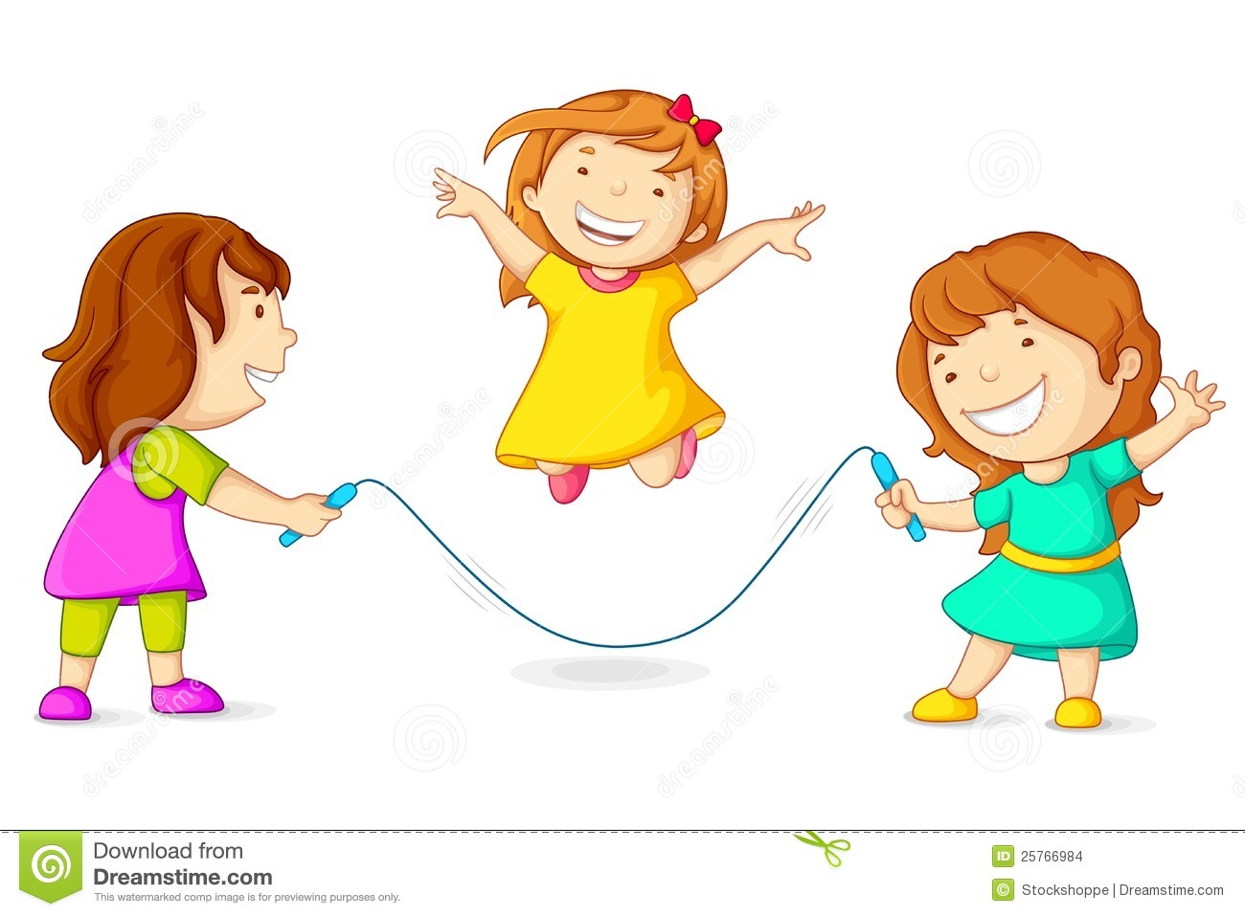 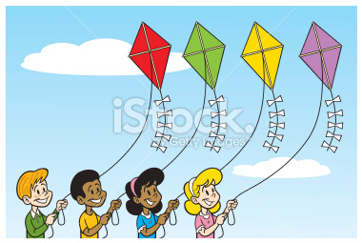

a. b. c.


3. a. b. c.


4.

a.
b.
c.
Question 5: Listen and complete. There is an example for you. (1 pt)
Example: 0. My sister is watching (0) TV.
1. Nam: Where are my books?
Quan: They’re there, (1) __________ the chair.
2. Nam: How many fans are there?
Quan: There are (2) __________.
3. Linda has a (3) ___________.
4. I have a new (4) ___________.

PART 2. READING AND WRITING
Question 6: Look and read. Put a tick() or a cross (  ) in the box (1pt).
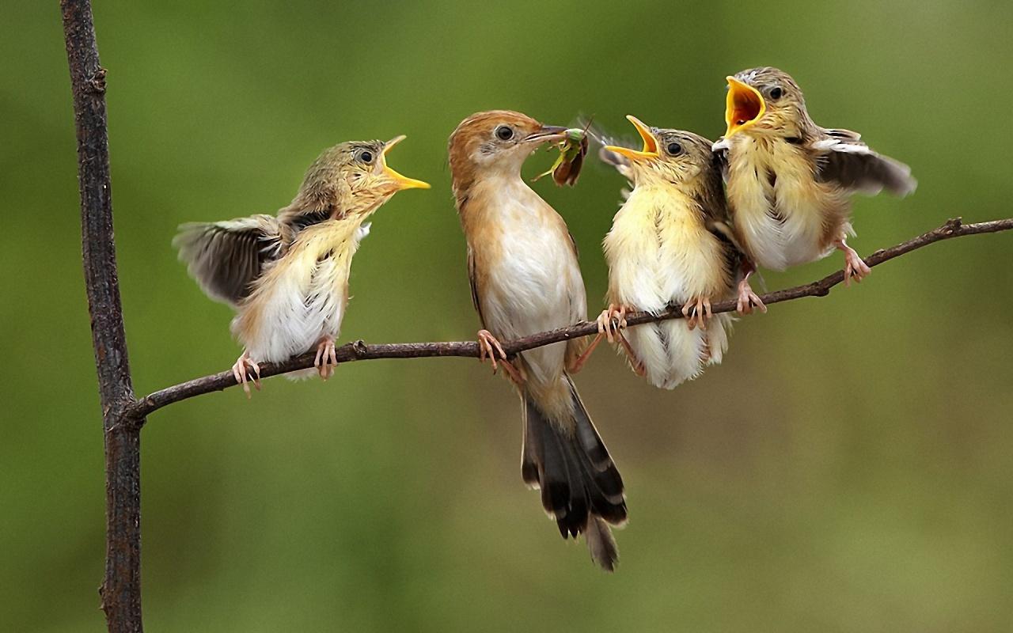 | - I have four birds. | ☑
 | - He is playing the piano.
 | - I have one car.
 | - It’s sunny.
 | - Where is Hanoi?

Question 7: Look and read. Write Yes or No on the line. (1 mark)
 | 0. This is Quan’s family. Yes  1. They’re watching TV. _____  2. Quan is playing the game. ____  3. His father’s reading ____  4. They’re in the living room. ____

Question 8: Look at the pictures and the letters. Write the words (1pt).
0.   | epn | pen
1.   | gsnign | _ _ _ _ _ _ _ _
2. | ysnun | _ _ _ _
3.  | rbabtis | _ _ _ _ _ _
4.  | deaginr | _ _ _ _ _ _ _ _

Question 9: Fill in each gap with a suitable word from the box. (1pt).
parrots | cats | dog | dogs | goldfish
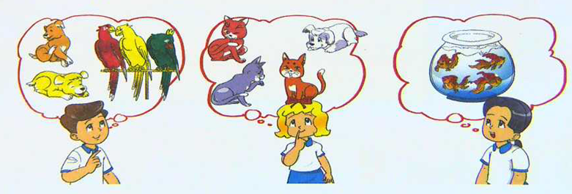

Nam, Linda and Mai like pets. They have different pets. Nam has two (0) dogs and three (1) __________. Linda has three (2) __________ and one (3) __________. Mai has four (4) __________ .

PART III: SPEAKING.
Question 10: Answer the question.(1pt)
- What are you doing?
………………………………….
- What toys do you like?
………………………………….
- What are they doing?
………………………………….
- What’s the weather like?
………………………………….
-The end-

TRANSCRIPT
PART I: LISTENING (20 MINUTES)
Question 1: Listen and number. There is an example for you. (1 mark)
- Tony: Do you have any bed?
Quan: Yes, I have one.
- Mai: Do you have a yo-yo?.
Nam: Yes, I do.
- Tony: Do you like dolls.
Quan: Yes, I like dolls
- Lan: How many kites do you have?
Peter: I have three.
- Hoa: What toys do you like?
Mai: I like truck.
Question 2: Listen and color. There is an example for you. (1 mark)
0. What color is the board?
It’s black.
1. What colour is this ship?
It’s green.
2. Is this your book?
Yes, it is. My book is red.
3. Do you like pink teddy bear?
Yes, I like
4. What is it?
It’s a yellow rabbit

Question 3: Listen and draw the lines. There is an example for you. (1 mark)
0. Tom, Where are they? They’re my family.
1. Mai, This is my living room. Wow it’s very nice.
2. What are you doing , Mary? I’m playing the piano.
3. What toys do you like, Peter? – I like puzzle.
4. Do you have any planes, Nam? Yes, I have one.

Question 4: Listen and tick ✓. There is an example for you. (1 mark)
0. Mary: How many goldfish do you have?
Tom: I have three.
1. Pupil A: Are there any chairs in your room?
Pupil B: Yes there are
2. Lilly: What are they doing?
Andy: They’re skipping
3. Mary: What is the weather like?
Tom: It’s sunny.
4. Mai: Where is Hanoi?
Nam: It is in North Vietnam.

Question 5: Listen and complete. There is an example for you. (1 mark)
Example: 0. My sister is watching (0) TV .
1. Nam: Where are my books?
Quan: They’re there, (1) on the chair .
2. Nam: How many fans are there?
Quan: There are (2) five.
3. Linda has a (3) puzzle.
4. I have a new (4) car.

ANSWER KEYS
PART I: LISTENING (20 MINUTES)
Question 1: Listen and number. There is an example for you. (1 mark)
0. a
1. e
2. b
3. c
4. d
Question 2: Listen and color. There is an example for you. (1 mark)
- black
- green
- red
- pink
- yellow
Question 3: Listen and draw the lines. There is an example for you. (1 mark)
- Tom – family
- Mai – living room
- Mary – playing the piano
- Peter – puzzle
- Nam – plane
Question 4: Listen and tick ✓. There is an example for you. (1 mark)
- C
- a
- b
- a
- c
Question 5: Listen and complete. There is an example for you. (1 mark)
- TV
- on
- five
- puzzle
- truck
Question 6: Look and read. Put a tick ( ) or cross (X) in the box. (1 mark)
- ✓
- ✓
- ✗
- ✓
- ✓
Question 7: Look and read. Write Yes or No on the line.(1 mark)
- Yes
- Yes
- No
- No
- Yes
Question 8: Look at the pictures. Look at the letters. Write the word. (1 mark)
- pen
- singing
- sunny
- rabbits
- reading

Question 9: Fill in each gap with a suitable word from the box. There is an example for you. (1 mark)
- dogs
- parrots
- cats
- dog
- goldfish
Question 10: Gồm 4 nội dung, mỗi nội dung 0,25 đ

