PHÒNG GD&ĐT HUYỆN KBANG  TRƯỜNG TH NGUYỄN ĐÌNH CHIỂU  ------------------- | ĐỀ KIỂM TRA HỌC KỲ II  Năm Học 2014-2015  MÔN: TIẾNG ANH - LỚP 3  Thời gian: 40 phút

Marks: | Q.1 | Q.2 | Q.3 | Q.4 | Q.5 | Q.6 | Q.7 | Q.8 | Q.9 | Total

PART 1. LISTENING (20 minutes)
Question 1. Listen and number (1pt)



1
A. B. C. D E.

Question 2. Listen and write a word: (2pts)
1. A: What color is this?
B: It’s red.
2. A: What color is that?
B: It’s ____________.
3. A: What color is that?
B.. It’s ____________.
4. A: What color is this?
B. It’s ____________.
5. A: What color is this?
B: It’s ____________.

Question 3. Listen and draw the line. ( 1pt)
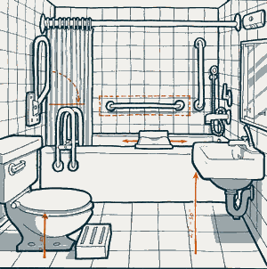
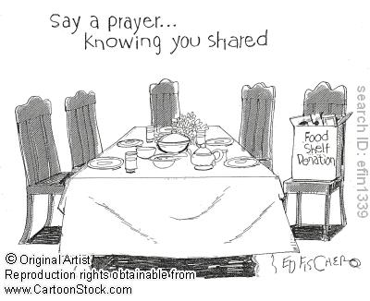
A. B. 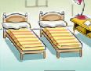 C. 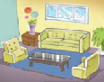 D. 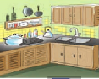 E.

1
2
3
4
5

Question 4. Listen and tick ( 1pt)
1.



A. B.
V

2.
A  B 
3.
A  B 
4.
A  B 

5.
A  B 

PART II. READING AND WRITING (15minutes)
Question 5. Look and read. Put a tick or a cross in the box as example.
   
0. He is a teacher. 00.This is Linda.
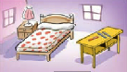
1. This is my brother. 2. There is one bed in the bedroom.

3. They are cooking. 4. It is rainy.
Question 6. Look at the pictures. Look at the letters. Write the words .(1 pt)
Example:
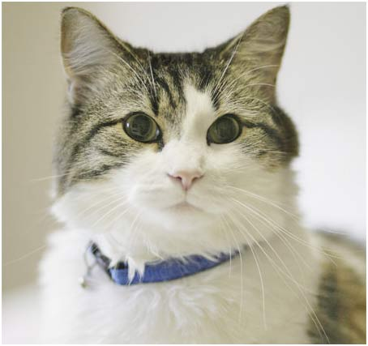 | atc |  | c a t
 | 1. rbitba |  | _ _ _ _ _ _
 | 2. odll |  | _ _ _ _
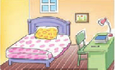 | 3. robomed |  | _ _ _ _ _ _ _
 | 4. saktnig |  | _ _ _ _ _ _ _

Question 7. Look and read. Write Yes or No (1pt).
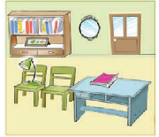 | Example: This is a bedroom  1. There is a desk.  2. There are three chairs.  3. The book is on the desk.  4. The lamp is under the chair | Yes  ..............  ...............  ..............  .................

Question 8. Choose a word from the box and write it next to numbers from 1-4. (1pt)

My family

Hello. My name’s Hung. I’m a pupil. This is my (0) family. We are at home now.

My father and I are in the(1)………………. It is large and we are (2)……………

My mother is (3)………………in the kitchen. My (4)……………..is playing the piano in her room. We are very happy.
 | 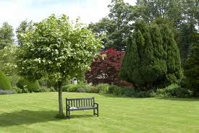 | 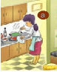 | 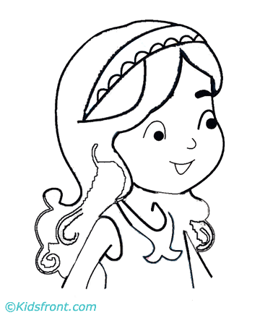 | 
family | garden | cooking | sister | running

PART III . SPEAKING (1pt) (5’)
Question 10.
1. Listen and repeat | 2. Point ask and answer
3. Listen and comment | 4. Interview

THE END

