PHÒNG GD&ĐT CƯMGAR  TRƯỜNG TH BẾ VĂN ĐÀN  ----------------------  ĐỀ CHÍNH THỨC |  |  |  |  |  |  | ĐỀ KIỂM TRA CUỐI NĂM  MÔN: TIẾNG ANH - LỚP 3  Năm học: 2015-2016  Thời gian làm bài: 40 phút
Marks: | Listening |  |  |  |  | Reading and writing |  |  |  |  | Speaking | Total
Marks: | Q.1 | Q.2 | Q.3 | Q.4 | Q.5 | Q.6 |  | Q.7 | Q.8 | Q. 9 | Q.10

PART I – LISTENING (20 minutes)
Question 1: Listen and match as example (1pt)
a.b.c.d.e.

1
2
3
4
5

Question 2: Listen and circle as example ( 1pt)
1. a. living room. b. dining room. c. bathroom.
2. a. two dogs b. five parrots c. nine parrots
3. a. cycling b. dancing c. singing
4. a. trains b. kites c. planes
5. a. a puzzle b. a yo-yo c. a robot

Question 3: Listen and number as example ( 1pt)
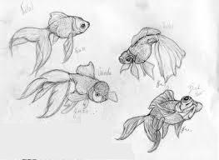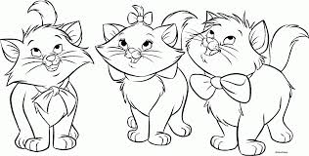
a.
b.
c.
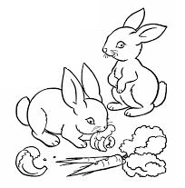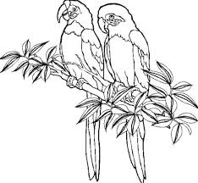
d.
e.
1

Question 4: Listen and tick as example (1pt)
1. a. b. 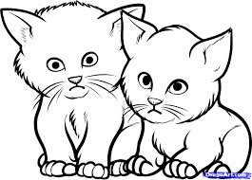

2. 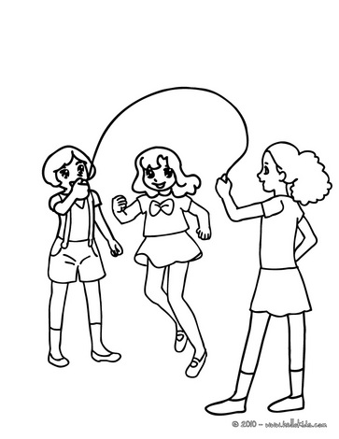 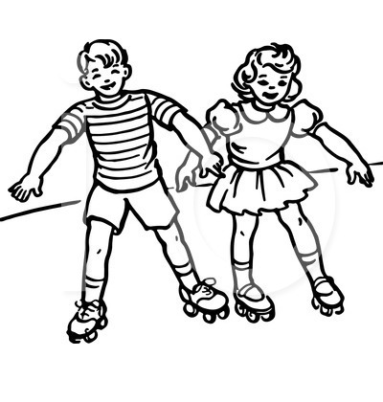
a.
b.
3. 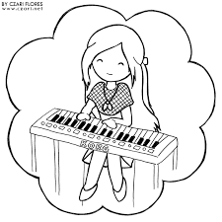 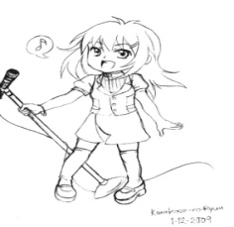
a.
b.
4. 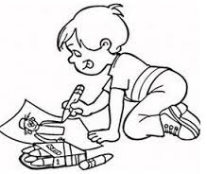 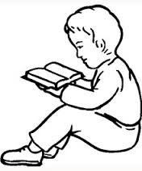
a.
b.
5. 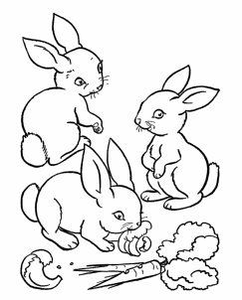 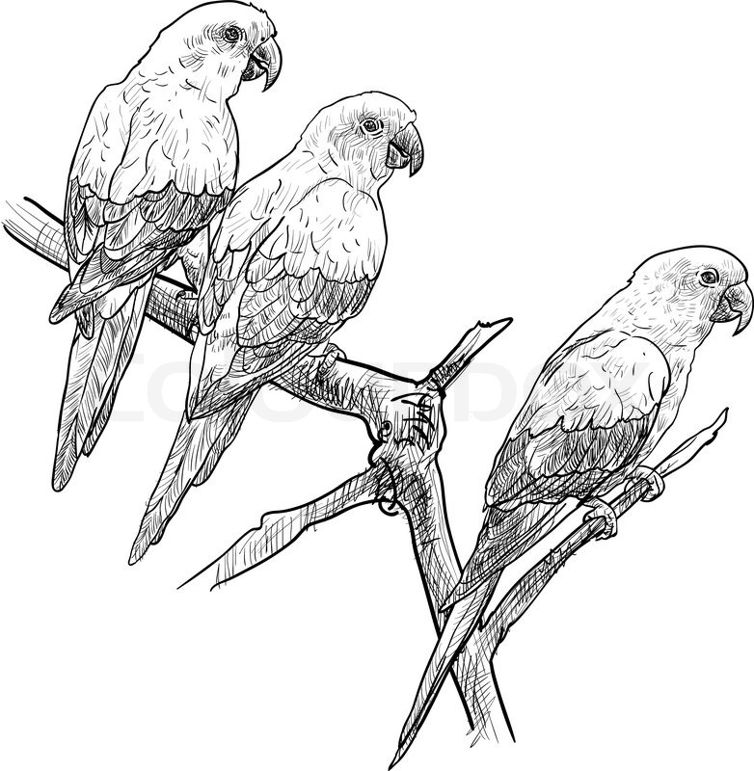
b.
a.
Question 5: Listen and complete as example (1pt)
bathroom; rainy; reading; on; kite.

1. The bathroom is large.
2. I have a new _____________.
3. My sister is _____________.
4. I like _____________ days.
5. The book is _____________ the chair.
PART II: READING AND WRITING ( 15 minutes)
Question 6. Look and read. Put a tick () or cross (X) in the box as example.(1pt)
      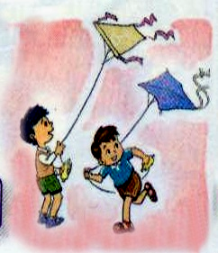 | 0. It is rainy.    00. He’s my sister.    1. She has got a rabbit.  2. They are flying kites.
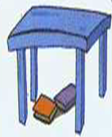 3.There are two books under the table.
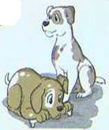 | 4. How many dogs do you have ?_ I have one.

Question 7. Look and read. Write Yes or No as example (1pt)
0.This is Linda. Yes
  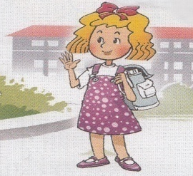  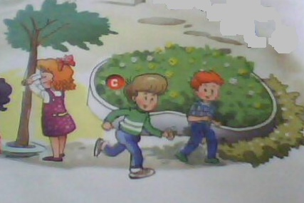    1. 2.  3. 4. | 1. Linda is a girl.  2. She has got two dogs.  3. She is playing badminton.  4. It is rainy today. | ________  ________  ________  ________

Question 8. Look at the pictures. Look at the letters. Write the words as example .(1 pt)
 | npe |  | p e n
 | 1. nysun |  | ……………….
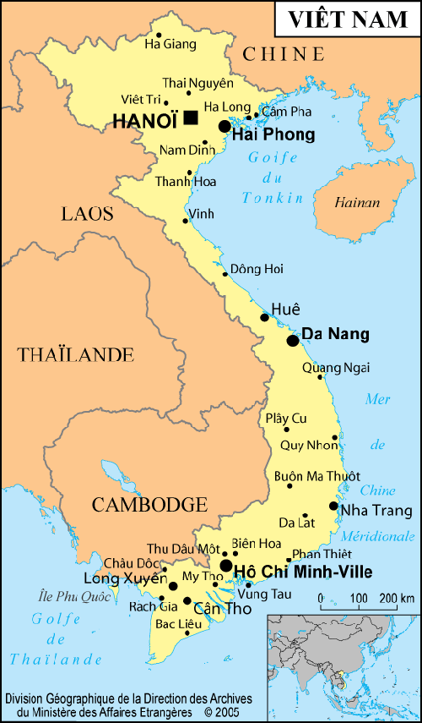 | 2. mpa |  | ……………….
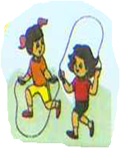 | 3. skppngii |  | ……………….
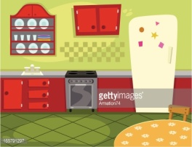 | 4. chkiten |  | ……………….

Question 9: Choose a word from the box and write it next to numbers from 1- 4 as example. (1 pt)

My new friends

They are my new friends. This is Lien. She has got some new (0) toys. She has got four (1)_________. She has got three(2) _________. That is Phong. He has got a (3)______

It is red. He has got two (4) __________. They are yellow and blue. Hoa and Phong are very happy with new toys.
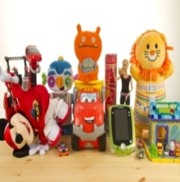 | 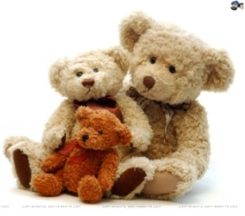 | 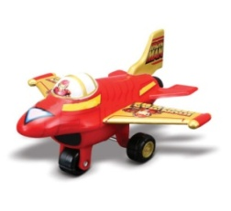 | 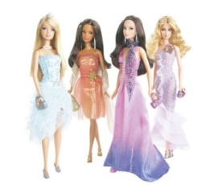 | 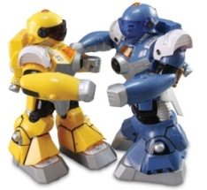
toys | teddy bears | plane | dolls | robots

PART III. SPEAKING ( 5 minutes)
Question 10: Speaking. ( 1pt)
- Listen and repeat.
- Point, ask and answer.
- Listen and comment.
- Interview

