THE FINAL TEST OF ENGLISH FOR THE THIRD GRADERS
School year: 2015-2016 – Testing date: ____________.Time allowed: 35 minutes

School:_______________________  Class: 3______ | Student’s name:  ___________________________ | Scores

I. Put the words next to the correct picture: ( 2.5 points )

a yellow rectangle markers two purple ovals
a bag see the board fat
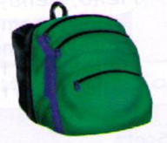

0. a bag

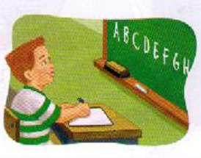
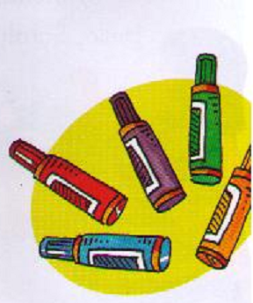
1. …………… 2. ……………....

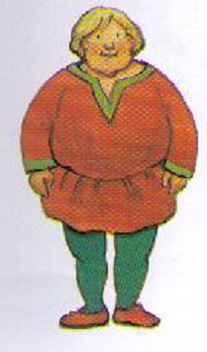
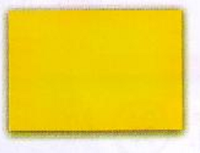
3……………… 4. ………….…

5…………………

II. Unscramble and write : (2,5 points)
0. these/ What/ are/? => What are these?
1. count/ I / ten/ can/ to
=>…………………….................…
2. color/ these/ What/ are/?
=>…………………….................…
3. meet/ nice/ you/ to/ It's
=>…………………….................…
4. is/ grandmother/ This/ my
=>…………………….................…
5. sister/ tall/ and/ is/ pretty/ My
=>…………………….................…

III. Answer the questions : (2,5 points)

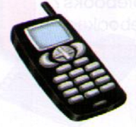
1. What’s your name?
…………………….........
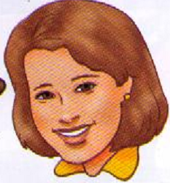
2. What’s this?
…………………………….
3. Who is she?
……………………………
4. What color are these?
…………………………… 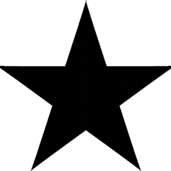

5. How many circles?
………………………………

IV. Read and match: (2,5 points)
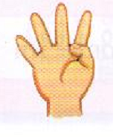
1. read a book a /

2. young b/
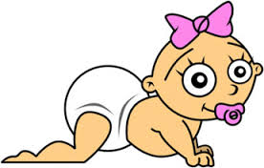
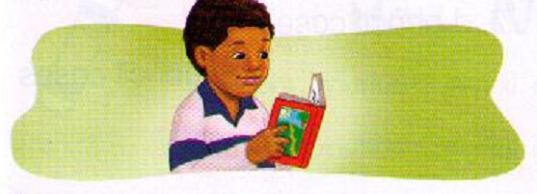
3. fingers c/

4. baby sister d/
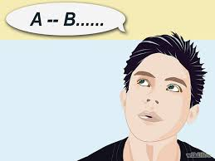
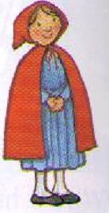

5. say the alphabet e/

The end!

