PHÒNG GD&ĐT TX PHỔ YÊN  TRƯỜNG TH PHÚC THUẬN II  ----------------------  Họ và tên: ………………………………  Lớp: 3…… | BÀI KIỂM TRA CUỐI NĂM  NĂM HỌC 2015-2016  MÔN TIẾNG ANH - LỚP 3  Thời gian: 40 phút

Marks | Listening |  |  |  | Reading and writing |  |  |  | Speaking |  | Total
 | Q.1 | Q.2 | Q.3 | Q.4 | Q.5 | Q.6 | Q.7 | Q. 8 | Q.9 | Q.10

PART 1. LISTENING (20 minutes)
Question 1. Listen and number. (1point)
A.  | B . 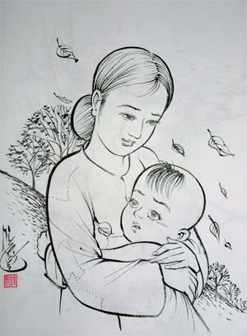
C.  | D. 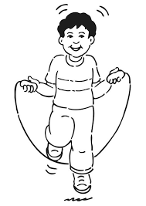

Question 2: Listen and draw the line. There is an example. (1 point)
A 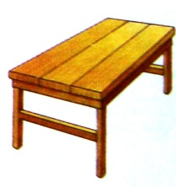BCD   1  2  3  4 | E  0

1--…. 2--….. 3--…… 4---……. 0-- E
Question 3. Listen and tick. (1 point)
1. Laura: Who is she ?
Jimmy. | A.  | B.  | C. 
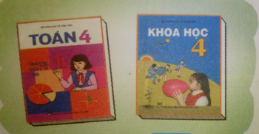
2. Lilly: How many books?
John | .  A. |   B. | C. 
3. Mary: How many cats?
Peter. |   A. |   B. | C. 
4. Jane: What are these?
Tom. | A.  | B.  | C. 

Question 4. Listen and complete. (1point)
This is my (1) _________________. She is 30 years (2) ___________. She is (3) ___
____________and (4) ____________.

PART II. READING AND WRITING (15 minutes)
Question 5. Look and read. Put a tick ( ) or cross (X) in the box. (1 point)
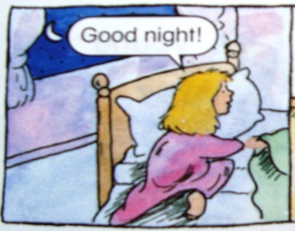 1. Wake up. |  3. Watch TV.
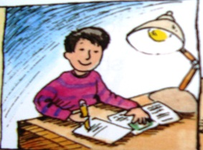 2. Do homework | 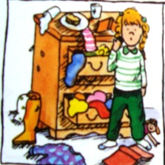 4. Make a mess

Question 6. Look and read. Write Yes or No (1pt).
 1.She is pretty. _________ |  3.She is ugly. ________
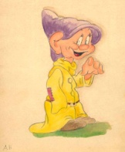 2.He is Short. ________ |  4.She is fat. _________

Question 7. Look at the pictures. Look at the letters. Write the words.(1 point)
 | 1. ATC |  | ___ ___ T
 | 2. ISX |  | S ___ ___
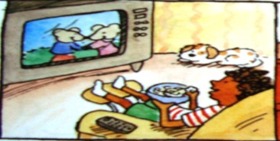 | 3. WACHT T.V |  | W___ ___CH TV
 | 4. THERE |  | TH___ ___E

Question 8. Choose a word from the box and write it next to numbers from 1-4.(1 point)

This is my (1) __________. She is (2) ________years old. She is (3)__________. She is (4)________.
 |  |    | 
Sister | pretty | young | ten

PART III: SPEAKING (2 points) (10’)
Question 9, 10.
1. Listen and repeat | 2. Point, ask and answer
3. Listen and comment | 4. Interview

The End
PHÒNG GD VÀ ĐT PHỔ YÊN  TRƯỜNG TH PHÚC THUẬN II | ĐÁP ÁN VÀ BIỂU ĐIỂM BÀI KIỂM TRACUỐI NĂM  NĂM HỌC 2015- 2016  MÔN: TIẾNG ANH- LỚP 3

PART 1: LISTENING ( 20 minutes)
Question 1. Listen and number. (1 pt)
Tape-script:
1. He is my baby brother 2. She is my mother
3. This is my grandfather 4. He is my bother.
Answer: 1.A 2.B 3.C 4.D
Question 2. Listen and draw the line. There is an example. ( 1 pt)
1. It is a table 2. This is my robot 3. This is a pencil case 4. These are crayons
Answer: 1-A 2- B 3-C 4-D
Question 3. Listen and tick. (1 pt)
Tapecript: 1.Laura: Who is she ? 2. Lilly: How many books ?
Jimmy: She is my sister John: There are two books.
3. Mary: How many cats? 4. Jane: What are these?
Peter: there are five cats. Tom: These are yo-yoes.
Answer: 1-B 2- A 3-B 4-C

Question 4. Listen and complete. (1pt)
This is my (1) mother. She is 30 years (2) old. She is (3) young and (4) pretty.

PART II. READING AND WRITING (15 minutes)
Question 5. Look and read. Put a tick ( ) or cross ( X ) in the box.(1pt).
- X 2. X 3. 4.
Question 6. Look and read. Write Yes or No (1pt).
1. Yes 2.Yes 3. Yes 4.Yes

Question 7. Look at the pictures. Look at the letters. Write the words .(1 pt)
1.CAT 2.SIX 3.WATCH TV 4.THREE

Question 8. Choose a word from the box and write it next to numbers from 1-4. (1 pt)

This is my (1) SISTER . She is (2) TEN years old. She is (3)YOUNG. She is (4)PRETTY.

Part III: Speaking:

Question 9, 10: (2 points ) - (10 minutes)
1. Listen and repeat  - pretty, short, fat, grand mother | 2. Point, ask and answer  -Who is he? / Who is she?  He is my friend/teacher  - What are these? / What are those?  They are books.
3. Listen and comment  - house, father, ugly, star | 4.Interview  -What is your name? =>my name is……  -What color is it? => it is black  - Who is he? => he is my friend.

