TRƯỜNG TH ĐỒNG KHO 1  ----------------  Họ tên:…………....................................  Lớp: 3………….. | ĐỀ KIỂM TRA CUỐI NĂM  NĂM HỌC 2014 - 2015  MÔN: TIẾNG ANH - LỚP 3  Thời gian làm bài: 40 phút

Marks | Listening |  |  |  |  | Reading and writing |  |  |  | Speaking | Total
Marks | Q.1 | Q.2 | Q.3 | Q.4 | Q.5 | Q.6 | Q.7 | Q.8 | Q.9 | Q.10

PART I: LISTENING: (20 minutes)

Question 1. Listen and number. (1pt)

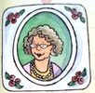




A. B. C. D.
Question 2. Listen and color. (1pt)
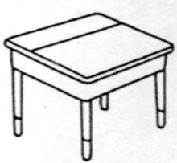
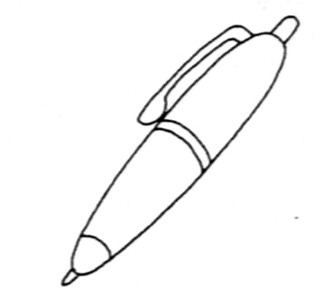
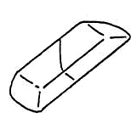
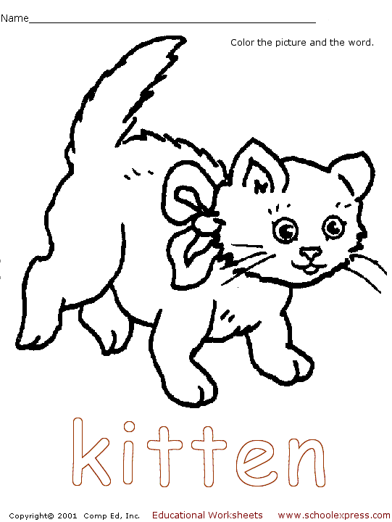
1. 2. 3. 4.

Question 3. Listen and draw the line. There is an example. (1pt)
Baby sister Nga The children Nam John and Scott


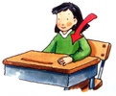
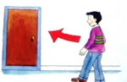
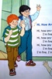

Question 4. Listen and tick. (1 pt) Example: 1.C
٧


٧

Mai: A. B. C.

2. Andy: I’m home. This is my mother.
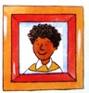

Andy: A. B. C.


3. Lan: What is this?
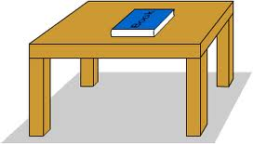

Hoa: A. B. C.


4. Mai: How many notebooks?



Nga: A. B. C.

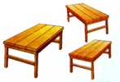

5. Nam: What are these?


An: A. B. C.

Question 5. Listen and complete. (1pt)
1. Tom: What's his name?
Linda: His name is ..........................
2. Mai: How old are you, Tom?
Tom: I'm ....................... years old.
3. Peter: How many pencils?
Lisa: One …………………..
4. Linda: Who is she?
Mai: She is my …………………...

PART II: READING AND WRITING: (15 minutes)

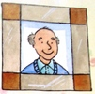
Question 6. Look and read. Put a tick or cross in the box as examples. (1pt)
V

- He is my grandfather.

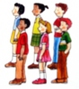
2. Make a circle

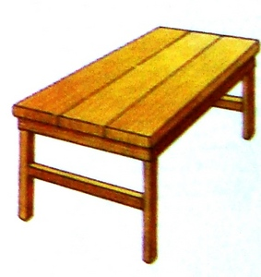
3. This is a table.


4

4. It’s a jump rope.


5. He is my brother.

Question 7. Fill in the blanks (1pt)
nice home too is

Kate: Hi, Mom! I’m ………(1)…………. .
This ……(2)……… my friend, Andy. This is my mother.
Andy : It’s ………(3)………….. to meet you, Mrs. Hill.
Mrs. Hill: It’s nice to meet you, …………(4)…………, Andy.
Question 8. Look at the pictures. Look at the letters. Write the words. (1 pt)
 1. nep ....................................

2. ookb ....................................

3. stersi .....................................

4. therfa ……………………………

Question 9: Choose a word from the box and write it next to number from 1- 4 ( 1pt)

watching is listening playing in

My name is Nam. Today my family (0) is at home. We are (1) ...................the living room. My father is (2)……………….TV. My mother is(3)…………....the piano. My brother is (4)………………….to music and I am singing.
PART III: SPEAKING: (5 minutes)
Question 1. Speaking (1 pt)
1. Listen and repeat. 2. Point, ask and answer.
3. Listen and comment. 4. Interview.
The End

