PHÒNG GD&ĐT HUYỆN ĐĂK GLEI  TRƯỜNG PTDT BTTH ĐĂK CHOONG  ------------------------------  Name: …………………………  Class: 3… | ĐỀ THI HỌC KỲ 1  NĂM HỌC 2014 - 2015  MÔN: TIẾNG ANH - LỚP 3  Thời gian: 40 phút

Marks: | Listening |  |  |  |  | Reading and writing |  |  |  | Speaking | Total
Marks: | Q.1 | Q.2 | Q.3 | Q.4 | Q.5 | Q.6 | Q.7 | Q.8 | Q. 9 | Q.10

PART 1: LISTENING (20 minutes)

Question 1: Listen and match (Nghe và nối) (1pt)
A 
1
2
B 
C 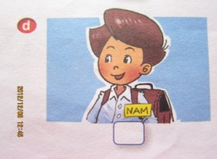 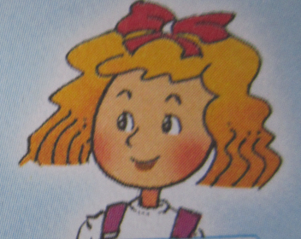 D
3
4

Question 2: Listen and check (Đánh dấu  vào tranh mà em nghe được) (1pt)

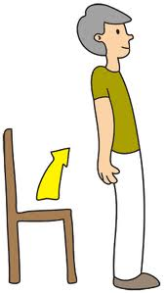  1. A.  |   B.  |   2.A. |   B.
  3.A. | B.    | 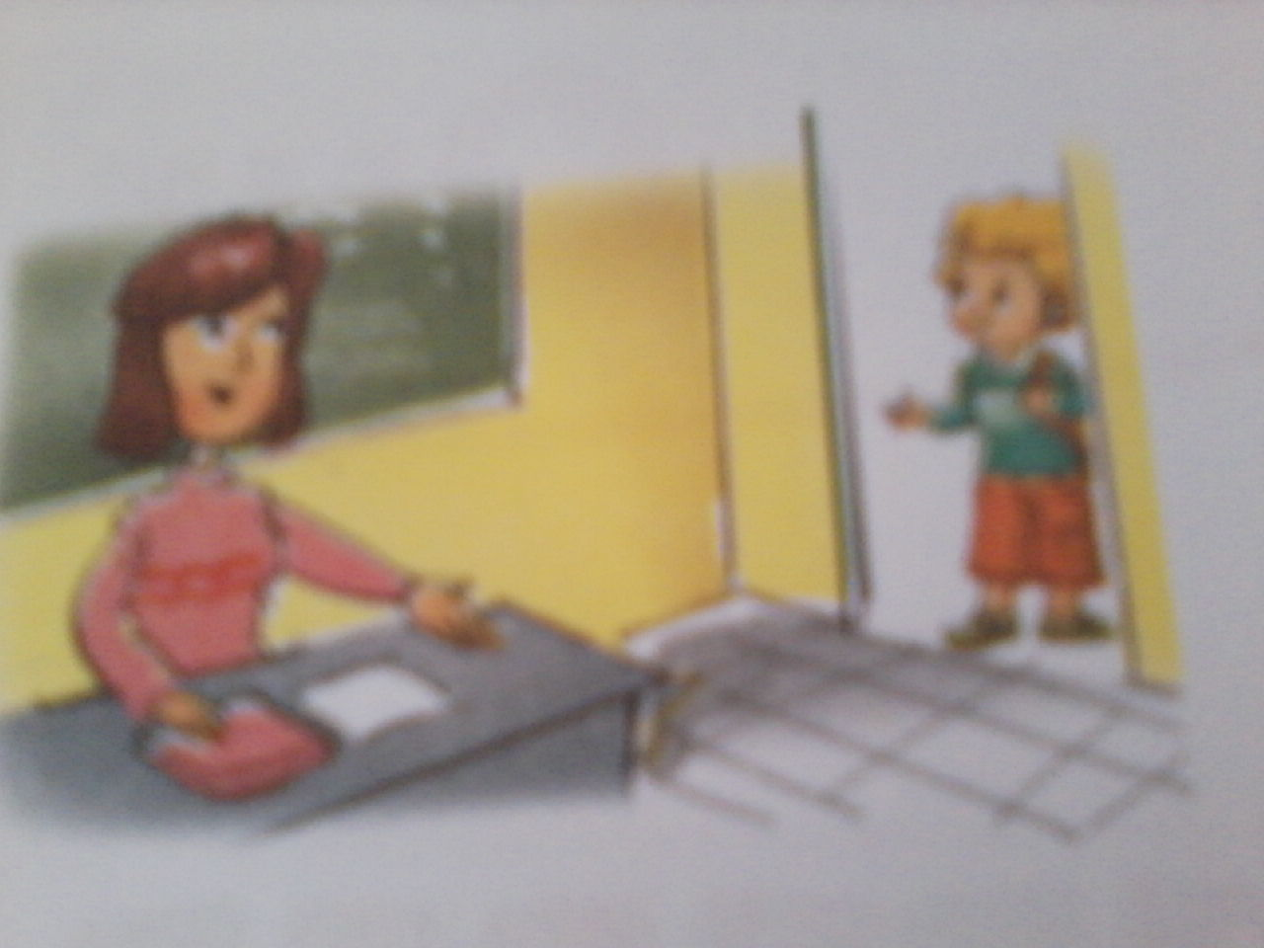  4.A.  | 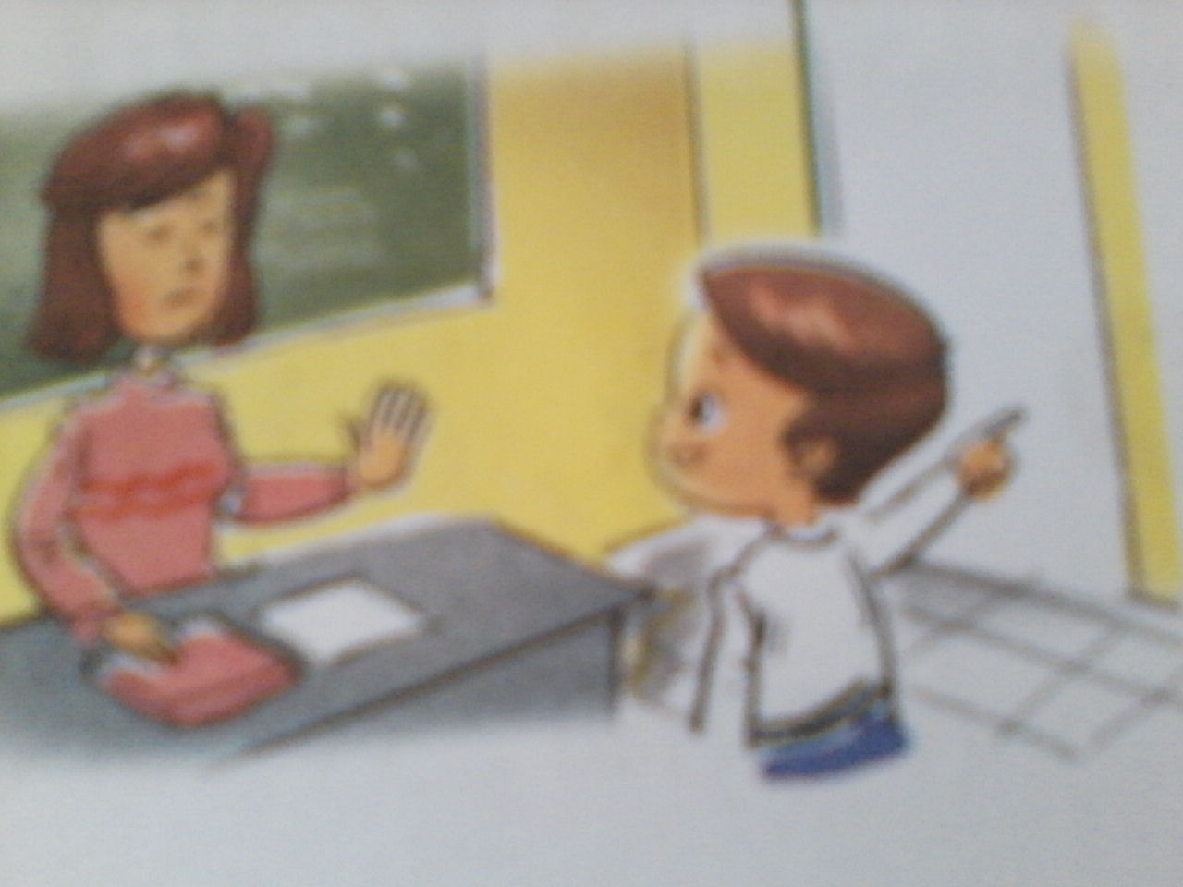  B. 

Question 3: Listen and number (Nghe và đánh số thứ tự ) (1pt)

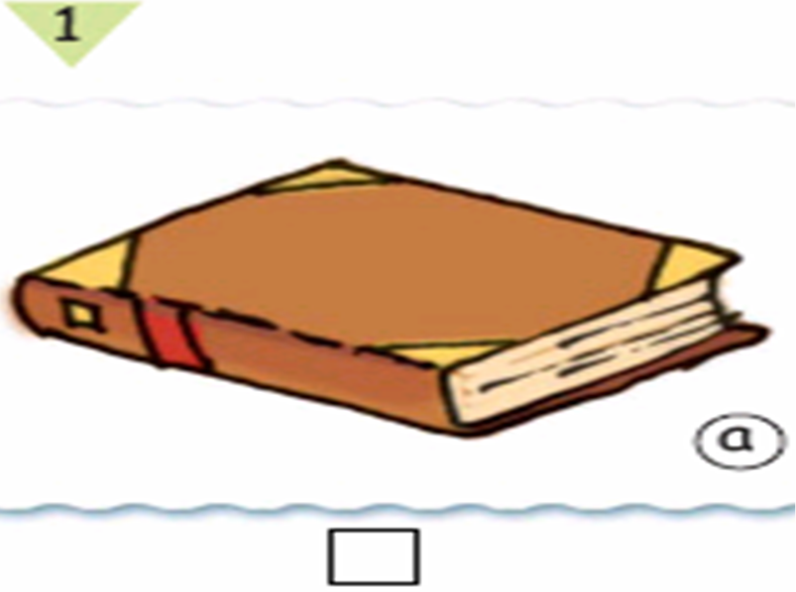



A B C D

Question 4: Listen and check. (Đánh dấu  vào từ mà em nghe được) (1pt)

1. o school o classroom
2. o thanks o bye
3. o this o that
4. o sit o stand

Question 5: Listen and write (Nghe và viết) (1 pt)

1. | A: | What is your name?
 | B: | My name is .......................

2. | A: | How do you spell your name?
 | B: | ..........................

3. |  | .......... is my new friend Mary.

4. | A: | How are you today?
 | B: | I’m ................., thank you.

PART 2: READING AND WRITING (20 minutes)

Question 6: Match the question in column A with the answers in column B (Nối các câu hỏi ở cột A với các câu trả lời ở cột B) (1pt)

A | B | Answer
1. What’s your name? | a. I’m fine, thank you. | 1 -
2. May I go out? | b. My name’s Hue. | 2 -
3. How are you? | c. Nice to meet you, too | 3 -
4. Nice to meet you | d. Sure | 4 -
Question 7: Read and match (Đọc và nối) (1pt)

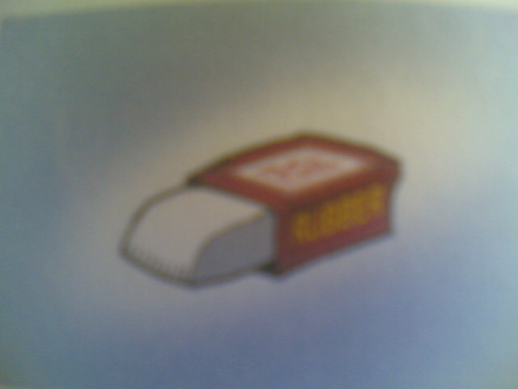
1. Nam: This is my school.
Mai: What’s its name?
Nam: It’s Kim Dong School.
Mai: Oh, it’s big.
A

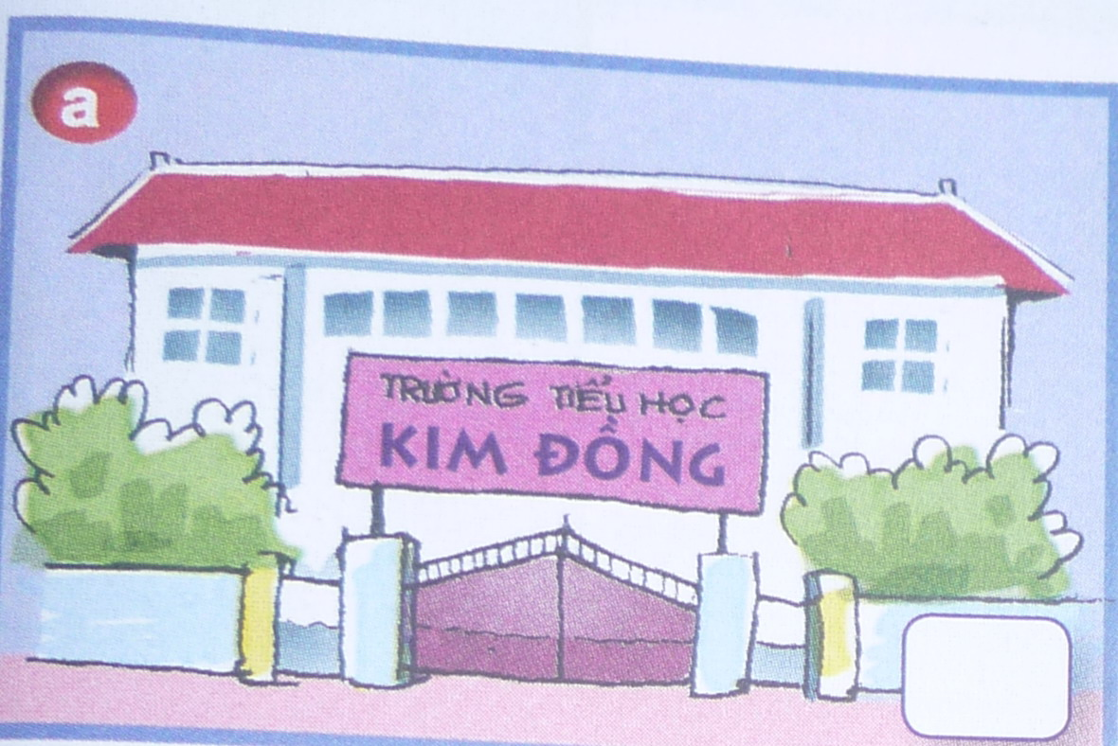
2. Alan: Look. This is my eraser.
Li Li: Is it big?
Alan: No, it isn’t. It’s small.

B


3. This is my library.
It’s big.
C

4. Close your book, please.
D
Question 8: Reorder the words to make sentences (Sắp xếp lại các từ để tạo thành câu đúng) (1pt)

1. name / is / Li Li / My /. /
………………………………………………………………………………………….
2. your / please / book / Open / , /
…………………………………………………………………………………………
3. in / May / out / I / ? /
…………………………………………………………………………………………
4. This / school / my / is / . /
…………………………………………………………………………………………

Question 9: Look at the pictures and write the words. (Nhìn vào tranh và viết các từ thích hợp) (1pt)

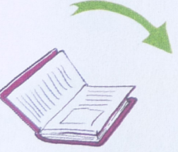 | 1.…………...your book, please.
 | 2. They are my ………………
 | 3. A: Is your………… big ?  B: Yes, it is.
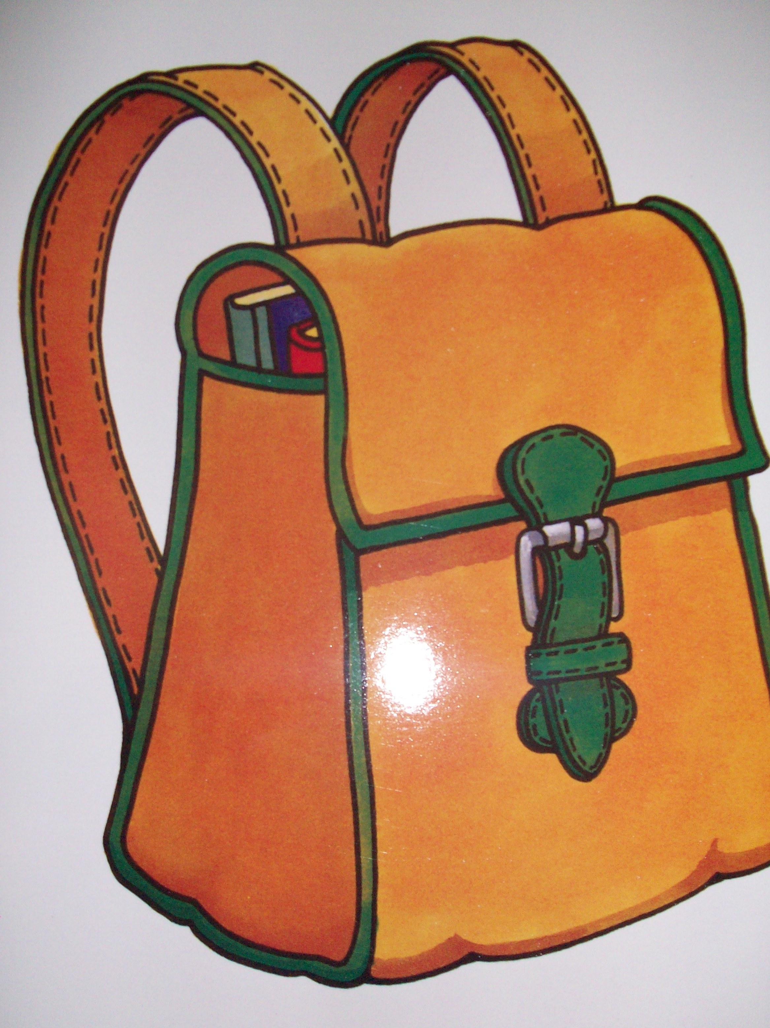 | 4. This is a ……………..

PART 3: SPEAKING (1pt)

ANSWER KEYS
(Mỗi câu đúng 0,25 điểm)
PART 1: LISTENING:
Question 1. 1. D 2. B 3. C 4. A
Question 2. 1. B 2. A 3. B 4. A
Question 3. 1. D 2. A 3. C 4. B
Question 4. 1. school 2. thanks 3. that 4. stand
Question 5. 1. Peter 2. H-O-C 3. She 4. fine
PART 2: READING AND WRITING:
Question 6. 1. b 2. d 3. a 4. c
Question 7. 1. B 2. A 3. D 4. C
Question 8. 1. My name is LiLi.
2. Open your book, please.
3. May I go out?
4. This is my school.
Question 9. 1. Close 2. friend 3. pen 4. bag
PART 3: SPEAKING:
Question 10:
1. Listen and repeat:
- library
- school
- friends
- name
2. Point, ask and answer.
- What is this?
- Who’s she?
- Who’s he?
3. Listen and comment:
- Is this book/ pen / ruler / eraser / big?
- Is your school / book big / small?
4. Interview.
- What’s your name?
- How are you?
TRANSCRIPT

Question 1: Listen and match (1pt).
1. A: Who’s she?
B: She’s Linda.
She’s my friend.
2. Hello. I’m Alan. That’s A-L-A-N.
3. A: What’s your name?
B: My name’s Nam.
4. She’s Mai. She’s my friend.
Question 2: Listen and check (1pt)
1. Sit down, please.
2. This is my classroom.
3. Close your book, please.
4. May I come in?
Question 3: Listen and number (1pt)
1. A: Goodbye Mai.
B: Bye Nam. See you later.
2. A: Is your book big?
B: No, is isn’t. It’s small.
3. This is my classroom. It’s small.
4. I have a ruler.
Question 4: Listen and check (1pt)
1. school
2. thanks
3. that
4. stand
Question 5: Listen and write (1pt)
1. Peter
2. H – O – C
3. She
4. fine

