PHÒNG GD&ĐT QUẬN CẨM LỆ  TRƯỜNG TIỂU HỌC ÔNG ÍCH ĐƯỜNG  LỚP: Ba/………  HỌC SINH:…………………………………. | KIỂM TRA ĐỊNH KÌ CUỐI KÌ I NH: 2014 – 2015  MÔN: TIẾNG ANH 3 Thời gian: 35 phút  Giáo viên coi:………………………………………  Giáo viên chấm…………………………………….
****************************************************************Tờ 1

PHẦN NGHE Điểm:
Question 1: Listen and draw the lines: (1M)
A B C D E
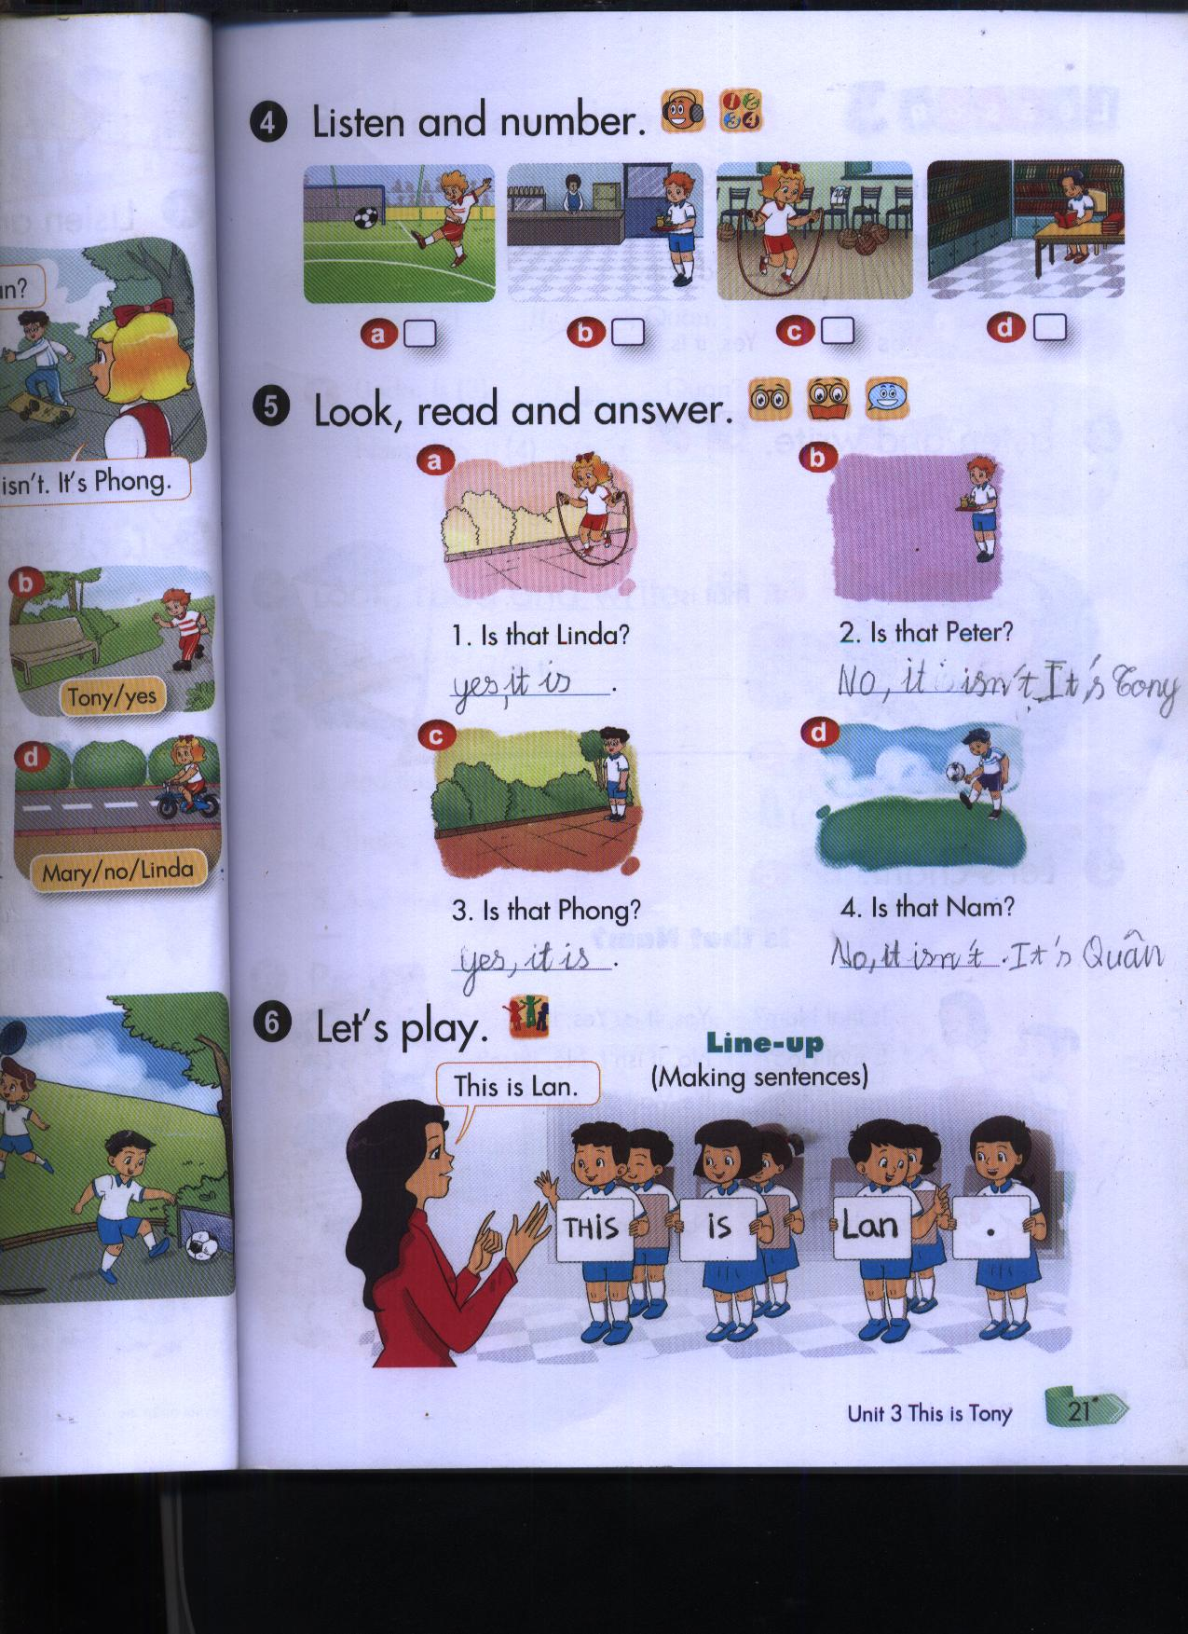
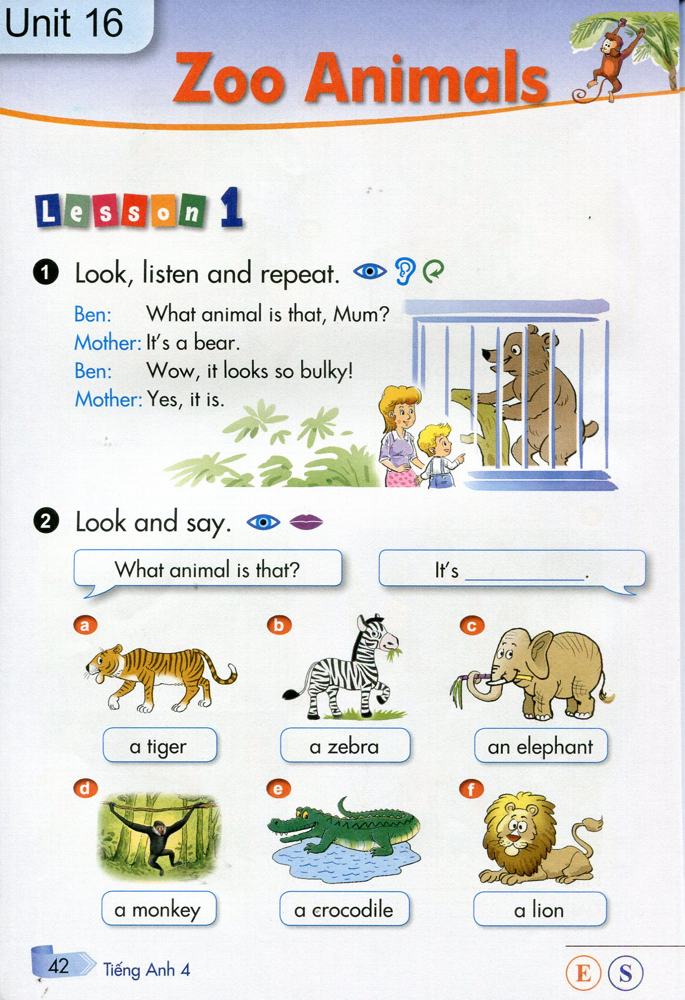

1
2
3
4
0

Question 2: Listen and number: (1M)
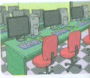
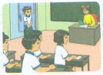
A 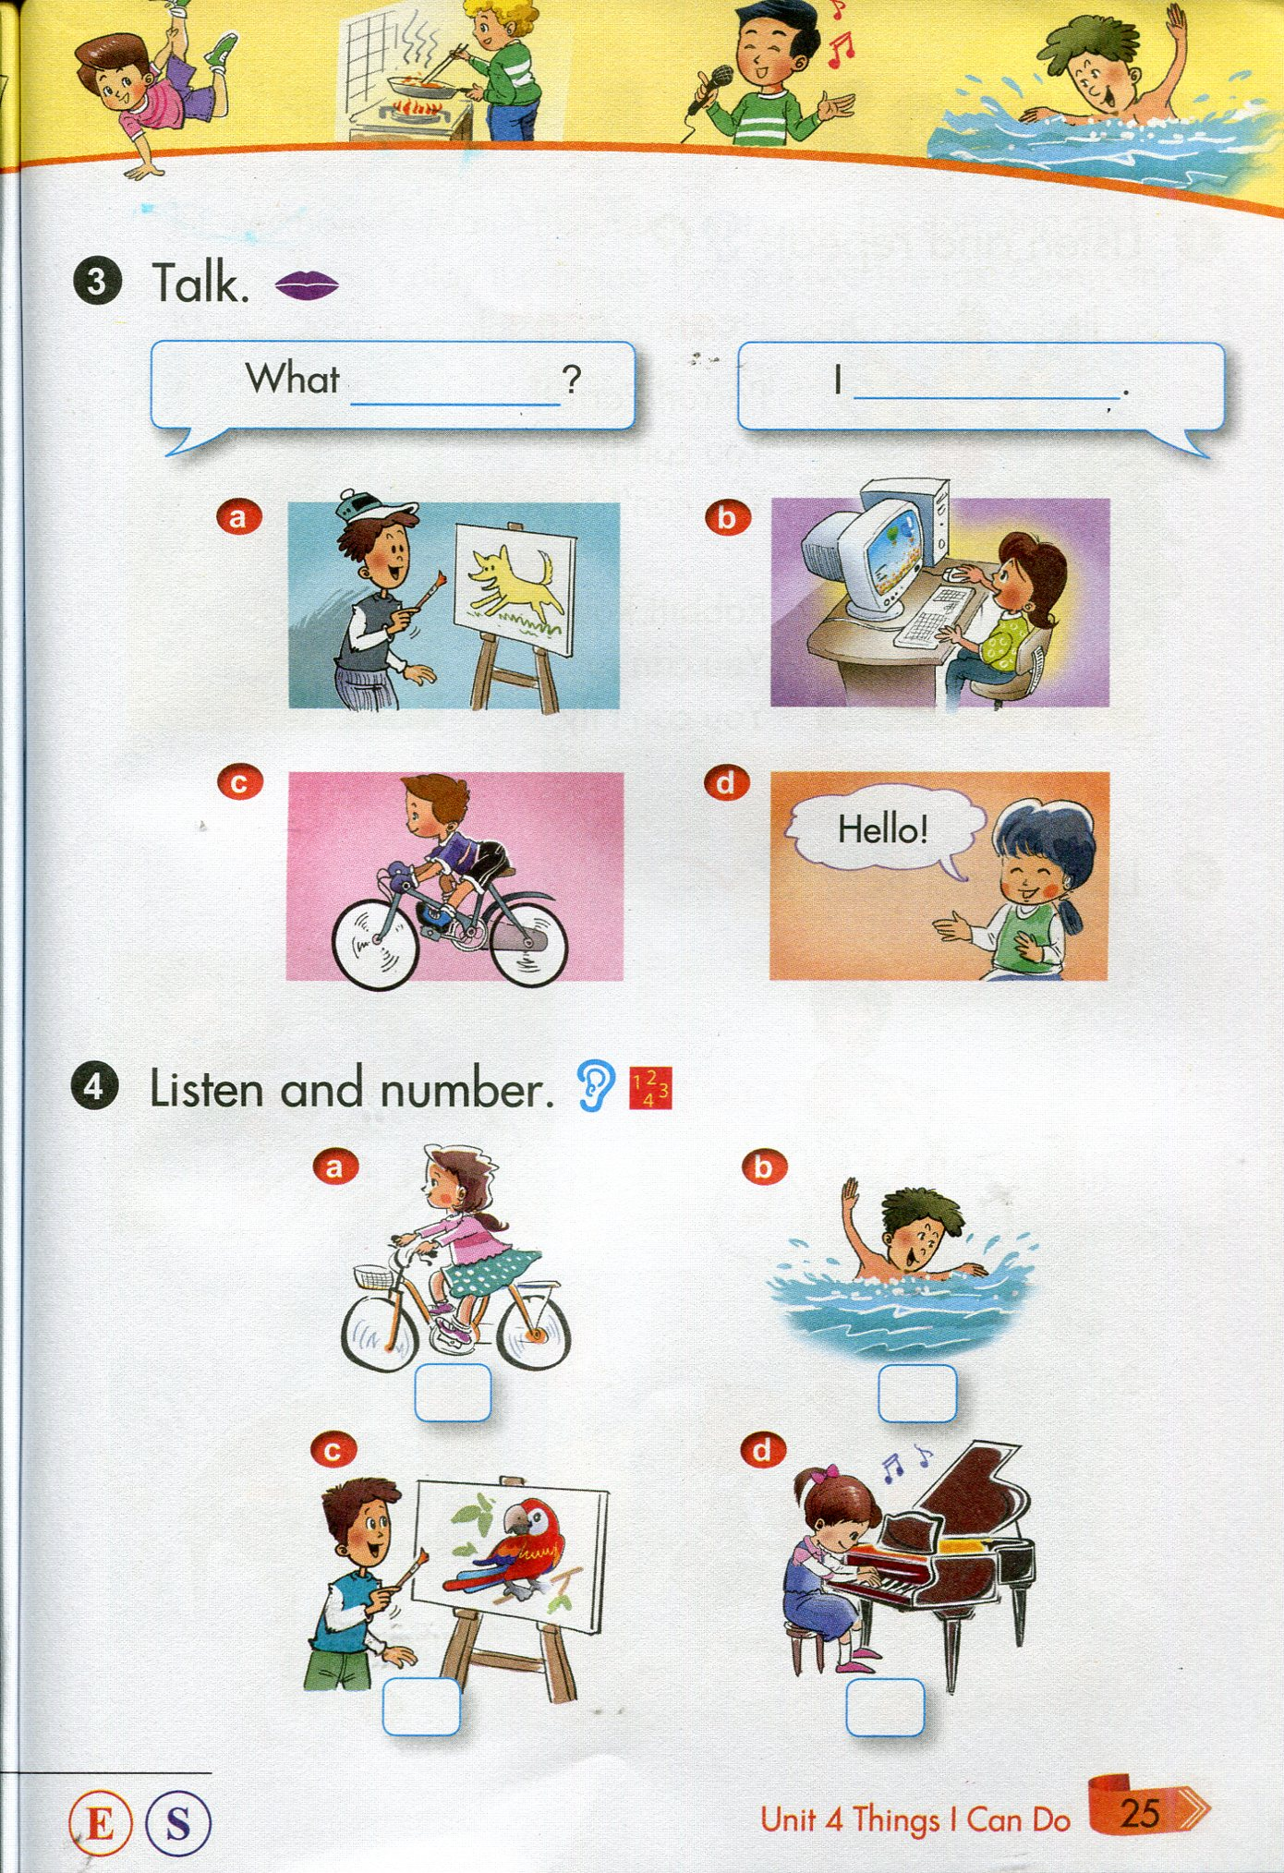 B C.
0
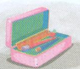
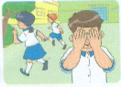

D. E.
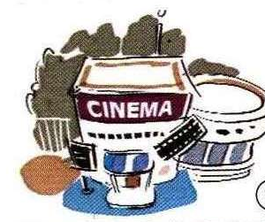
Question 3: Listen and tick: (1M)
0. A. 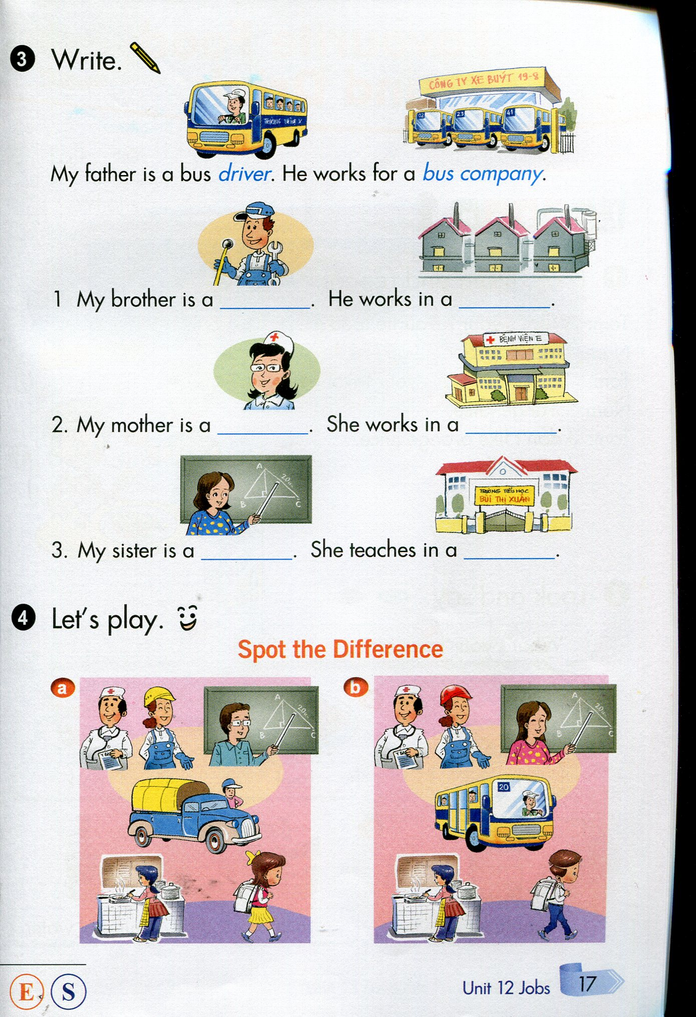 B.

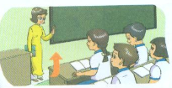
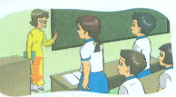

1 A. B.
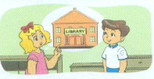
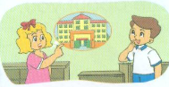

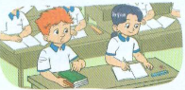
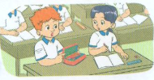
2 A. B.

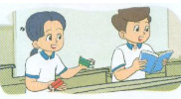
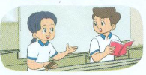
3 A. B.

4. A. B.

Question 4: Listen and write T (True) or F (False): (1M)
F
--------- 0. The playground is beautiful.
---------- 1. The school is old.
---------- 2. The library is large.
---------- 3. Your classroom is small.
---------- 4. The school gym is new.
Question 5: Listen and write a word: (1M)
1. Lan: May I (0) come in?
Miss Hien: Yes, you can.
2. Lan: May I (1) ………….. the book?
Miss Hien: Yes, you can.
3. Thu: May I (2)…………… down?
Miss Hien: No, you can’t.
4. Hong: (3)……………… I write now?
Miss Hien: Yes, you (4) ………………...

PHÒNG GD&ĐT QUẬN CẨM LỆ  TRƯỜNG TIỂU HỌC ÔNG ÍCH ĐƯỜNG  LỚP: Ba /………  HỌC SINH:…………………………………. | KIỂM TRA ĐỊNH KÌ CUỐI KÌ I NH: 2014 – 2015  MÔN: TIẾNG ANH 3 Thời gian: 35 phút  Giáo viên coi:………………………………………  Giáo viên chấm…………………………………….

****************************************************************Tờ 2

PHẦN ĐỌC – VIẾT Điểm:
Questions 6: Look and read. Put a tick (√) or a cross (x) in the box: (1M)
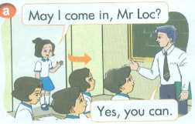


0. May I come in?
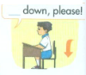

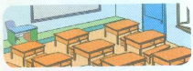
1. Stand up, please .

2. My school is big.


3. This is my robot.
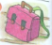

4. My school bag is pink..

Questions 7: Look and read. Write Yes or No: (1M)
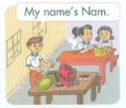
0. He is Peter ……No….
1. His name is Nam. .………….
2. He is in the classroom. …………..
3. The classroom is big. …………..
4. These are books and notebooks. …………..

Questions 8: Look at the pictures and the letters. Write the words: (1M)


0. epn …pen……
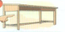

1. sdke …………….
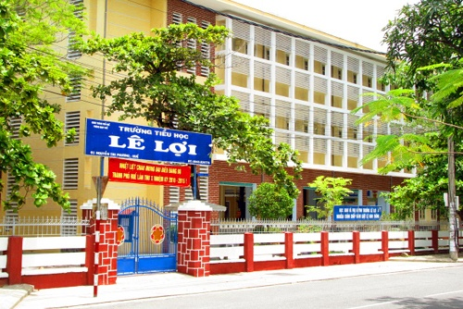

2. hlosco …………….


3. myg …………….
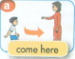

4. moec …………….

Questions 9: Look and read. Choose the words to fill the blanks: (1M)
they pens colour desk green

This is my school bag. It is (0) …green… . That is my (1)……………………. It is brown. These are my books. (2) ………………….. are blue. Those are my (3) …………………. They are black. And what (4) ………………………..is your school bag?

ĐÁP ÁN TIẾNG ANH 3 HK 1 - 2014 - 2015
PHẦN NGHE
Question 1: Mỗi câu đúng ghi 0,25đ
1. D 2. E 3. C 4. A
Transcript:
- A: Is that Linda? 2. A: Is that Peter?
B: Yes, It is B: No, it isn’t. It’s Tony.
- A: Is that Peter? 4. A: Is that Linda?
B: Yes, It is B: No, it isn’t. It’s Mai.
Question 2: Mỗi câu đúng ghi 0,25đ
1. B 2. C 3. D 4. E
Transcript:
1. Nam: May I come in? 2. Tom: Is that the classroom?
Miss Hien: Yes, you can. Mai: No, it isn’t. It’s the computer room.

3. Tom: Is that your pencilcase? 4. Mary: What do you do at break time?
Mai: What colour is it?. Mai: I play hide-and-seek
Tom: It’s pink.
Mai: It’s my pencil case.
Question 3: Mỗi câu đúng ghi 0,25đ
1. B 2. 3. B 4. B
Transcript:
1. Class: Good morning, Miss Hien. 2. Linda: Is your school big?
Miss Hien: Sit down, please. Nam: Yes, it is.

3. Mai: What colour is your book? 4. Mai: What colour are your pencil, Nam?
Tony: It’s green. Nam: They’re red.
Question 4: Mỗi câu đúng ghi 0,25đ
1. T 2. F 3. T 4. F
Transcript:

- Tom: Is your school new?
Linda: No, it isn’t. It’s old.
- Tom: Is your library big?
Linda: Yes, it is.
- Tom: Is your classroom big?
Linda: No, it isn’t. It’s small.
- Tom: Is your gym large?
Linda: Yes, it is.

Question 5: Mỗi câu đúng ghi 0,25đ
- Open 2. Sit 3. May 4. Can

PHẦN ĐỌC - VIẾT

Questions 6: Mỗi câu đúng ghi 0, 25đ
1. X 2. X 3. V 4. V
Questions 7: Mỗi câu đúng ghi 0, 25đ
1. Yes 2. Yes 3. No 4. Yes
Questions 8: Mỗi câu đúng ghi 0, 25đ
1. desk 2. school 3. gym 4. come
Question 9: Mỗi câu đúng ghi 0,25đ
1. desk 2. They 3. pens 4. colour

