Hoa Phu 2 Primary School  --------------------  Full name: ……………………………  Class : 3 … |  |  |  |  |  | THE FIRST-TERM TEST  Subject: English - Grade 3  Academic year: 2014- 2015  Time: 40 minutes
Marks: | Listening |  |  |  |  | Reading and writing |  |  |  | Speaking | Total
Marks: | Q.1 | Q.2 | Q.3 | Q.4 | Q.5 | Q.6 | Q.7 | Q.8 | Q.9 | Q.10

PART 1: LISTENING (20 minutes)
Question 1: Listen and number. (1 pt)
 | 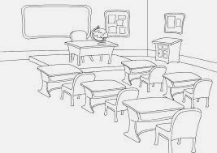
 | 

Question 2: Listen and tick (1pt).

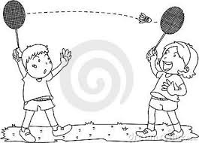  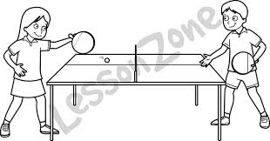  - B. | - 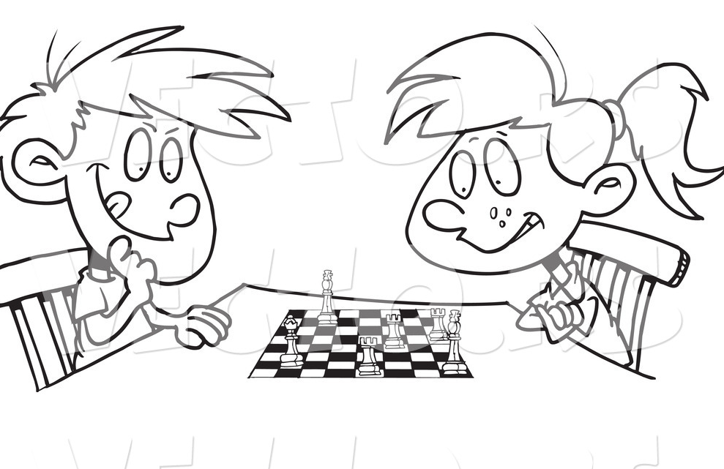  - B.
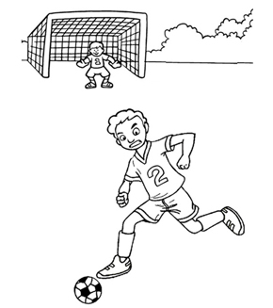  - B. | 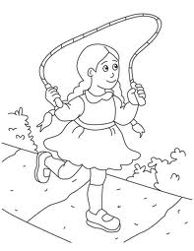  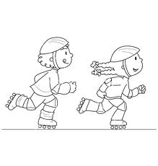  - B.

Question3. Listen and match. (1 pt)
0

1

2

3

4
5
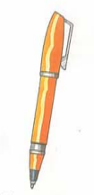
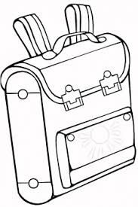

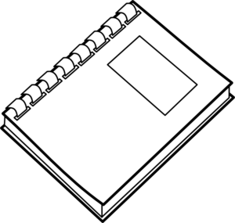

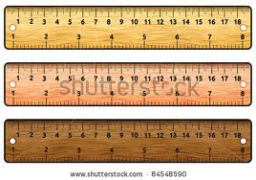

Question 4. Listen and write T (True) or F (False). (1 pt)
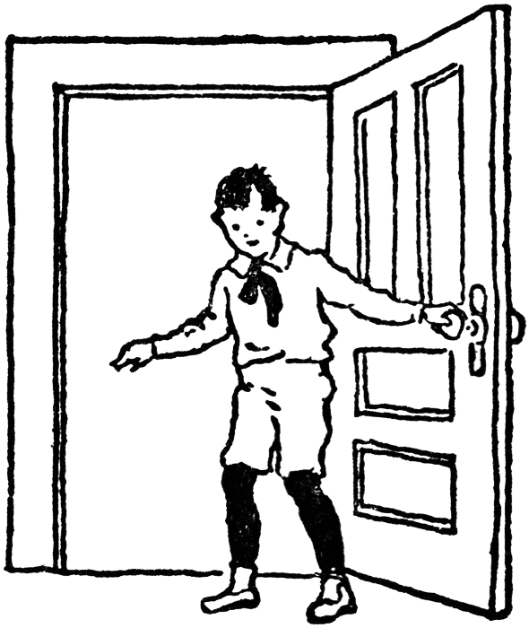  Example:  T | 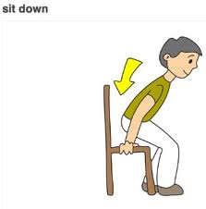  F
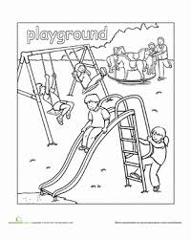

  3. | My favourite colour is orange.    4.

Question 5. Listen and write. (1pt)
six seven eight nine ten

Ex: I’m nine years old.

- A: How old are you?
B: I’m ………….. years old.

- A: How old are you?
B: I’m ………….. years old.
- A: How old are you?
B: I’m ………….. years old.

- A: How old are you?
B: I’m ………….. years old

PART II: READING AND WRITING (15 minutes)
Question 6. Look and read. Put a tick (V) or cross (X) in the box. (1pt).

   | - This is a pen. | ✓
 | - This is a pencil | X
 | - This is a school bag.
 | - That is the playground.
 | - May I stand up?
 | - These are my pencil cases.

Question 7. Look, read and color (1pt)

- What color is your pen?  It is blue. | 
- What color is your notebook?
It is pink.
- What color are your pencil sharpeners?  They are orange. | 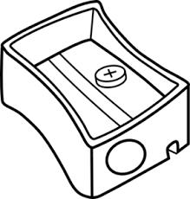
- What color are your rulers?  They are green. | 

Question 8. Look and complete (1 pt)

 | - p e n
 | - rub…er
 | - Boo…s
 | - Be qui…t!
 | - Skatin…

Question 9. Read and complete (1 pt)

MY BREAK- TIME ACTIVITIES

Hello. My (0) name is Nam. These are my friends, Quan, Mai, Linda, Tony and Phong. At break time, we play different games and sports. Quan and I play chess. Mai and Phong play table tennis. Linda and Tony play badminton.
- They play different ………………………………………………….
- Quan and Nam play …………………………………………………
- Mai and Phong ………………………………………………………
- Linda and ……………………………………………………………

PART III: SPEAKING (1pt) (5’)
Question 10.
1. Listen and repeat | 2. Point, ask and answer
3. Listen and comment | 4. Interview

The End

