TRƯỜNG TIỂU HỌC THANH THỦY  -------------------------- | ĐỀ THI HỌC KỲ 1  NĂM HỌC 2015 - 2016  MÔN: TIẾNG ANH - LỚP 3

 | Q. 1 | Q. 2 | Q. 3 | Q. 4 | Q. 5 | Q. 6 | Q. 7 | Q. 8 | Q. 9 | Q. 10 | Total
Marks

I. Listen and match: (1pt)
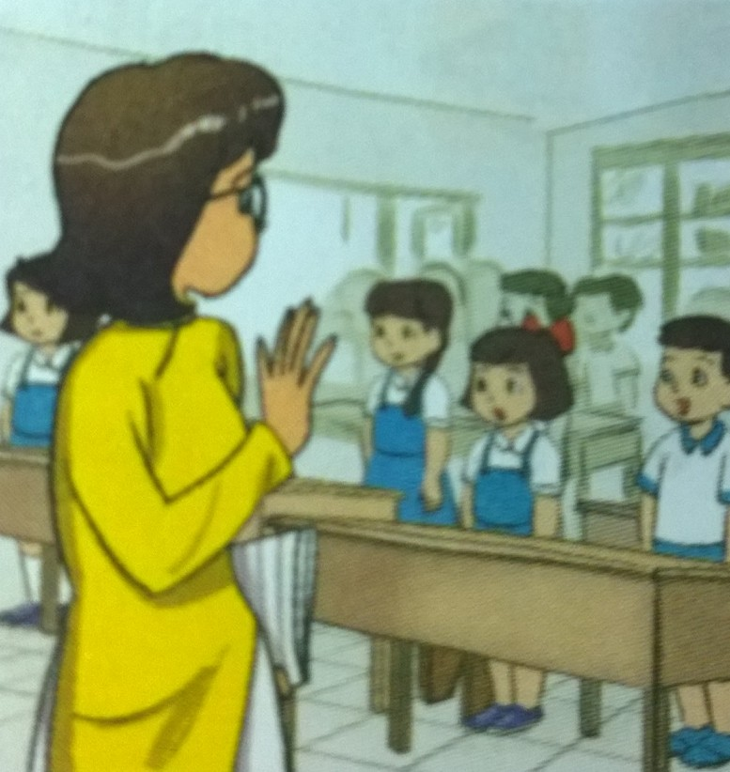

1
a


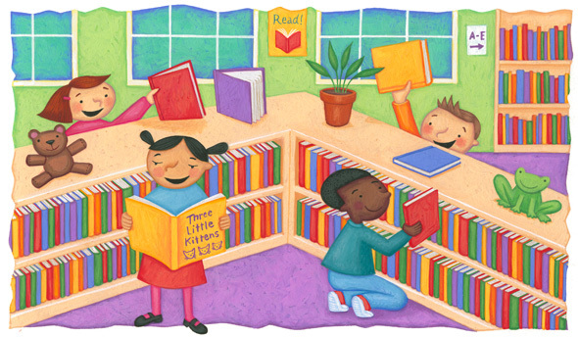
b
c
2

3

4
5

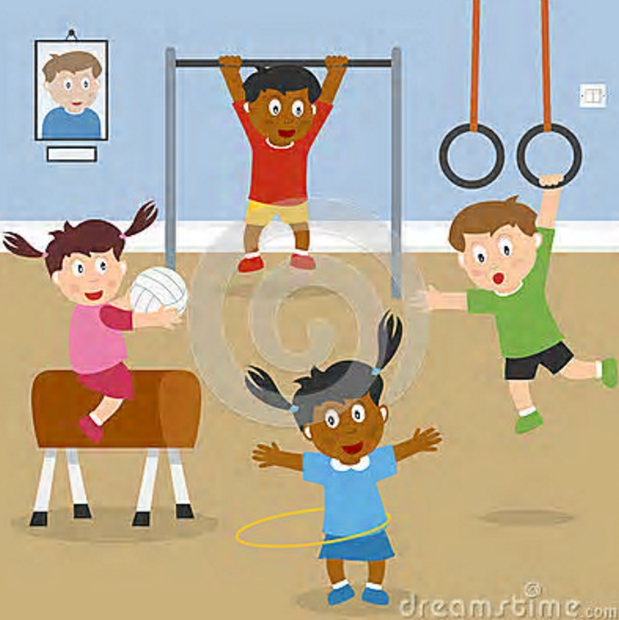
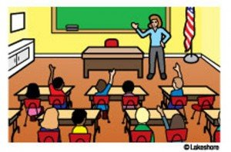

d
e

II. Listen and color. (1pt)





III. Listen and number: (1pt)
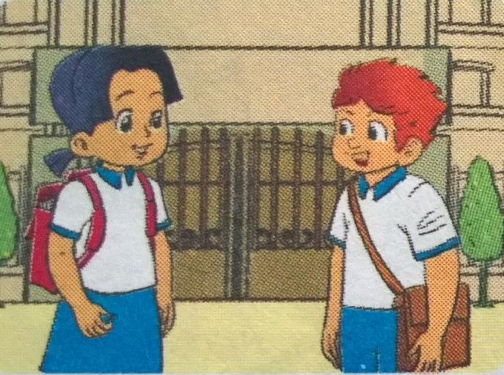
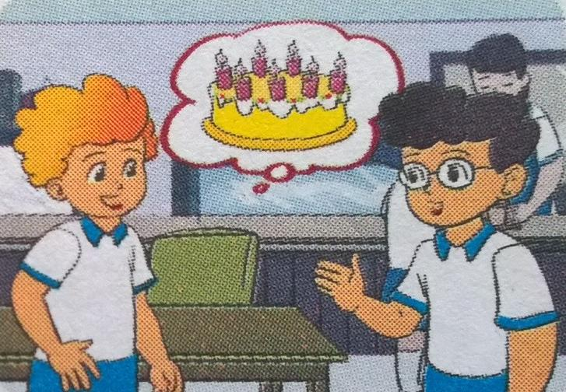
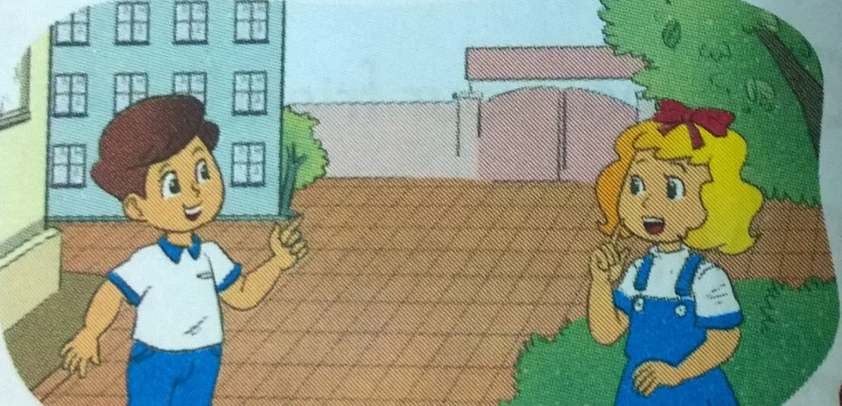

b
a
c
11

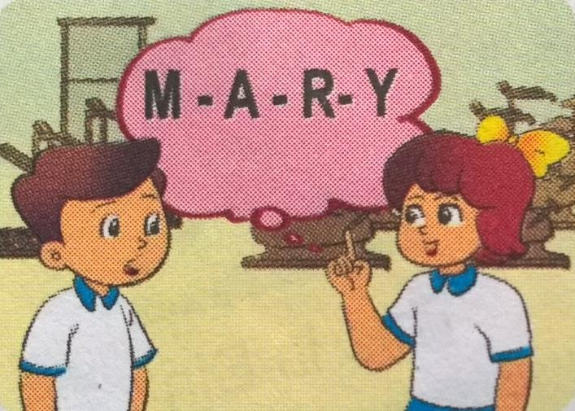
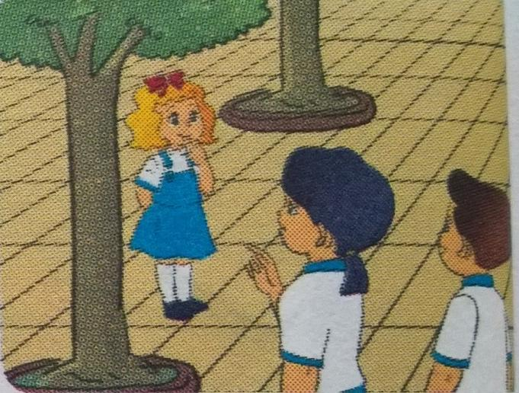

d
e

IV. Listen and tick: x (1pt)
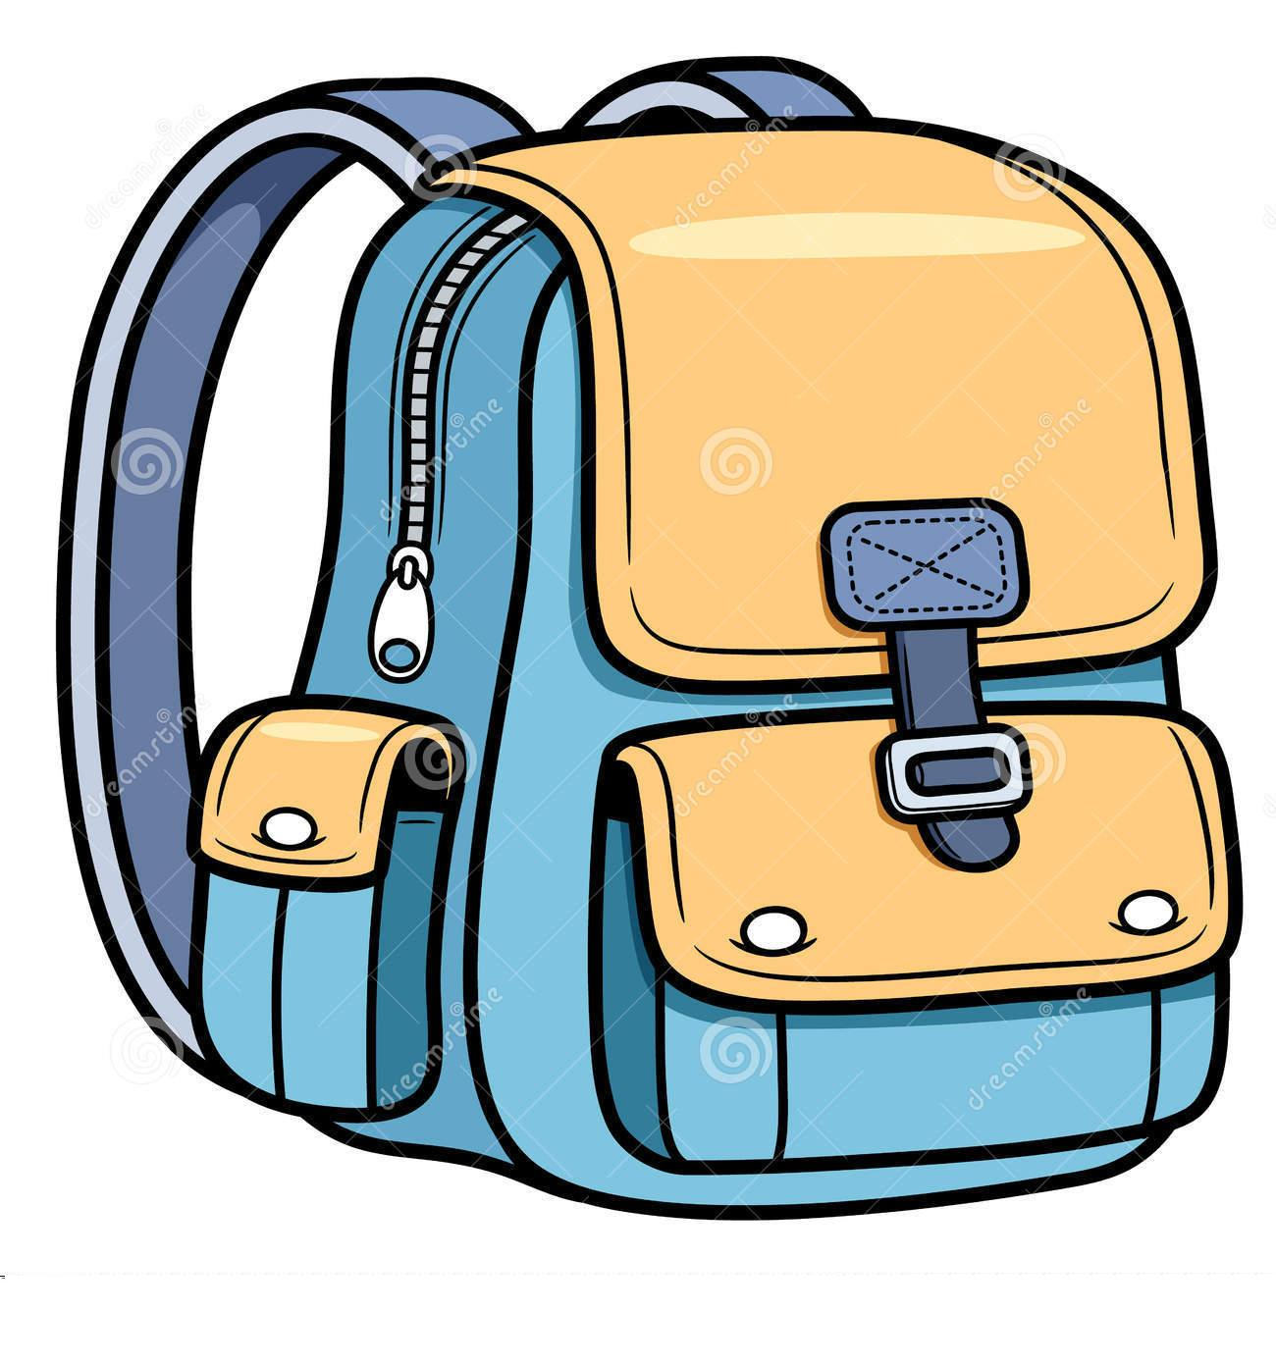
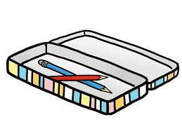

1.

a
b
x

c

2.

a
b
b
c

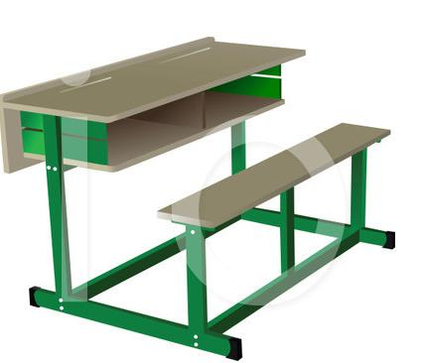


3.

a
b
c

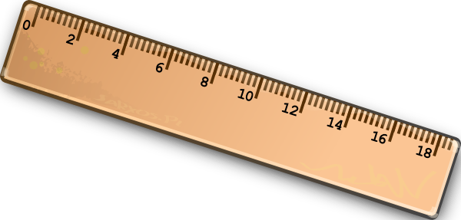

4.

a
b
c

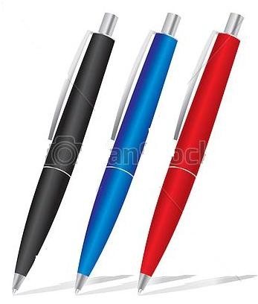
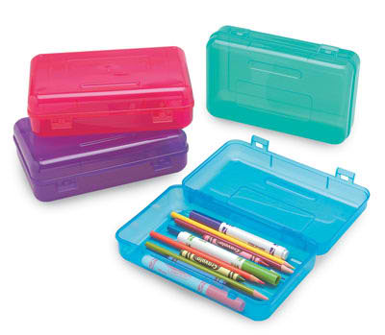


5.

a
c
c
b

V. Listen and complete: (1pt)
five rulers that orange gym

1. I’m …five… years old.

2. Is ………your friend?

3. These are my ………

4. My favorite color is………

5. The school ………..is large.

PART II. READING AND WRITING (15 minutes)
Question 6. Look and read. Put a tick ( ) or cross (X) in the box. (1pt).
 | 1. This is pen.
 | 2. This is a pencil | X
 | 3. This is a desk.
 | 4. We are in the classroom.
 | 5. That’s my school bag.
 | 6. This is a book.

Question 7. Look and read. Write Yes or No as example: This is Peter. Yes (1pt).
 | - Peter is a boy.  - He’s nine years old.  - He’s at home.  - He’s in the Computer room. | ________  ________  ________  ________

Question 8. Look at the pictures. Look at the letters. Write the words. (1 pt)
Example: | npe |  | p e n
 | 1. rbeubr |  | _ _ _ _ _ _
 | 2. lerur |  | _ _ _ _ _ _
 | 3. oadrb |  | _ _ _ _ _ _
 | 4. ribylar |  | _ _ _ _ _ _ _

Question 9. Choose a word from the box and write it next to numbers from 1-4. (1 pt)

My new school

Hello. My name’s Hoa. I’m a pupil. This is my new (0) school. It’s big. I’m in (1) ________ 3A. It’s big. We draw in the (2) ______________ and study Computer in the 3)__________________. At break we play in the (4) ______________________. I’m happy in my new school.
 | 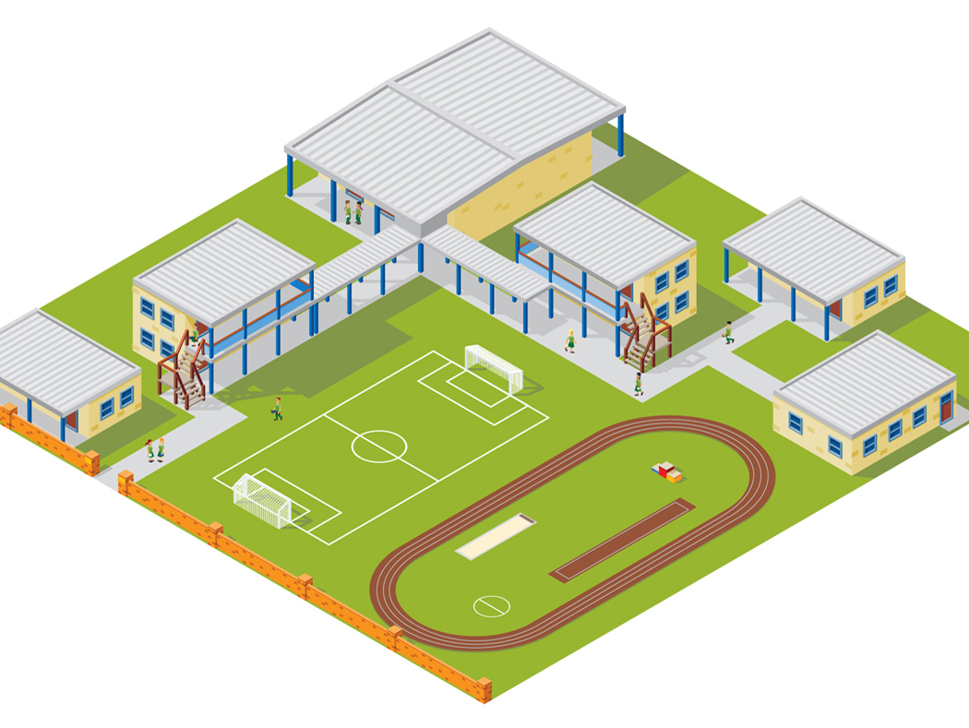
school | playground | Art room | Computer room | classroom
PART III SPEAKING (1pt) (5’)
Question 10.
1. Listen and repeat | 2. Point, ask and answer
3. Listen and comment | 4. Interview

ANSWER KEYS
I. Listen and match: (1pt)
2-b 3-d
4-c 5-e
II. Listen and color: (1pt)
1, blue 2, yellow 3, red 4, green
III. Listen and number: (1pt)
2-c 3-d
4-e 5-b
IV. Listen and tick. (1pt)
2-a 3-b
4-a 5-c
V. Listen and complete. (1pt)
(2) that (3) ruler
(4) orange (5) gym
II.
Q6 : 3v 4 5 X 6

Q7: 1 YES, 2 NO, 3 NO, 4 YES

Q8: 1 rubber, 2 ruler, 3 board, 4 library

Q9: 1 classroom, 2 Art room, 3 Computer room, 4 Playground

*************The end*************

