Ngoc Lam Primary School THE FIRST TERM TEST

Full name: ………………………….. School year: 2016-2017

Class: 3 ………

Listening | Reading & Writing | Speaking | Total | Mark

PART I: LISTENING (20 minutes)
Question 1: Listen and number.
 |  |  | 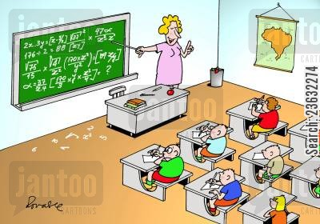
A. | B. | C. | D.

Question 2: Listen and write T for True and F for False.

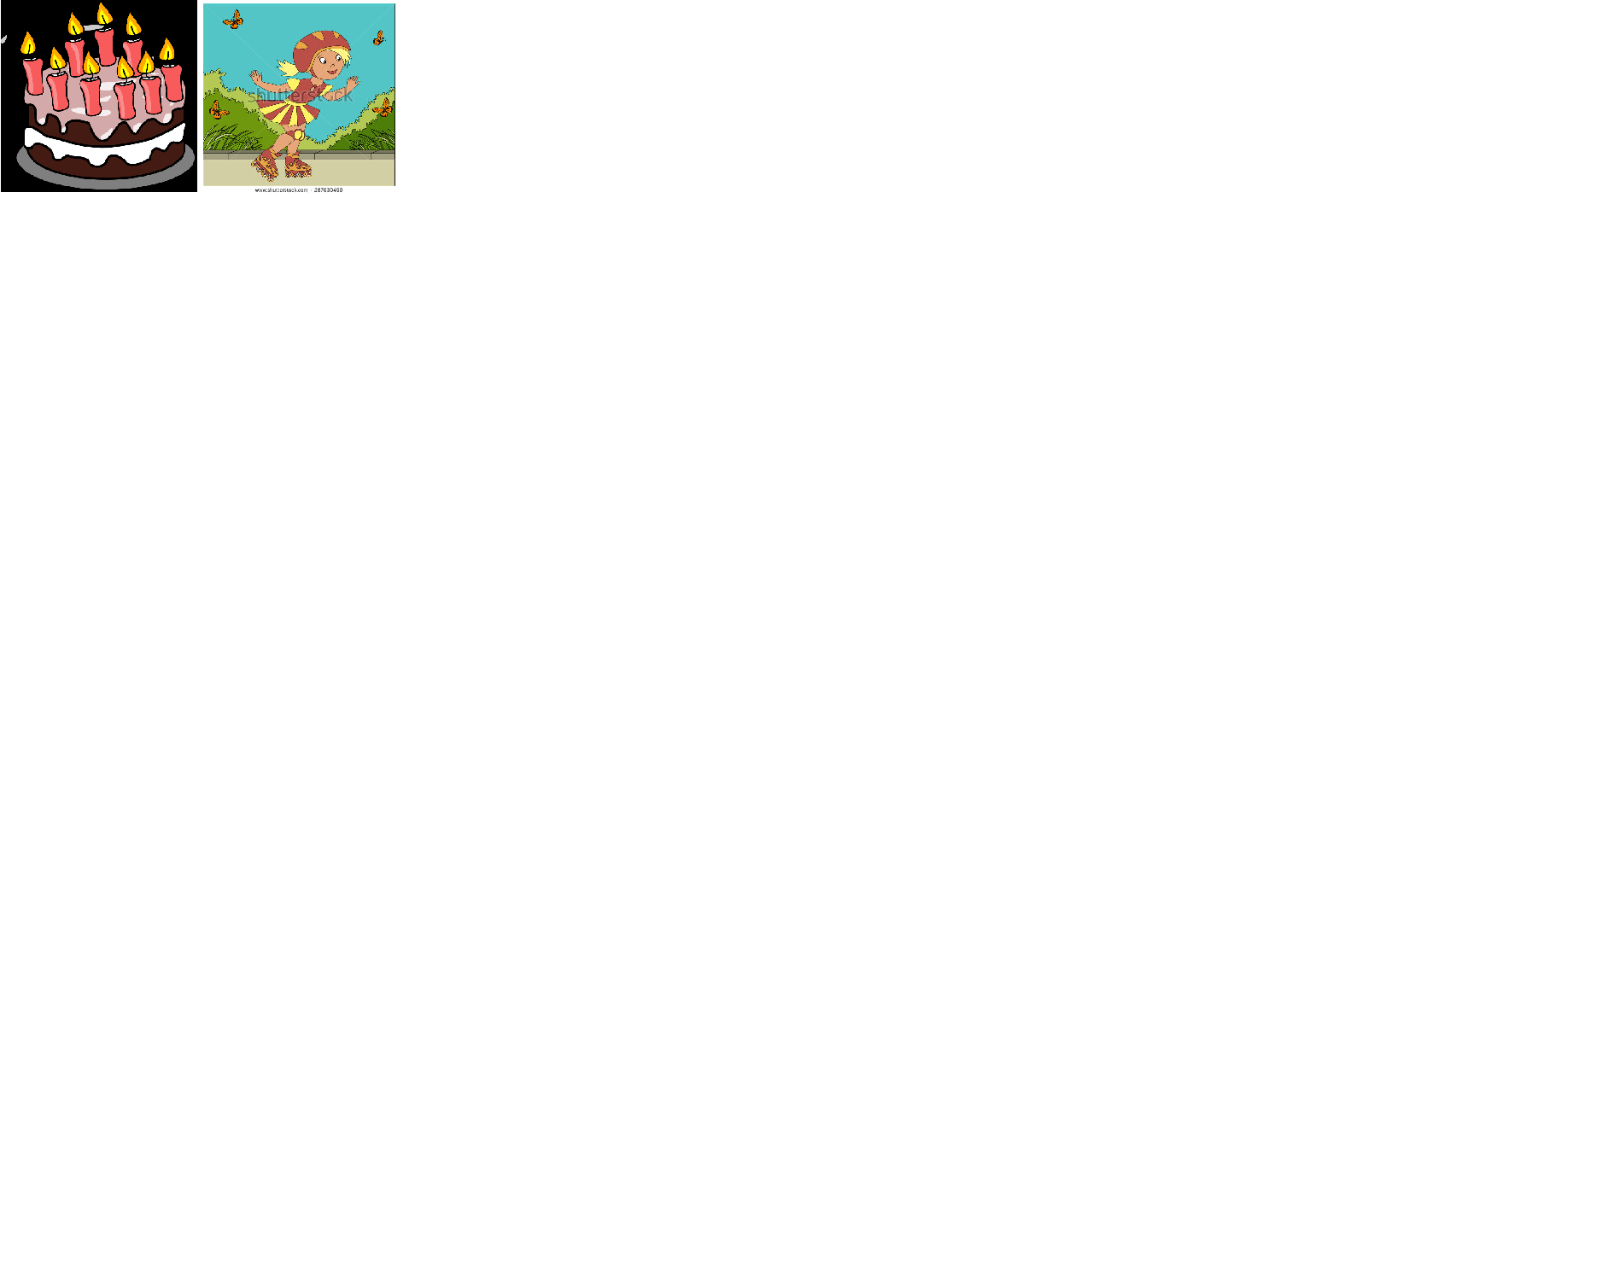
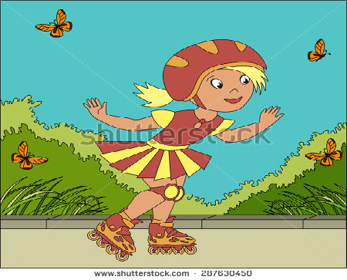 | 

- His name is Linda.
- She’s seven years old.
- She’s short.
- She’s skating in the park.

Question 3: Listen and match.
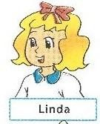


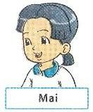


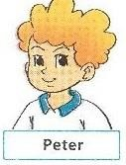


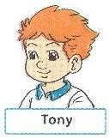



2 3 4

A. | B. | C. | D.
 |  | 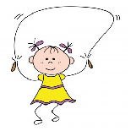 | 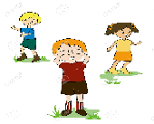

Question 4: Listen and tick.

1.
 | 
A. | B.

2.
 | 
A. | B.
3.
 | 
A. | B.

4.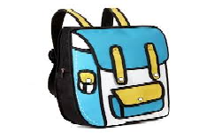 | 
A. | B.

Question 5: Listen and complete.
1. Linda: Is this your pencil __________?  Peter: Yes, it is. | 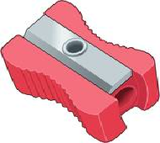

2. Do they like table tennis?  - No, they don’t. They like __________. | 

3. Hello. I’m David. __________ to meet you.  - Hi David. My name is Susan. | 

4. Teacher: Are these ________rubbers?  Student: Yes, they are my rubbers. | 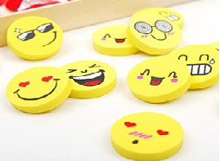
Question 6. Look and read. Put a tick ( ) or cross (X) in the box. (1pt).
 | 1. This is pen.
 | 2. This is a pencil | X
 | 3. This is a desk.
 | 4. We are in the classroom .
 | 5. My ruler is long.
 | 6. The answer is six.
Question 7. Look and read. Write Yes or No as example: This is Peter. Yes (1pt).
 | - Peter is a boy.  - He’s nine years old.  - He’s short.  - He’s in the Music room. | ________  ________  ________  ________
Question 8. Look at the pictures. Look at the letters. Write the words .(1 pt)
Example: | Npe |  | p e n
 | 1. rbeubr |  | _ _ _ _ _ _
 | 2. arnyoc |  | _ _ _ _ _ _
 | 3. oadrb |  | _ _ _ _ _ _
 | 4. ribylar |  | _ _ _ _ _ _ _

Question 9. Choose a word from the box and write it next to numbers from 1-4. (1 pt)

My new school
 | 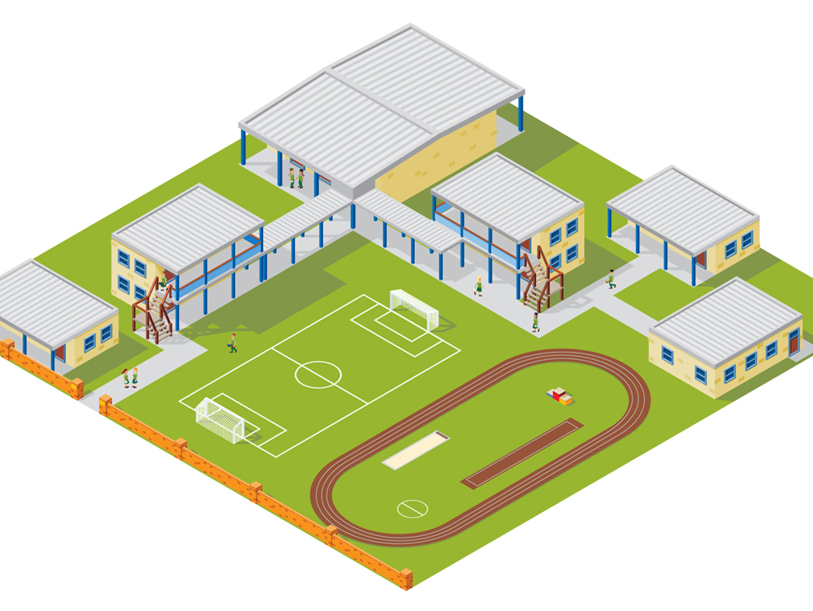
School | Playground | Art room | Computer room | classroom | Music room

Hello. My name’s Hoa. I’m a pupil. This is my new (0) school. It’s big. I’m in (1)

_________ 3A. It’s big. We draw in the (2) _________ and study Computer in the

(3)__________________. At break we play in the (4) _______. I’m happy

in my new school.

PART III: SPEAKING (5 minutes)
Question 10. Interview.
- Hello. How are you?
- What’s your name?
- How do you spell your name?
- How old are you?
- Is your school big?
- Is your classroom small?
- Is your school bag?
- What colour is your pen?
- Is your school playground large?
- What do you do at break time?
Question 11. Listen and act or reply.
- Sit down, please.
- Please stand up.
- Raise your hand, please.
- Write your name.
- Open your book.
- Close your book.
- Ask the teacher to go out.
- Ask the teacher to come in.
- Ask the teacher to speak.
- Ask the teacher to write.
THE END

KEY
Question 1: 1C, 2A, 3B, 4D
Audio script:
- – These are my rulers.
- Are they?
- Yes, they are.
- – What colour is your book?
- It’s green.
- – What do you do at break time?
- I play basket ball.
- – Is your classroom big?
- No, it isn’t. It’s small.
Question 2: 1F, 2T, 3F, 4T
Audio script:
- Her name is Linda.
- She’s seven years old.
- She’s tall.
- She’s skating in the park.
Question 3: 1D, 2B, 3A, 4C
Audio script:
- – What do you do at break time, Tony?
- I play hide-and-seek.
- – Do you like table tennis, Linda?
- No, I don’t. I like skating.
- – Do you play football at break time, Peter?
- Sure, I do.
- – What do you do at break time, Mai?
- I play skipping.

4: 1A, 2B, 3B, 4A
Audio script:
- How old are you?
- I’m eight years old.
- Do you like badminton?
- No, I don’t. I like hide-and-seek.
- What is that?
- It’s my pencil case.
- Is your school bag big?
- Yes, it is.
Question 5:
- sharpener
- badminton
- Nice
- your
Audio script:
1. Linda: Is this your pencil sharpener?
Peter: Yes, it is.
2. Do they like table tennis?
- No, they don’t. They like badminton.
3. Hello. I’m David. Nice to meet you.
- Hi David. My name is Susan.
4. Teacher: Are these your rubbers?
Student: Yes, they are my rubbers.
Question 6:
 | 3. X | 4. | X | 5.V |  | 6.X
Question 7:
- YES | - NO | - YES | - NO

Question 8:
- Rubber | - crayon | - board | - library

Question 9:
- classroom | - Artroom | - Computer room | - Playground

