SỞ GIÁO DỤC & ĐÀO TẠO ĐĂK LĂK  PHÒNG GD & ĐT EAH'LEO  TRƯỜNG TIỂU HỌC EAKHĂL  Họ tên: ……………........................  Lớp:………………………………... |  |  |  |  |  |  |  | ĐỀ KIỂM TRA HỌC KỲ I  MÔN TIẾNG ANH - LỚP 3  NĂM HỌC: 2016 - 2017  Thời gian: 40 phút  (TỜ 1)
 | Marks: | Listening |  |  |  |  | Reading and writing |  |  |  |  | Speaking | Total
 | Marks: | Q.1 | Q.2 | Q.3 | Q.4 | Q.5 | Q.6 |  | Q.7 | Q.8 | Q. 9 | Q.10
PART I. LISTENING (20 minutes)
Question1. Listen and number. (1 pt)


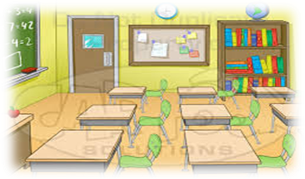

Question 2: Listen and write T (True) or F (False) as examples (1pt).
T
- Look at this girl. Her name is Mary.
F

- Hello, Mai. Nice to meet you.
- It is Thang Long Primary School.
- It’s a pen.
- It’s a rubber.
- It is a library.


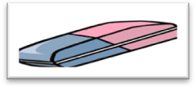

Question 3. Listen and draw the line. There is an example. (1 pt)

1
2
3
4
5

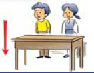


Question 4. Listen and tick. (1 pt)
- What is this?
-  B.  C. 

- What are they?
-  B.  C. 
- What do they do at break time?
- 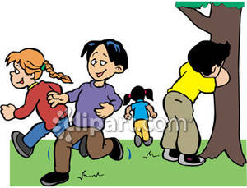 B.  C. 

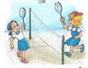

- What does Mai do at break time?

- B. C.
Question 5. Listen and complete. (1pt)
- A: Hi. I’m Tom. What’s your name?
B: Hello, Tom. My name’s ___________
- Nam: How do you ___________ your name?
Linda: L-I-N-D-A.
- Tony: Is that girl ___________?
Tom: Yes, she is.
- Mai: This is my school.
Tony: Wow. It’s ___________.
SỞ GIÁO DỤC & ĐÀO TẠO ĐĂK LĂK  PHÒNG GD & ĐT EAH'LEO  TRƯỜNG TIỂU HỌC EAKHĂL  Họ tên: ……………........................  Lớp:………………………………... | ĐỀ KIỂM TRA HỌC KỲ I  MÔN TIẾNG ANH - LỚP 3  NĂM HỌC: 2016 - 2017  Thời gian: 40 phút  (TỜ 2)
PART II. READING AND WRITING (15 minutes)

Question 6. Look and read. Put a tick ( ) or cross (X) in the box. (1pt).
0. These are books.


X
0. This is a music room.

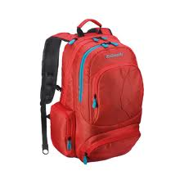

1. It’s a school bag.



2. This is my computer room.

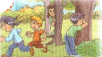

3. I like playing chess.



4. The pencil is blue.

.
Question 7. Look and read. Write Yes or No as example (1pt).
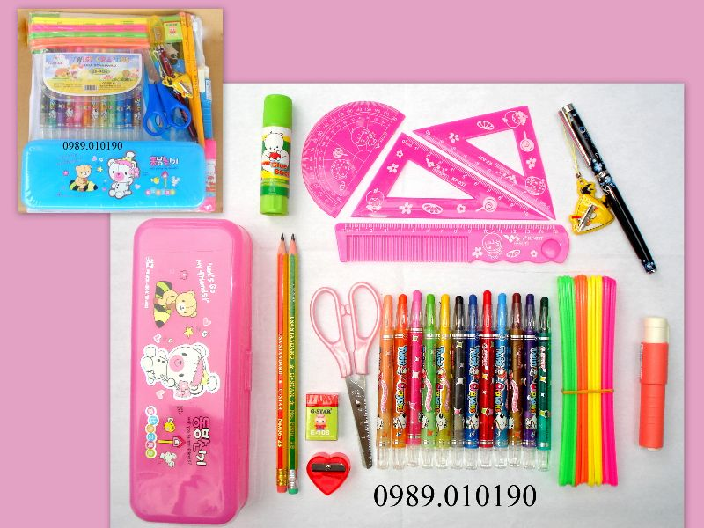
0. These are some rulers Yes
1. This is a pencil sharpener. ___________
2. This is a book. ___________
3. These are two pencils. ___________
4. This is a pen. ___________

Question 8. Look at the pictures. Look at the letters. Write the words. (1 pt)

Example:
n p e pen



- o s l c e ___________.



- b o y g o d e ___________.

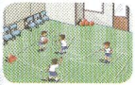

- m y g ___________.

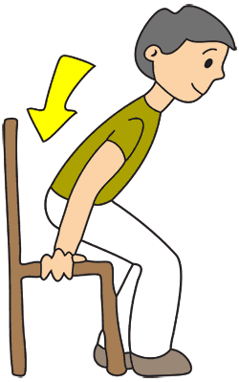
- i t s w o n d ___________.

Your name: My name is ……………………………....
Your age: I am ……………………………………...
Your school things: …………………….., ……………….. ,
………………… and ……………… are my school things.

1
2
3
Question 9. Write about you. (1 pt)

PART III SPEAKING (1pt) (5’)
Question 10.
1. Listen and repeat | 2. Point, ask and answer
3. Listen and comment | 4. Interview

The End

