UBND HUYỆN CÁT HẢI  TRƯỜNG TIỂU HỌC CHU VĂN AN | BÀI KIỂM TRA CUỐI HỌC KÌ 1  Năm học 2016 - 2017  Môn: Tiếng anh  Thời gian: 35 phút

PART 1: LISTENING 20 minutes (3, 5 points).
Marks | Listening | Reading and writing | Speaking

Question1. Listen and number. (1 pt)
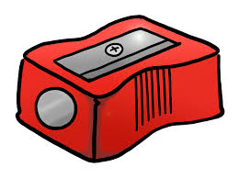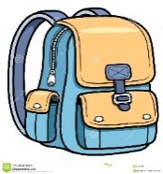  A  B | B.  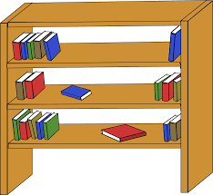  D

C

Question 2. Listen and tick. (1, 5 pts)
1
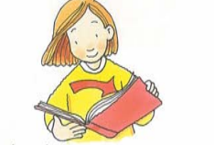  A  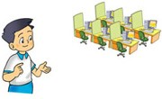  2.  A |  |   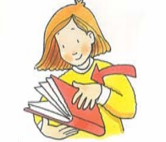  B  B
3.  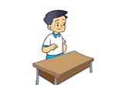 |  |  | 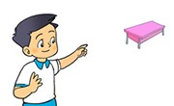
 |  |  | B
A

Question 3. Listen and complete. (1pt)

(1)______, I’m Mai. What’s your name? My name’s (2) ________.How old are you? I’m (3) _____ years old.What colour is your school bag? It’s (4) _______.

PART II: READING AND WRITING 15 minutes (4 points)

Question 4. Read and match. (1pt).

1.This is a | a. books
2.Those are | b. cases
3.Is the library big? | c. Yes, it is
4. These are pencil d. pen

Question 5. Look, read and write Yes or No. (1 pt)

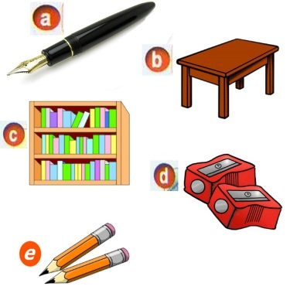 | - This is a pens. ____  - That is a desk.____  c) These are my pencil sharpeners. _____  - Those are pencil cases ______

Question 6. Look at the pictures. Look at the letters. Write the words .(1 pt)
 | - npe  1. rbeubr | →  → | pen  _ _ _ _ _ _
 | 2. o l s h o c | → | _ _ _ _ _ _
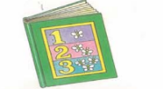 | 3. okob | → | _ _ _ _
 | 4.ribylar | → | _ _ _ _ _ _ _

Question 7. Fill in each gap with a suitable word from the box .(1pt)
 | pens | school bag | are | aren’t | my

Mai: Hello! My nameis Mai.
Tony: Hello! Nice to meet you. (0) My name is Tony. Is this your (1) ________?
Mai: Yes, it is.
Tony: And (2) __________ these your pencils?
Mai: No, they (3) __________.
Tony: And are those your (4) __________?.Mai: Yes, they are.

Keys

PART 1: LISTENING 20 minutes (3, 5 points)
Question1. Listen and number. (1 pt)

1. B, 2.D. 3. C 4.A

Question 2. Listen and tick. (1, 5 pts)

1.B 2.A 3.B

Question 3. Listen and complete. (1pt)

1. Hello 2. Linda 3. Eight 4. Pink

PART II: READING AND WRITING 15 minutes (4 points)

Question 4. Read and match. (1pt).

1. d 2. a 3.c 4.b

Question 5. Look, read and write Yes or No. (1pt).

1.No 2. Yes 3. Yes 4. No

Question 6. Look at the pictures. Look at the letters. Write the words. (1 pt)

1. Rubber 2. School 3. Book 4. Library

Question 7. Fill in each gap with a suitable word from the box .(1pt)

1. school bag 2 are 3 aren’t 4 pencils

