PHÒNG GD&ĐT THÀNH PHỐ KON TUM  Trường Tiểu học Lê Lợi  Họ và tên: ........................................................  Lớp:3/…… | KIỂM TRA CUỐI HỌC KỲ I  Môn: Tiếng anh lớp 3  Năm học: 2016- 2017  Thời gian : 60 phút
Listening |  |  |  | Reading |  |  |  | Writing |  |  | Speaking |  |  | Total
 |  |  |  |  |  |  |  |  |  |  |  |  |  | 100 | 10
P1 | P2 | P3 | P4 | P1 | P2 | P3 | P4 | P1 | P2 | P3 | P1 | P2 | P3
Comments

I. LISTENING (25 POINTS). 20 minutes
Part 1: Listen and number from 1 to 6. There is one example (6points)
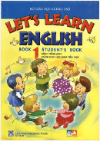


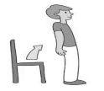


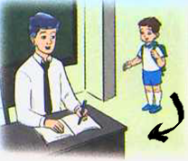
0
D
C
B
A
E
F
G

Part 2: Listen and tick the box. There’s one example (4 points)
0. Jenny: Hello. I’m Jenny
✓

A. Hi. Jenny. My name is Dawn B. Hi, Jenny. My name’s Hoa
1. Alex: How are you, Simon?

A. Simon: I am not good, thanks. B. Simon: I’m fine, thanks.
2. Phong: What’s your name?

A. My name’s Quang. B. My name is Tuan.
3. Dawn: What is the name of your school?

A. It’s Le Loi Primary School B. It’s Kim Dong Primary School.
4. Phong: Hi, Hoa. Is your schoolbag big?

A. No, it isn’t. It is small. B. Yes, it is.
Part 3: Listen and tick the the box. There is one example (10 points)
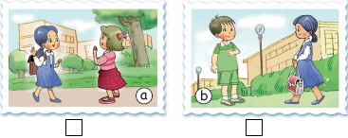
0.

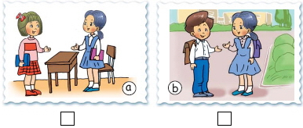

1.

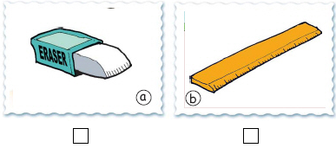

2.

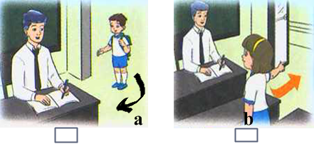

3.

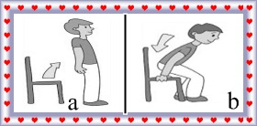

4.

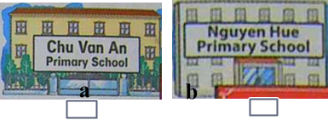

5.

Part 4: Listen and write True (T) or False (F). There is one example (5 points)
True False

0. My name is Trang.
1. Its name is Le Lai Primary School.
2. The school is small.
3. The classroom is big.
4. The English room is new and large.
5. The school library is new but small.

Họ và tên: ........................................................ | Lớp:3/……
II. READING (25 points): 20 MINUTES
Part 1: Look at the pictures. Look at the letters. Write the words (5points)

Example:
0. bogodye Goodbye



1. lcohos __________________


2. olsce ____________________


3. gablocsho _____________________



4. dfrine ________________________

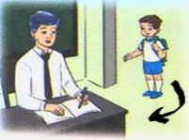
5. omec ni __________________________

Part 2: Look and read. Put a tick (✓)or a cross () in the box(5 points). There’s one example. Đánh dấu✓ nếu câu đúng hoặc nếu câu sai
 | 0. This is a pen | ✓
 | 00. Hello. My name is LiLi | ✗
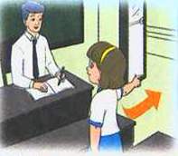 | 1. May I come in, Mr Phong?
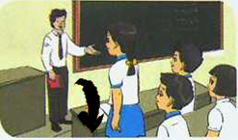 | 2. Sit down, please.
 | 3. This is my school. It’s Le Loi primary school.
 | 4. This is my friend. She is Nga.
 | 5. Close your book, please.
Part 3: Reorder the sentences to make a dialogue. There is one example (10 points)

No, it isn’t. It is small.

Is it big?

Your school is big. Your classroom is small.
Hello, Nga. Is this your school?

Yes, it is. And that is my classroom.
1 Hi, Nam.

Part 4: Look at the pictures and write in the blanks. There’s one example. (5 points)
0. Stand up, please. |   1. This is my …………….. It is big.
  2. ………….your book, please. |   3. Mai: Goodbye, Nam.  Nam: Bye. ……………. you again.
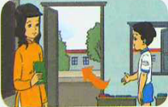  4. Nam: May I………………...?  Miss Hien: Yes, you can |   5. A: What’s your name?  B: My …………….is Peter.
III. WRITNG (25 points): 20 MINUTES
Part 1: Fill in each gap with a suitable word. There is one example. (10 points)


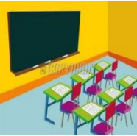
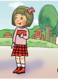


LiLi School friend classroom teacher Alan
Hello. My name’s (0) LiLi. I’m a pupil. This is my(1) __________________. It is Le Loi Primary school. It’s small. This is my(2)___________________. It’s small too. This is my(3) __________________. His name is Truyen. He’s short. This is my (4)__________________. He is a pupil at my school. His name is(5) ____________.

Part 2: Reorder the words to make sentences. There is one example. (10 points)

Example: 0. am / I / Hello. / Nam.
Hello. I am Nam.
1. today / are / ,Nga?/ How/ you
__________________________________________________________
2. name?/ is / What/ your
__________________________________________________________
3. big?/ Is / your/ schoolbag
___________________________________________________________
4. book, / your / Open / please.
___________________________________________________________
5. come / May / ,Mr. Tuan? / in / I
___________________________________________________________
Part 3: Write about your school (school, classroom, school library). (5 points)
……………………………………………………………………………………………………………………………………………………………………………………………………
………………………………………………………………………………………………………………………………………………………………………………………………………………………………………………………………………………………………………………………………………………………………………………………………………………………………………………………………………………………………………………………………………………………………………………………………………………………………………………………………………………………………………………………………………………………………………………………………………………………………………………………………………………………………………………………………………………………………………………………………………………………………………………………………………………………………………………………………………………………………………………………………………………………………..
IV: SPEAKING: 25 POINTS (HỌC SINH KHÔNG LÀM PHẦN NÀY VÀO BÀI THI)
1: Interview (10 points)
2: Listen, comment and answer (10 points)
3: Describe pictures (5 points)

ĐÁP ÁN VÀ HƯỚNG DẪN CHẤM MÔN TIẾNG ANH LỚP 3 CHƯƠNG TRÌNH 2 TIẾT/ TUẦN HỌC KÌ I NĂM HỌC 2016-2017
SỬ DỤNG THANG ĐIỂM 100 SAU KHI CHẤM XONG THÌ QUI VỀ THANG ĐIỂM 10, KHÔNG CHO ĐIỂM 0 VÀ ĐIỂM THẬP PHÂN.
I. LISTENING: 40 ĐIỂM
Part 1: Listen and number(6 ĐIỂM) . Mỗi đáp án đúng được 1 điểm
G | A |  |  | B |  |  | C |  | D |  |  | E |  |  | F
0 | 2 |  |  | 4 |  |  | 3 |  | 6 |  |  | 5 |  |  | 1
Part 2: Listen and tick the box (4 ĐIỂM). Mỗi đáp án đúng được 1 điểm
0 |  |  | 1 |  |  | 2 |  |  |  | 3 |  |  | 4
A |  |  | B |  |  | A |  |  |  | A |  |  | B
Part 3: Listen and tick the box (10 ĐIỂM). Mỗi đáp án đúng được 2 điểm
0 |  | 1 |  |  | 2 |  |  | 3 |  |  | 4 |  |  | 5
B |  | A |  |  | B |  |  | B |  |  | B |  |  | A
Part 4: Listen and write True (T) or False (F) (5ĐIỂM). Mỗi đáp án đúng được 1 điểm
0 |  | 1 |  |  | 2 |  |  | 3 |  |  | 4 |  |  | 5
F |  | F |  |  | T |  |  | F |  |  | T |  |  | T
II. READING 20 ĐIỂM
Part 1: Look at the pictures. Look at the letters. Write the words (5 ĐIỂM). Mỗi đáp án đúng được 1 điểm
0 |  |  | 1 |  | 2 |  | 3 | 4 |  | 5
Goodbye |  |  | School |  | Close |  | Schoolbag | Friend |  | Come in
Part 2: Look and read. Put a tick (✓)or a cross ( ) in the box(5 points). Mỗi đáp án đúng được 1 điểm
0 |  | 0.0 |  | 1 |  | 2 | 3 | 4 |  | 5
✓ |  | × |  | × |  | ✓ | × | × |  | ✓
Part 3: Reorder the sentences to make a dialogue (10 ĐIỂM). Mỗi đáp án đúng được 2 điểm
1. Hi, Nam.
2. Hello, Nga. Is this your school?
3. Yes, it is. And that is my classroom.
4. Is it big?
5. No, it isn’t. It is small.
6. Your school is big. Your classroom is small.
Part 4: Look at the pictures and fill in the blanks (5 ĐIỂM). Mỗi đáp án đúng được 1 điểm
0 | 1 |  |  |  | 2 |  | 3 | 4 | 5
stand up | book |  |  |  | open |  | see | go out | name
III. WRITING: 20 ĐIỂM
Part 1: Fill in each gap with a suitable word (10 ĐIỂM). Mỗi đáp án đúng được 2 điểm
0 | 1 | 2 | 3 | 4 | 5
LiLi | school | classroom | Teacher | friend | Alan
Part 2: Reorder the words to make sentences (10 ĐIỂM). Mỗi đáp án đúng được 2 điểm
1. How are you today, Nga?
2. What is your name?
3. Is your school bag big?
4. Open your book, please.
5. May I come in, Mr Loc?
Part 3: Write about your school (school, classroom, school library). (5 points)
Giáo viên chấm theo cảm nhận của mình. Chú ý lỗi chính tả, dấu câu và cấu trúc câu.
Model passage:
Hi. My name is Quynh. This is my school. It is small but nice. This is my classroom. It is small too. That is my school library. It is new and large.

