Hoa Loc Primary School KIỂM TRA MÔN TIẾNG ANH
Class: 3… LỚP 3
Full name:……………………… Thời gian: 40 phút

Marks | Listening |  |  | Reading and writing |  |  |  |  | Speaking | Total
Marks | Q.1 | Q.2 | Q.3 | Q.4 | Q.5 | Q.6 | Q.7 | Q.8 | Q.9

PART 1. LISTENING
Question 1: Listen and tick. (1pt)
Example 1.A 
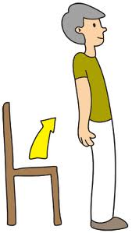  1. A.  | 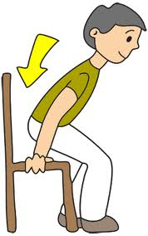  B.  |   2.A. |   B.
  3.A. |   B.  | 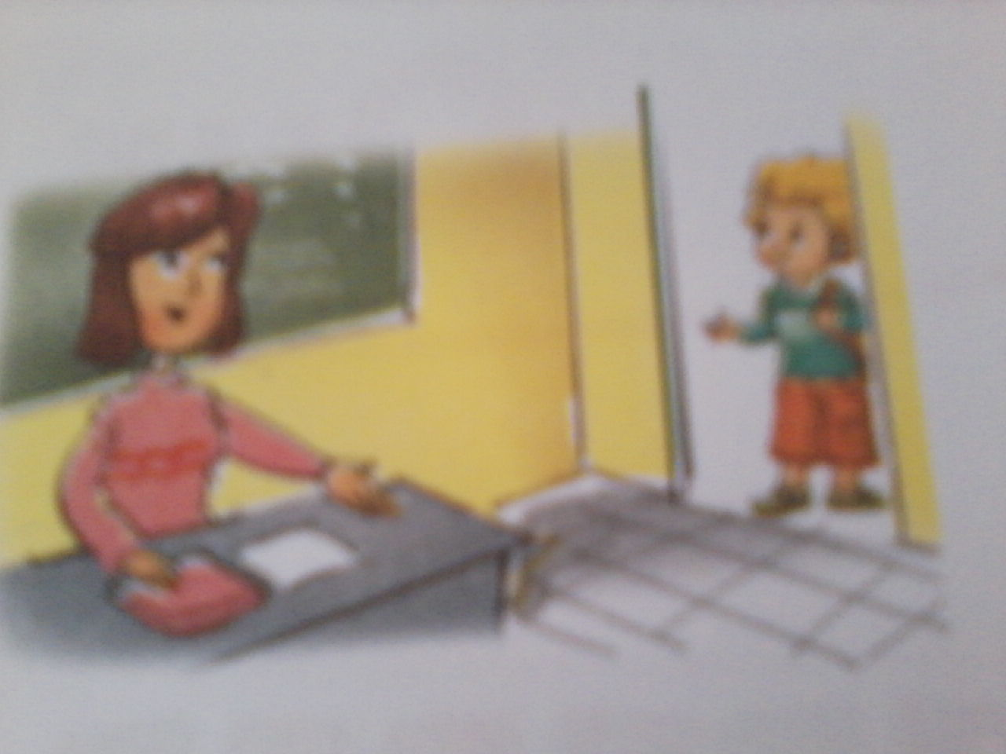  4.A.  | 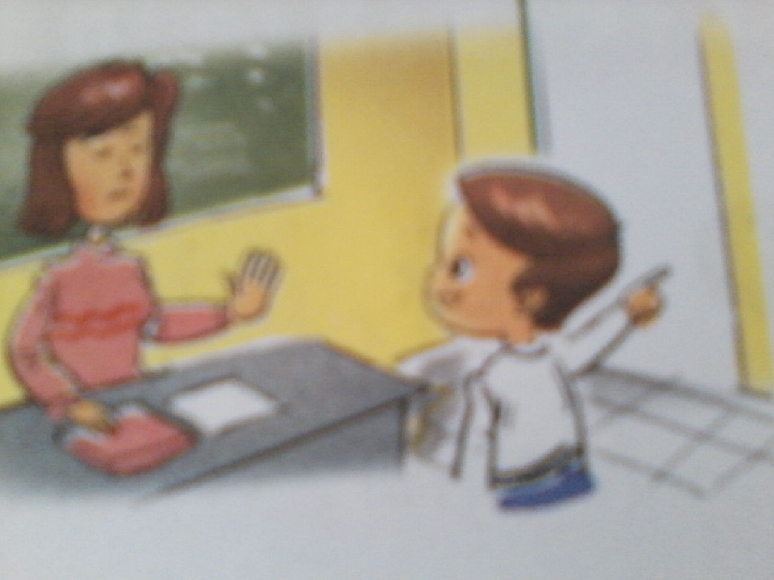  B. 
Question 2: Listen and number.( 1pt) Example 1.A aa
1

 |  | 
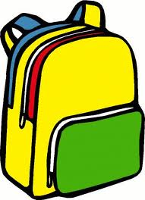  A. | B.    | C.  | 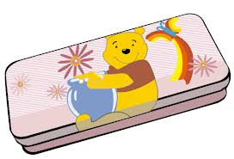  D. 

Question 3: Listen and complete the dialogue with words given (1pt):
book that this bag
What’s _____?
What’s this?
A _____
It’s a book.
What’s ______?
What’s that?
A school _____.
It’s a school bag.

PART II. READING AND WRITING ( 20 minutes )
Question 4:Read and tick (1pt):
1. This is a pen. | A. | B. 
2.This is my book. | 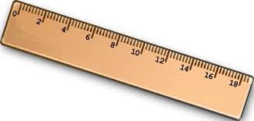  A. | B. 
3.That is a pencil sharpenner. | A.   |     B. 
4. I like chating with friends. | 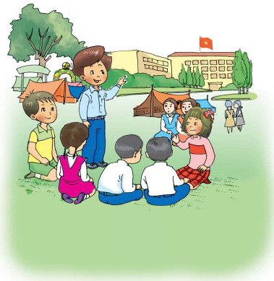  A. | B. 
5.I don’t like playing chess. |   A. | 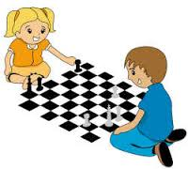  B. 

Question 5 : Look at the picture. Write the word (1pt) :
1.That is a p e n.

2.This is my ru_ _ _ _ | 
3.What’s that? –It’s a pe_ _ _ _ . | 
4.These are my ru_ _ _ _. | 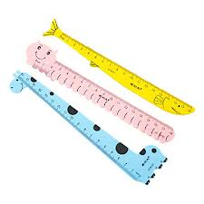
5.My cla_ _ _ _ _ _ is big. | 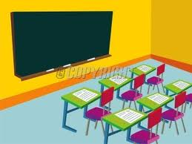

Question 6 : Match column A with column B (1pt) :

A |  | B
1.How do you spell your name? | 1 - d | a.No,you can’t.
2.May I come in,Sir? | 2 - | b.Bye.
3.What’s that? | 3 - | c.I play hide-and –seek.
4.Goodbye | 4 - | d.T-O-N-Y.
5.What do you do at break time? | 5 - | e.It’s a book.

Question 7:Choose the word from the box and complete the dialogue(1pt):

nice computer old No

Mai: This is my (1)________.
Mary: Really? Is it (2) _________?
Mai: (3)_______. It’s new.
Mary: It’s also (4)____________.

Question 8:Look and read.Write Yes or No(1pt ):

Hi.My name is Nga. This is Dong Khoi Primary School.It is my new school. It is big. That is my classroom.It is very large. My computer room is big,too. Those are my pens.They are new and nice.
1.Her name is Mai ____No___
2.Dong Khoi Primary School is old. _________
3.The classroom is large. _________
4.The computer room is small _________
5. The pens are long. _________

Question 9: Reorder the words (2pts):

1./Mai/ am/ I / ./
=> __________________________
2./ up,/ Stand/ please/ ./
=>__________________________
3. are/ Where/ from /you/?
=> _________________________
4. / is/ name/ My/ Phong/ ./
=> _________________________
5. / break/ like/ football/ I / playing/ at/ time./
=>_____________________________________

Question 6:Look and read. Put a tick √ or cross X in the box as examples
(1 pt ):
 | 1. This is a pen. | √
 | 2. This is a pencil. | X
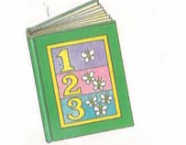 | 3. This is a book
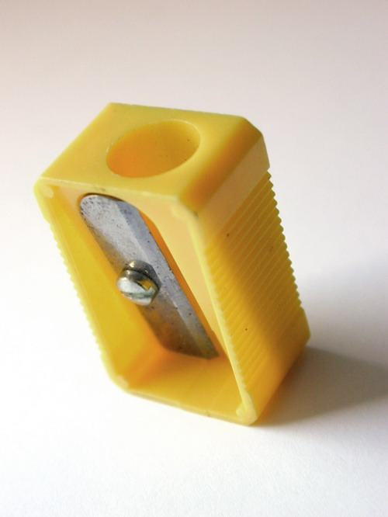 | 4. This is a ruler.
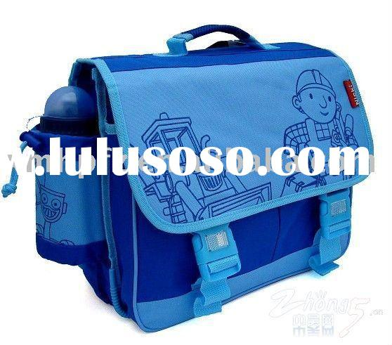 | 5. This is a school bag.
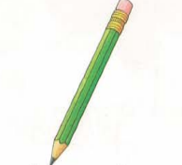 | 6. This is a pen.

Question 8: Look at the picture. Look at the letters. Write the words:
 | 1.npe = pen
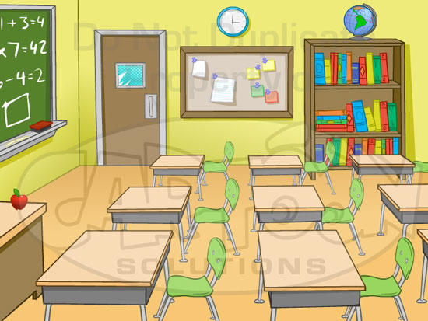 | 2. roomlassc = ________
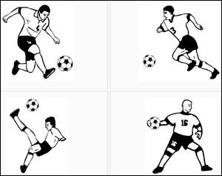 | 3. balltfoo=___________
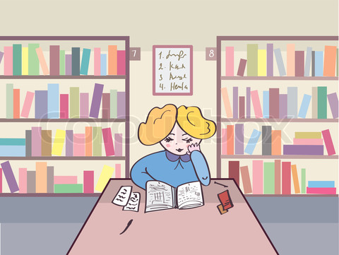 | 4. brarily=____________

The end

